1. Open the terminal:

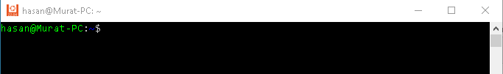

2. To know which directory you are in, you can use the “pwd” command.

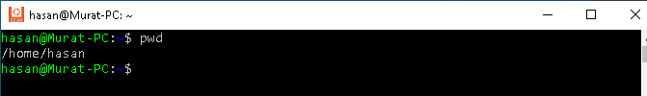

3. Go to desktop

4. Create a directory named "clarusway"

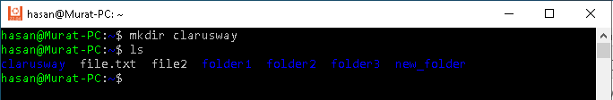

5. List all the files/folders with details

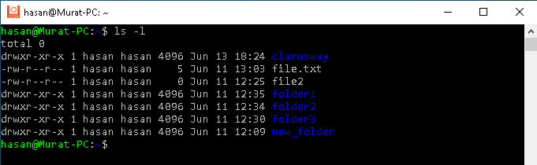

6. Create a file named test.txt

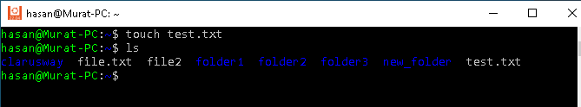

7. Write "hello" to test.txt

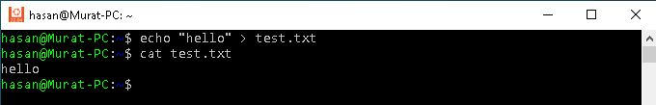

8. Add "My name is Robert" to test.txt

9. Print the content of test.txt

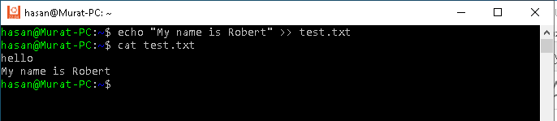

10. Create a file named test1.txt and write "hello, this is second text file" while creating.

11. Print the contents of test1.txt

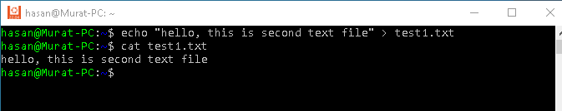

12. Display the contents of the file test.txt and test1.txt at the same time.

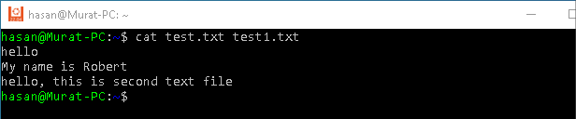

13. Create text files with the name multiple1.txt through multiple10.txt in current directory.

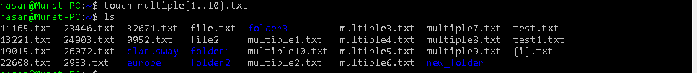

14. Go to upper directory



15. Create a directory named "europe"

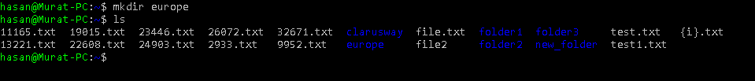

16. Create two files named lab.txt and lab1.txt at the same time

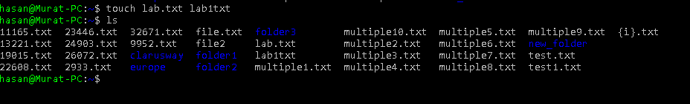

17. Write "This is the second directories first file" in lab.txt

18. cat lab.txt



19. Make a copy of lab.txt in the current directory as newlab.txt

20. List all the files in the current directory.

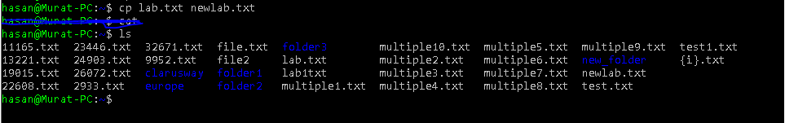

21. Print the contents of newlab.txt



22. List any file in current directory with the extension of ".txt"



23. List any file which begins with "n" and ends with".txt"



24. Copy newlab.txt to the clarusway directory.

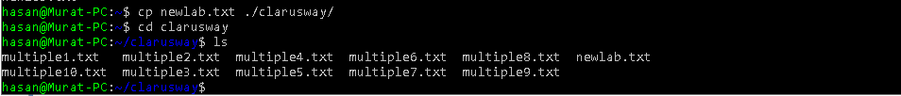

25. Copy the files beginnig with "m\*{6..10}" and ending with ".txt from clarusway directory to europe

directory.

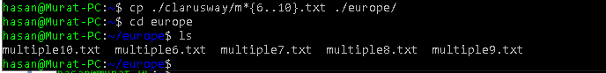

26. Move the files beginnig with "m\*{1..3}" and ending with ".txt from clarusway directory to europe

directory.

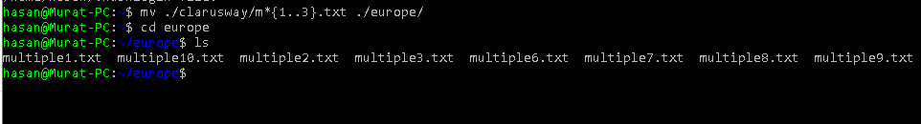

27. List all the files on Clarusway directory.



28. Rename the newlab.txt file as linuxlab.txt.



29. List the files with details on clarusway directory and see the renamed linuxlab.txt file.

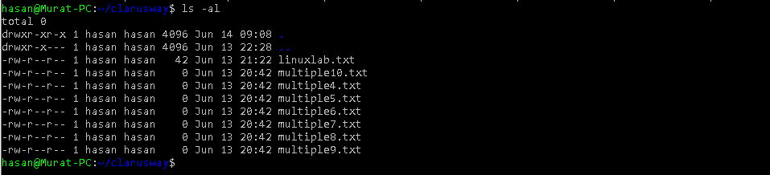

30. Print the permission details of linuxlab.txt.



31. Change file permissions of the linuxlab.txt as everybody can read, write and execute.

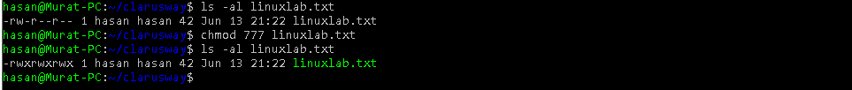

32. Change execute permissions of everybody to no execute permission on linuxlab.txt

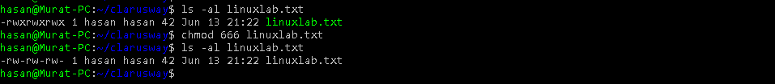

33. Change the file permissions one level up on linuxlab.txt

34. Delete the linuxlab.txt file



35. Create "america" directory

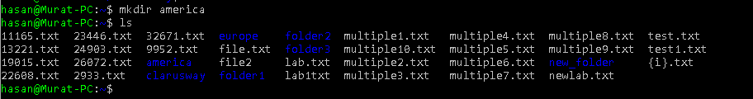

36. Delete america directory

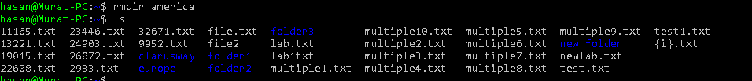

37. Delete clarusway directory

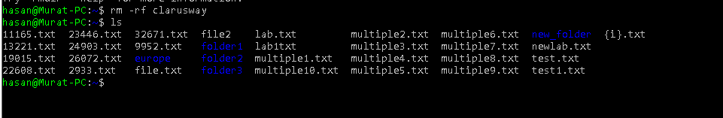

38. Go to the europe directory

39. List the contents of europe directory



40. Create a hidden linuxworkshop.txt file

41. Use ls command to list the contents of the europe directory

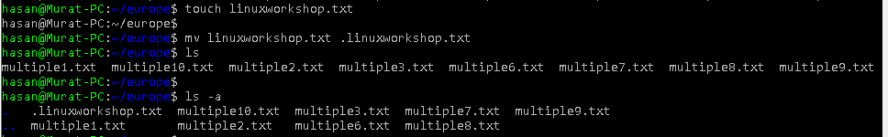

42. Make the linuxworkshop.txt visible

