**CSE208L Object Oriented Programming Lab**

**LAB # 4**



**2020**

**Submitted to:**

**Engr. Sumayyea Salahuddin**

**Submitted by:**

**TAYYABA**

**Registration No :**

**19PWCSE1854**

**Semester: 3nd**

**Class Section:** **C**

“On my honor, as student of University of Engineering and Technology, I have neither given nor received unauthorized assistance on this academic work.”

**Dec, 28, 2020**

**Department of Computer Systems Engineering**

**University of Engineering and Technology, Peshawar**

**Objectives of the Lab:**

Objectives of the lab are to:

1. Understand and implement parameter less and parameterized constructor in a class.
2. Write a class (C++/Java) with overloaded constructors.
3. Write a test program to use default copy constructor (C++).
4. Understand the difference between a Shallow Copy and a Deep Copy.
5. Understand the concept of dynamic memory allocation.
6. Implement deep and shallow copy in a class (C++/Java).
7. Use and test deep and shallow copy in a class.
8. Understand and implement destructor in a class (C++/Python).

**ACTIVITY # 01**

**Title:**

Make a class for employee and model it using employee data.

**Problem analysis:**

Create a class called employee. This class maintains information about name (*char) , department(*char), salary(double), and period of service in years (double).

**Algorithm:**

UML diagram for the above problem is given below:

* First make class employee.
* 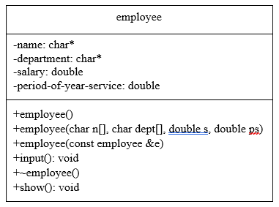Declare name & department as private character pointer field and salary & period of service in year as private integer field.
* Define no argument constructor to set default values of data members.
* Define four arguments constructor.
* Define copy‐constructor that performs the deep copy of the data members.
* Define input function to take input from the user.
* Define show function to display the output
* Define a destructor to free the memory allocated to name and department in constructor.
* In main function, make objects of employee to demonstrate the use.
* Call each function one after the other and display the show function.

**In C++**

**Source code:**

#include <iostream>

#include <conio.h>

#include <string>

#include <cstring>

using namespace std;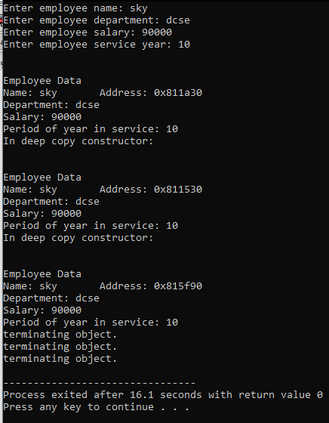 **Output:**

class employee{

private:

char* name; char* department;

double salary; double period_of_year_service;

public:

employee(){

name=""; department="";

salary=0; period_of_year_service=0;

}

employee(char n[], char dept[],double s, double ps){

int len =strlen(n)+1;

name=new char[len];

strcpy(name,n);

len =strlen(dept)+1;

department=new char[len];

strcpy(department,dept);

salary=s;

period_of_year_service=ps;

}

employee(const employee &e){

cout<<"In deep copy constructor: "<<endl;

int len=strlen(e.name);

name= new char[len+1];

strcpy(name,e.name);

len=strlen(e.department);

department= new char[len+1];

strcpy(department,e.department);

salary=e.salary;

period_of_year_service=e.period_of_year_service;

}

void input(){

cout<<"enter employee name: ";

name=new char[100];

cin>>name;

cout<<"enter employee department: ";

department=new char[100];

cin>>department;

cout<<"enter employee salary: ";

cin>>salary;

cout<<"enter employee service year: ";

cin>>period_of_year_service;

}

~employee(){

cout<<"terminating object."<<endl;

delete name;

delete department;

}

void show(){

cout<<"Employee Data"<<endl;

cout<<"Name: "<<name<<"\tAddress: "<<(void *)name<<endl;

cout<<"Department: "<<department<<endl;

cout<<"salary: "<<salary<<endl;

cout<<"period of year in service: "<<period_of_year_service<<endl<<endl;

}

};

int main()

{

employee e1; e1.input(); e1.show();

employee e2=e1; e2.show();

employee e3(e1); e3.show();

return 0

}

**In Python**

**Source code: Output:**

import copy

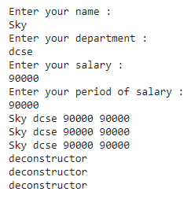class employee:

def __init__(self,n,d,s,p):

self.name=n

self.dept=d

self.salary=s

self.period=p

def __del__(self):

print('deconstructor')

def show(self):

print(self.name,self.dept,self.salary,self.period)

def dataln(self):

print('Enter your name : ')

self.name=input()

print('Enter your department : ')

self.dept=input()

print('Enter your salary : ')

self.salary=input()

print('Enter your period of salary : ')

self.period=input()

e1=employee("","",0,0)

e1.dataln()

e1.show()

e2=copy.copy(e1)

e2.show()

e3=copy.deepcopy(e1)

e3.show()

del e1

del e2

del e3

**Conclusion:**

This program helps us in understanding the basic concepts of classes and objects in different languages. It acts as a base for us and helps us in preparing ourselves for the higher level of programming. We get to know about the shallow and deep copy in OOP with the help of this program.