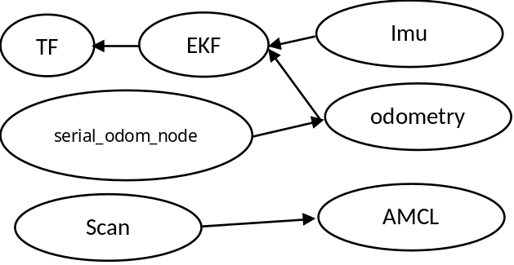


ROS2 Humble
GPIO

USB Serial

USB Serial

USB Serial

Arduino Shield

DDS over WiFi

