

Build a Data Mart in SQL
Phase 1 – Conception Phase

Course: DLBDSPBDM01
Tutor: Musharaf Doger
Name: Anita Skynar
Matriculation: 92124577
Submission Date: 27 August 2024

Summary of Phase One: Database Design for Airbnb Datamart
In the first phase of this project, the goal was to plan and design a database for an Airbnb-like platform. The main challenge was figuring out how to organize the data to handle complex relationships between guests, hosts, vacation rentals, bookings, and more, while keeping everything consistent and scalable.
Steps Taken: First, I started with a detailed analysis to understand the roles and actions that the database needs to support. Based on this, I created an Enhanced Entity Relationship Diagram (EER) using MySQL Workbench. The EER includes 25 entities that cover all the important parts of the system. 2-3 triple relationships were included to handle the more complex data interactions as well as recursive relationships where it made sense. Each entity was designed with matching attributes, and the key attributes were marked accordingly.
Chen notation was used to define the cardinality of the relationships, which helped ensure that the connections between the entities are clear and accurate. Throughout the design process, I focused on normalization to avoid data redundancy and maintain integrity, especially when dealing with locations and cities.
MySQL Workbench was extremely useful as it allowed me to extract the EER diagram that visually represents the planned database structure. Additionally, I put together a data dictionary that provides the description of each entity’s attributes, including their data types and how they are used.

Enhanced Entity Relationship Diagram
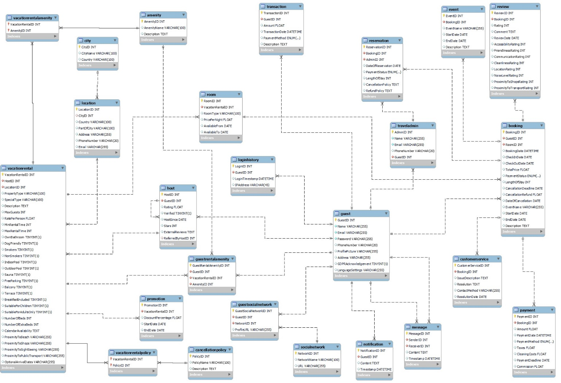

Data Dictionary
1. Guest Table
Attribute | Data Type | Description
GuestID | INT | Unique identifier for each guest.
Name | VARCHAR(255) | The full name of the guest.
Email | VARCHAR(255) | The guest's email address, which must be unique.
Password | VARCHAR(255) | Encrypted password for the guest's account.
PhoneNumber | VARCHAR(20) | The guest's contact phone number (including + or ()).
ProfilePicture | VARCHAR(255) | URL or path to the guest's profile picture.
Address | VARCHAR(255) | The guest's residential address.
GDPRAcknowledgement | BOOLEAN | Indicates if the guest has acknowledged GDPR compliance.
LanguageSettings | VARCHAR(255) | The preferred language of the guest.
2. Host Table
Attribute | Data Type | Description
HostID | INT | Unique identifier for each host.
GuestID | INT | Foreign key linking to the GuestID in the Guest table.
Rating | FLOAT | The average rating given to the host by guests.
Verified | BOOLEAN | Indicates if the host has been verified by the platform.
HostSince | DATE | The date when the user became a host.
Stars | INT | Number of stars awarded to the host based on guest reviews.
ExternalReviews | TEXT | Reviews about the host from external platforms.
ReferredByHostID | INT | Recursive foreign key referencing another host who referred them.
3. TravelAdmin Table
Attribute | Data Type | Description
AdminID | INT | Unique identifier for each travel administrator.
Name | VARCHAR(255) | The full name of the admin.
Email | VARCHAR(255) | The admin's email address, which must be unique.
PhoneNumber | VARCHAR(20) | The admin's contact phone number.
GuestID | INT | Foreign key linking to the GuestID in the Guest table.
4. SocialNetwork Table
Attribute | Data Type | Description
NetworkID | INT | Unique identifier for each social network.
NetworkName | VARCHAR(100) | The name of the social network (e.g., Facebook).
URL | VARCHAR(255) | URL of the social network's main page.
5. GuestSocialNetwork Table
Attribute | Data Type | Description
GuestSocialNetworkID | INT | Unique identifier for each social network connection for a guest.
GuestID | INT | Foreign key linking to the GuestID in the Guest table.
NetworkID | INT | Foreign key linking to the NetworkID in the SocialNetwork table.
ProfileURL | VARCHAR(255) | URL to the guest's profile on the social network.
6. LoginHistory Table
Attribute | Data Type | Description
LoginID | INT | Unique identifier for each login record.
GuestID | INT | Foreign key linking to the GuestID in the Guest table.
LoginTimestamp | DATETIME | Date and time when the guest logged in.
IPAddress | VARCHAR(45) | The IP address used by the guest during login.
7. Notification Table
Attribute | Data Type | Description
NotificationID | INT | Unique identifier for each notification.
GuestID | INT | Foreign key linking to the GuestID in the Guest table.
Content | TEXT | The content of the notification sent to the guest.
Timestamp | DATETIME | Date and time when the notification was sent.
8. Message Table
Attribute | Data Type | Description
MessageID | INT | Unique identifier for each message.
SenderID | INT | Foreign key linking to the GuestID of the sender.
ReceiverID | INT | Foreign key linking to the GuestID of the receiver.
Content | TEXT | The content of the message sent between guests.
Timestamp | DATETIME | Date and time when the message was sent.
9. Location Table
Attribute | Data Type | Description
LocationID | INT | Unique identifier for each location.
Country | VARCHAR(100) | The country where the location is situated.
City | VARCHAR(100) | The city where the location is situated.
PartOfCity | VARCHAR(100) | The specific area or neighborhood within the city.
Address | VARCHAR(255) | The full address of the location.
PhoneNumber | VARCHAR(20) | Contact phone number for the location.
Email | VARCHAR(255) | Contact email address for the location.
10. VacationRental Table
Attribute | Data Type | Description
VacationRentalID | INT | Unique identifier for each vacation rental property.
HostID | INT | Foreign key linking to the HostID in the Host table.
LocationID | INT | Foreign key linking to the LocationID in the Location table.
PropertyType | VARCHAR(100) | The type of property (e.g., Apartment, House).
SpecialType | VARCHAR(100) | Any special type of property (e.g., Treehouse, Boat).
Description | TEXT | Detailed description of the property.
MaxGuests | INT | Maximum number of guests that can stay at the property.
RatePerPerson | FLOAT | Rate charged per guest per night.
MinRentalTime | INT | Minimum rental time in days.
MaxRentalTime | INT | Maximum rental time in days.
OwnBathroom | BOOLEAN | Indicates if the rental includes a private bathroom.
DogFriendly | BOOLEAN | Indicates if dogs are allowed at the rental.
Smokers | BOOLEAN | Indicates if the rental is suitable for smokers.
NonSmokers | BOOLEAN | Indicates if the rental is suitable for non-smokers.
IndoorPool | BOOLEAN | Indicates if the rental includes an indoor pool.
OutdoorPool | BOOLEAN | Indicates if the rental includes an outdoor pool.
Sauna | BOOLEAN | Indicates if the rental includes a sauna.
FreeParking | BOOLEAN | Indicates if free parking is available.
Balcony | BOOLEAN | Indicates if the rental includes a balcony.
Terrace | BOOLEAN | Indicates if the rental includes a terrace.
BreakfastIncluded | BOOLEAN | Indicates if breakfast is included in the rental.
SuitableForChildren | BOOLEAN | Indicates if the rental is suitable for children.
SuitableForAdultsOnly | BOOLEAN | Indicates if the rental is suitable for adults only.
NumberOfBeds | INT | Number of beds available in the rental.
NumberOfExtraBeds | INT | Number of extra beds available in the rental.
CalendarAvailability | TEXT | Text field indicating the availability calendar for the rental.
ProximityToBeach | VARCHAR(255) | Description of the rental's proximity to the nearest beach.
ProximityToShops | VARCHAR(255) | Description of the rental's proximity to nearby shops.
ProximityToSightSeeing | VARCHAR(255) | Description of the rental's proximity to tourist attractions.
ProximityToPublicTransport | VARCHAR(255) | Description of the rental's proximity to public transport.
OptionalArrivalDates | VARCHAR(255) | Description of any optional arrival dates.
11. Room Table
Attribute | Data Type | Description
RoomID | INT | Unique identifier for each room within a vacation rental.
VacationRentalID | INT | Foreign key linking to the VacationRentalID in the VacationRental table.
RoomType | VARCHAR(100) | The type of room (e.g., Single, Double, Suite).
PricePerNight | FLOAT | Price charged per night for the room.
AvailableFrom | DATE | Date from which the room is available.
AvailableTo | DATE | Date until which the room is available.
12. Amenity Table
Attribute | Data Type | Description
AmenityID | INT | Unique identifier for each amenity.
AmenityName | VARCHAR(100) | The name of the amenity (e.g., WiFi, Pool).
Description | TEXT | Detailed description of the amenity.
13. VacationRentalAmenity Table
Attribute | Data Type | Description
VacationRentalID | INT | Foreign key linking to the VacationRentalID in the VacationRental table.
AmenityID | INT | Foreign key linking to the AmenityID in the Amenity table.
PRIMARY KEY | INT | Composite primary key ensuring the uniqueness of the combination of VacationRentalID and AmenityID.
14. CancellationPolicy Table
Attribute | Data Type | Description
PolicyID | INT | Unique identifier for each cancellation policy.
PolicyName | VARCHAR(100) | The name of the cancellation policy (e.g., Flexible, Strict).
Description | TEXT | Detailed description of the cancellation policy.
15. VacationRentalPolicy Table
Attribute | Data Type | Description
VacationRentalID | INT | Foreign key linking to the VacationRentalID in the VacationRental table.
PolicyID | INT | Foreign key linking to the PolicyID in the CancellationPolicy table.
PRIMARY KEY | INT | Composite primary key ensuring the uniqueness of the combination of VacationRentalID and PolicyID.
16. Booking Table
Attribute | Data Type | Description
BookingID | INT | Unique identifier for each booking.
GuestID | INT | Foreign key linking to the GuestID in the Guest table.
RoomID | INT | Foreign key linking to the RoomID in the Room table.
BookingDate | DATETIME | Date and time when the booking was made.
CheckInDate | DATE | Date of guest check-in.
CheckOutDate | DATE | Date of guest check-out.
TotalPrice | FLOAT | Total price for the booking.
PaymentStatus | ENUM | Status of the payment (e.g., Paid, Pending, Cancelled).
LengthOfStay | INT | Duration of the stay in days.
CancellationDeadline | DATE | Deadline for cancellation without penalty.
CancellationRefund | FLOAT | Amount refundable upon cancellation.
DateOfCancellation | DATE | Date when the booking was cancelled.
EventName | VARCHAR(255) | Name of any event associated with the booking.
StartDate | DATE | Start date of the event.
EndDate | DATE | End date of the event.
Description | TEXT | Detailed description of the event or booking.
17. Review Table
Attribute | Data Type | Description
ReviewID | INT | Unique identifier for each review.
BookingID | INT | Foreign key linking to the BookingID in the Booking table.
Rating | INT | Overall rating given by the guest.
Comment | TEXT | Detailed comment or feedback provided by the guest.
ReviewDate | DATE | Date when the review was submitted.
AccessibilityRating | INT | Rating of the rental's accessibility features.
FriendlinessRating | INT | Rating of the host's friendliness.
CommunicationRating | INT | Rating of the host's communication.
CleanlinessRating | INT | Rating of the rental's cleanliness.
LocationRating | INT | Rating of the rental's location.
NoiseLevelRating | INT | Rating of the rental's noise level.
ProximityToShopsRating | INT | Rating of the rental's proximity to shops.
ProximityToTransportRating | INT | Rating of the rental's proximity to public transport.
18. Payment Table
Attribute | Data Type | Description
PaymentID | INT | Unique identifier for each payment.
BookingID | INT | Foreign key linking to the BookingID in the Booking table.
Amount | FLOAT | Total amount paid.
PaymentDate | DATETIME | Date and time when the payment was made.
PaymentMethod | ENUM | Method of payment (e.g., CreditCard, PayPal).
Taxes | FLOAT | Amount paid in taxes.
CleaningCosts | FLOAT | Additional cleaning costs associated with the booking.
PaymentDeadline | DATE | Deadline for completing the payment.
Commission | FLOAT | Platform commission on the payment.
19. Reservation Table
Attribute | Data Type | Description
ReservationID | INT | Unique identifier for each reservation.
BookingID | INT | Foreign key linking to the BookingID in the Booking table.
AdminID | INT | Foreign key linking to the AdminID in the TravelAdmin table.
DateOfReservation | DATE | Date when the reservation was made.
PaymentStatus | ENUM | Status of the payment for the reservation (e.g., Paid, Pending).
LengthOfStay | INT | Duration of the stay in days.
CancellationPolicy | TEXT | Description of the cancellation policy.
RefundPolicy | TEXT | Description of the refund policy.
20. CustomerService Table
Attribute | Data Type | Description
CustomerServiceID | INT | Unique identifier for each customer service issue.
BookingID | INT | Foreign key linking to the BookingID in the Booking table.
IssueDescription | TEXT | Detailed description of the issue reported by the guest.
Resolution | TEXT | How the issue was resolved.
ContactMethod | VARCHAR(255) | Method used to contact customer service (e.g., Email, Phone).
ResolutionDate | DATE | Date when the issue was resolved.
21. Event Table
Attribute | Data Type | Description
EventID | INT | Unique identifier for each event.
BookingID | INT | Foreign key linking to the BookingID in the Booking table.
EventName | VARCHAR(255) | Name of the event.
StartDate | DATE | Start date of the event.
EndDate | DATE | End date of the event.
Description | TEXT | Detailed description of the event.
22. City Table
Attribute | Data Type | Description
CityID | INT | Unique identifier for each city.
CityName | VARCHAR(100) | Name of the city.
Country | VARCHAR(100) | Country where the city is located.
23. Promotion Table
Attribute | Data Type | Description
PromotionID | INT | Unique identifier for each promotion.
VacationRentalID | INT | Foreign key linking to the VacationRentalID in the VacationRental table.
DiscountPercentage | FLOAT | Percentage discount offered by the promotion.
StartDate | DATE | Start date of the promotion.
EndDate | DATE | End date of the promotion.
24. Transaction Table
Attribute | Data Type | Description
TransactionID | INT | Unique identifier for each transaction.
GuestID | INT | Foreign key linking to the GuestID in the Guest table.
Amount | FLOAT | Total amount transacted.
TransactionDate | DATETIME | Date and time of the transaction.
PaymentMethod | ENUM | Method of payment (e.g., CreditCard, PayPal).
Description | TEXT | Description of the transaction.
25. GuestRentalAmenity Table
Attribute | Data Type | Description
GuestRentalAmenityID | INT | Unique identifier for each amenity associated with a guest's rental.
GuestID | INT | Foreign key linking to the GuestID in the Guest table.
VacationRentalID | INT | Foreign key linking to the VacationRentalID in the VacationRental table.
AmenityID | INT | Foreign key linking to the AmenityID in the Amenity table.

