Question 4 - A script for the Ndyuka (20 marks)
The Afaka script, named after its inventor Afáka Atumisi, was invented around 1910 to write the Ndyuka language of Suriname. The Ndyuka people trace their ancestry to communities of escaped South American slaves, and their language is a creole language with roots in both West African languages and English. Although the grammatical structure of the language is more similar to other creole languages and to West African languages, you will find that many of the individual words are derived from English words. The following letter, probably written by Afáka himself in 1917, is one of the earliest surviving documents in this writing system.

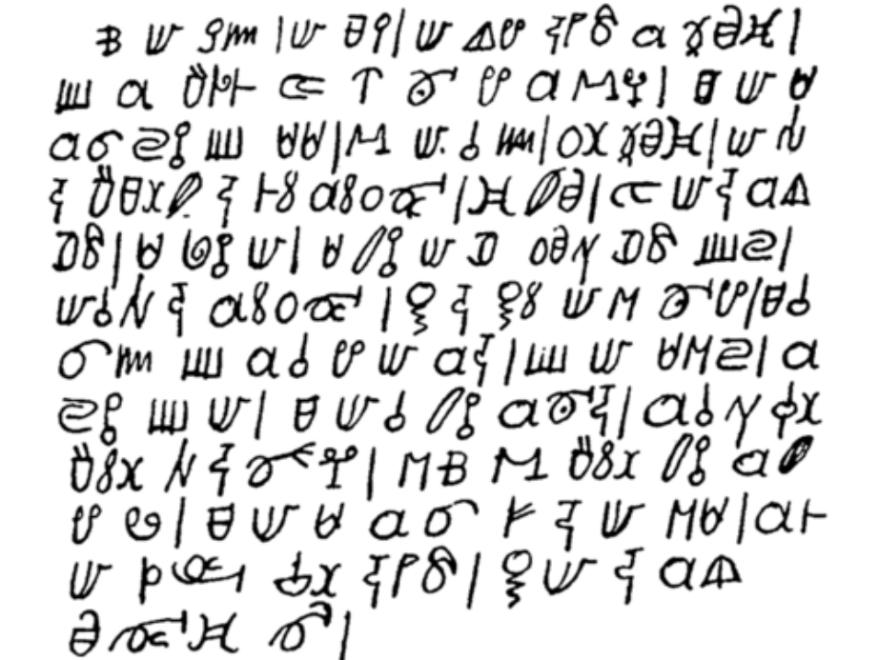

Here is a translation:

Oh my God, my Lord, I start with the words on the paper that you've given Afaka. But I'm deathly ill. How can I say it? I went to Paramaribo, Lands Hospital, two times. Because I have no money, they chased me away. They say I must first earn money before I go to the Hospital. Therefore I pray the Lord God that he will give me a hand with the medicine for my illness. But I will talk to Abena. He will bring this to the Priest of the Ndyuka. So as the Father says it is good for us. But I have pain in my head. All my nose is rotting from the inside. So I have no rest, I tell you.

For your convenience, the letter is also presented with more spacing between the lines on the last sheet of this question paper.

In the table on the next page, Afáka’s letter is presented in a Roman alphabet transcription. It has, however, been broken into 23 phrases and then scrambled. (The phrases are split according to Afaka’s punctuation; they won’t necessarily line up with the phrases or sentences of the English translation.) Furthermore, we have left labelled blanks in many of these phrases (e.g. _A_) where one or more words are missing.

4.1. Write the missing words in the first column on the answer sheet.

4.2. Write the meanings of these missing words in the second column

A script for the Ndyuka (20 marks)

 | 1. missing word(s) |  | 2. meanings
A
B
C
D
E
F
G
H
I
J
K
L
M
N
O

a _A_ kon tyali patili go na ndyuka | ma mi de aga pe na _I_
_B_ mi mu oloko moni fosi | ke mi _J_
a _C_ | eke fa patili taki a bun gi wi
_D_ na ati osu | mi _K_ na ini a ulotu
fu a papila di yu be gi _E_ | oli ulotu
_F_ bolo | ma mi de aga _L_
fa mi sa du | mi masa
masa gadu fu _G_ ana | di mi ná _M_
de yaki mi | da na dati mi e begi
mi go na _H_ na lati ati oso | _N_ mi noso poli na ini
da mi ná abi losutu ye | _O_
fu mi deesi

Answers and marks

A script for the Ndyuka (20 marks)

 | 1. missing word(s) | 15 | 2. meanings | 5
A | sa | @1 | will | @1/3
B | de taki |  | they say
C | siki fu mi |  | my illness
D | mi sa go |  | I will go
E | afaka |  | Afaka
F | tu |  | two
G | a sa gi me |  | he will give me
H | pamalibo |  | Paramaribo
I | mi ede |  | my head
J | gadu |  | god
K | bigi |  | begin
L | siki fu dede |  | deathly ill
M | abi moni |  | have money
N | ala |  | all
O | ma mi sa taki abena |  | but I will talk to Abena

