Round 2 Problem 2 Nivkh
Nivkh (also known as Gilyak) is a language (apparently unrelated to any other language) spoken by approximately 1,000 people in Outer Manchuria. In the following problem, someone called Balda (a male Nivkh name) needs supplies quickly because he must leave for a long journey immediately, where he must accomplish many quests. If he doesn’t have all of these items, he will not be able to complete the quests he has been assigned. Figure out how to say what Balda is asking for so that he can get going in time! Note that p', t', and k' are single sounds in Nivkh.
Here are some Nivkh statements and (in a different order) their English translations, followed by some further Nivkh nouns.
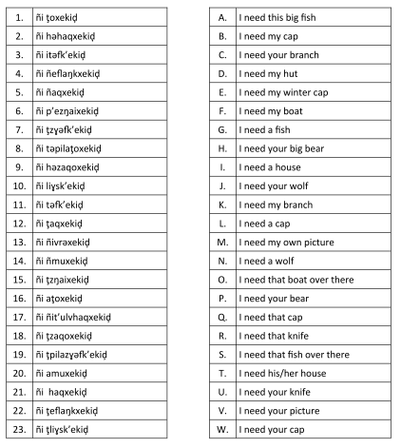
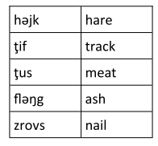

Q.2.1. Match the Nivkh statements 1-23 to their English translations A-W.
Q.2.2. Translate the following into English:
- ñi ţpilamuxekiḑ
- ñi hәzɣәfk’ekiḑ
- ñi tәfləŋgxekiḑ
- ñi p’eţusk’ekiḑ
- ñi ahaqxekiḑ
Q.2.3. Translate the following into Nivkh:
- I need your big track.
- I need my knife.
- I need that cap over there.
- I need your hare.
- I need my nail.

Problem 2 Nivkh
2.1 | 1 | 2 | 3 | 4 | 5 | 6 | 7 | 8 | 9 | 10 | 11 | 12
2.1 | 13 | 14 | 15 | 16 | 17 | 18 | 19 | 20 | 21 | 22 | 23
2.2 | a. |  |  |  |  |  | b.
2.2 | c. |  |  |  |  |  | d.
2.2 | e.
2.3 | a. |  |  |  |  |  | b.
2.3 | c. |  |  |  |  |  | d.
2.3 | e.

Solution and marking.
Scoring (max 43)
- 2.1 1 point for each correct cell (max 23)
- 2.2 2 points for each correct answer. (max 10)
  - 1 point with one word wrong
- 2.3 2 points for each correct answer. (max 10)
  - 1 point with one letter wrong.
2.1 | 1 | 2 | 3 | 4 | 5 | 6 | 7 | 8 | 9 | 10 | 11 | 12
2.1 | G | Q | T | K | B | M | P | A | R | N | I | W
2.1 | 13 | 14 | 15 | 16 | 17 | 18 | 19 | 20 | 21 | 22 | 23
2.1 | D | F | V | S | E | U | H | O | L | C | J
2.2 | a. I need your big boat |  |  |  |  |  | b. I need that bear
2.2 | c. I need this big ash |  |  |  |  |  | d. I need my own meat
2.2 | e. I need that cap over there
2.3 | a. ñi ţpilaţifk’ekiḑ / xekiḑ |  |  |  |  |  | b. ñi ñzaqoxekiḑ
2.3 | c. ñi ahaqxekiḑ |  |  |  |  |  | d. ñi ţәjkxekiḑ
2.3 | e. ñi ñzrovsk’ekiḑ / xekiḑ

Commentary
(From NACLO solution – presumably written by the author.)
How to solve:
Easy step 1
- See that ñi = I
- See that xekiḑ = need (x →k’ aft er f and s)
- alternate analysis zɣәfk ’ and liɣsk’ end in k’ (x→/aft er k ’)
- These analyses might not pop out at fi rst, but they are seeable.
Easy step 2
- Count the nouns in the English translations.
- See that fi sh shows up 3 times.
- See that cap shows up 5 times.
- See that hut shows up 1 time.
- See that all other nouns show up twice.
Step 3a
- Look for correspondences in the Nivkh data (looking for fish, cap, and hut)
Step 3b
- Notice ‘pila’ (could initially mean ‘big’ or ‘over there’ by factoring out all of the nouns – cap is tricky, but the others are easy)
- Noti ce ţo 3 ti mes (after segmentati on of pila), ţo = fish
- Noti ce ñivra = my hut, so ivra = hut, ñ means my, which is nice because it goes with ñi=I
- Noti ce (h)aq = hut (5 ti mes) – the h will be tricky
Step 4
- figure out if pila is ‘big’ or ‘over there’
- compare ţpilazɣәfk ’ and tәpilaţo = ??(that or this)- pila –fi sh
- Notice that the two words containing pila have diff erent prefixes (t vs. ţ)
- Look at the other sentences that contain ‘big’ or ‘over there’ in their translations.
- zɣәfk ’ = either boat or bear
- Compare I need that boat over there vs I need that fish over there
- Notice that the prefixes don’t match
- Compare I need this big fish with I need your big bear
- Notice they have different prefixes, so tә = this, ţ=your
- Now you can match up 13 with D, 19 with H, 7 with P and 8 with A, …
Step 5
- You still have ţo and a -ţo – one means a fish and the other means that fish over there
- Notice a -mu and ñ-mu. ñmu is my ___. Of the nouns that appear twice, boat, branch, and picture have ‘my’ in their translation.
- Only ‘boat’ also goes with ‘that over there’, none have ‘a’ translations. So mu = boat, ñ = my, and a= ’that over there.
- So 1=G, 16=S, 14=F and 20=O
Step 6 : Cap
- aq shows up 5 times (it is haq, and x →/after a prefix) :
  - 2: ñi hә-haq-xekiḑ
  - 5: ñi ñ-aq-xekiḑ
  - 12: ñi ţ-aq-xekiḑ
  - 17: ñi ñ-it’ulv-haq-xekiḑ
  - 21 : ñi haq-xekiḑ
- Meanings :
  - B : ‘I need my cap’
  - E: ‘I need my winter cap’
  - L; ‘I need a cap’
  - Q: ‘I need that cap’
  - W: ‘I need your cap’
- evident that 12=W, 5=B, 17=E (so it’ulv(h) = winter, but the ‘h’ shows up in 21 too, so it’ulv)
- a cap vs that cap, we know ‘a’ = no prefi x on fi sh, and haqxekiḑ is obviously less prefi xed than h әhaqxekiḑ , so haq = cap (h deletes
- aft er a C, or aft er ‘my’ and ‘your’) hә = that
- 21=L, 2=Q
Step 7
- hә-zaqo and ţ-zaqo = that X and your X , so zaqo = knife and 9=R and 18=U
- liɣsk’ and ţ-liɣsk’ = a X and your X, so liɣsk’ = wolf and 10=N and 23=J
- ţ-efl aŋk and ñ-efl aŋk = your X and my X, so 22=C and 4=K
- p’-ezŋai and ţ-ezŋai = my own X (we haven’t seen p’ before, but we know ţ is ‘your’) and your X, so 6=M and 15=V
- i-tәfk ’ and tәfk ’ = his/her X (by elimination) and a X, so 3=T and 11=I

The only thing left was the vowels of the prefixes of a few forms. I took the offenders out. I modified the answers so that there are 2 right answers for 2 of the Eng to Nivkh translations.

