Question 7 - The War of the Dots (15 marks)
Before the Braille tactile writing system was well-established throughout the English-speaking world, the New York Point system was widely used in American blind education. New York Point was developed in the 1860s by William Bell Walt for the New York Institute for the Blind, and was intended to fix the shortcomings he perceived in the French and English Braille standards.

The next six decades in blind education became known as the War of the Dots, as bitter feuds developed between proponents of this homegrown system and more international Braille-based systems. New York Point finally met its end after a series of public hearings convinced educational authorities that there should be a single standard for the entire English-speaking world.

Experts from both sides weighed in on the systems’ merits. The proponents of New York Point argued that allowing letters to vary in size (from a 2x1 grid to a 2x4 grid, rather than a fixed 3x2 grid) allowed the most frequent letters to use fewer columns, resulting in space (and cost!) savings when publishing texts for the blind. For example, consider the number of dots needed to write the following names in each system:

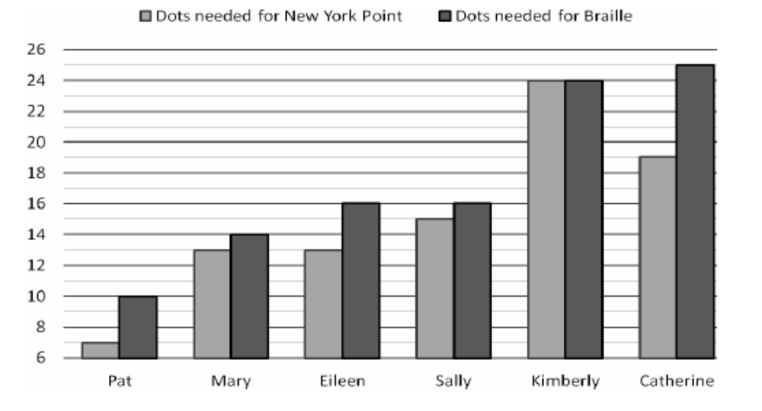
They also pointed out that New York Point had a distinct series of capital letters, whereas Braille only had a “capital” punctuation mark.

On the Braille side, experts such as Helen Keller wrote that the New York Point capitalization system was unintuitive and confusing (“I have often mistaken D for j, I for b and Y for double o in signatures, and I waste time looking at initial letters over and over again”), and that using Braille allowed her to correspond with blind people from all over the world.

7.1. (6 marks) The following words in New York Point represent (in no particular order) the names Ashley, Barb, Carl, Dave, Elena, Fred, Gerald, Heather, Ivan, Jack, Kathy, and Lisa. Which is which? Use the table in the answer sheet to show the answer.

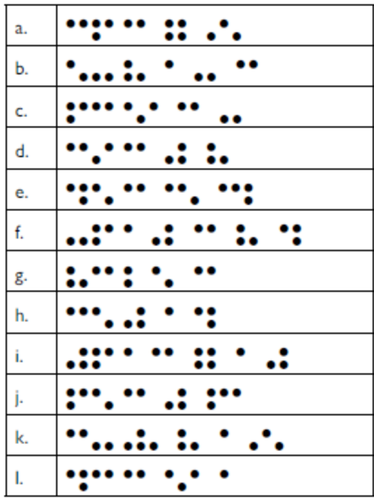

7.2. (9 marks) How would you write the following names in New York Point? Use the dot-grids in the answer sheet.

a. Billy

b. Ethan

c. Iggie

d. Orson

e. Sasha

f. Tim

Answer blank

Question 7 The War of the Dots (15 marks)

7.1 | Ashley | Barb | Carl | Dave
 | Elena | Fred | Gerald | Heather
 | Ivan | Jack | Kathy | Lisa
7.2 | a. Billy  b. Ethan  c. Iggie  d. Orson  e. Sasha  f. Tim | 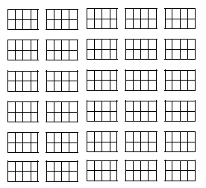

Answers and marks

Question 7 The War of the Dots (15 marks)

7.1 | Ashley | Barb | Carl | Dave | @0.5
 | k | j | d | l | @0.5
 | Elena | Fred | Gerald | Heather | @0.5
 | b | h | f | i | @0.5
 | Ivan | Jack | Kathy | Lisa | @0.5
 | c | e | a | g | @0.5
7.2 | a. Billy  b. Ethan  c. Iggie  d. Orson  e. Sasha  f. Tim | 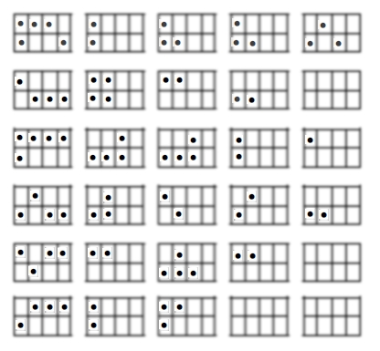  Accept dots starting in any column within the 2x4 block.  In d-f, give 1 for correct initial letter and 1 for remaining letters if they are all correct |  |  | 1  1  1  2  2  2

