Round 2 2013

Solution and grading sheet

[Point allocation: Feel free to modify your scheme if you feel the answers justify it, but please record your changes so that we can include them in the published version of this document.]

1. Deer father
1.1: 1 point for each pair [8]
1.2: 1 point for each word [4]
1.3: 1 point for each word-part [2]
1.4: 1 point [1]
Total: 15 points

1.1. 1 | 2 | 3 | 4 | 5 | 6 | 7 | 8
E | D | G | A | F | H | C | B
1.2. a. unya |  | nyak’ari  (or: nyak’a) |  | mama |  | taruka
1.3. a. –chus |  |  |  | b. -aypak
1.4. God, literally “Spirit Father” or “Father of the Spirits”

2. Putting the books in order
2.1: 2 points for each part [4]
2.2: 2 points for each part [4]
2.3: 1 point for each part [13]
total: 21 points

2.1. 9 = September |  |  |  |  |  |  | H = February
2.2. Yellow: XIII |  |  |  |  |  |  | Green: G
2.3. I | II | III | IV | V | VI | VII |  | VIII | IX | X | XI | XII | XIII
A | J | E | M | C | B | F |  | D | K | H | I | L | -

Explanation:
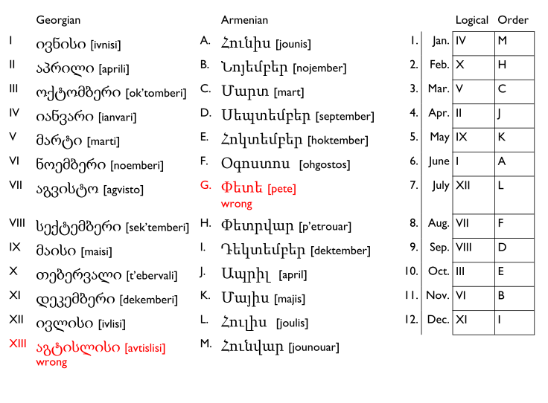

3. Beja
3.1,2: 2 points for a perfect answer; 1 point for up to two mistakes. [20]
3.3: 1 point per bullet covered. [12]

3.1.1. | The camel has seen the man
2. | He does not eat a flower
3. | She can eat a horse
4. | The man can collect water
5. | She cannot see a donkey
3.2.6. | Tak oogwib kanriif
7. | Idooba katamya
8. | Uumeek oofaar tamaab kiike
9. | Uugwib win kiike
10. | Tuuyaas yooaab danbiilt kitte

3.3. How Beja works
- gender: masculine (no t: -y, e.g. tamya; -b, e.g. tamaabu) vs feminine (t-/-t, e.g. tilaga, rhitni, tidbil; tilaga wint kitte).
- case: nominative/subjective (prefix = uu, e.g. uutak, tuukaam, uumeek) vs accusative/objective (prefix = oo, e.g. ootak, oomeek, oofaar); neutralized to i before two or more syllables.
- definiteness: indefinite (no prefix, e.g. yooaab, doobaab) vs definite (uu/oo/i-, e.g. ooyoo, tidooba, )
  - Also suffix –b marks masculine accusative/objective indefinite (e.g. yoob, kil’oob)
- person/number/tense: some verbs take suffixes (e.g. diwiini, kadiwta), others take prefixes and infixes (e.g. tidbil, danbiil)
- past participle: suffix –aa for all verbs (e.g. tamaabu, diblaab)
- negative: marked by prefix ka- + suffixing verb, or k- + prefixing verb.
- negative present: k(a) + past tense [odd!]
- ‘be’/copula: suffix –u (e.g. gwibu, winu)
  - added to accusative/objective (e.g. tamaabu)
- negative ‘be’: negative iike/itte (e.g. k-iike/k-itte)
- perfect/has done: past participle + ‘be’ (e.g. tamaabu, diblaab kiike)
- ‘can’: present, treated as an adjective so add t for feminine + ‘be’ (e.g. kanriifu, tamtiniit kitte)
- word order: subject/nominative + object/accusative + verb/‘be’ suffix

4. Stockholms Tunnelbana
1 point for each item. Total = 41.

29 | Abraham’s Mountain | 1 | King’s Garden
31 | Alder Bay | 78 | Lake Mälaren Heights
70 | Alder Village | 76 | Manor
79 | Axel’s Mountain | 90 | Mary Market
50 | Band Pasture | 26 | Meadow Village Square
64 | Birch Pasture | 32 | Mount Christine
7 | Channel Village Mountain Centre | 98 | Mountain Hammer
92 | Charles Square | 36 | Odin Square
24 | Dark Mountain | 53 | Pasture Manor
61 | Fathertown | 10 | Rink Village
62 | Fathertown Beach | 74 | Spring Mountain
57 | Forest Church Garden | 73 | Spring Village Farm
44 | Gullmar’s Square | 35 | St. Eric’s Square
69 | Hall Grove | 49 | Sture Village
63 | Hammer Village Heights | 84 | Telephone Square
38 | Haymarket | 100 | Tender Village Center
19 | Hazel Village Beach | 33 | Thorild’s Square
20 | Hazel Village Farm | 3 | Town Pasture
17 | House Village | 86 | Western Cottage
25 | Iceland Market | 4 | Westwood
21 | John’s Grove

5. Playing the cognate game
5.1: 1 point for each correct answer (total = 40)
5.2: 1 point for each correct pair and an additional point for each correct English translation (total = 4)
5.3: 2 points for each perfect answer, 1 point for getting the basic idea with minor errors (total = 40)
Grand total = 84.

5.1. English | Swahili (1-20) | Indonesian (a-t)
Bring me your notebook. | 10 | A
Bring your books to school. | 9 | B
He sold me a book. | 1 | E
His shirt is on his thigh. | 17 | J
I didn't have time on Friday. | 19 | S
I have books about Jews. | 11 | Q
I like the Dutch flag. | 13 | R
I speak Swahili. | 14 | O
I study biology. | 12 | N
In Swahili you can say what's new. | 5 | D
My brother's shirt is green | 16 | I
My sister studies chemistry. | 2 | H
My sister's headscarf is blue. | 3 | G
On Fridays I pray. | 18 | K
These districts are safe. | 20 | T
This list says that you are poor. | 15 | M
This neighborhood is safe. | 7 | L
Today is Thursday. | 8 | F
Tomorrow you're going to Egypt. | 6 | C
Yesterday I read the Bible. | 4 | P

5.2. Swahili word | English meaning of Swahili word | Indonesian misleading cognate | English meaning of Indonesian misleading cognate
daftari  kaka | notebook  brother | daftar  kakak | list  (older) sister (or brother)
katika  kitabu | in  book | ketika  (al-)kitab | on  the bible

5.3. | Swahili | Indonesian
1. | Ninasema Kiyahudi | Saya bisa berbahasa Yahudi
2. | Ninapenda shati la dada wangu | Saya suka kemeja adikku OR Saya suka kemeja kakakku
3. | Aliniuza bendera | Dia menjual saya bendera
4. | Misri ni salama | Mesri (adalah) selamat
5. | Ananiuza hijabu | Dia menjual saya jilbab
6. | Leo ninasoma kitabu | Hari ini saya membaca buku
7. | Katika Kiswahili unaweza kujifunza biblia | Di Bahasa Swahili Anda bisa belajar al-kitab
8. | Waholanzi ni meskini | Belanda-Belanda (adalah) miskin
9. | Siku za alhamisi ninasoma vitabu | Ketika hari kamis saya membaca buku-buku
10. | Kaka wangu anajifunza kitabu chako | Adikku belajar bukumu OR Kakakku belajar bukumu

