Presents from St Nicolashas … in your shoe
In the Netherlands, children get their “Christmas” presents on the night of the 5th of December or on the morning of the 6th from St Nicolas, or “Sinterklaas”, who is very similar to Father Christmas. Traditionally, Dutch children leave a treat out for Sinterklaas’ horse alongside their shoe and Sinterklaas puts presents in the shoes (which might explain why Dutch people have big feet – although scientists argue it’s because the Dutch are on average very tall people).
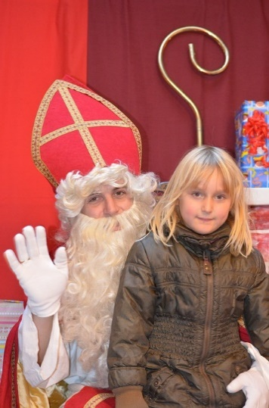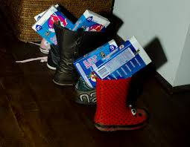
Sinterklaas and friend a family’s shoes with traditional gift of chocolate letters – delivered by Sinterklaas
Sinterklaas visited all Dutch families in 2017 and left presents for everyone. Among the families visited are those of Jeroen and his neighbour Marieke.
Here are some of the presents that Jeroen and his family have been given by Sinterklaas.
Please note that Dutch has two words for “the”: “het” and “de” – “de” is used for nouns that are either masculine or feminine, while “het” is used for neuter gender nouns. Grammatical gender has not much to do with biology: “the girl” is, grammatically, speaking neuter: “het meisje”. Dutch has only one word for “a / an”, namely “een”, which is the same regardless of the gender of the noun it appears with.

Dutch presents: | English translation:
een gouden ketting | a gold necklace
de katoenen tas | the cotton bag
de nieuwe jas | the new coat
het leuke computerspel | the fun computer game
een nieuw computerspel | a new computer game
de mooie ketting | the beautiful necklace
een katoenen jas | a cotton coat
een mooi poppenhuis | a beautiful doll’s house
een nieuwe fiets | a new bicycle
het mooi koffiezetapparaat | the beautiful coffeemaker
een houten poppenhuis | a wooden doll’s house
de groene fiets | the green bicycle

Can you complete the table with the gifts that Sinterklaas left for Marieke’s family?
Here are the objects – Dutch nouns with their definite article (“the”):
Dutch: | English:
t-shirt (het) | t-shirt (the)
boek (het) | book (the)
armband (de) | bracelet (the)
bedeltje (het) | charm (to put on bracelet) (the)
gsm (de) | mobile phone (the)
chocoladeletter (de) | chocolate letter (the) (traditional Sinterklaas gift – you get given a letter made from chocolate – usually the first letter of your name)

And here are some new adjectives in Dutch – Note that these adjectives are in their dictionary form and do not have the correct endings, such as -e or -en which get attached to adjectives when used with nouns.
Dutch: | English:
zilver | silver
koel | cool (Dutch teens borrowed this from English!)
leder | leather
lekker | tasty

Now translate Marieke’s and her family’s gifts into Dutch:
 | English: | Your Dutch translation:
1 | a cotton t-shirt
2 | a leather coat
3 | the silver bracelet
4 | a silver charm
5 | the tasty chocolate letter
6 | a new mobile phone
7 | the cool book
8 | a green t-shirt
9 | a fun book
10 | a beautiful, green, leather bag
11 | a new, silver charm
12 | the cool, green t-shirt

