We wish you Germanic Christmas and a Happy New Year!
English is a Germanic language, which means that it is related to other languages, which have all descended from the original Germanic language spoken by the tribes that settled in Northern and Western Europe.
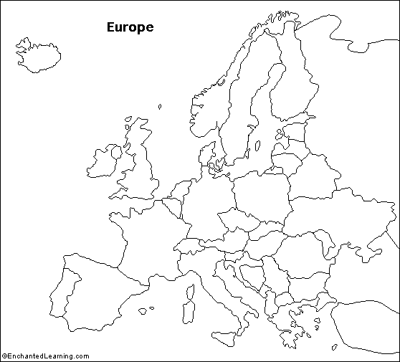
English
Dutch (spoken in Netherlands and Belgium)
Danish
Swedish
Frysian (spoken in North of Netherlands)
Just as our languages have similarities because of their shared roots, our festivals are also very similar. And the biggest festival is of course Christmas! Here is some seasonable vocabulary from some of the other Germanic languages.
English | Christmas Eve | Santa Claus | New Year’s Day | Christmas wreath | Christmas tree
Dutch | Kerstavond | Sinterklaas | Nieuwjaarsdag | kerstkrans | kerstboom
Frysian | krystjûn | Sinteklaas | nijjiersdei | krystkrânse | krystbeam
Swedish | julafton | Jultomten | nyårsdagen | julkran | julgran
Danish | juleaften | Julemanden | nytårs dag | Jul krans | juletræ

Activity 1: Can you match the greeting “Merry Christmas and a Happy New Year” to the right language? Fill in “Danish”, “Dutch”, “Frysian”, and “Swedish” in the languages column below:
Language: | Seasonal greeting :
English | Merry Christmas and a happy new year!
 | God Jul och Gott Nytt År!
 | Vrolijk kerstfeest en een gelukkig nieuw jaar!
 | Noflike krystdagen en in gelokkich nijjier!
 | Glædelig jul og et godt nytår!

Activity 2 A (an easier version of this activity, 2 B, is on the next page): By looking at the map and the phrases, you have probably realised that Danish and Swedish are more closely related to each other than any of the other languages are related to them or to each other.

Here are three more translations for “Merry Christmas and a happy new year” from three other Germanic languages.
- Geseënde Kersfees en 'n gelukkige nuwe jaar!
- E vroolek kerstfeejst èn e ghelu'g'gegh nieuwjoar!
- Gleðilig Jól og gott nýggjár! (the letter ð is pronounced as English “th” in “that”)

Questions: | Answer - Choose from a, b, or c or any of the languages Danish, Dutch, Frysian, or Swedish
Of the three languages (a, b, c), which two are closely related to each other?
Which one language (Danish, Dutch, Frysian or Swedish) is the most closely related to language b)?
Which one language (Danish, Dutch, Frysian or Swedish) is the most closely related to language c)?

Activity 2 B (easier version of 2A): By looking at the map and the phrases, you have probably realised that Danish and Swedish are more closely related to each other than any of the other languages are related to them or to each other.
Here are three more translations for “Merry Christmas and a happy new year” from three other Germanic languages:

- Geseënde Kersfees en 'n gelukkige nuwe jaar!
- E vroolek kerstfeejst èn e ghelu'g'gegh nieuwjoar!
- Gleðilig Jól og gott nýggjár! (the letter ð is pronounced as English “th” in “that”)

Language closely related to: | Language (a, b, or c):
Dutch
Danish and Swedish

Activity 3: English has got some of the Christmas words we use today from its relatives. For example, “Santa Claus” is the English version of the Dutch “Sinterklaas”. English has also borrowed the seasonal word “Yule” from a fellow Germanic language. Which two languages do you think are the most likely source for our word “yule”?

First Language:
Second Language:

