NAME: Peter Tran

ID: A11163016

LOGIN: cs12sho

**HW1-Answers**

**Problem 1A)**

Using a single command line argument when inside the current directory containing Counter.java using the cs12 unix terminal :

javadoc -author -version - d /home/linux/ieng6/cs12s/cs12sho/HW1/docs Counter.java

Note: The path i.e: " /home/linux/ieng6/cs12s/cs12sho/HW1/docs " can be whatever path you desire to generate the javadocs to.

**Problem1B)**

Move into the countertest folder

To compile: javac -cp .:"/home/linux/ieng6/cs12s/cs12sho/HW1/countertest/junit-4.10.jar" CounterTest.java Counter.java

Then move to the directory above (cd ..)

To run: java -cp .:"/home/linux/ieng6/cs12s/cs12sho/HW1/countertest/junit-4.10.jar" org.junit.runner.JUnitCore countertest.CounterTest

Note: The class path depends on the directory of where the files are stored. The cp I used was the one created inside my cs12 unix terminal.

**Problem1C)**

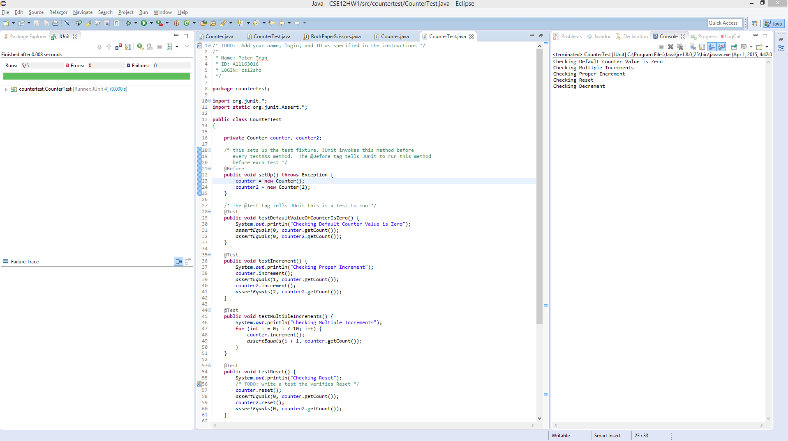

The most difficult part about setting up Eclipse was finding and navigating all the required jar files and place them in our build path.