CSC 326 Assignment

**NAME:** ORAEGBU CHARLES CHUKWUMA

**MATRIC NO:** 170805083

# Source to source compiler

A source-to-source translator, source-to-source compiler (S2S compiler), transcompiler, or transpiler is a type of translator that takes the source code of a program written in a programming language as its input and produces an equivalent source code in the same or a different programming language.

Examples of source-to-source compilers are CFRONT, open COBOL, Closure Compiler, CoffeeScript, Dart, Haxe, TypeScript etc.

Some of the problems that source-to-source compilers solve include:

* Automatic parallelization for a sequential source code
* Source code optimization
* Translating source code written in one language to other with approximately the same level of abstraction
* Translating source code to another version of a language

The image below shows a typical source to source compiler from C to JavaScript:

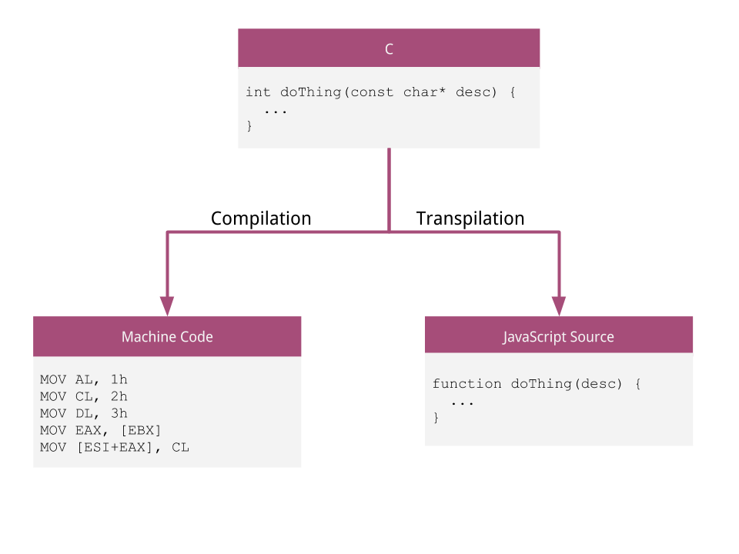

# Cross Compiler

A cross compiler is a type of compiler. This type of compilers can create an executable code for a platform other than the one on which the compiler is running. For example, a compiler that runs on Windows platform also generates a code that runs on Linux platform is a cross compiler. The process of creating executable code for a different machine is also called **retargeting**. Therefore, the cross compiler is also known as a **retargetable compiler**. GNU GCC is an example for cross compiler.

Cross-compilers enable you to develop on one platform (the host) while actually building for an alternative system (the target). The target computer doesn't need to be available: All you need is a compiler that knows how to write machine code for your target platform.

It's a very useful technique, for instance when the target system is too small to host the compiler and all relevant files.

The image below shows a typical cross compiler:

