
BRAND IDENTITY & DIGITAL IMPLEMENTATION PACK
Concept 3 - Bold & Premium
Official website: harleydigitalworks.com

A division of The Harley Group

1. Brand Foundation
Harley Digital Works is the digital agency division of The Harley Group. The brand should feel premium, technically capable, modern and commercially confident without becoming flashy, cold or over-engineered.
Brand name | Harley Digital Works
Website | harleydigitalworks.com
Parent brand | The Harley Group
Primary tagline | Better websites. Smarter systems. Simpler growth.
Core proposition | Premium websites, practical automation and scalable digital systems for businesses and organisations.

Brand personality
Confident. Premium. Practical. Modern. Trustworthy. Precise. Human. The tone must communicate expertise and quality without inflated claims or generic AI language.

Commercial role
The identity must support high-value website projects while making recurring services - hosting, maintenance, automation support, domains and SaaS - feel like natural extensions of the brand.

2. Approved Creative Direction
Concept 3 is the selected direction. It uses a geometric gold H monogram, dark premium surfaces, disciplined typography and restrained digital detailing.
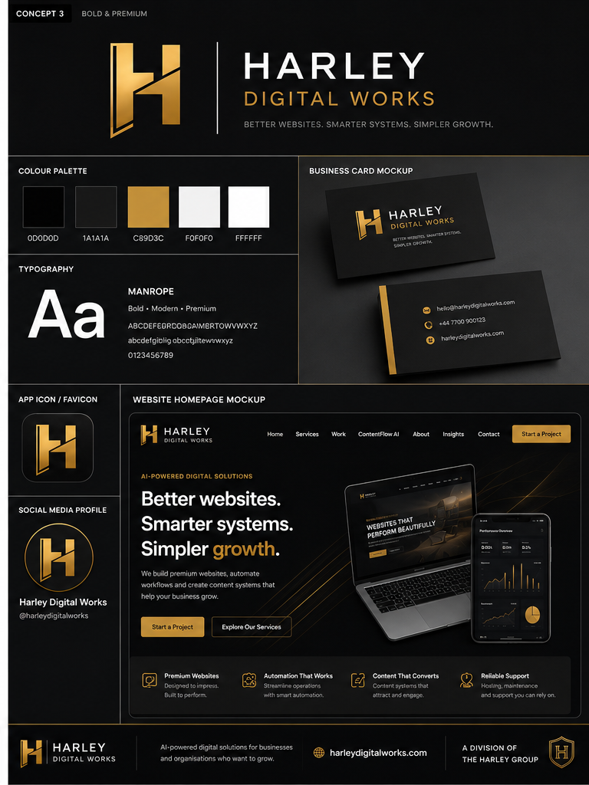
The concept board is a visual reference. The supplied SVG and PNG assets in this pack should be used for implementation. Any final logo refinement should preserve the same geometry, proportions and premium character.

3. Logo System

 | 

Logo hierarchy
- Primary logo: full horizontal wordmark for website headers, proposals, documents and formal brand use.
- Secondary logo: H monogram for favicons, app icons, avatars, compact navigation and social profiles.
- Dark version: preferred on black or charcoal backgrounds.
- Light version: use on white or pale surfaces.

Clear space and minimum size
Maintain clear space around the logo equal to at least one-quarter of the monogram width. Do not display the full wordmark below 180px wide on screen. Use the monogram below this size.

Do not
Do not stretch, rotate, outline, add drop shadows, recolour with unapproved colours, place over busy imagery, separate the monogram geometry, or use the gold logo on low-contrast backgrounds.

4. Colour Palette
 | Harley Black | #0D0D0D | Primary backgrounds, header, footer, premium surfaces
 | Works Charcoal | #1A1A1A | Cards, panels, navigation states
 | Signature Gold | #C89D3C | Primary accent, CTA emphasis, key highlights
 | Soft Silver | #F0F0F0 | Secondary backgrounds, separators, muted surfaces
 | Pure White | #FFFFFF | Primary text on dark backgrounds and clean light surfaces

Usage ratio
Recommended digital balance: 65% black/charcoal, 25% white/off-white, 10% gold. Gold should signal action, value or distinction - not decorate every element.

Accessibility
Use white text on Harley Black or Works Charcoal. Use Harley Black text on white or Soft Silver. Do not use gold for small body text. Validate all combinations against WCAG 2.2 AA.

5. Typography
Primary typeface: Manrope. It should be used across the website, application UI, digital documents and marketing assets.
Display / Hero | Manrope ExtraBold or Bold | Large, compact line height, strong visual authority
H1 / H2 | Manrope Bold | Clear page hierarchy
H3 / UI labels | Manrope SemiBold | Cards, navigation, labels and buttons
Body | Manrope Regular | Readable, direct and uncluttered
Technical / data | Manrope Medium | Dashboard metrics and structured information

Fallback stack
Manrope, Inter, ui-sans-serif, system-ui, -apple-system, BlinkMacSystemFont, 'Segoe UI', sans-serif

Digital scale
Suggested responsive starting points: hero 56-80px desktop / 40-48px mobile; H1 48-64px; H2 32-44px; H3 22-28px; body 16-18px; small UI 13-14px.

6. Website & Product Design Direction

Visual principles
- Dark-first premium interface with clean white sections used for contrast and breathing space.
- Large, confident headlines with short supporting copy.
- Gold reserved for primary calls to action, active states, dividers and selected data highlights.
- Subtle motion and fine-line digital patterns; never excessive neon, particle effects or generic AI graphics.
- Use polished website, dashboard and workflow mockups rather than stock corporate imagery.
- Cards should use restrained borders, 12-20px radii and controlled shadows.

Primary homepage copy
Headline: Better websites. Smarter systems. Simpler growth.
Supporting copy: Harley Digital Works helps businesses and organisations build better websites, automate repetitive work and create scalable digital systems.
Primary CTA: Start a Project
Secondary CTA: Explore Our Services

Core service labels
Website Works - premium websites and redesigns
Automation Works - lead capture, onboarding and workflow automation
Growth Works - SEO, content systems and digital optimisation
Care Works - hosting, maintenance, monitoring and ongoing support

7. Brand Voice & Copy Rules

Voice
Plainspoken, expert, commercially aware and helpful. Explain outcomes before tools. Sound confident but never exaggerated.
Use | Premium websites designed to convert.
Use | Automation that removes repetitive work.
Use | Ongoing support that keeps your digital systems reliable.
Avoid | Revolutionary AI solutions that transform your future.
Avoid | A one-stop shop for cutting-edge digital innovation.

Naming conventions
Always write Harley Digital Works in full on first reference. Use HDW only in internal documentation or constrained UI labels. Use harleydigitalworks.com without 'www' in brand materials. Reference The Harley Group as the parent company where legally or strategically relevant.

8. Implementation Instructions for ChatGPT Works
Use this section as the build specification for all digital work.
- Apply the supplied SVG logo files. Do not trace the logo from the concept-board image.
- Use the dark wordmark in dark headers and the light wordmark on white or pale backgrounds.
- Set Manrope as the primary font and use the approved fallback stack.
- Create reusable design tokens for colours, typography, spacing, radii, shadows and animation.
- Build dark and light component variants while preserving the gold accent hierarchy.
- Update metadata, PWA icons, favicons, Open Graph assets, emails, dashboards and legal pages.
- Use harleydigitalworks.com as the canonical production domain through environment configuration.
- Retain The Harley Group as the parent company in the footer and legal wording.
- Do not invent testimonials, metrics, clients, awards or product capabilities.
- Test desktop, tablet and mobile layouts and meet WCAG 2.2 AA.

Suggested design tokens
--color-harley-black: #0D0D0D;
--color-works-charcoal: #1A1A1A;
--color-signature-gold: #C89D3C;
--color-soft-silver: #F0F0F0;
--color-white: #FFFFFF;
--font-brand: 'Manrope', 'Inter', ui-sans-serif, system-ui, sans-serif;

9. Supplied Asset Inventory
- hdw-monogram-dark.svg / .png - primary app icon and dark-surface mark
- hdw-monogram-light.svg / .png - light-surface monogram
- hdw-wordmark-dark.svg / .png - full logo on dark background
- hdw-wordmark-light.svg / .png - full logo on light background
- favicon-32.png, favicon-64.png, favicon-180.png, favicon-192.png, favicon-512.png
- concept-3-reference.png - approved visual direction reference
- Harley-Digital-Works-Brand-Pack.docx
- Harley-Digital-Works-Brand-Pack.pdf

Production note
The included vector logo is a practical implementation asset based on the approved Concept 3 direction. Before major print production, trademark registration or high-volume merchandise, commission a final professional vector refinement and legal clearance.

Approval status
Approved creative direction: Concept 3 - Bold & Premium.
Official brand: Harley Digital Works.
Official domain: harleydigitalworks.com.
Parent company: The Harley Group.

