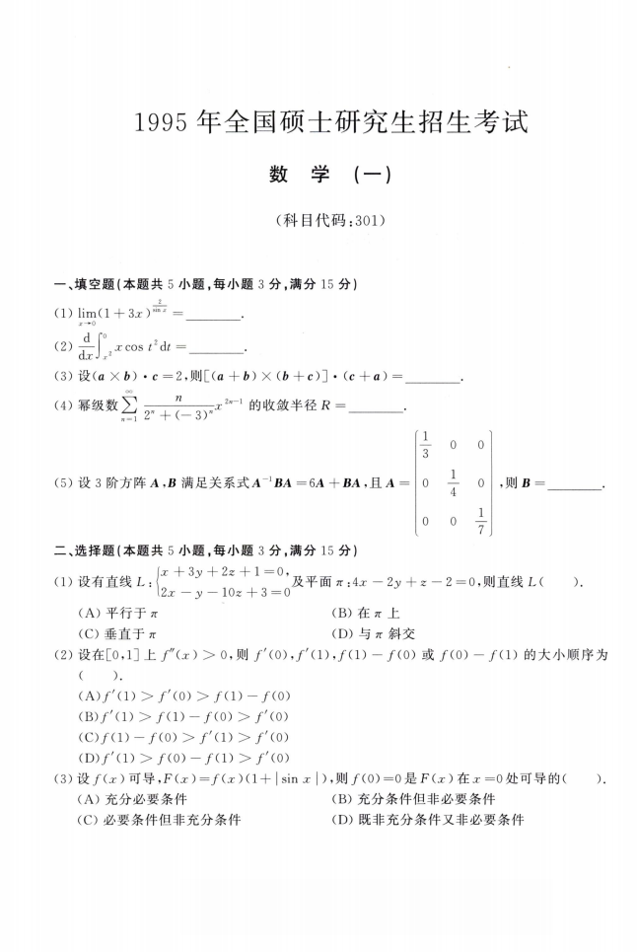
T 0
(5) 设3阶方阵满足关系式A^BA =6A + BA ,且人=0 丄 4
0 0
0

0 ，则B =
1_

