**Predicting Stock Price Trend Using Neural Network**

**Based on Financial Lexicon and Technical Indicators**

Liang-Ching Pan, Che-Cheng Chang

Department of Information Engineering and Computer Science, Feng Chia University

No. 100, Wenhua Rd., Xitun Dist.

Taichung City 407, Taiwan

liangchingpan1022@gmail.com, checchang@fcu.edu.tw

**Abstract**

This study uses multiple linear regression (MLR) model and artificial neural network (ANN) model to predict stock price trend, taking TSMC, a company with a large amount of news, as the study object. Collecting TSMC historical stock price, news, and financial statements. we crawl financial news published by various newspapers from January 1, 2017 to December 31, 2021. We tag financial news as two major categories: "TSMC Related News" and "Market Related News” and calculate the news sentiment scores of the two major categories using a customized sentiment analysis dictionary.

**Key words:** Sentiment analysis, Artificial neural network, Linear regression, Stock price prediction

**Introduction**

Since investing in stocks can make considerable profit, stock price trend prediction has become a popular academic research topic. A large number of academic papers related to stock price prediction have been published worldwide. Most of the stock trend prediction research are conducted in machine learning due to the development and prevalence of it. [1] is market-level research: Using news sentiment as a correlation between companies and stock prices to predict stock price trends. [2] is industry-level research: Studying all three industries - IT, banking, and healthcare - MARS has proven to be the best performing model for stock forecasting in the study. [3] is company-level research: Building up neural network models for short-term technical analysis to study TSMC.

Except for the difference between the size of the research subjects, these inputs of stock price trend prediction models also differ from their features, which may be news analysis [4], fundamental analysis, and technical analysis [3], and different data processing will be done to make a dataset.

The development of internet technologies has made it easier for investors to access stock market information through media. The impact of news on the stock market has three main aspects: (1) fundamental information in company-specific news articles affects investors' trading activities; (2) news evokes public sentiment, and investors' decisions are influenced by public sentiment and thus interfered with investment decisions; (3) the impact of online media on stocks varies depending on news content and company (3) the impact of online media on stocks varies with the content of the news and the characteristics of the company [5].

According to [6], fundamental analysis is based on three basic aspects (1) macroeconomic analysis, such as Gross Domestic Product (GDP) and Consumer Price Index (CPI), to analyze the impact of the macroeconomic environment on the company's future profits, (2) industry analysis, to estimate the value of the company based on the current status and future of the industry, and (3) company analysis, to analyze the current operational and financial status of the company to assess its internal value.

There are many fundamental analysis indicators, technical analysis indicators and others like GDP, CPI can be the features of machine learning, thus [7] used decision trees and multiple regression methods to predict the banking industry and the results showed that the reduction of input variables had a positive impact on the predictive performance of the model.

There are many factors that affect stock price movements. In terms of size, the economy, industry, and individual companies all have different influencing factors, and investors need to obtain information about the economy, industry, and individual companies through news and information regularly to make investment decisions.

In addition to news, investors can also judge the current operating conditions of a company from a single company's accounting statements. To make it easier for investors to interpret accounting data, investors will calculate information using EPS, ROE, gross margin, etc. These analytical indicators can be easily obtained from the Internet without investors having to do their own calculations or graphs, so it is a stock price analysis tool often used by many investors.

Historical stock prices like open, min, max, close price etc. can also be used as a reference in short-term investment decisions, investors may use recent stock price movements to determine when to invest.

This study aims to use news information, analytical indicators, and historical stock prices as stock price references, and to use multiple linear regression (MLR) and artificial neural network (ANN) to develop a single-company stock price trend model to support investors to invest in stocks.

We collect historical stock prices, stock market news, and financial statements as datasets, and examines the stock market data of Taiwan from January 1, 2017 to December 31, 2021 to investigate whether the prediction method of stock prices using multivariate feature input models is appropriate; and whether different methods of cutting datasets can improve the prediction accuracy of the models. We also calculate root mean squared error (RMSE), accuracy, precision, recall, and F1-Score to evaluate the model effectiveness of this study, in order to train the most suitable model for predicting stock prices.

**Literature Review**

*A. Multiple Linear Regression, MLR*

A linear model with ordinary least squares linear regression fitted with coefficients $w=w_{1},w_{2},{…,w}_{n}$, it minimizes the sum of squared error between the observed and predicted targets by linear approximation. It is widely used in the case of machine learning for sequential or categorical models.

In the case where the input variable is single, the linear regression is called simple linear regression; in the case where the inputs are multiple variables, the linear regression is called multiple linear regression. Multiple linear regression finds the sum of squared error through iterating.

$$y =w_{1}x_{1}+w_{2}x_{2}+…+w_{n}x_{n}+b$$

$x_{i}$ is feature, $w_{i}$ is coefficient, $b$ is bias and $y$ is predict target.

*B. Artificial neural network, ANN*

The computing power of computers has increased dramatically that computers can afford the huge matrix computing capacity of neural network, resulting in the prevalence of machine learning. Neural networks can be applied to time series prediction and classifiers, which can input multiple features, and the types of data can be text, speech, video, etc. The number of neurons, the number of hidden layers, and the type of activation functions can be changed to achieve better prediction results.

The artificial neural network itself is backward propagation neural network because it updates the model by minimize the loss function by iterations, so that the model coefficients are updated in the direction of minimizing the loss function. It is characterized by fast iteration speed, high learning accuracy, and the ability to handle nonlinear relational data [3].

*C. News Sentiment Analysis*

News sentiment can influence investors and cause market volatility [5]. News articles can reveal individual companies, the overall market situation, and have both short-term and long-term effects. By analyzing the news, we can get some useful information that can be used as a factor to influence the stock price.

*D. Dictionary-based Sentiment Analysis*

Dictionary-based sentiment analysis is often used in literature as a feature extraction method. A dictionary contains words with specific features, and the more precise word is, the more precisely specific features in a text can be extracted. Specific features are often classified as positive or negative. For example, in [4], the specific feature of the dictionary is stock price fluctuation, and the positive implication for stock market news is that the stock price is going up; the negative implication is that the stock price is going down. The sentiment score is calculated from the word frequency, we predict stock price will go up if the number of positive sentiment words deduct the number of negative sentiment words > 0, and we predict stock price will go down if the number of positive sentiment words deduct the number of negative sentiment words < 0. Both [4] and [8] used the same approach to extract sentiment features from texts.

**Research Structure**

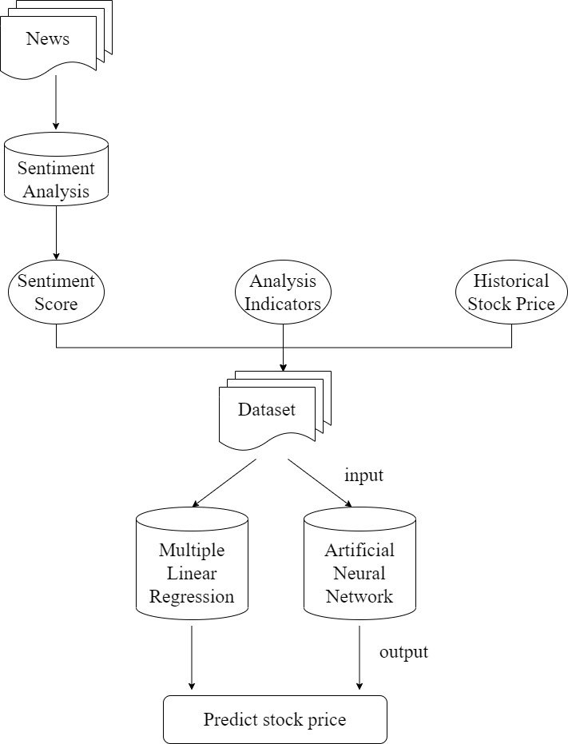

Fig. 1 Experiment structure

The experiment structure overview is shown in Fig. 1.

*A. News*

We called the news API on Fugle with custom python crawler to collect TSMC stock market related news from January 1, 2017 to December 31, 2021, and the total number of news was 12,796 after removing duplicate data.

*B. Sentiment analysis model*

Sentiment analysis model can slice news article into sentences, sentences categorization, word segmentation, calculate sentiment score with lexicon.

*C. Sentiment score*

When the sentiment score is positive, it represents the stock price will go up; when the sentiment score is negative, it represents the stock price will go down.

*D. Analysis indicators*

There are seven categories of analysis indicators: revenue, EPS, profit ratio, ROE and ROA, growth capacity, operating capacity, and solvency, which are collected from January 1, 2017 to December 31, 2021.

*E. Historical stock price*

Collecting stock price, including trading volume, trading money, open, max, min, close, from January 1, 2017 to December 31, 2021.

*F. Dataset*

Adding sentiment score, analysis indicators, historical stock price into dataset, and the number of records is 1,223.

*G. Forecast models*

Building up multiple linear regression model and artificial neural network model with python to predict stock price.

**Research Method**

*A. Data collection*

We collect news with python custom program, we call the Fugle API to get TSMC news. We can crawl about 2~15 news articles per day, the articles come from the financial news published by various newspapers.

TABLE 1

NEWS DATA

|  |  |
| --- | --- |
| Columns | Description |
| _id | News ID |
| title | News title |
| content | News content |
| source | Publisher |
| timestamp | Published date |
| url | News URL |

We also collect analysis indicators from Fugle, the collected analysis indicator is displayed in TABLE 2.

TABLE 2

ANALYSIS INDICATOR

|  |  |  |
| --- | --- | --- |
| Fundamental category | Duration | Analysis indicator |
| Revenue | Month | Revenue |
| EPS | Quarter | EPS |
| Profit ratio | Quarter | Gross margin |
| Operating margin |
| Net income margin |
| Rate of return | Quarter | ROE |
| ROA |
| Growth ability | Quarter | Revenue QoQ |
| EPS QoQ |
| Gross margin QoQ |
| Operating margin QoQ |
| Net income margin QoQ |
| Operating ability | Quarter | Receivables turnover |
| Inventory turnover |
| Fixed asset turnover |
| Total asset turnover |
| Solvency | Quarter | Current ratio |
| Quick ratio |
| Times interest earned ratio |

We collect stock price with python package FinMind, the collected stock price is date, trading volume, trading money, open, max, min, close.

*B. Data preprocessing*

When people read a sentence, the reader can segment each word correctly while reading, so that reader can understand the correct meaning of the sentence. In Chinese, if a word is segmented incorrectly, it will be misunderstood. In order to proceed semantic analysis tasks, it is necessary to segment the words of Chinese text correctly, which requires word segmentation tools.

We use CKIP tagger as our word segmentation tool. CKIP tagger is a deep learning model-based word segmentation tool developed by the CKIP Lab formed by the Institute of Information Science and the Institute of Linguistics of Academia Sinica. The training text is based on data from the Central News Agency, Wikipedia, and Sinica Corpus, and the dictionaries are stored in the form of word vectors. The word segmentation is very accurate, but the process time is slow.

In neutral language process (NLP) tasks, words with emotion can be used to calculate whether a text has positive or negative emotion, so the higher the number and accuracy of words in a dictionary, the more accurate it is to identify the emotion of a text. Therefore, we manually build a sentiment lexicon named VFinDict contains financial field words based on the criterion mentioned above(Table 3 VFinDict example); this study also adds the Chinese sentiment dictionary NTUSD [9] developed by the Natural Language Processing Research Laboratory at National Taiwan University. After we remove duplicates, the number of positive words is 3,159, the number of negative words is 8,472, total amount of words is 11,631.

TABLE

VFinDict EXAMPLE

|  |  |
| --- | --- |
| Positive | Negative |
| 熱錢湧入 | 訂單流失 |
| 擴大市佔 | 商譽受損 |
| 法人看好 | 收賄弊案 |
| 財報亮眼 | 資金出逃 |
| 銷售一空 | 擦鞋童 |

TABLE

TOTAL AMOUNT OF WORDS IN LEXICON

|  |  |  |  |
| --- | --- | --- | --- |
| Lexicon | Positive | Negative | Amount |
| NTUSD | 2,812 | 8,276 | 11,088 |
| VFinDict | 412 | 237 | 649 |
| total | 3,159 | 8,472 | 11,631 |

Because CKIPTagger cannot identify the name of stock company, the words could be segment in wrong way. It is necessary to obtain a list of all stocks in Taiwan first and add them into CKIPtagger’s coerce dictionary. The contents in the list is like “ 元大台灣50”, “元大中型100”, “富邦科技” and so on.

The news from Fugle can be categorized into three situation: (1) It only reported TSMC related information. (2) It reported economic information. (3) It reported many companies’ information at the same time. It is necessary to categorize the news in order to focus on TSMC without adding other irrelevant news into the dataset. We refer to the extraction of sentence features method in [4] . First, we slice the news from the beginning of a sentence to the end of a sentence punctuation marks ".”,”?”,”!” as a sentence. We use the list of all stocks in Taiwan to find the company mentioned in the sentence and save it to files according to the company name. We also select some keywords which help us find the TSMC related news, as shown in TABLE 5. The keywords “三星”, “英特爾” are TSMC International Competitors. If they were reported good news, it may mean that international orders will give to the competitors, and TSMC miss out the opportunity.

TABLE

KEYWORDS HELP TO EXTRACT SENTENCES

|  |  |  |
| --- | --- | --- |
| News  category | If sentence is positive, TSMC will go up | If sentence is positive,  TSMC will go down |
| TSMC-related | 半導體、電子、 晶圓、台積電、奈米 | 三星、英特爾 |
| Economy-related | 台股、大盤、外資、投信、自營商、 法人、加權指數、 台灣、 景氣、 美股、美國 |  |

After we process the news article with extraction of sentence features method, we can calculate the sentiment score. The sentiment feature that makes the stock price increase is considered as positive sentiment feature, and the sentiment feature that makes the stock price decrease is considered as negative sentiment feature. 1 point is scored for each word that matches the positive sentiment feature, -1 point is scored for each word that matches the negative sentiment feature. Then we sum up scores in that day. If the sum score is greater than 0, it means that the news of the day has positive sentiment and the stock price may go up; if the sum score is less than 0, it means that the news of the day has negative sentiment and the stock price may go down. An example of the sentiment score calculation is shown in TABLE 6.

The purpose of this study is to predict stock prices, and the day on which we want to predict stock prices is called "forecast day". If we want to predict close price at forecast day, then we will choose the features at the day before the forecast day. If the feature is null at the day before the forecast day, then we will choose the feature is not null at the closest day before the forecast day. The dataset example is shown in TABLE 7.

Finally, the dataset containing the data from January 1, 2017 to December 31, 2021 was cut and put into machine learning training using two different methods.

Method 1: Tradition method. Divide data until December 31, 2020 into training dataset and the rest of data into testing dataset. The dataset cut with tradition method is shown in TABLE 8.

TABLE

EXAMPLE OF SENTIMENT SCORE CALCULATION

|  |  |  |  |
| --- | --- | --- | --- |
| date | 2017-02-13 | 2017-02-13 | total |
| Word segmentation | 在 台幣升值 態勢 ， 熱錢湧入 明顯 下 ， 台股 今日 再 收上 9700 關卡 壓力 ， 目前 台積電 正在 區間 上緣 位置 ， 一旦 上 攻 突破 前 高 ， 台股 將 持續 加速 上漲 幅度 。 | 台北 晶圓 代工 大廠 台積電 (2330) 將 在 本 周 二 ( 14 日 ) 舉行 董事會 ， 可望 公布 股利 政策 ， 市場 預期 ， 台積電 今年 現金 股利 將 從 去年 6 元 起跳 ， 上'看 8 元 ， 利多 帶動 下 台積電 今 (13) 日 股價 走強 ， 漲幅 逾 2% ， 站穩 多頭 均線 之上 。 |
| Sentiment match | 0 -1 0 0 1 0 0 0 0 0 0 1 0 0 -1 0 0 0 0 0 0 0 0 0 0 1 1 0 0 0 0 0 0 0 1 0 0 | 0 0 0 0 0 0 0 0 0 0 0 0 0 0 0 0 0 0 1 0 0 0 0 0 0 0 0 0 0 0 0 0 0 0 0 0 1 0 0 0 1 1 0 0 0 0 0 0 1 0 1 0 0 0 1 1 0 0 0 |
| Sentiment score | 4 | 8 | 12 |

TABLE

DATASET EXAMPLE

|  |  |
| --- | --- |
| Target | Features |
| 2021-12-24 (Fri.) close | Historical stock price at 12/23 Sentiment score at 12/23 Analysis indicators at November Analysis indicators at third quarter |
| 2021-12-27 (Mon.) close | Historical stock price at 12/24 Sentiment score at 12/26 Analysis indicators at November Analysis indicators at third quarter |

TABLE

DATASET CUT WITH TRADITION METHOD

|  |  |  |  |
| --- | --- | --- | --- |
| Training  duration | Counts | Testing  duration | Counts |
| 2017/01/03 ~ 2020/12/30 | 979 | 2021/01/03 ~ 2021/01/17 | 244 |

Method 2: Incremental window method. The training dataset will become bigger as time goes by, and the testing dataset always contains data within 10 days. The concept of incremental window method is shown in Figure 2 and the example is shown in TABLE 9.

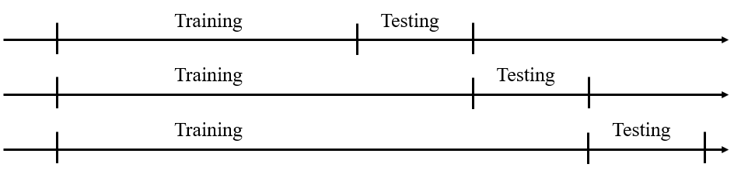

Fig. 2 Incremental window method conceptual diagram.

TABLE

DATASET CUT WITH   
INCREMENTAL WINDOW METHOD  
FIRST THREE DURATION

|  |  |  |  |  |
| --- | --- | --- | --- | --- |
| No. | Training  duration | Counts | Testing  duration | Counts |
| 1 | 2017/01/03 ~ 2020/12/30 | 979 | 2021/01/03 ~ 2021/01/17 | 10 |
| 2 | 2017/01/03 ~ 2021/01/14 | 989 | 2021/01/17 ~ 2021/01/31 | 10 |
| 3 | 2017/01/03 ~ 2021/01/28 | 999 | 2021/01/31 ~ 2021/02/23 | 10 |

*C .Predictive model*

We use multiple linear regression (MLR) model to predict stock price, we build the model with python package sklearn.

The other model we use is artificial neural network (ANN) model, we build the model with python package tensorflow.

*D .Experiment design*

This study has three major experiments. The three major experiments are shown in TABLE 10.

TABLE

EXPERIMENTS

|  |  |  |
| --- | --- | --- |
| Experiment | Dataset method | Model structure |
| Tradition-MLR | Tradition | MLR |
| Tradition-ANN | Tradition | ANN |
| Window-ANN | Incremental window | ANN |

*D .Experiment evaluation method*

We use some evaluate indicators to evaluate experiment results. We use root mean squared error (RMSE) to calculate the difference between actual data and predicted data. And we also use accuracy, precision, recall, F1-score to evaluate the relationship between predicted data and actual data.

$$RMSE=\sqrt{\frac{1}{m}\sum_{i=1}^{m}{{(y_{i}-\hat{y_{i}})}^{2}}}$$

In equation, m is amount of predict data, $y_{i}$ is actual data, $\hat{y_{i}}$ is predicted data.

The case of stock price go up is positive sample, the case of stock price go down is negative sample. We use true positive(TP), false positive(FP), true negative(TN), false negative(FN) these four categories to calculate accuracy, precision, recall, F1 score.

TABLE

THE ARRAY OF MODEL EVALUATION INDICATOR

|  |  |  |
| --- | --- | --- |
|  | Stock price go up tomorrow | Stock price go down tomorrow |
| Predict stock price will go up | TP | FP |
| Predict stock price will go down | FN | TN |

Accuracy: In all categories, the rate of correct predict the positive and negative sample.

Precision: In all cases of predict stock price will go up tomorrow, the rate of the stock price actually go up tomorrow.

Recall: In the case of stock price go up tomorrow, the rate of correctly predicted that the stock price will go up tomorrow.

F1-score: rate the performance with precision and recall.

$$Accuracy=\frac{TP+TN}{TP+TN+FP+FN}$$

$$Precision=\frac{TP}{TP+FP}$$

$$Recall=\frac{TP}{TP+FN}$$

$$F1-score=\frac{2*Precision*Recall}{Precision+Recall}$$

*E .* *Investment simulation*

The purpose of forecasting stock price trend is to make profit on the actual investment. The profit of stock can be divided into dividend and profit from the sale of stock share, and this study aims to buy low and sell high to earn spreads for short-term trading. In Taiwan, we have to pay for 0.1425% of the call price as the trading fee to buy a share, pay for 0.1425% of the put price as the trading fee and 0.3% of the put price as the transfer tax on stock.

Each model category is used to simulate the investment for one year from 2021/1/1 to 2021/12/31. Each day, after we obtain all the features today, the stock price tomorrow is predicted and the action is taken when the stock market open tomorrow, and only two situations in the simulation, one situation is we hold 1,000 shares , the other is we don’t hold stock shares.

Our investment strategy is to gain from day trading, If the model predicts the stock price will increase tomorrow, buy 1,000 shares of TSMC stock at the opening of the stock market tomorrow, sell them with predicted price before the stock market close. If the model predicts the stock price will decline tomorrow, then we don’t do any investment. Whether the call price or the put price should be in the range from max price to min price, or this trade will fail. If our purchase fail, then we don’t do any investment. If our sell fail, then we sell all the shares with open price at the opening of the stock market at the next day.

The result of the investment simulation will record in the investment performance statement[10], as shown in TABLE 12.

TABLE

INVESTMENT PERFORMANCE STATEMENT

|  |  |
| --- | --- |
| Subject | Description |
| Year | Trading year |
| Total income  (INCO) | Sum of all daily income |
| Trading times  (Times) | Take purchase and sell the stock as one time, show the total trading times this year |
| Trading cost  (Cost) | Sum of all trading fee and transfer tax on stock |
| Odds | $$odds =\frac{times that we make a profit}{trading times}$$ |
| Maximum loss  (Loss) | Maximum loss in the year |
| Maximum gain  (Gain) | Maximum gain in the year |
| Return on investment  (ROI) | $$ROI％=\frac{INCO}{Invested capital} x 100％$$ The invested capital is the highest call price. |
| Average ROI  (AROI) | $$AROI％=\frac{ROI％}{Times}$$ |

**Results and Discussion**

*A .Tradition-MLR*

We use python package sklearn and its function LinearRegression to train multiple linear regression model. The parameters are copy_X=True, fit_intercept=True, n_jobs=None, normalize= False.

The Tradition-MLR model prediction result is shown in Fig. 3, the prediction result is much different from actual value from 2021/09/01. The prediction performance is shown in TABLE 13.

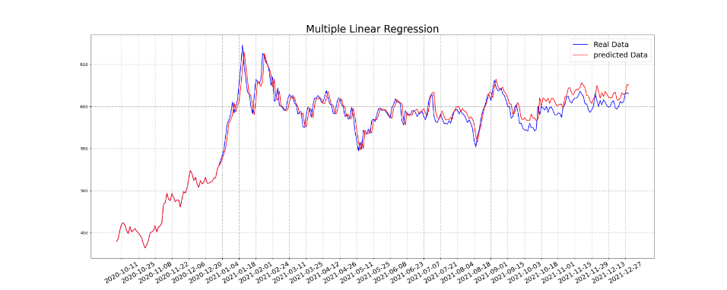

Fig. Tradition-MLR model prediction result

TABLE

Tradition-MLR PREDICTION PERFORMANCE

|  |  |  |  |  |  |
| --- | --- | --- | --- | --- | --- |
|  | RMSE | Accuracy | Precision | Recall | F1-score |
| Tradition-MLR | 10.24 | 70.1% | 57% | 80.2% | 66.7% |

*B .Tradition-ANN*

This study used multiple sets of parameters to train model. The best model parameters are as follows: After two hidden layers, the output layer outputs a target value, which is the predicted closing price; the number of neurons in the first hidden layer is 40, and the number of neurons in the second hidden layer is 58, each layer uses the activation function relu. Whole parameters of Tradition-ANN are shown in TABLE 14.

The Tradition-ANN prediction result is shown in Fig. 4, the prediction result is much different from actual value from 2021/09/01. The prediction performance is shown in TABLE 15.

TABLE

Tradition-ANN PARAMETER

|  |  |
| --- | --- |
| parameter | value |
| seed | 200 |
| input_dim | 23 |
| layer1-units | 40 |
| activation | relu |
| Layer2-units | 58 |
| activation | relu |
| optimizer | SGD |
| loss function | mean_square_error |
| learning_rate | 0.00001 |
| decay | 0 |
| momentum | 0.9 |
| nesterov | True |
| batch_size | 10 |
| epochs | 2000 |

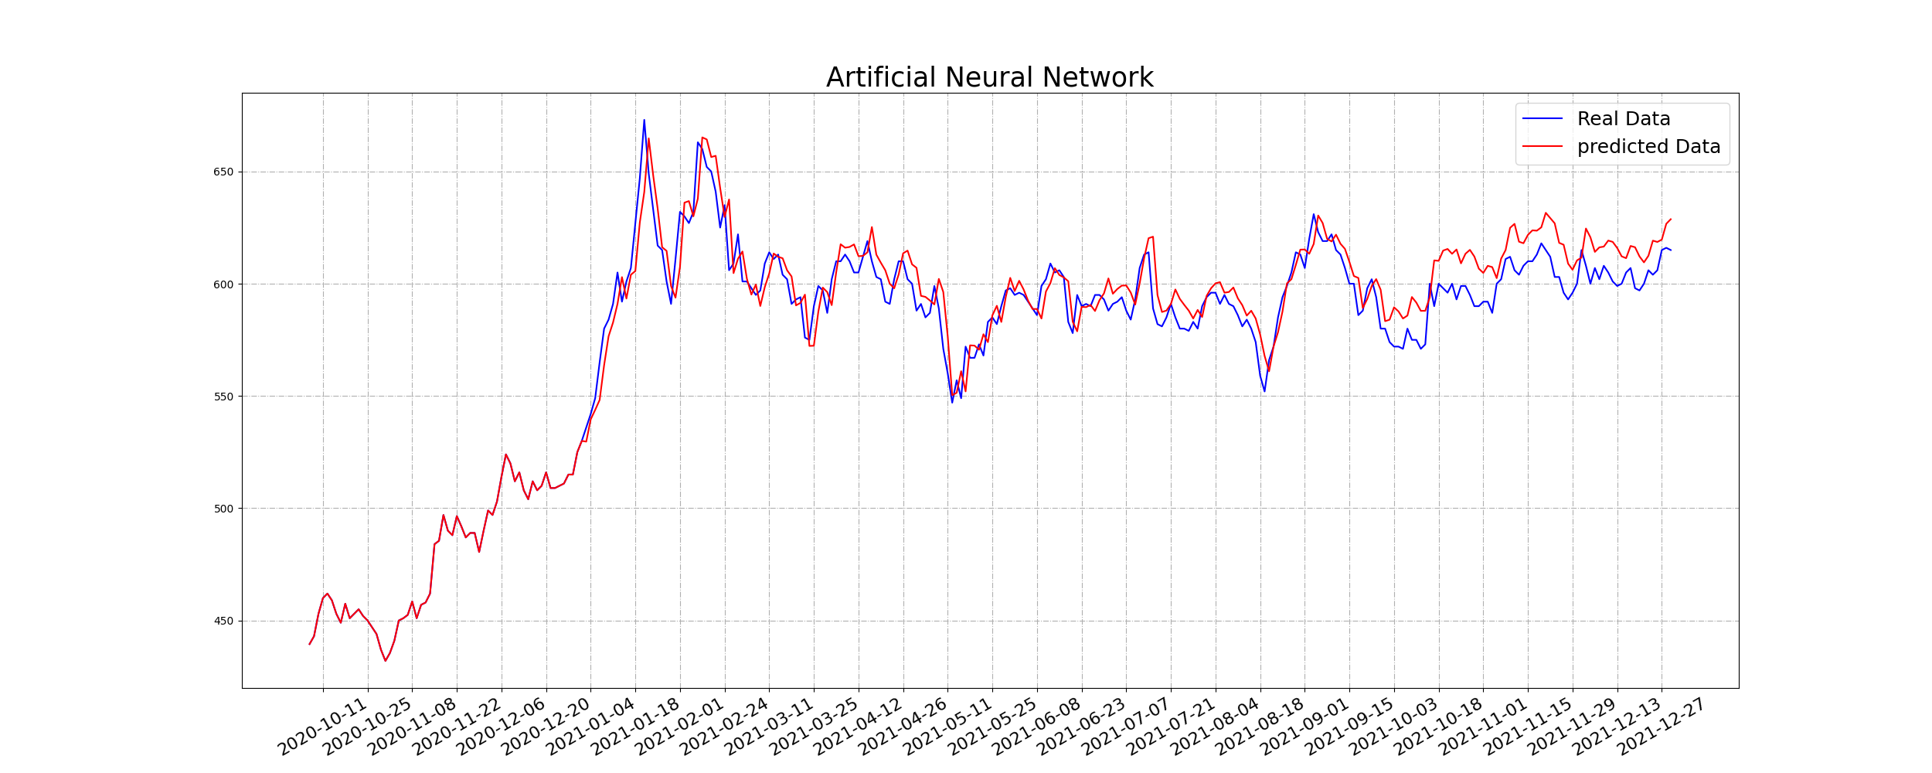

Fig. Tradition-ANN model prediction result

TABLE

Tradition-ANN PREDICTION PERFORMANCE

|  |  |  |  |  |  |
| --- | --- | --- | --- | --- | --- |
|  | RMSE | Accuracy | Precision | Recall | F1-score |
| Tradition-ANN | 11.64 | 68% | 49.2% | 82.9% | 61.8% |

*C .Window-ANN*

Whole parameters of Window-ANN are shown in TABLE 16. The Window-ANN prediction result is shown in Fig. 5, and the prediction performance is shown in TABLE 17.

TABLE

Window-ANN PARAMETER

|  |  |
| --- | --- |
| parameter | value |
| seed | 39 |
| input_dim | 23 |
| layer1-units | 21 |
| activation | relu |
| Layer2-units | 151 |
| activation | relu |
| optimizer | SGD |
| loss function | mean_square_error |
| learning_rate | 0.000001 |
| decay | 0 |
| momentum | 0.9 |
| nesterov | True |
| batch_size | 10 |
| epochs | 4000 |

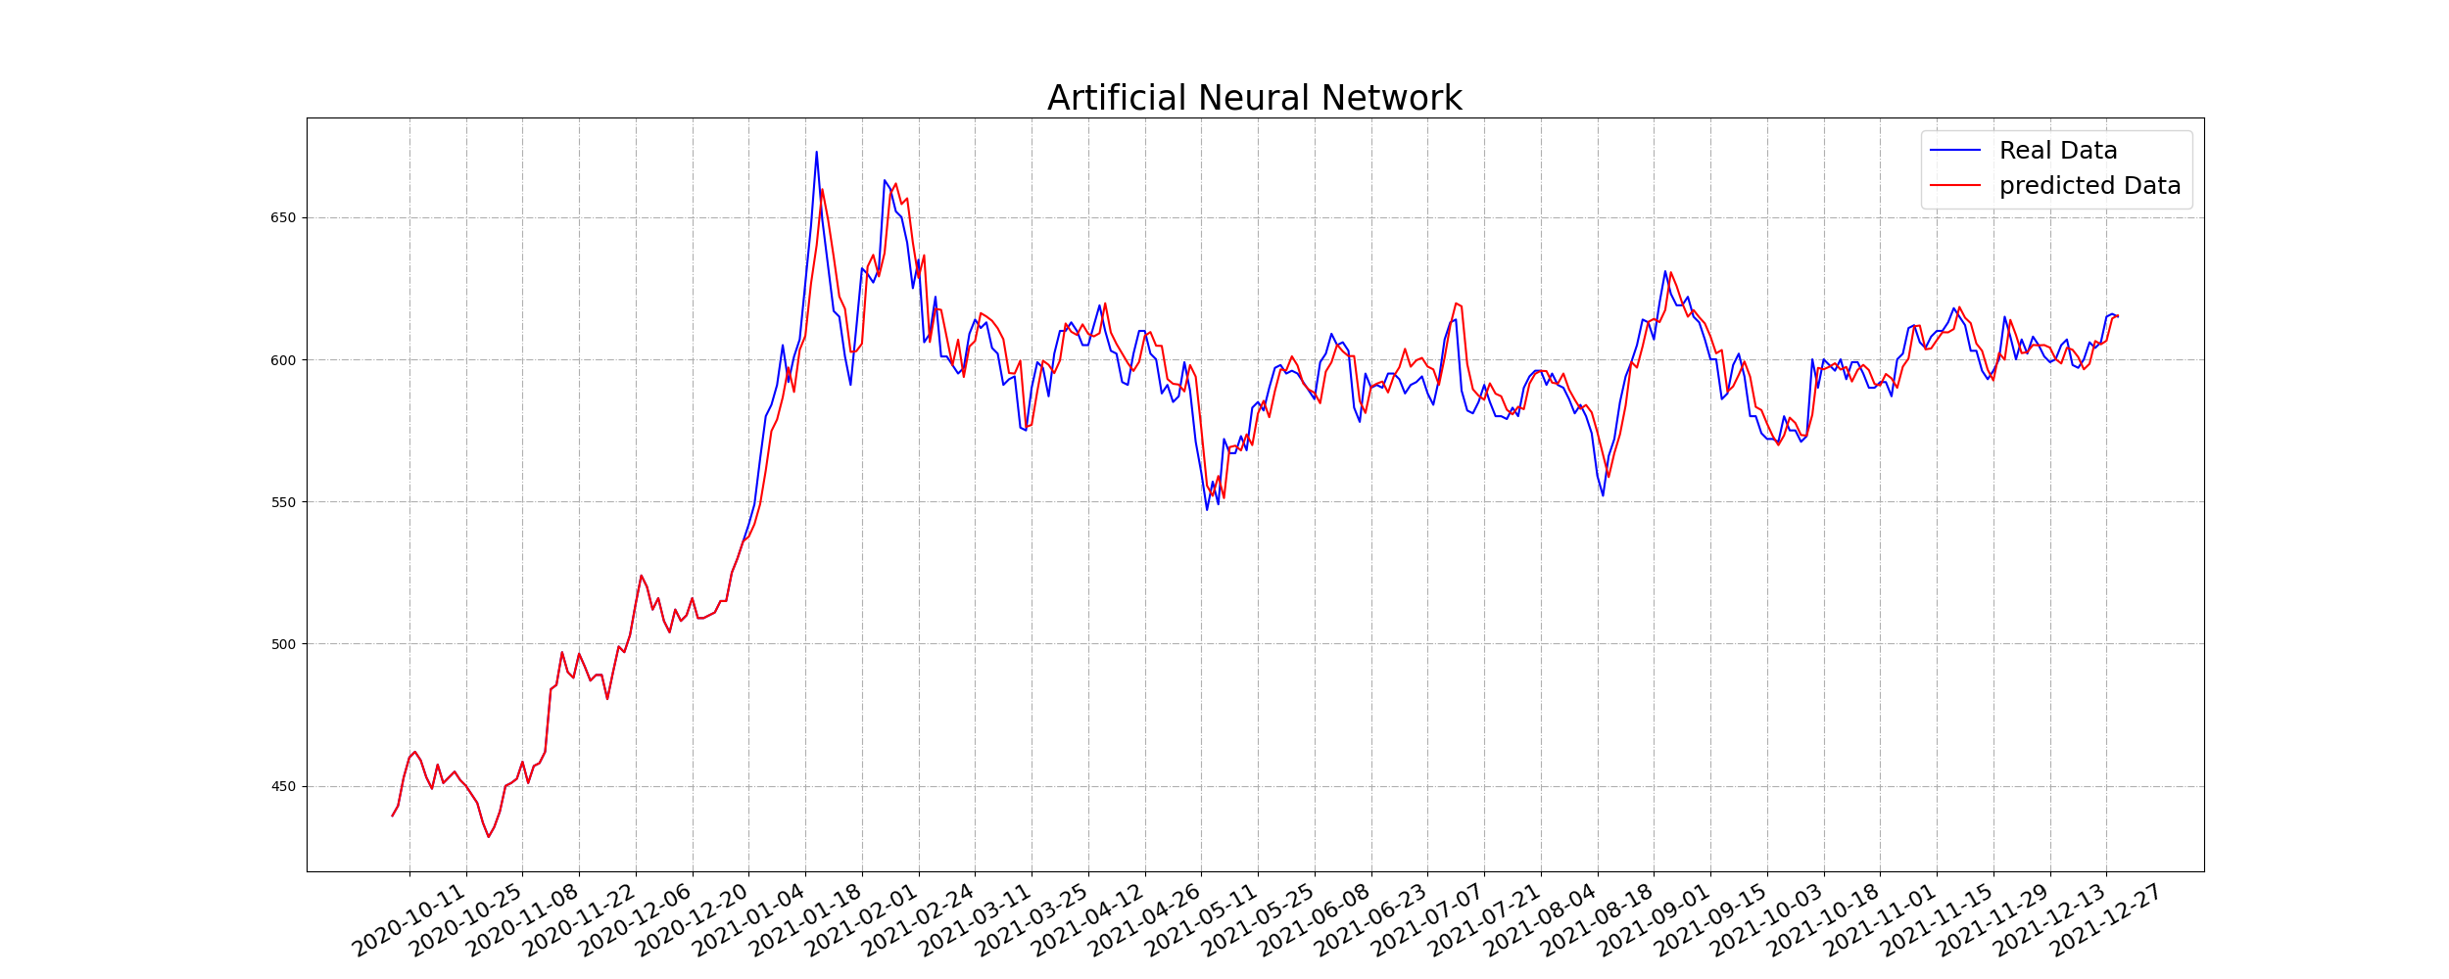

Fig. Window-ANN model prediction result

TABLE

Window-ANN PREDICTION PERFORMANCE

|  |  |  |  |  |  |
| --- | --- | --- | --- | --- | --- |
|  | RMSE | Accuracy | Precision | Recall | F1-score |
| Window-ANN | 9.15 | 75% | 71.9% | 78.6% | 75.1% |

*D .Investment simulation*

The investment performance statement of all models is shown in TABLE 18.

TABLE

INVESTMENT PERFORMANCE STATEMENT

|  |  |  |  |
| --- | --- | --- | --- |
| Subject | Tradition-MLR | Tradition-ANN | Window-ANN |
| Year | 2021 | 2021 | 2021 |
| INCO | 191,722 | 276,595 | 325,398 |
| Times | 97 | 126 | 122 |
| Cost | (-163,650) | (-214,615) | (-206,298) |
| Odds | 76.29% | 73.81% | 92.62% |
| Loss | (-22,968) | (-23,966) | (-23,966) |
| Gain | 18,973 | 18,973 | 18,973 |
| ROI | 30.77% | 41.72% | 49.3% |
| AROI | 0.32% | 0.33% | 0.4% |

*E .Discussion*

The RMSE difference between models is shown in Fig. 6. Window-ANN has smallest RMSE, it means the prediction value is much close to the actual value.

The performance comparison between models is shown in Fig. 7. Window-ANN has the highest accuracy, precision and F1-score, which means Window-ANN can well predict the stock price will go up or go down.

Window-ANN can performance well that can be attribute to the increment window method, because it can update the newest information from features. Thus Window-ANN fitted very well, the difference between prediction value and actual value almost disappears.

Fig. Model performance comparison I

Fig. Model performance comparison II

Window-ANN also has the highest income and odds in investment simulation. This approve that we can make a profit with the investment strategy we proposed, and it can gain more profit if we use Window-ANN.

Fig. Income comparison

Fig. Odds comparison

**Conclusion**

In this study, multiple features were input into the dataset, and the ANN model was trained by different methods of cutting the dataset. For example, the training data set of the traditional method covers the period from 2017 to 2020, but in September 2021, the central bank raises interest rates and inflation causes stock price trend fluctuations, but the traditional method does not have the ability to update the impact information immediately, resulting in inaccurate forecasts after that. Therefore, we use the increment window method to solve the problem that the training information cannot be updated by the traditional method.

The results of this study show that the Window-ANN has the best prediction performance among the three models, and the performance of the simulated investment with the investment strategy we proposed is the best among the three models, with 92.62% win rate and a profit of $325,398. This shows that the increment window method has better prediction performance because it can update information in real time, and using the investment strategy we proposed can gain more profit if we use Window-ANN.

**References**

[1] J. Liu, Z. Lu, and W. Du, “Combining Enterprise Knowledge Graph and News Sentiment Analysis for Stock Price Prediction,” Hawaii International Conference on System Sciences, 2019.

[2] A. Chatterjee, H. Bhowmick, and J. Sen, “Stock Price Prediction Using Time Series, Econometric, Machine Learning, and Deep Learning Models,” 2021 IEEE Mysore Sub Section International Conference (MysuruCon), pp. 289–296, Oct. 2021, Hassan, India.

[3] P.-C. Lan, W.-L. Kung, Y.-L. Ou, C.-Y. Lin, W.-C. Hu, and Y.-H. Wang, “Machine learning model with technical analysis for stock price prediction: Empirical study of Semiconductor Company in Taiwan,” 2019 International Symposium on Intelligent Signal Processing and Communication Systems (ISPACS), pp. 1–2. Dec. 2019, Taipei, Taiwan.

[4] CHIU, YEN-CHENG, ”Deep Learning for Stock Price Trend Prediction Using Financial News and Sentiment Analysis: BI-GRU, BERT and ALBERT”, National Taipei University Graduate Institute of Information Management, New Taipei City.

[5] Q. Li, T. Wang, P. Li, L. Liu, Q. Gong, and Y. Chen, “The effect of news and public mood on stock movements,” Inf. Sci., vol. 278, pp. 826–840, Sep. 2014.

[6] Y. Hu, K. Liu, X. Zhang, L. Su, E. W. T. Ngai, and M. Liu, “Application of evolutionary computation for rule discovery in stock algorithmic trading: A literature review,” Appl. Soft Comput., vol. 36, pp. 534–551, Nov. 2015.

[7] Z. D. Aksehir and E. Kilic, “Prediction of Bank Stocks Price with Reduced Technical Indicators,” 2019 4th International Conference on Computer Science and Engineering (UBMK), pp. 206–210, Sep. 2019, Samsun, Turkey.

[8] V. Kalyanaraman, S. Kazi, R. Tondulkar, and S. Oswal, “Sentiment Analysis on News Articles for Stocks,” 2014 8th Asia Modelling Symposium, pp. 10–15, Sep. 2014, Taipei, Taiwan.

[9] NTUSD. URL: http://nlg.csie.ntu.edu.tw/download.php

[10] LEE, CHIA-WEI, “A Study of Stocks Price Trend Forecasting Model Based on C-RNN-GAN Neural Network-Taking U.S. Stock Market for Example”, Fu-Jen Catholic University Graduate Institute of Information Management, New Taipei City.