(a)

**Shell commands in the row:**

touch 20301118_1.txt 20301118_2.txt 20301118_3.txt 20301118_4.txt

mkdir shouvik1 shouvik2

mv 20301118_1.txt 20301118_2.txt 20301118_3.txt shouvik1

cd shouvik1

cp shouvik1/20301118_1.txt shouvik1/20301118_2.txt shouvik2

mkdir shouvik3

cp -r shouvik1 shouvik3

cd shouvik3

ls -l

chmod 755 shouvik1

ls -l

cd

pwd

mv shouvik3 /home/Shouvik

rm -r shouvik1 shouvik2

rm 20301118_4.txt

**Terminal:**

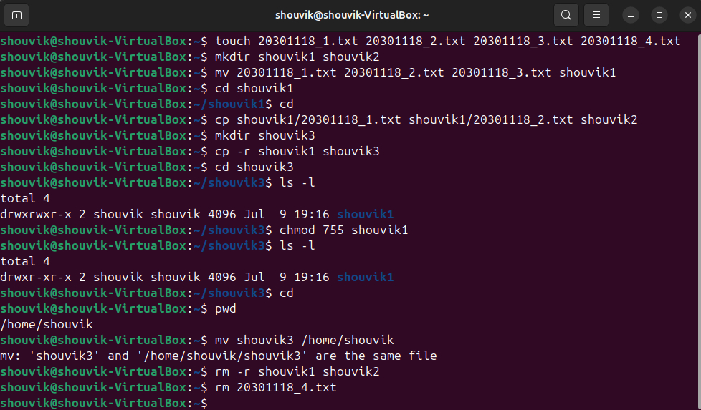

(b)

**Shell commands:**

touch courses.txt

cat>courses.txt

CSE321 Operating System 08

HUM102 Introduction to Philosophy 04

^C

grep -c “CSE” courses.txt

**Terminal:**

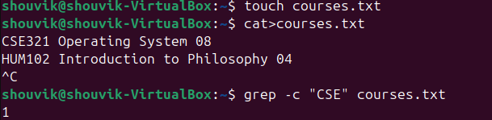

(c)

**Shell commands:**

ls -a

**Terminal:**

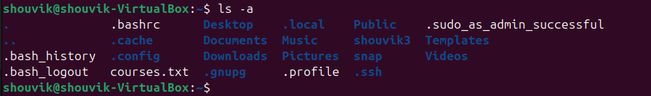

(d)

**Shell commands:**

touch numbers.txt

cat>numbers.txt

sed -n '5,17p' numbers.txt

