BUSINESS ANALYSIS CASE STUDY
Reducing Member No-Shows at
FitLife Studio
A booking-pattern diagnosis and process redesign, backed by a 110,522-record analysis
Prepared by Raffano Rajasa

1. Background
FitLife Studio is a single-location boutique gym in a mid-size city. It has roughly 900 members and runs about 45 instructor-led group classes a week: spin, HIIT, yoga, and strength, each capped at 16 spots. Members book classes through a basic app and a front desk. Monthly membership is $89, and classes are included but must be reserved.
The owner, Maya, identified a problem: about 20.2% of booked class spots end up as no-shows. Because classes are capped and popular classes show as 'full,' those empty spots mean members who wanted in get turned away, instructors teach half-empty rooms, and waitlisted members quietly get frustrated and cancel their memberships. There is no structured reminder strategy and no penalty for booking then skipping.
This case study was engaged to understand why no-shows happen and to recommend a fix backed by evidence rather than guesswork.

A note on the data
A real class-booking dataset with FitLife's exact structure was not available for a business of this size, so the analysis uses a real, public appointment dataset (110,522 medical appointment records from Kaggle's 'Medical Appointment No Shows' set) as a structural stand-in. It has the same shape as a class-booking system: a booking timestamp, an appointment or class timestamp, a reminder flag, and an attendance outcome. The FitLife narrative is fictional; the analysis and numbers behind it are real.

2. Problem statement
FitLife loses class capacity and member goodwill because 20.2% of booked spots go unused, and the current ad-hoc reminder approach is not reducing risk where it matters most.
Who it affects:
Waitlisted members turned away from 'full' classes that are, in practice, running under capacity; instructors teaching under-filled rooms; and the owner, through lost member goodwill and higher churn risk.
Target:
Reduce class no-show rate from 20.2% to under 12% within one quarter.
Secondary metrics:
Class fill rate, no-show rate by lead-time bucket, waitlist conversion, and the Saturday-specific no-show rate.

Key finding
No-show risk rises sharply the further in advance a class is booked: 4.6% for same-day bookings versus 33.0% for bookings made 30+ days out. On the surface, reminders look like they hurt (27.6% no-show rate for reminded bookings versus 16.7% for non-reminded), but that is a confound. Reminders were sent almost exclusively to bookings made 4+ days ahead, which is exactly the highest-risk group, so the comparison was never a fair one. The real lever is not 'add reminders,' it is fixing lead-time risk specifically. Day of week is a smaller secondary factor: Saturday runs at 23.1% no-shows versus 19.3% on the best day, Thursday.

3. Stakeholder analysis
Stakeholder | Their concern / what they want | Influence | Interest | How to engage
Owner | Revenue, member retention, low-cost fix | High | High | Primary sponsor; weekly check-in, sign-off on scope
Front desk staff | Less manual chasing, simple process | Med | High | Interview for as-is process; test to-be flow
Instructors | Full classes, predictable attendance | Low | High | Short interviews; validate pain points
Active members | Easy booking, fair access to full classes | Low | High | Survey; represent their needs in requirements
Waitlisted members | Get into classes they want | Low | High | Analyze booking data; design waitlist auto-fill
App / software vendor | Feasible, supported changes | Med | Med | Confirm what reminders/waitlist features exist

4. Process redesign: as-is vs. to-be
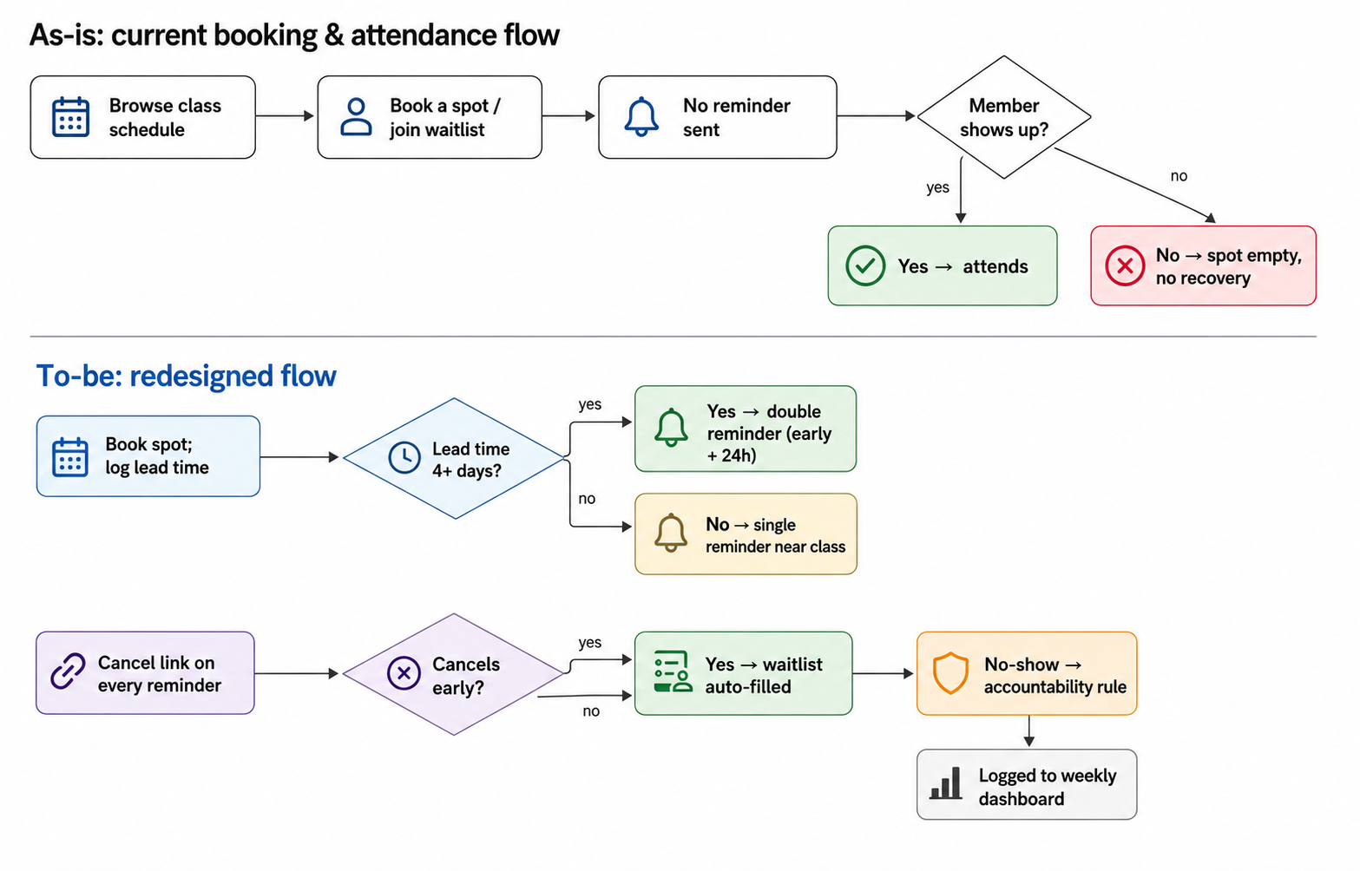

As-is (current booking and attendance flow)
- Member opens the app and browses the class schedule.
- Member books a spot (or joins a waitlist if full).
- No reminder is sent before the class.
- Decision: does the member show up? If yes, they attend. If no, the spot sits empty with no notification to the waitlist.
- Front desk manually notices empty spots at class time, but nothing recovers them.

To-be (proposed flow)
- Member books a spot; system confirms and logs the lead time (days until class).
- Decision: is lead time 4+ days? If yes, it is flagged as elevated-risk and gets a standard reminder now plus a second reminder 24 hours before class. If no (booked within 3 days), it gets a single reminder closer to class time, since same-day and next-day risk is already low.
- Every reminder includes a one-tap 'cancel my spot' link.
- Decision: does the member cancel early? If yes, the spot is released and the waitlist is auto-filled and notified.
- Decision: is it still a no-show? If yes, a light accountability rule applies, for example three no-shows a month limits priority booking.
- Post-class: attendance is logged automatically, and no-show data feeds a weekly dashboard, broken out by lead-time bucket and day of week.

5. Business Requirements Document

5.1 Executive summary
FitLife Studio loses roughly a fifth of its booked class capacity to no-shows, and the loss is not evenly spread: bookings made more than a week in advance are two to seven times more likely to fall through than same-day bookings. The current reminder approach does not account for this, so it ends up reminding the wrong bookings at the wrong time. This document proposes a lead-time-targeted reminder and waitlist system that reminds high-risk bookings more aggressively, recovers cancelled spots through automatic waitlist fill, and gives the owner a weekly view of where no-shows are actually coming from. The goal is to bring the no-show rate from 20.2% to under 12% within a quarter.

5.2 Business objectives
- Reduce class no-show rate from 20.2% to under 12% within one quarter.
- Increase average class fill rate (attended divided by capacity).
- Reduce monthly membership churn linked to members being unable to get into classes.

5.3 Scope
In scope:
Class booking flow, lead-time-based reminder logic, cancel and waitlist auto-fill, no-show tracking and reporting.
Out of scope:
Billing system changes, a new mobile app build, personal-training bookings, and any change to membership pricing.

5.4 Functional requirements
ID | Requirement | Priority | Source
FR-1 | System logs lead time (days between booking and class) for every booking. | Must | Data analysis
FR-2 | Bookings made 4+ days out receive two reminders: one at booking confirmation and one 24h before class. | Must | Data analysis, owner
FR-3 | Bookings made within 3 days receive a single reminder closer to class time. | Must | Data analysis
FR-4 | Every reminder includes a one-tap cancel link that releases the spot immediately. | Must | Members
FR-5 | When a spot is released, the waitlist is auto-filled and the new member notified. | Must | Waitlisted members
FR-6 | System tracks no-shows per member per month for the accountability rule. | Should | Owner
FR-7 | Weekly dashboard shows no-show rate and fill rate broken out by lead-time bucket and day of week. | Should | Owner

5.5 Non-functional requirements
- Reminders must send reliably to at least 99% of booked members.
- Any new process must add no more than a few minutes to front-desk workload per day.
- Member contact information used for reminders must not be shared outside the booking system.

5.6 Assumptions and constraints
- FitLife's current booking app can support two reminder sends per booking without a platform change.
- Budget covers a reminder tool or an upgrade to the existing app; no new hires are assumed.
- The lead-time thresholds (4+ days vs. within 3 days) are based on the no-show pattern in the real dataset used for this analysis, and should be re-checked against FitLife's own booking data once available.

6. User stories
User story | Acceptance criteria | Priority
As a member who books far in advance, I want an extra reminder closer to class time so that a plan I made weeks ago doesn't slip my mind. | Bookings with 4+ days lead time get a confirmation reminder and a second reminder 24h before class. | Must
As a member who books last minute, I want a single well-timed reminder so that I'm not spammed for a class I already remember. | Bookings within 3 days of class get exactly one reminder, sent closer to class time. | Must
As a member, I want a one-tap way to cancel from the reminder so that I can free up my spot the moment I know I can't make it. | Every reminder includes a cancel link; tapping it releases the spot within 1 minute. | Must
As a waitlisted member, I want to be auto-added when a spot frees up so that I can get into a class that was showing as full. | On cancellation, the next waitlisted member is booked and notified within 1 minute. | Must
As the owner, I want a weekly dashboard broken out by lead-time bucket and day of week so that I can see whether the fix is actually working and where risk is concentrated. | Dashboard shows no-show rate, fill rate, and trend by lead-time bucket and day of week, updated weekly. | Should
As the owner, I want repeat no-show members flagged so that I can apply the accountability rule fairly. | System tracks no-shows per member per month and flags members who hit the threshold (e.g. 3 in a month). | Should

7. Data analysis
Source: Kaggle's 'Medical Appointment No Shows,' 110,522 rows, cleaned and relabeled to gym-booking terms. Columns after cleaning:
Column | Type | Notes
booking_id | ID | Unique booking record.
member_id | ID | Unique member/patient identifier.
class_datetime | Datetime | When the class/appointment was scheduled for.
booked_at | Datetime | When the booking was made.
lead_time_days | Number | class_datetime minus booked_at, in days.
reminder_sent | Yes/No | Whether a reminder went out ahead of the class.
attended | Yes/No | The outcome: did the member show up.
day_of_week | Category | Derived from class_datetime.

Findings
- Overall no-show rate: 20.2% across 110,522 bookings.
- Lead time is the strongest driver. No-shows run 4.6% for same-day bookings and climb steadily to 33.0% for bookings made 30+ days out.
- Reminders appear to correlate with more no-shows (27.6% versus 16.7%), but that is a confound. Reminders were sent almost only to bookings made 4+ days out, which is already the highest-risk group, so reminder effectiveness was never tested fairly against lead time.
- Day of week has a smaller effect: Saturday is worst at 23.1%, Thursday is best at 19.3%.
A live dashboard with these findings, built from the full dataset with formula-driven KPIs and charts, is included alongside this document.

8. Recommendation
Recommendation:
Replace the flat reminder policy with a lead-time-targeted one as the primary fix: double reminders (at booking and 24h before class) for bookings made 4+ days out, since that is where most of the no-show risk actually sits, paired with automatic waitlist fill on cancellation. As a secondary lever, apply a light accountability rule for repeat no-shows (for example, three no-shows in a month limits priority booking), since reminders alone are unlikely to change the behavior of habitual no-shows.
Expected impact:
Baseline no-show rate is 20.2%. Assuming FitLife runs close to its 45 classes x 16 spots weekly capacity (roughly 650 weekly bookings at typical demand), that is about 131 no-shows a week, or roughly 524 a month. Bringing the rate to the 12% target implies about 312 no-shows a month, recovering roughly 210 booked spots a month, worth about 13 classes' worth of capacity. This is a directional estimate: the lead-time thresholds come from a real but external dataset, so the actual impact should be re-measured once the fix is piloted.
Cost, effort, and risks:
Low cost if the existing booking app already supports scheduled reminders; otherwise a lightweight reminder tool is a modest monthly cost. Rollout effort is a few weeks: configure the lead-time logic, connect the waitlist auto-fill, and train front desk staff on the accountability rule. Two risks are worth naming. First, reminders have not been proven to causally reduce no-shows, only that the existing comparison was unfair, so the impact estimate could be optimistic; mitigate by piloting on a subset of classes and measuring before and after. Second, the accountability rule risks feeling punitive for a boutique gym's brand; mitigate by framing it as a fair-use policy and communicating it clearly before enforcing it.
A one-page visual summary of this recommendation is included alongside this document.

