**Cycle 1 Report**

**‘The George Eliot Archives’**

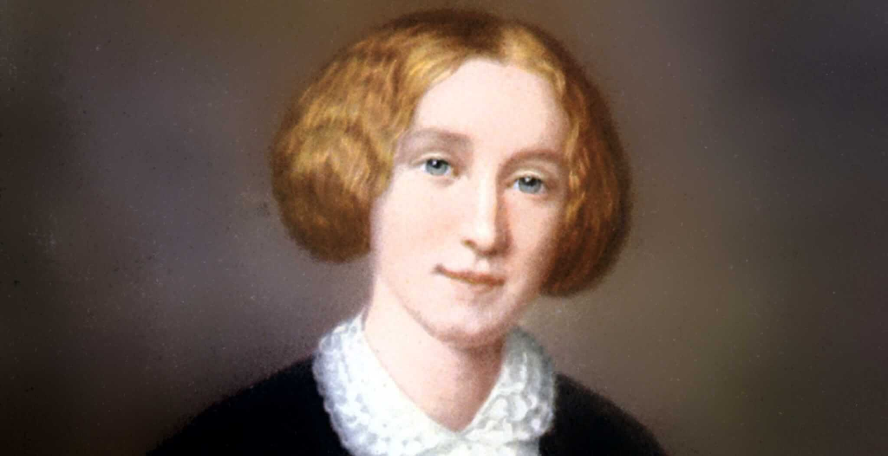

Team Member

George Martin

Sponsor:

Beverley Park Rilett, Ph.D.

Comp 4710 Senior Design Team **#6a**

Department of Computer Science and Software Engineering

Samuel Ginn College of Engineering, Auburn University

February 22, 2023

Table of Contents

1. System Metaphor 3

2. Previous Development 3

3. Cycle Intent 3

4. Future Work 4

4.1. Cycle 1 – (Completed) 4

4.2. Cycle 2 4

4.2.1. Adding Homepage Navigational Tab – Journals 4

4.2.2. Developing a more complex display and search model 4

4.3. Cycle 3 4

5. User Stories 5

6. Design Documentation 7

6.1. Language 7

6.2. Web-Tools and Resources 7

6.3. New Navigational Tab 7

6.4. Data Sourcing 7

7. Entity Relationship Diagram 7

8. Infrastructure 8

8.1. Homepage Navigational Toolbar 8

8.2. Search Functionality 8

9. Management Plan 8

10. Lessons Learned 9

11. Meeting Minutes 9

12. Testing Plan 10

13. Security Aspect 10

14. Memorandum of Sponsor Approval 11

# System Metaphor

The George Eliot Archive is a digital humanities project and website used by scholars, researchers, and students when looking into the life of author George Eliot. George Eliot is the pen name of Mary Ann Evans that she maintained throughout her life. The website hosts all of George Eliot's public literary works, articles about her, and intimate verifiable details regarding her life. The website's intent is to be the most complete, accurate, and trusted source for researchers interested in George Eliot. The exhibit is designed to not only host verified information about George Eliot, but to display it in an interactive (dynamic) and visually appealing way for easy referencing and research.

# Previous Development

Prior to cycle 1, there was no development for this group. At the time the group of five students were struggling logistically to find meeting times with one another and the sponsor. Admin permissions and clear intent / project focus delayed progress, but was hashed out towards the end of the architectural spike (January 30th). One Dr Bev agreed to move me into a solo-project, we were able to make significant progress. This section is being included for use in Cycle 2.

# Cycle Intent

The intent of cycle 1 was to develop a proof of concept that would pull data from the admin archives, display it on the live site in a simple way, and provide search functionality. Ideally a working product would be available by the end of cycle 1, but a proof of concept met cycle 1 goals. This goal was achieved on February 8th. Currently a user can search through a simplified version of the ‘Master Reference List’ using keywords and will be returned every row that matches their search.

# Future Work

## Cycle 1 – (Completed)

During cycle 1, I was requested to come up with a proof of concept for a simple method (no CSS or fancy formatting) that would pull data from an administrative file, display it on the live site, and allow users to search through over 1,878 journal entries by keyword or in its entirety.

## Cycle 2

### Adding Homepage Navigational Tab – Journals

An additional navigational category will be added to the website titled, 'Journals' which will allow users to navigate to a new page that will allow users to scroll through all 1,878 journal entries or search for specific journals using keyword / key date. (This will remain as a ‘private’ tab until completion of cycle 3).

### Developing a more complex display and search model

With the proof of concept being achieved in cycle 1, a more complex model will be developed that will allow users to search through the data and view it in a professionally formatted and easily readable way. This method should be free of bugs and may need to use a different method for data aggregation; switching from .csv file sourcing to webhosted data sourcing.

## Cycle 3

In the 3rd and final cycle, the user interface will have added functionality. Keywords should be highlighted for easy navigation and how data is updated by admin should be seamless and easy. The team will have free reign over display, using CSS to make it ‘appealing’ to users.   
  
[Optional] - Team 6a and 6b may end up integrating projects during this cycle. 6b is currently working on the George Eliot chronology, tree, timeline, and referencing. If 6b has met their goals, we will be able to begin working together to parse journal data into these dynamic interactive models.

# User Stories

|  |  |
| --- | --- |
| **Story** | 1 – Text-Explorer Journal Search |
| **Summary** | As a user I want to be able to search through George Eliot’s Journals using the current Text-Explorer tool. |
| **Description** | User input will be collected using a simple keyword text box. This input will be checked and then search through the journal source data using jQuery, returning the information in table/header format. |
| **Hours** | Planned Hours: 40  Planned Hours in this cycle: 20 |
| **Cycle** | 1 |
| **Assigned** | George Martin |

|  |  |
| --- | --- |
| **Story** | 2 – Uploading New Journals |
| **Summary** | As an admin, I want to be able to add, modify, or delete journal entries. |
| **Description** | From the administrative side of the website, admin will be able to directly add/edit/remove journal entries to the Journals category. The Okema webtool should push changes to the site every 5 minutes or so |
| **Hours** | Planned Hours: 10  Planned Hours in this cycle: 0 |
| **Cycle** | 2 |
| **Assigned** | George Martin |

|  |  |
| --- | --- |
| **Story** | 3 – Journal Web Navigation |
| **Summary** | As a user, I want to be able to view all of George Eliot’s raw journals |
| **Description** | The homepage toolbar will include an interactable title ‘Journals’ that will allow users to click and navigate to a new page. The new page will include a list of years that the user can click on. This will expand that year showcasing all the journals George Eliot authored that year. |
| **Hours** | Planned Hours: 5  Planned Hours in this cycle: 0 |
| **Cycle** | 2 |
| **Assigned** | George Martin |

|  |  |
| --- | --- |
| **Story** | 4 – Journal Page Interaction |
| **Summary** | As a user, I want to be able to be able to read each journal entry easily |
| **Description** | Users can navigate to the Journals page and do a default, empty entry, search to view all 1,878 journal entries. Entries will be returned in a formatted fashion that will help users easily delimit the information they are looking for. |
| **Hours** | Planned Hours: 40  Planned Hours in this cycle: 20 |
| **Cycle** | 1 |
| **Assigned** | George Martin |

|  |  |
| --- | --- |
| **Story** | 5 – Journal Interface and Display |
| **Summary** | As a user, I want to view the journal data in a more interactive and professional way, beyond simple black and white text returns. |
| **Description** | I will develop a way to display the searched data in a way that highlights the keyword(s) and dates, allows searchability by ‘book’ to further delimit search results, and add color to the page to create a more professional appearance. |
| **Hours** | Planned Hours: 40  Planned Hours in this cycle: 0 |
| **Cycle** | 3 |
| **Assigned** | George Martin |

# Design Documentation

## Language

Our team will be utilizing a combination of Javascript, PHP, and CSS for this web-development project

## Web-Tools and Resources

The George Eliot Archives uses several resources for hosting and collaboration.   
Front-end site: https://georgeeliotarchive.org/  
Back-end site: https://georgeeliotarchive.org/admin/  
A webhost of all journals: https://georgeeliotarchive.github.io   
Senior Design Documentation: https://auburn.app.box.com/  
Public Github Repo: <https://github.com/GeorgeEliotArchive>

## New Navigational Tab

A 'Journals' category will be added to the homepage of the George Eliot Archives. This tab will allow users to navigate to a new page which will display George Eliot's journals by year -> month.

## Data Sourcing

The journal data is currently hosted on a ‘Master Reference List’ .csv file.   
<https://georgeeliotarchive.org/admin/files/show/8218>

# Entity Relationship Diagram

*Items in red are those that need to be developed and implemented this project.  
** This ERD showcases both group 6a and 6b which may be integrated during cycle 3. See section 4.3.

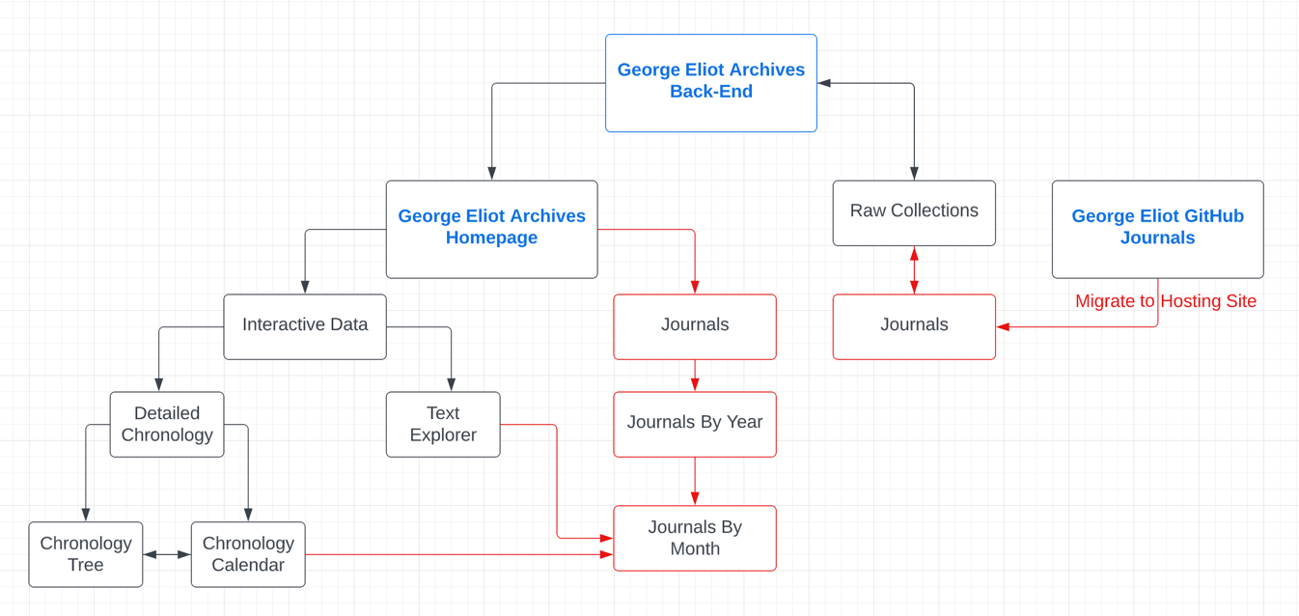

# Infrastructure

## Homepage Navigational Toolbar

## Search Functionality

# Management Plan

Having been moved into a ‘solo’ project, team management has become a non-issue. I currently meet with Dr Bev and Brad at least once a week in person, if not twice a week. I am meeting with the grad student Ravindra as he can support, though he is very busy and does not have much time to offer or knowledge when it comes to JS or html, so he and I are learning together. I am documenting my effort and time on project using notepad and my status report document (which is a ‘living document’).

# Lessons Learned

It seems that the source file that data is pulled from can cause unforeseen problems that seem contradictory to the code itself. Despite exhaustive efforts over nearly 2 weeks, both Ravindra and I have been unsuccessful in mitigating the formatting issue caused by unsupported ‘new-lines’ being copy&pasted into the .csv file.. because of this it is likely that we will have to develop an entirely different method of approach and pull from a web-hosted source, though I am not entirely sure how this will function just yet. Worst case, we can remove all ‘new-lines’ from the .csv file and indicate new lines using something different.

We are currently ahead of schedule. With cycle 1 only requiring a proof of concept, the functionality we have as it stands puts us ahead. Though it is important to note that having to develop an entirely new code and sourcing will certainly impact our schedule. Thankfully, with Dr Bev agreeing for this solo-project to run in a more ‘dynamic’ fashion, this does not pose an issue and our cycle forecasting has been updated to appropriately reflect this.

# Meeting Minutes

*The minutes below encompass only the period covering Cycle 1.   
Previous minutes can be found in the Architectural Spike report.*

January 31st: Met with Dr Bev and Brad for our regularly scheduled group meeting. Was moved into a ‘solo group’ and had project intent and focus changed. Requested elevated site access and resources.

February 3rd: Met with Dr Dozier via Zoom regarding the group-change. Was approved for solo work with Dr Bev taking the lead as far as grading goes.

February 6th: Met with grad student, Ravindra, who will be assisting me with the project. Began working on pseudo code.

February 8th: Created a private-playground on the live site that is hidden from user view, enabling me to see real time updates and changes I make to the code. Was able to create a simplified .csv file hosting the George Eliot Journal data to use with code. A successful proof of concept was established with a formatted display from the site-hosted source file and searchability.

February 9th: Testing revealed a bug in search formatting due to unsupported ‘new-lines’ in csv files, but the presence of them in cells because of copy & paste functionality. Met with graduate development team for a solution, but was unable to find an easy way to resolve this.

February 14th: Met with Dr Bev and Brad to go over proof of concept. Showed the good and ‘the bad’. Discussed possibly needing to come up with an entirely new solution to the project that doesn’t use .csv files, but uses web-hosting. This would be incredibly more complicated, but would yield easier backend useability. Was given approval on proof of concept.

February 17th: Met with Ravindra for help with the formatting bug and was unable to find a solution.

February 21st: Met with Dr Bev and Brad to report on project progress and status. Will be developing an entirely new data display solution using a different source file format.

# Testing Plan

A ‘private’ web-hosting simple page was developed for as a coding environment so that I can make changes to code and see the changes on site in *almost* real time (refresh needed). Additionally, Replit.com has been used as a playground if major changes are being implemented. Because of the nature of the project, ‘testing’ does not seem to be an integral part of development as would be the case in more complicated projects. Very few functions or methods are being used, and since it is in html, there isn’t really a good way to ‘test’ this beyond seeing what the site displays.

# Security Aspect

When speaking with Dr Bev regarding security, I was told this is a ‘non-issue’. Regardless, I will do my best to make sure user input in the search bar is sanitized or limited as to not allow potential buffer overflow or unexpected issues. I have informally tried several penetrative methods, and none have been successful. I intend to speak with the lead developer on this during cycle 3 and will update the cycle forecast as needed.

# Source Code

Source code can be found following this URL: <https://github.com/SkydivingSquid/Senior-Design>   
*Note, code is html and will change periodically. Code can be viewed in .txt format or functional html format.

# 

# Memorandum of Sponsor Approval

[Sponsor Approval] – Architectural Spike (outdated)

[Sponsor Approval] – Cycle 1

