**Cycle 2 Report**

**‘The George Eliot Archives’**

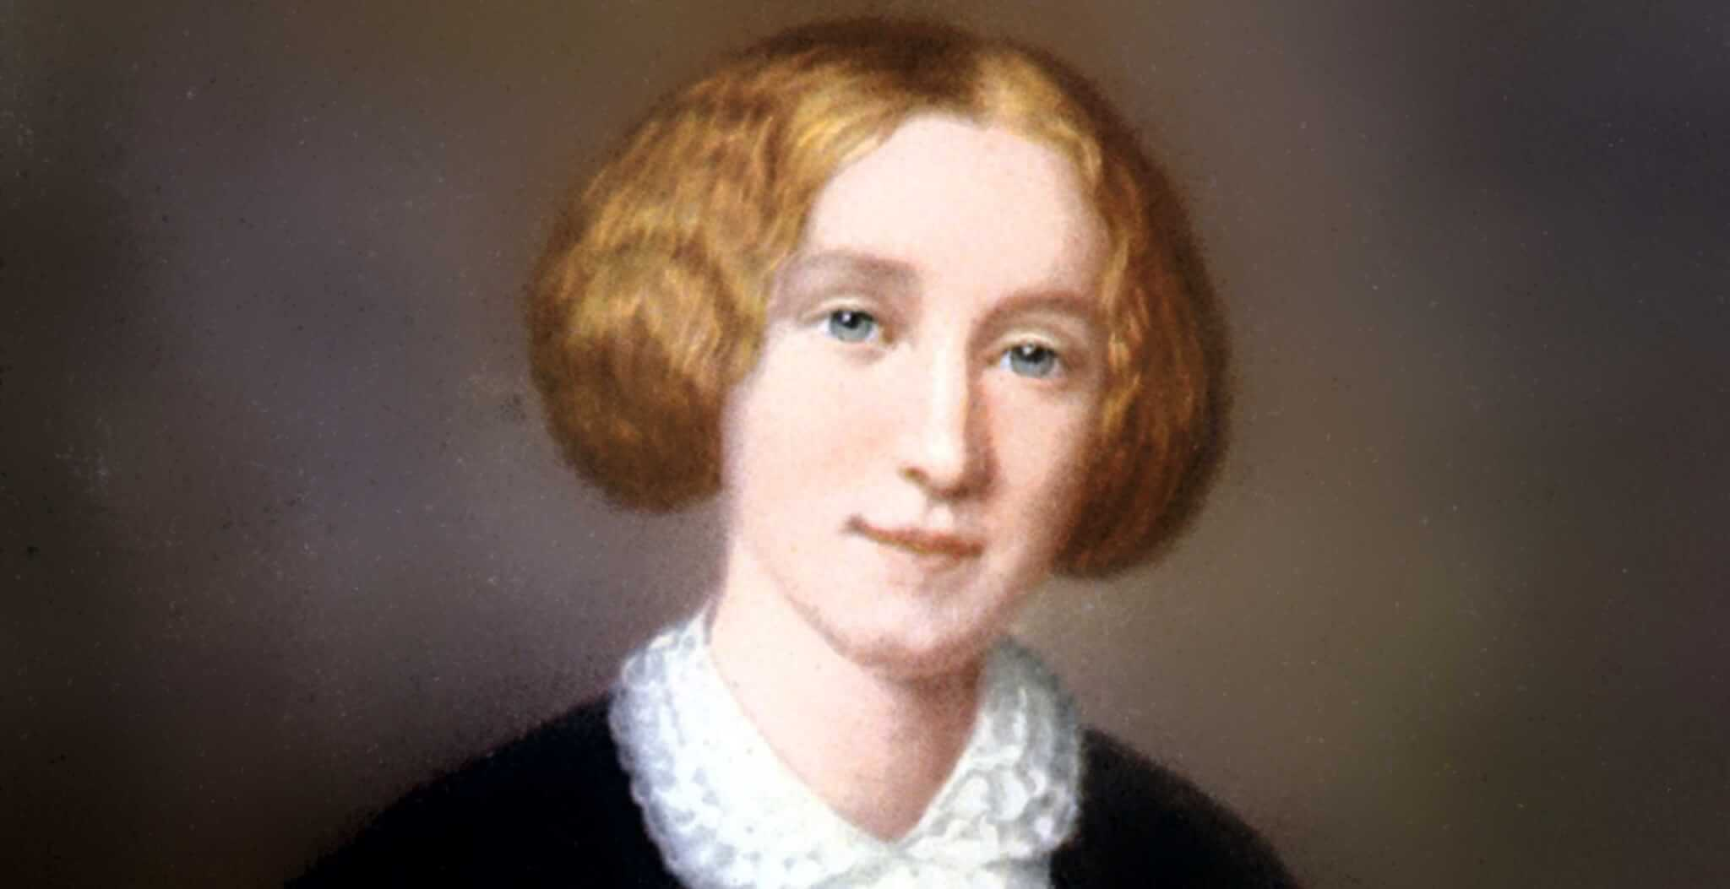

Team Member

George Martin

Sponsor:

Beverley Park Rilett, Ph.D.

Comp 4710 Senior Design Team **#6a**

Department of Computer Science and Software Engineering

Samuel Ginn College of Engineering, Auburn University

March 22, 2023

Table of Contents

1. System Metaphor 3

2. Previous Development 3

3. Cycle Intent 3

4. Future Work 4

4.1. Cycle 1 – (Completed) 4

4.2. Cycle 2 – (Completed) 4

4.2.1. Adding Homepage Navigational Tab – Journals 4

4.2.2. Developing a more complex display and search model 4

4.3. Cycle 3 4

5. User Stories 5

6. Design Documentation 7

6.1. Language 7

6.2. Web-Tools and Resources 7

6.3. New Navigational Tab 7

6.4. Data Sourcing 7

7. Entity Relationship Diagram 7

8. Infrastructure 8

8.1. Navigation Toolbar 8

8.2. Search Feature (old) 8

8.3. Search Feature (new) 9

9. Management Plan 10

10. Lessons Learned 10

11. Meeting Minutes 10

12. Testing Plan 11

13. Security Aspect 11

14. Source Code 11

15. Memorandum of Sponsor Approval 12

# System Metaphor

The George Eliot Archive is a digital humanities project and website used by scholars, researchers, and students when looking into the life of author George Eliot. George Eliot is the pen name of Mary Ann Evans that she maintained throughout her life. The website hosts all of George Eliot's public literary works, articles about her, and intimate verifiable details regarding her life. The website's intent is to be the most complete, accurate, and trusted source for researchers interested in George Eliot. The exhibit is designed to not only host verified information about George Eliot, but to display it in an interactive (dynamic) and visually appealing way for easy referencing and research.

# Previous Development

Prior to cycle 1, there was no development for this group. At the time the group of five students were struggling logistically to find meeting times with one another and the sponsor. Admin permissions and clear intent / project focus delayed progress, but was hashed out towards the end of the architectural spike (January 30th). One Dr Bev agreed to move me into a solo-project, we were able to make significant progress. This section is being included for use in Cycle 2.

In cycle 1 focused on developing a ‘proof of concept’ to show the journal data could be searched and displayed. This was completed early on and enabled the team to begin working on display features such as color, boxes, table formatting etc. After finishing the initial set milestones, troubleshooting on data display became the primary focus. When the reader would find a ‘/n’ (new-line) in a .csv row, it would display on the site in a new row, under the wrong column. This was solved using the Papa Parse library.

# Cycle Intent

The intent of cycle 2 was to launch the proof of concept into a fully functioning web-page that a user could navigate to from a toolbar. The webpage was to display all results in a professional looking way that made it easy for the user to see exactly what they were searching for, based on keyword(s) or date(s).

# Future Work

## Cycle 1 – (Completed)

During cycle 1, I was requested to come up with a proof of concept for a simple method (no CSS or fancy formatting) that would pull data from an administrative file, display it on the live site, and allow users to search through over 1,878 journal entries by keyword or in its entirety.

## Cycle 2 – (Completed)

### Adding Homepage Navigational Tab – Journals

An additional navigational category will be added to the website titled, 'Journals' which will allow users to navigate to a new page that will allow users to scroll through all 1,878 journal entries or search for specific journals using keyword / key date. (This will remain as a ‘private’ tab until completion of cycle 3).

### Developing a more complex display and search model

With the proof of concept being achieved in cycle 1, a more complex model will be developed that will allow users to search through the data and view it in a professionally formatted and easily readable way. This method should be free of bugs and may need to use a different method for data aggregation; switching from .csv file sourcing to webhosted data sourcing.

## Cycle 3

In the 3rd and final cycle, the solution should pull from the web-host database instead of a static .csv file. This will allow Dr Bev and her research team to update the data and have it reflected on the site in real-time, vice having to update and save a new .csv file and update the code-based URL each time, though arguably this would still be a rare occurrence.   
  
[Optional] - Team 6a and 6b may end up integrating projects during this cycle. 6b is currently working on the George Eliot chronology, tree, timeline, and referencing. If 6b has met their goals, we will be able to begin working together to parse journal data into these dynamic interactive models.

# User Stories

|  |  |
| --- | --- |
| **Story** | 1 – Text-Explorer Journal Search |
| **Summary** | As a user I want to be able to search through George Eliot’s Journals. |
| **Description** | User input will be collected using a simple keyword text box. This input will be checked and then search through the journal source data using jQuery, returning the information in table/header format. |
| **Hours** | Planned Hours: 40  Planned Hours in this cycle: 20 |
| **Cycle** | 1 |
| **Assigned** | George Martin |

|  |  |
| --- | --- |
| **Story** | 2 – Journal Page Interaction |
| **Summary** | As a user, I want to be able to be able to read each journal entry easily |
| **Description** | Users can navigate to the Journals page and do a default, empty entry, search to view all 1,878 journal entries. Entries will be returned in a formatted fashion that will help users easily delimit the information they are looking for. |
| **Hours** | Planned Hours: 40  Planned Hours in this cycle: 20 |
| **Cycle** | 1 |
| **Assigned** | George Martin |

|  |  |
| --- | --- |
| **Story** | 3 – Uploading New Journals |
| **Summary** | As an admin, I want to be able to add, modify, or delete journal entries in real-time. |
| **Description** | From the administrative side of the website, admin will be able to directly add/edit/remove journal entries to the Journals category. The Okema webtool should push changes to the site every 5 minutes or so |
| **Hours** | Planned Hours: 40  Planned Hours in this cycle: 0 |
| **Cycle** | 2 |
| **Assigned** | George Martin |

|  |  |
| --- | --- |
| **Story** | 4 – Journal Web Navigation |
| **Summary** | As a user, I want to be able to view all of George Eliot’s raw journals |
| **Description** | The homepage toolbar will include an interactable title ‘Journals’ that will allow users to click and navigate to a new page. The new page will include a list of years that the user can click on. This will expand that year showcasing all the journals George Eliot authored that year. |
| **Hours** | Planned Hours: 5  Planned Hours in this cycle: 3 |
| **Cycle** | 2 |
| **Assigned** | George Martin |

|  |  |
| --- | --- |
| **Story** | 5 – Journal Interface and Display |
| **Summary** | As a user, I want to view the journal data in a more interactive and professional way, beyond simple black and white text returns. |
| **Description** | I will develop a way to display the searched data in a way that highlights the keyword(s) and dates. I would also like any links to be displayed as a hyper link and cross reference with the chronology. |
| **Hours** | Planned Hours: 40  Planned Hours in this cycle: 0 |
| **Cycle** | 3 |
| **Assigned** | George Martin |

# Design Documentation

## Language

Our team will be utilizing a combination of Javascript, PHP, and CSS for this web-development project

## Web-Tools and Resources

The George Eliot Archives uses several resources for hosting and collaboration.   
Front-end site: https://georgeeliotarchive.org/  
Back-end site: https://georgeeliotarchive.org/admin/  
A webhost of all journals: https://georgeeliotarchive.github.io   
Senior Design Documentation: https://auburn.app.box.com/  
Public Github Repo: <https://github.com/GeorgeEliotArchive>

## New Navigational Tab

A 'Journals' category will be added to the homepage of the George Eliot Archives. This tab will allow users to navigate to a new page which will display George Eliot's journals by year -> month.

## Data Sourcing

The journal data is currently hosted on a ‘Master Reference List’ .csv file.   
<https://georgeeliotarchive.org/admin/files/show/8218>   
  
Our intention is to modify this in cycle 3 to pull from the web-host instead.

# Entity Relationship Diagram

*Items in red are those that need to still be developed and implemented.  
** This ERD showcases both group 6a and 6b which may be integrated during cycle 3. See section 4.3.

# Infrastructure

## Navigation Toolbar

## Search Feature (old)

## Search Feature (new)

# Management Plan

Having been moved into a ‘solo’ project, team management has become a non-issue. I currently meet with Dr Bev and Brad at least once a week in person, if not twice a week. I am meeting with the grad student Ravindra as he can support, though he is very busy and does not have much time to offer or knowledge when it comes to JS or html, so he and I are learning together. I am documenting my effort and time on project using notepad and my status report document (which is a ‘living document’).

# Lessons Learned

Implementation of the ‘proof of concept’ onto the live site and toolbar was relatively seamless, though troubleshooting the display format ‘bug’ took significantly more time than expected. Thankfully, we were ahead of schedule enough to accommodate this set-back. We have met all goals for the project, and in cycle 3 will be attempting to change from a static data source to a dynamic one. This may require a complete coding redesign. Current issue at hand involves not knowing where the chronology code is saved or how it works. Once we can find it, we can model and implement a solution based on that for dynamic data display.

# Meeting Minutes

*The minutes below encompass only the period covering Cycle 2.   
Previous minutes can be found in the Cycle 1 or Architectural Spike reports.*

February 21st: Group meeting with the development team (Dr Bev and Brad not present). Showcased the ‘proof of concept’ to the development team and possible solution for the formatting bug.

February 22nd: Worked with Ravindra to find solution to the formatting bug and did some research on how to create a web-page toolbar.

February 23rd: Met with development team and Ravindra. Set up a meeting time with brad to discuss tool bar implementation. Launched proof of concept on the live website.

March 12th: Status Report for Senior Design. Meeting rescheduled with Brad and Ravindra.

March 14th: Weekly meeting with Development team.

March 17th: Meeting with Ravindra canceled. Toolbar for Journals launched, then moved to private.

March 18th: Status Report #2, Cycle 2 presentation, Cycle 2 report.

March 20th: Met with Ravindra to begin Cycle 3, dynamic data sourcing.

March 22nd: Cycle 2 Demo and Process for Senior Design.

# Testing Plan

A ‘private’ web-hosting simple page was developed for as a coding environment so that I can make changes to code and see the changes on site in *almost* real time (refresh needed). Additionally, Replit.com has been used as a playground if major changes are being implemented. Because of the nature of the project, ‘testing’ does not seem to be an integral part of development as would be the case in more complicated projects. Very few functions or methods are being used, and since it is in html, there isn’t really a good way to ‘test’ this beyond seeing what the site displays.

# Security Aspect

When speaking with Dr Bev regarding security, I was told this is a ‘non-issue’. Regardless, I will do my best to make sure user input in the search bar is sanitized or limited as to not allow potential buffer overflow or unexpected issues. I have informally tried several penetrative methods, and none have been successful. I intend to speak with the lead developer on this during cycle 3 and will update the cycle forecast as needed. Website security is being provided by a 3rd party and I was asked not to touch it.

# Source Code

Source code can be found following this URL: <https://github.com/SkydivingSquid/Senior-Design>   
*Note, code is html and will change periodically. Code can be viewed in .txt format or functional html format.

# 

# Memorandum of Sponsor Approval

[Sponsor Approval] – Architectural Spike (outdated)

[Sponsor Approval] – Cycle 1



[Sponsor Approval] – Cycle 2

[Email pending]