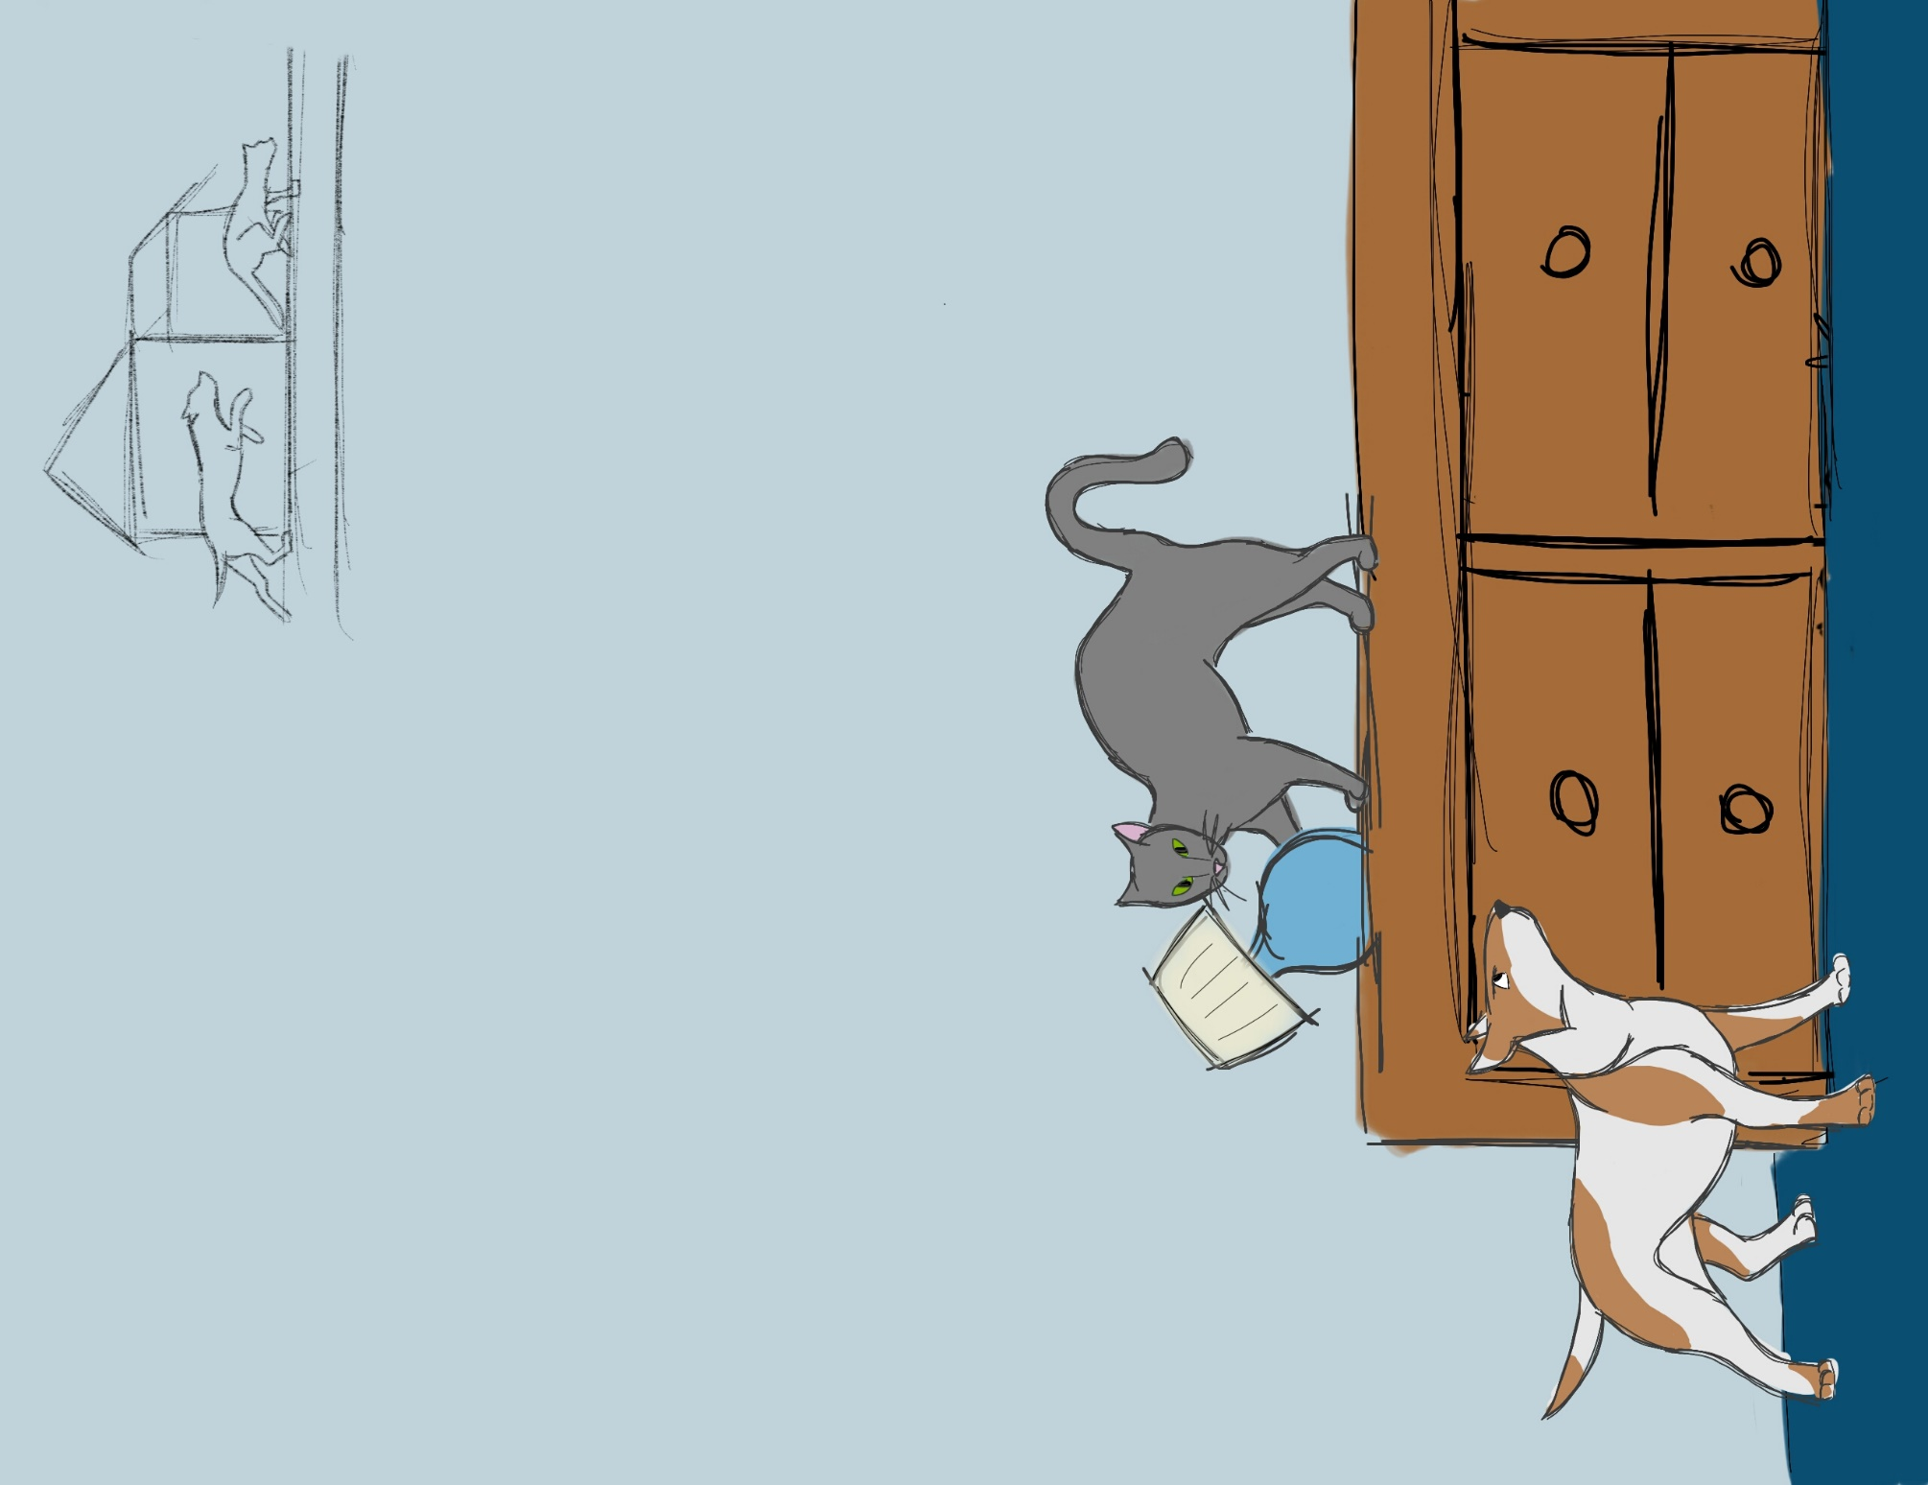 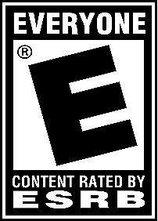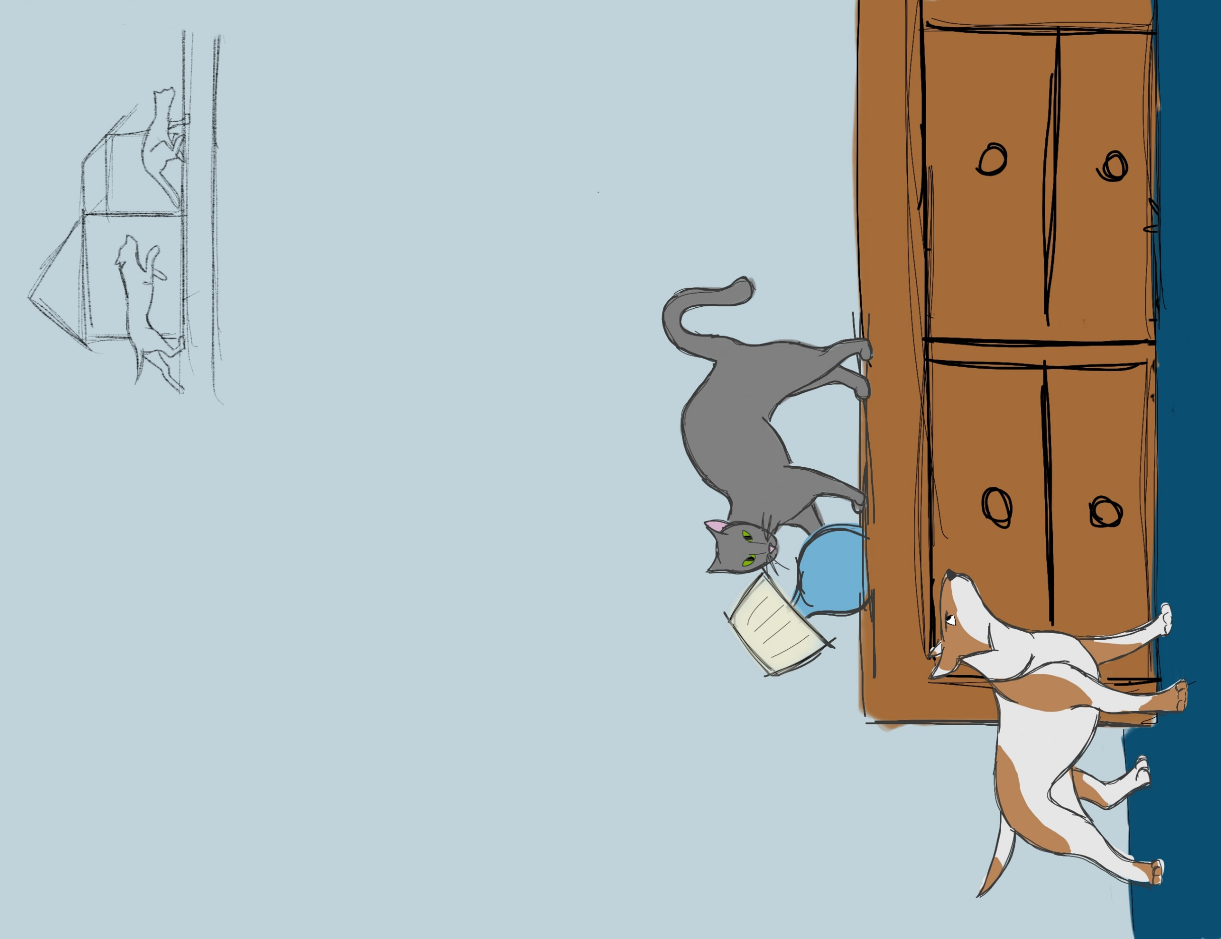

**Similar Games**

* Crashy Cats – Cats running through a house destroying objects
* Mario Party Minigames: Thrash-n-Crash & Bob-ombs Away - Drop/interact with objects to get players out

**Mechanics**

* Jump using <space> to get out of the reach of the dogs as well as in the reach of knock-able items
* Click on interactable items to knock them over onto the dogs
* Use the left and right arrows to change directions.

The Impawsible Pursuit

**Objective**

* Knock over items to stop the dogs in their tracks

**Summary**

* Side Scroller
* Target Audience: cat people everywhere
* Platform: PC

By Skye Slade

Cats – creatures with an amazing ability to knock things over. Use this ability to your advantage as you attempt to stop the dogs from overrunning the town.