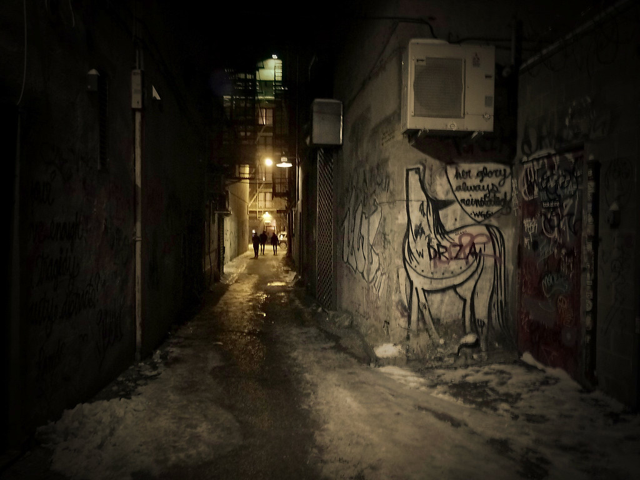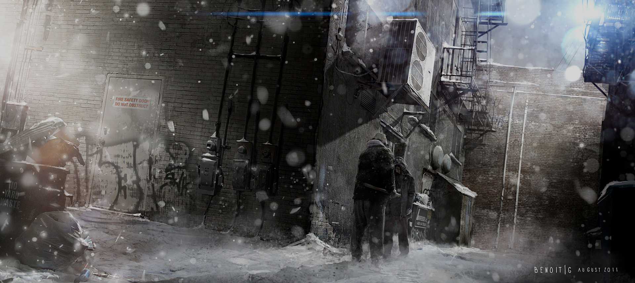

**Mechanics:**

* Arrows or WASD to move your character
* Crouch using <Ctrl> to hide behind objects
* Pick up objects to use <E> or Throw <Q> them

A Third Person, Action/Adventure game in which the player must use their skills to navigate their way through alleyways of the city, survive the cold of the winter night, avoid attacks from the local gang, and save their close friend from the clutches of the gang lord.

URBAN RECOVERY

**Plot Summary**

* A close friend, caught up in some shady business, has gotten himself captured by the local gang. It is your job to rescue him by navigating your way to the gang’s hideout through the alleys while being cautious to survive both the winter cold and attacks from the gang.



**Find Your Own Way**

Navigate your way through the alleyways of a large city

**Stealth vs Force**

Choose whether to avoid the enemies or take them down with force

**Game Information:**

* Genre: Action/Adventure
* Target Audience: Teen to Young Adult gamers
* Audience Type: Explorers
* Platform: PC

**Avoid the Cold**

Stay near the trash fires to avoid losing damage to the cold.