Concept: A Third Person, realistic, Action/Adventure game were the player must use their skills to navigate their way through the inner alleyways of a metropolis and survive both the cold of the winter night and attacks by the local gang members, in order to save their close friend from the clutches of the gang lord.

Product Information:

* Genre: Action/Adventure
* Target Audience: Teen to Young Adult gamers
* Audience Type: Explorer
* Platform: PC

Unique (What makes it different): Player will not only have to worry about avoiding death by the gang members, but they must also watch out that they do not freeze to death from the cold. The environment also will be maze like, with many different paths which the player must navigate to get to the gang hideout. Finally, the player will have a choice of either avoiding the gang through stealth methods, or take them down with force.

Brief Plot Summary (main point and objective): A close friend, caught up in some shady business, has gotten himself captured by the local gang. It is your job to rescue him by navigating your way to the gang’s hideout through the alleys while being cautious to survive both the winter cold and attacks from the gang.

Mechanics:

* Move around with Arrow keys or WASD
* Crouch using <Ctrl> to hide behind objects and stay out of the sight of enemies
* 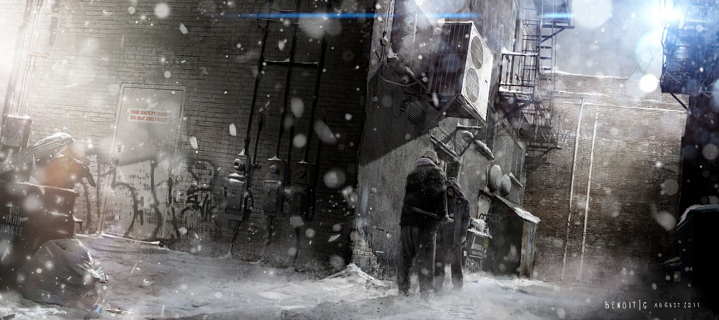Pick up Objects and use them with <E> or throw them with<Q>