二、
In this part,we are trying to apply BF decoding algorithm for 100 codewords encoded by H and BPSK,and count the total BER for the 100 codewords decoded by BF algoritm.
Important code[MatLab]:
H = genH(256,512);%Generate a check matrix of size 256 * 512
Num=100;%Test 100 code words
Snr=[1:0.5:3];%SNR value array
For j=1:size(Snr){%Calculate for each snr value in Snr array
While(i<100){%Callate for each codeword generated randomly by H’s correspoding G
s=round(rand(1, cols-rows));%s is the source data generated randomly
[u,P,rearranged_cols]=ldpc_encode(s,H); %encode s into codeword u
tx=bpsk(u);%encode u into bpsk code tx
sigma=sqrt(No(Snr(j))/2);%control the noise size by Snr value
rx=tx + sigma*randn(1,length(tx));%add noise
vhat1 = decodeBitFlip(tx, H,100);%decode the rx by BF algorithm
[num1, rat1] = biterr(vhat1, u);%count the num of wrong bits
biterrors1+=biterrors1+num1;
i++;
}
BER1(j)=biterrors1/(block1*n);%bit error rate for Snr(j)
j++
}
四、
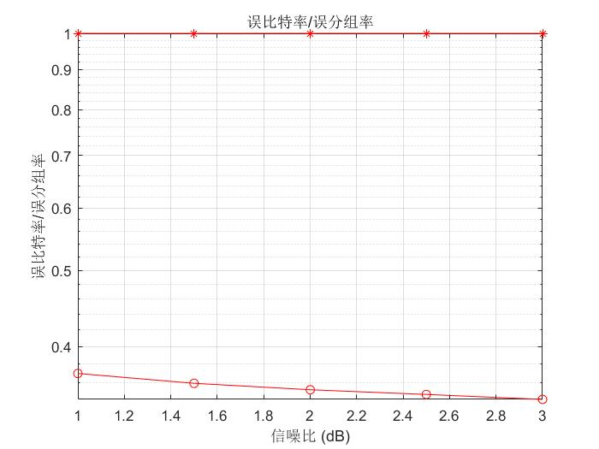
Figure 1.BER results for different SNR value

As shown in the figure 1,we can conclude that easily as the snr value goes higher,and BER of the results go smaller.Higher SNR means the power of signal is much higher than the power of noise, it’s easier for receiver to decode the code word correctly.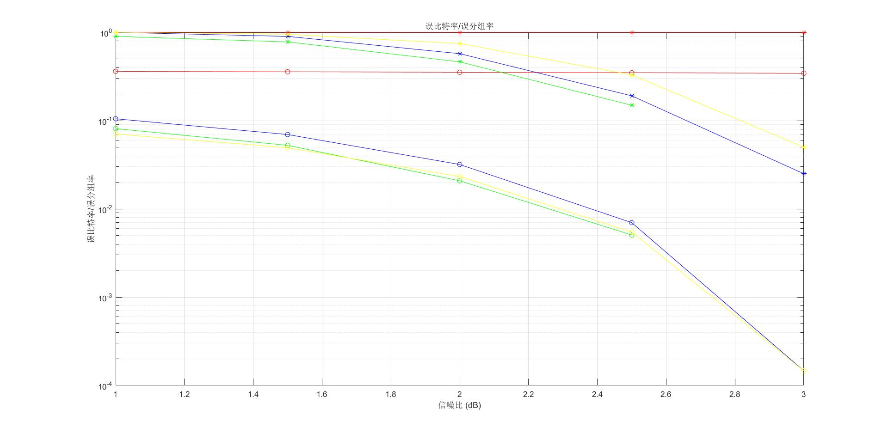
Figure 2.BER results for different decoding algorithms

As shown in figure 2,for green、blue、yellow curve,they standard for different decoding algorithms, yellow curve standards for the BF algorithm.It’s easily to conclude from figure 2 that BF algorithm performs closely to the yellow curve,and performs better than blue curve.

