# **TASK 1.1**

### Screenshot 1

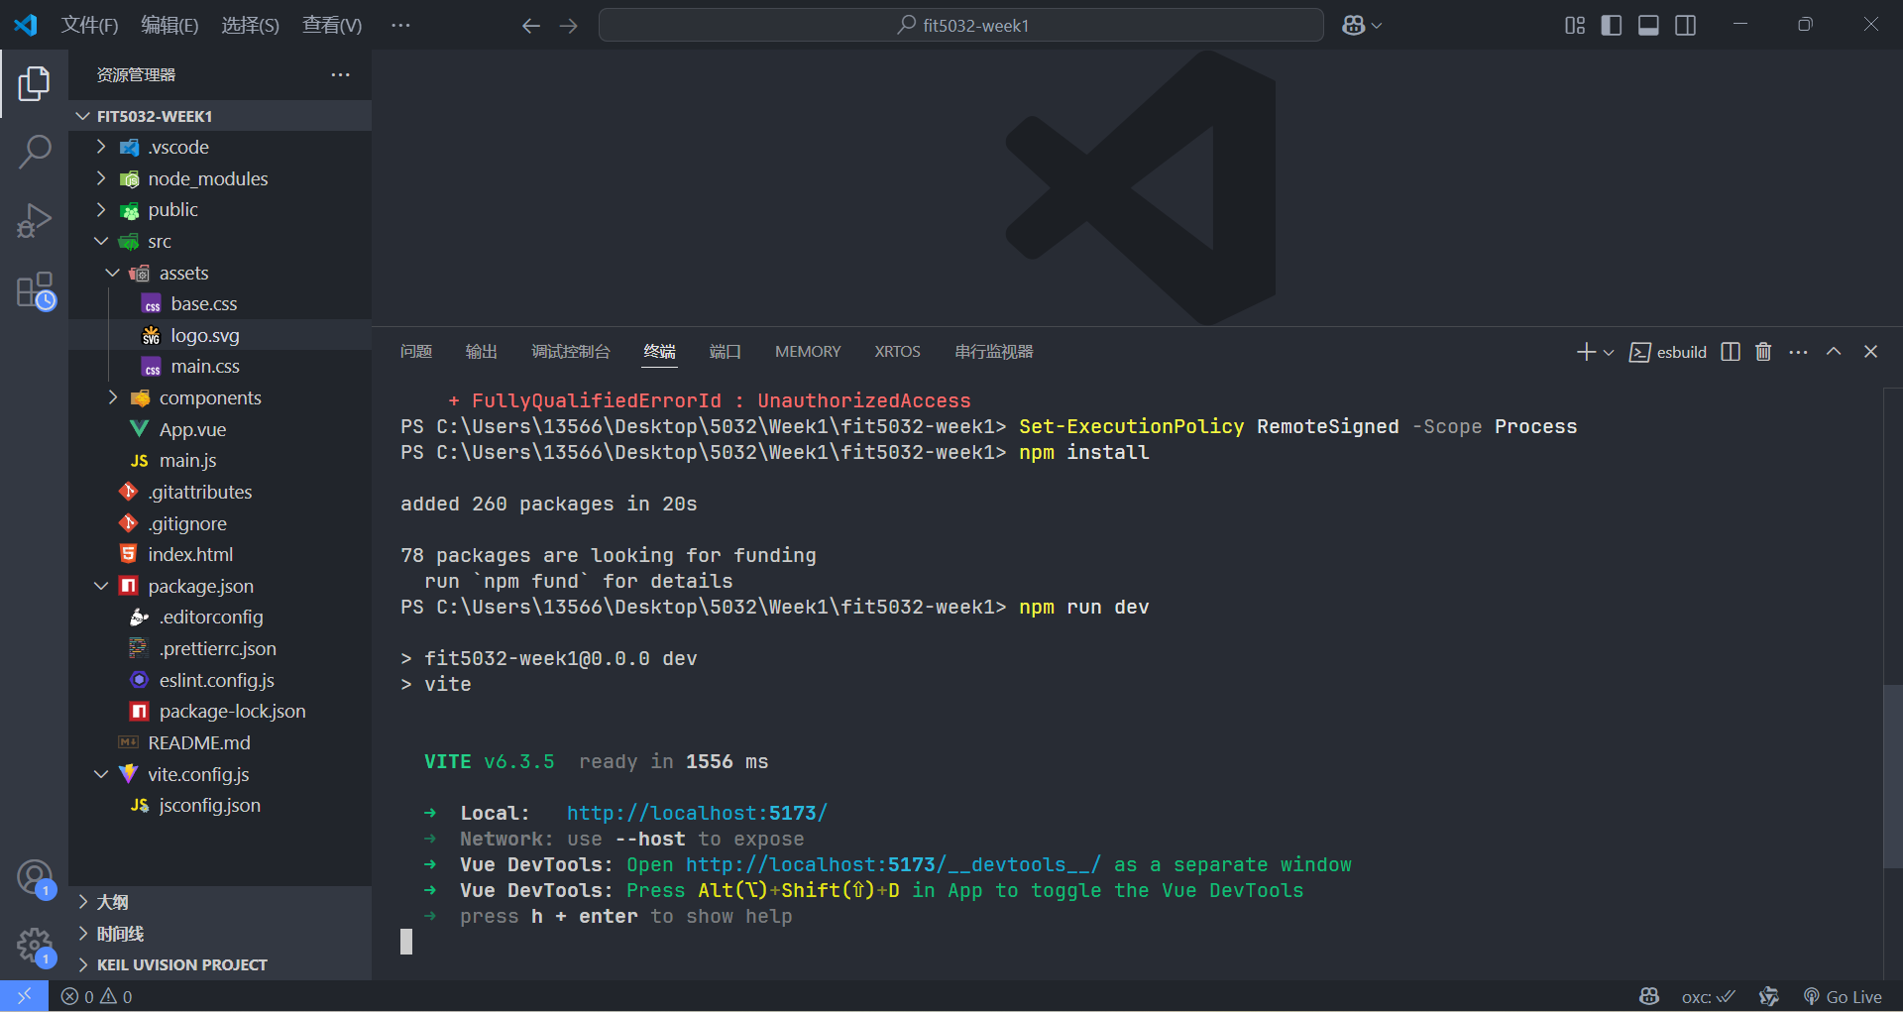

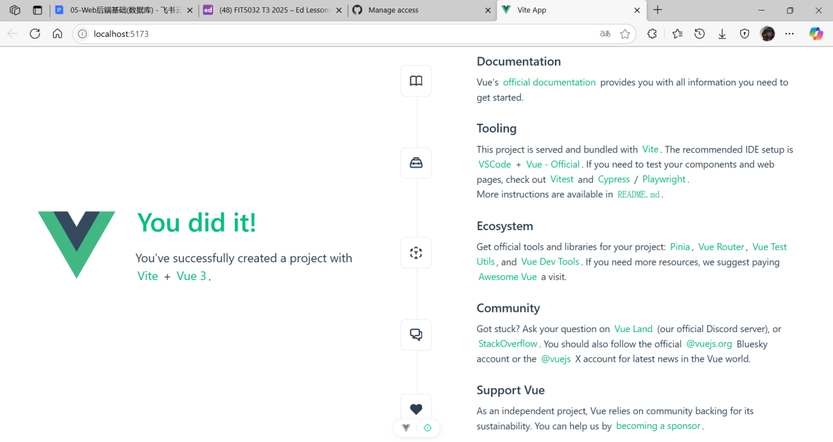

# **TASK 1.2**

### Screenshot 2

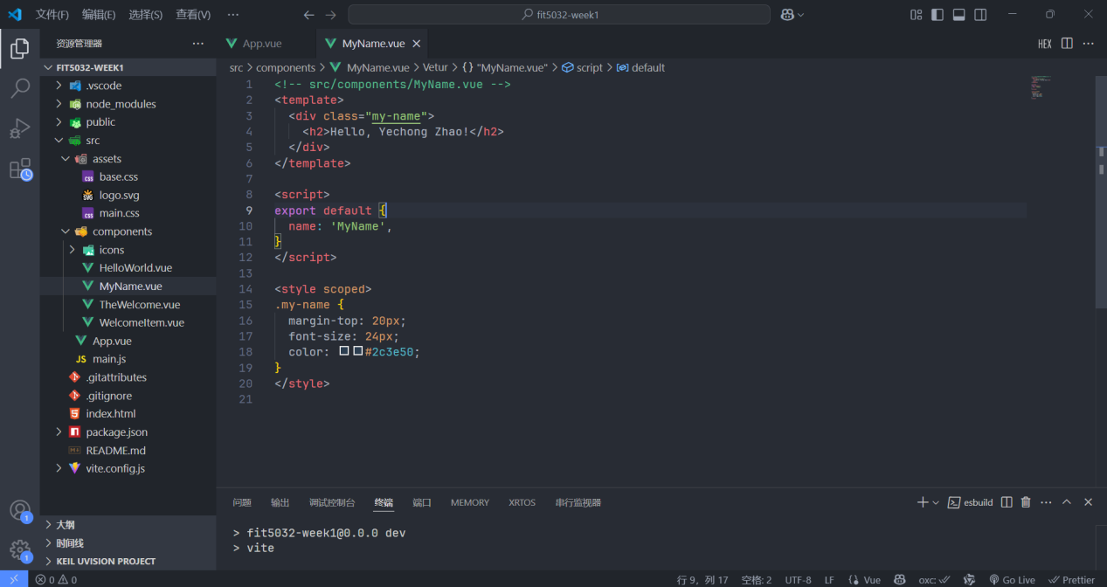

### Screenshot 3

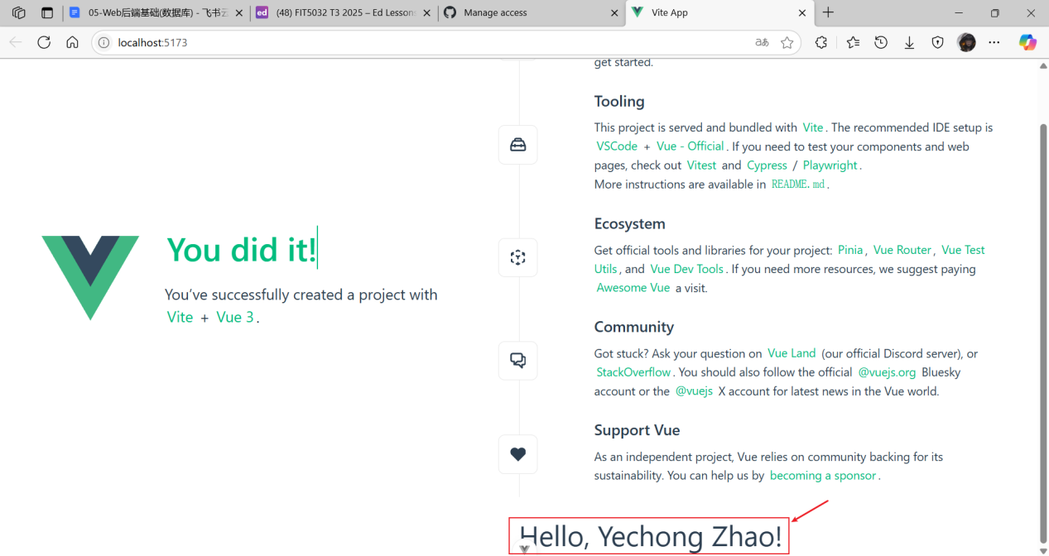

### Github URL

[Skyeon-monash/FIT5032_2025_YechongZhao_35523115](https://github.com/Skyeon-monash/FIT5032_2025_YechongZhao_35523115)

**Descriptions on how did you engage with peers**

Today I finished adding the MyName.vue component to my Vue project. It now shows my name on the welcome page. Although it was a simple task, it helped me understand how to create and use custom components in Vue. I ran into a small issue with the import path at first, but fixing it made the process more rewarding.