# **EFOLIO TASK 2.1**

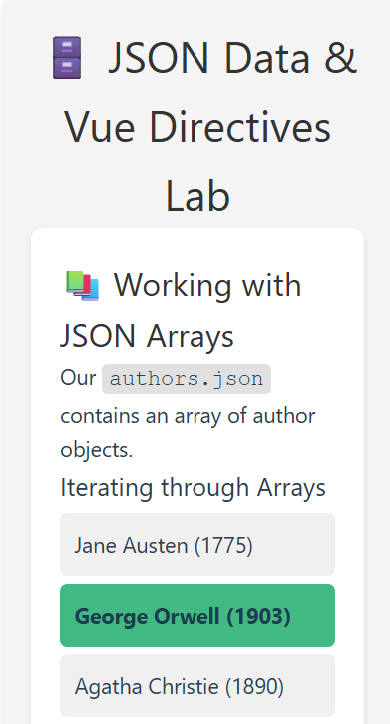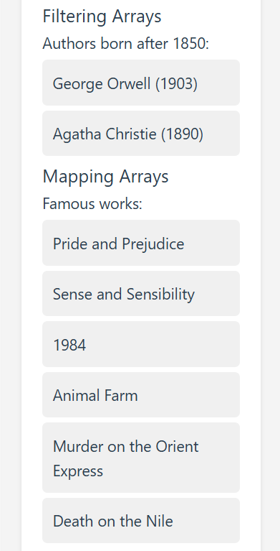

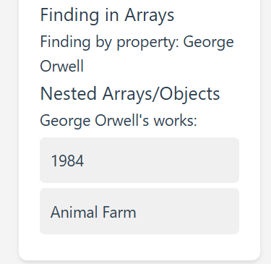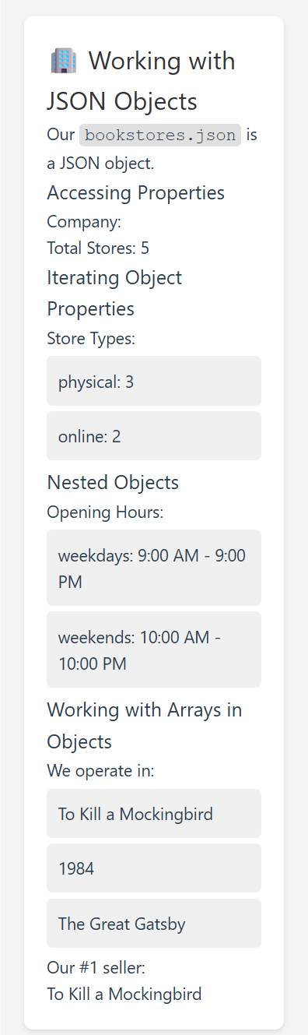

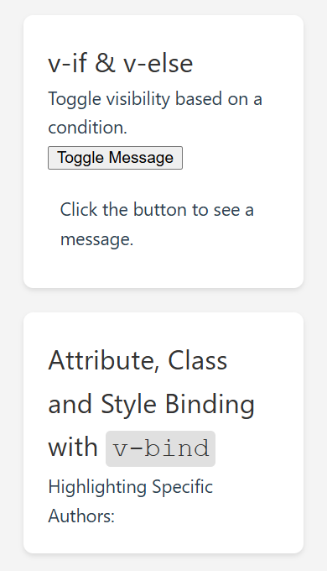

# **EFOLIO TASK 2.2**

**Author-highlight functionality**

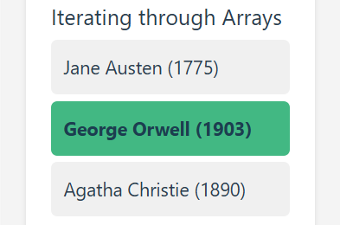

**Code**

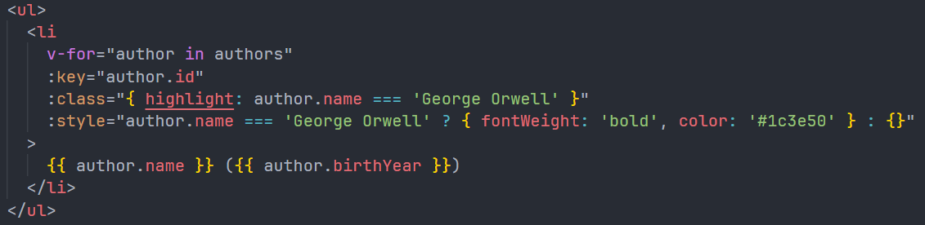

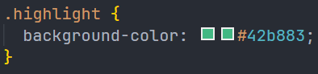

**GitHub history with your project update**

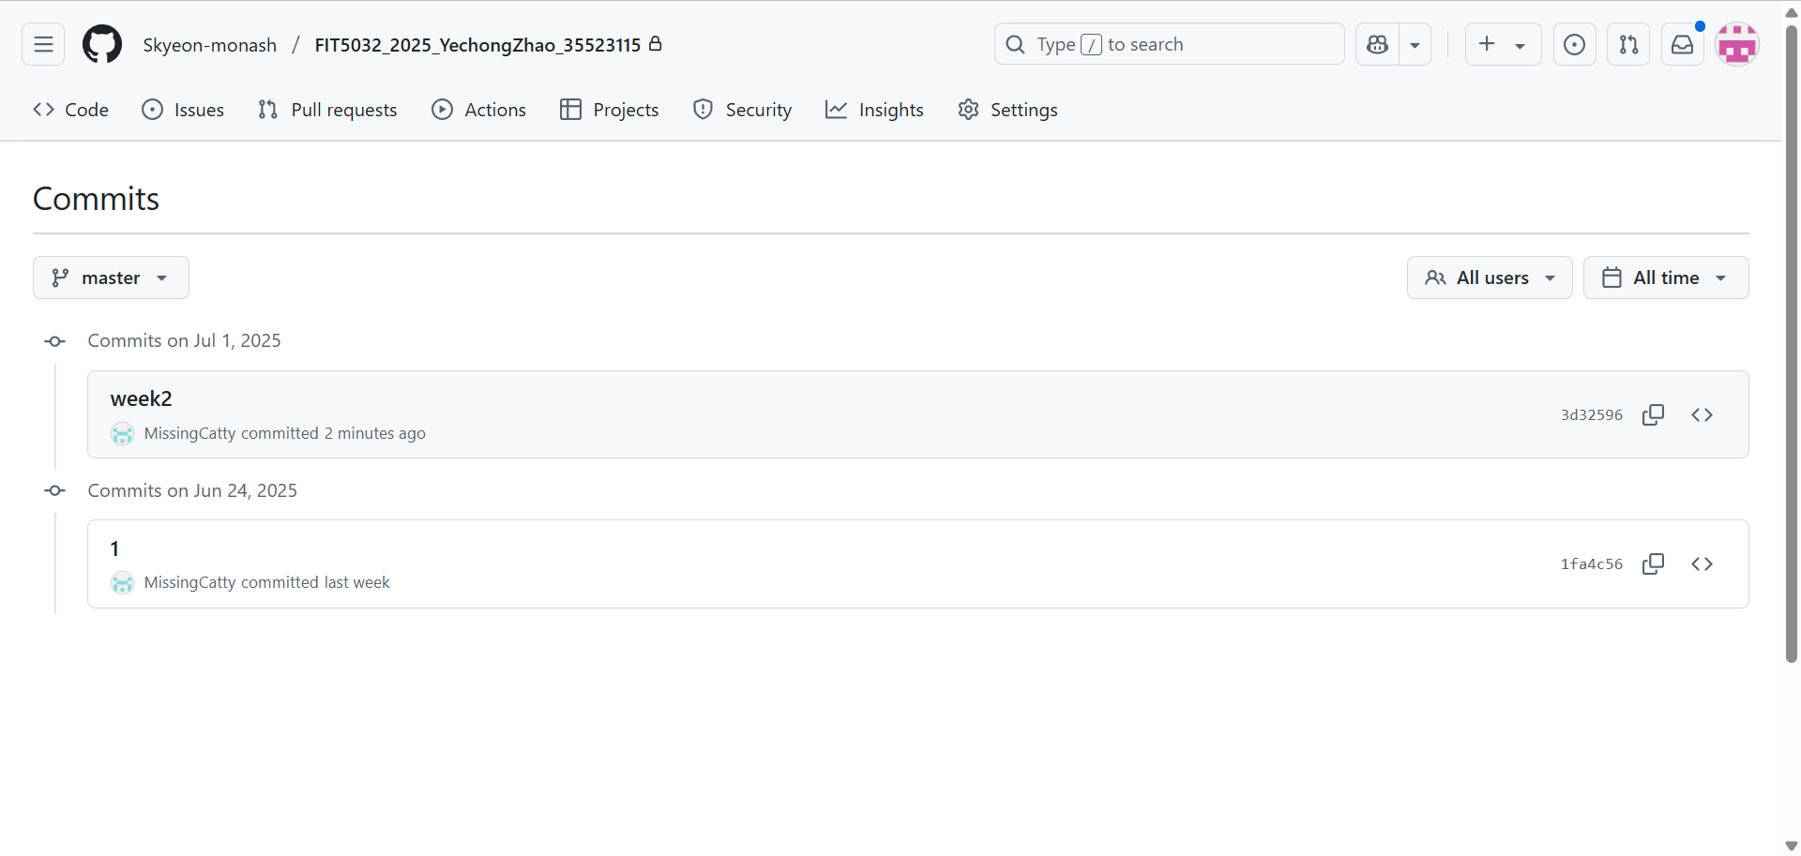

### Github URL

[Skyeon-monash/FIT5032_2025_YechongZhao_35523115](https://github.com/Skyeon-monash/FIT5032_2025_YechongZhao_35523115)