# EFOLIO TASK 3.1

## Activity 1

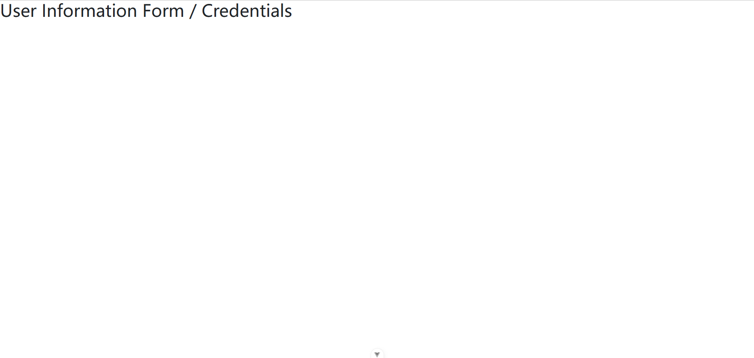

## Activity 2

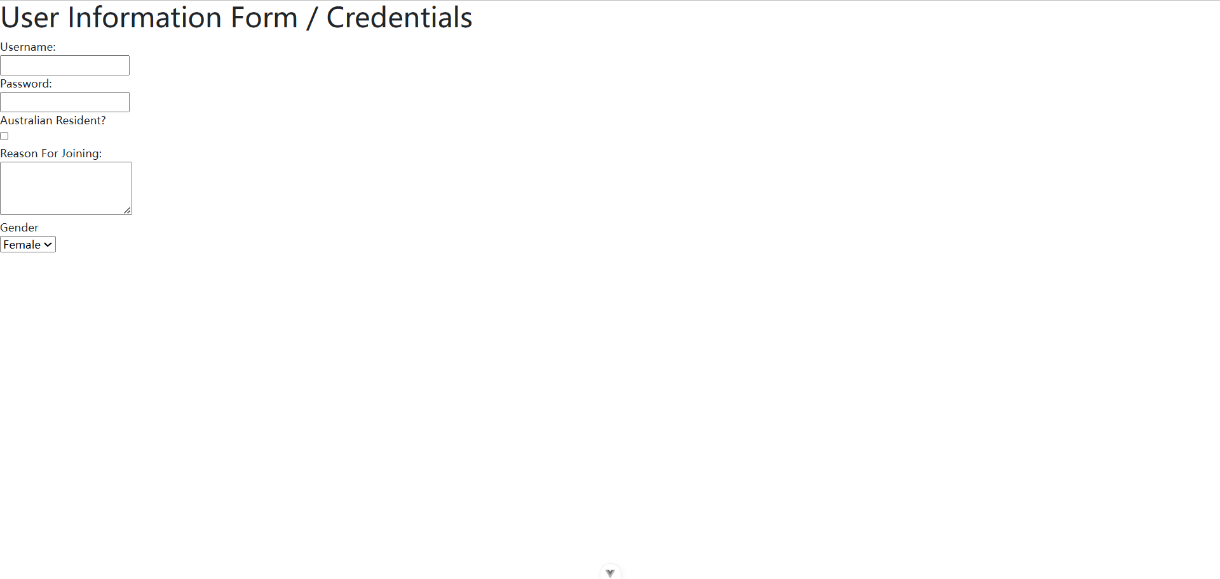

### Activity 3

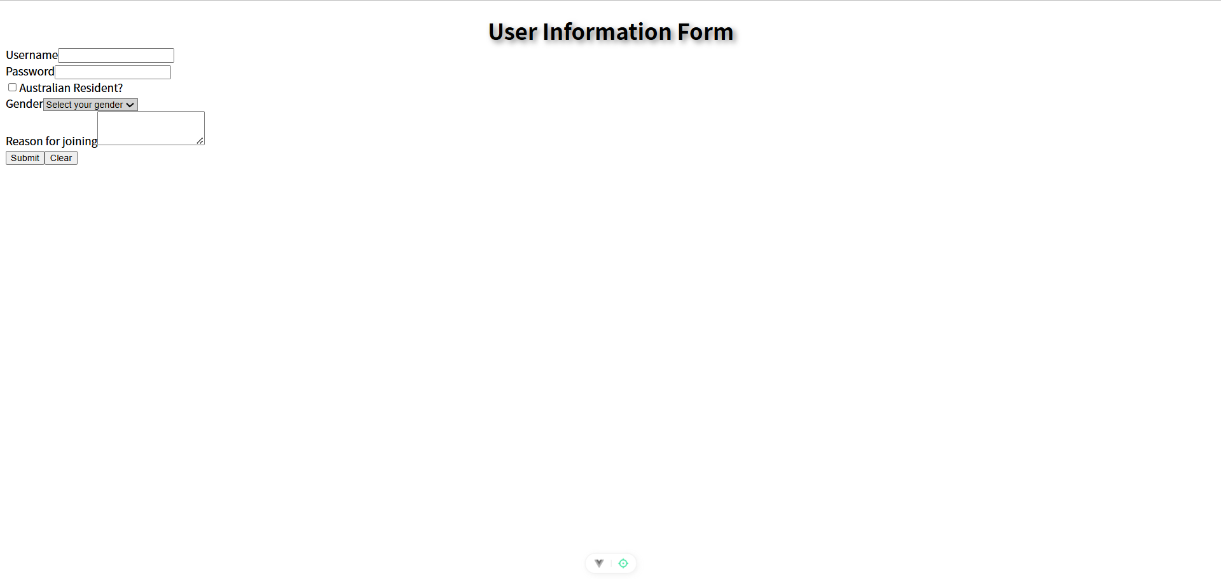

## Activity 4

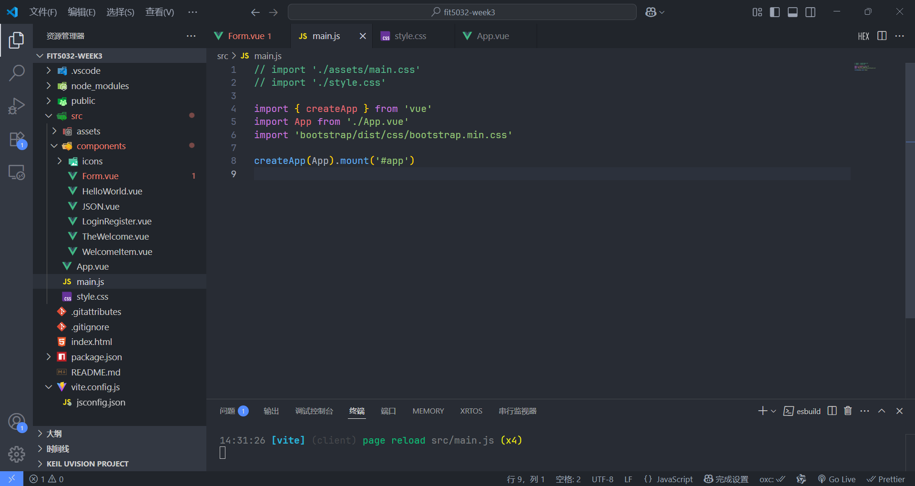

## Activity 5

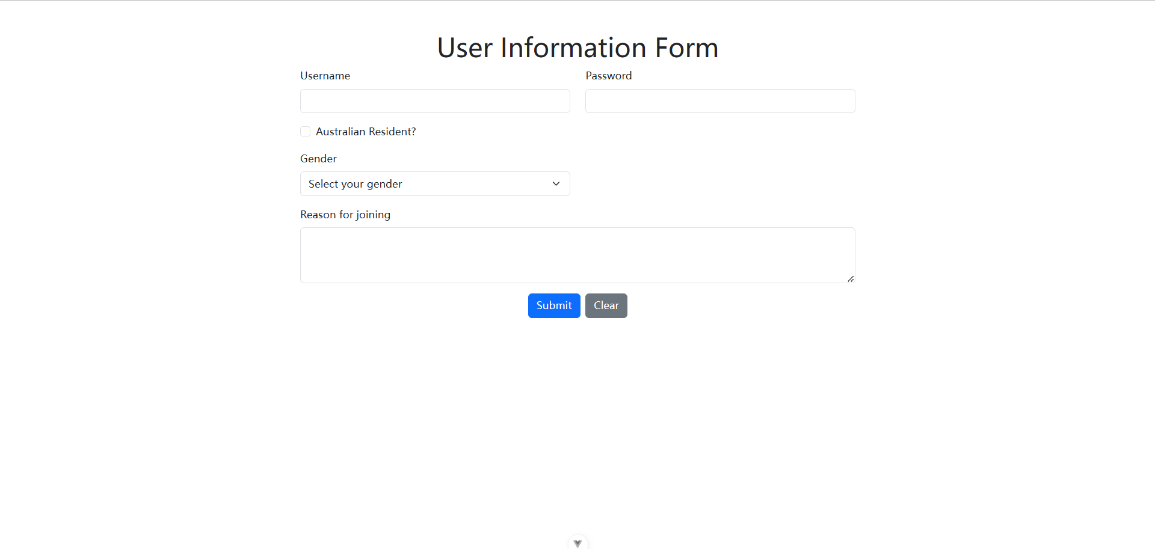

## Activity 6

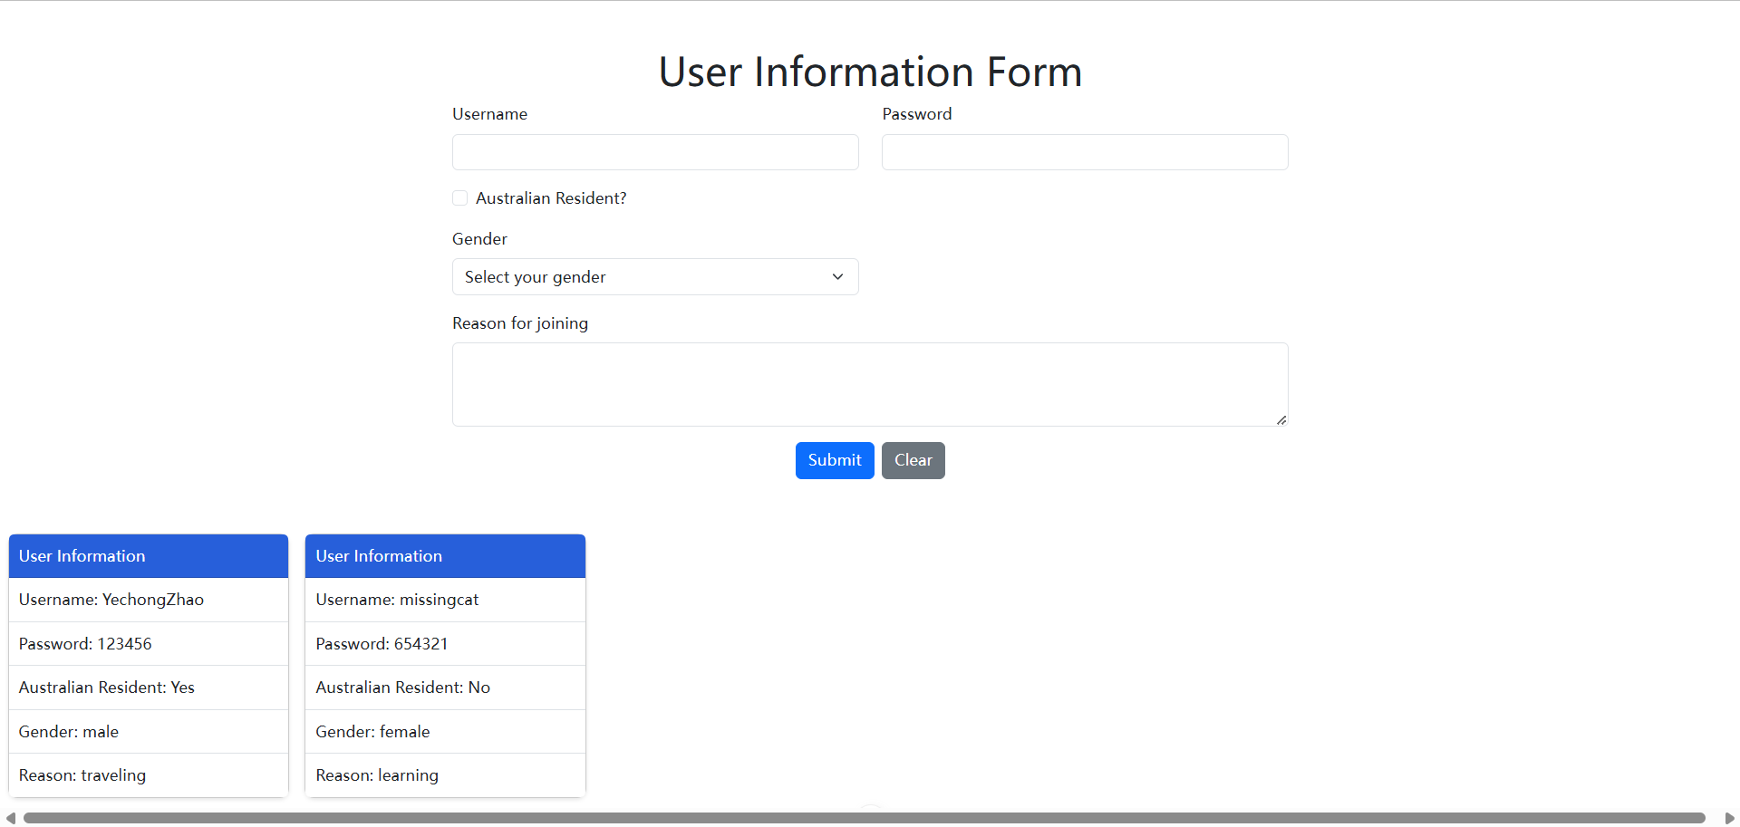

# EFOLIO TASK 3.2

## Screenshots of your front-end demonstrating the form support on different devices

### 900×630

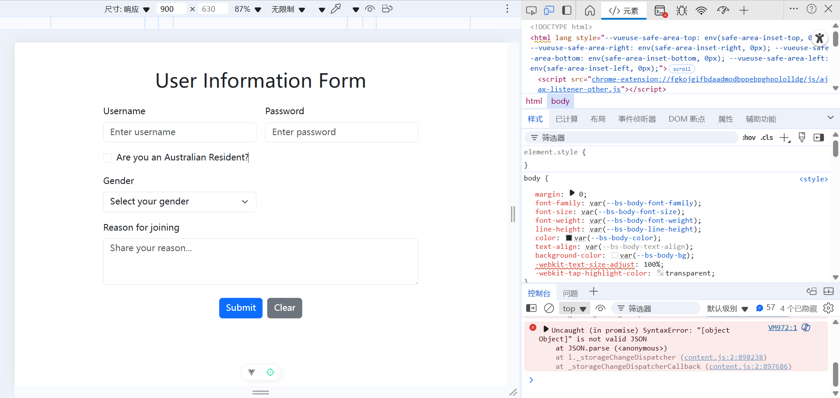

### 600×630

## 

**Screenshot of the code for implementing the Bootstrap's breakpoints**

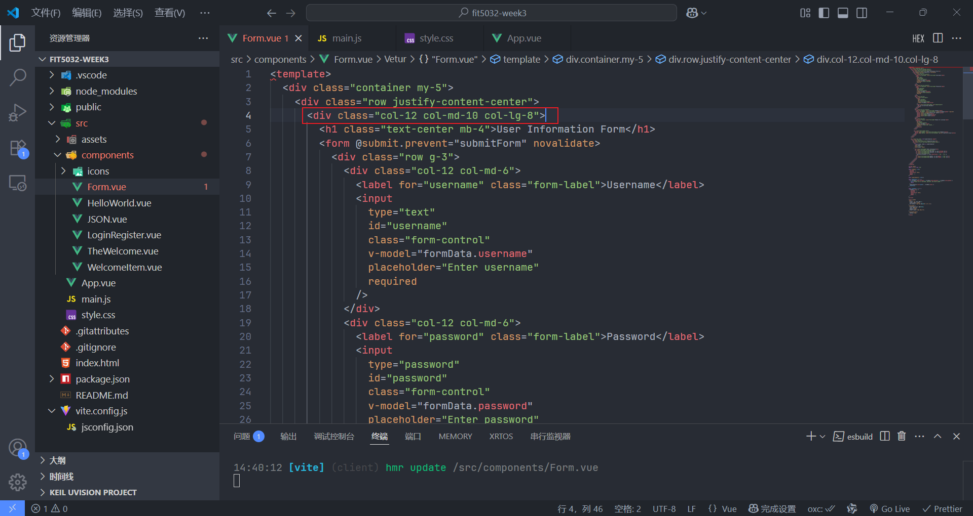

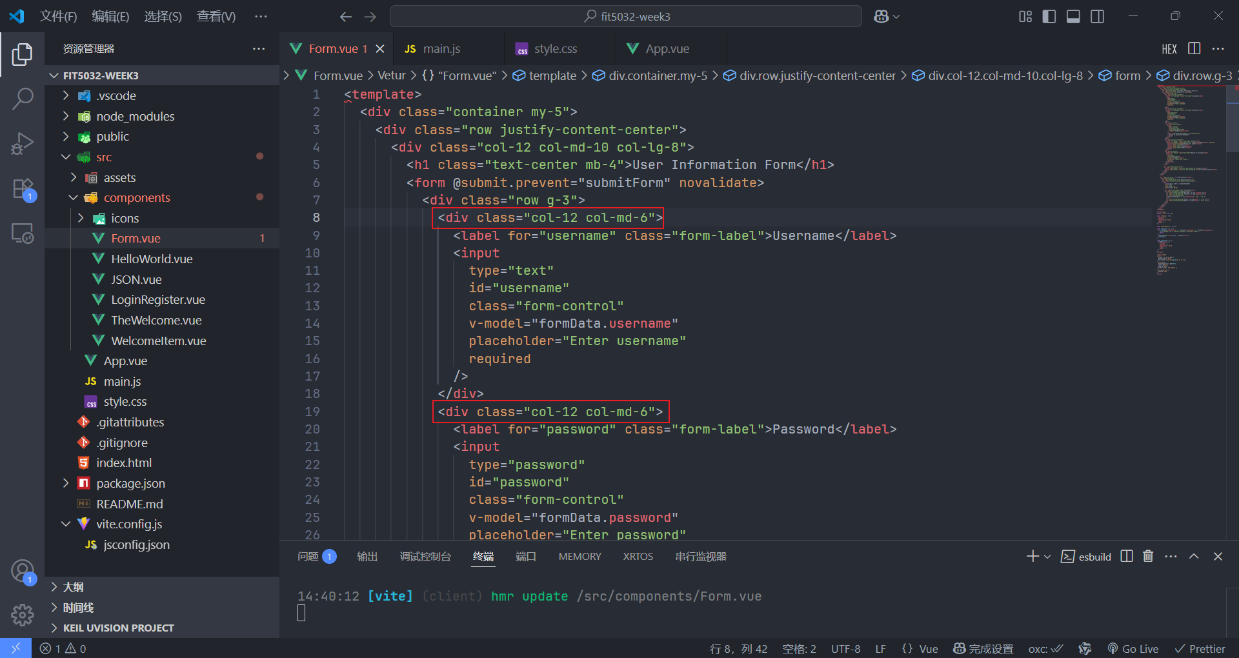

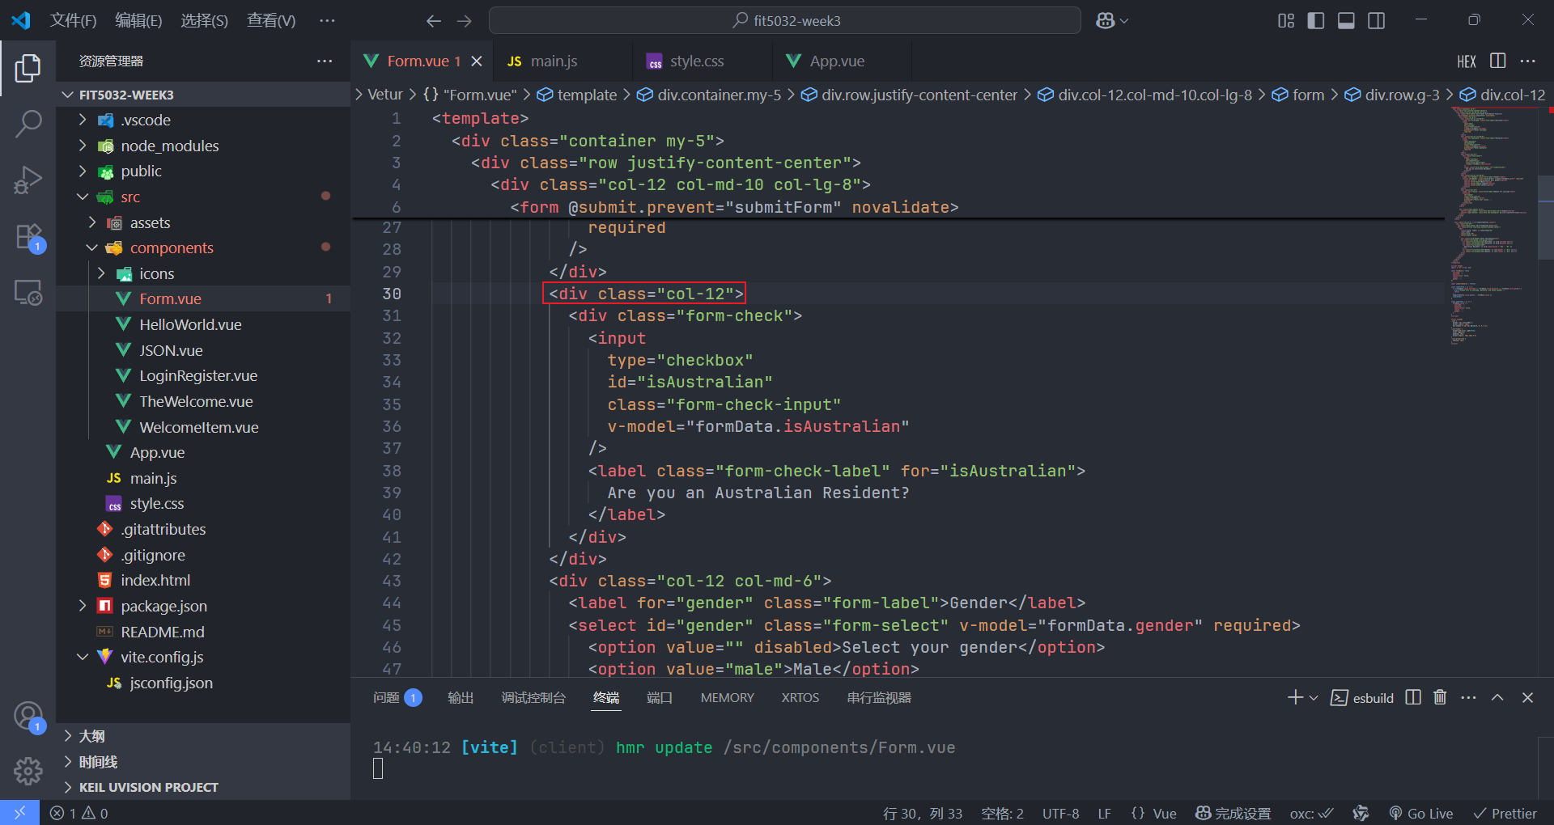

## Screenshot showing the GitHub commit history with your project update

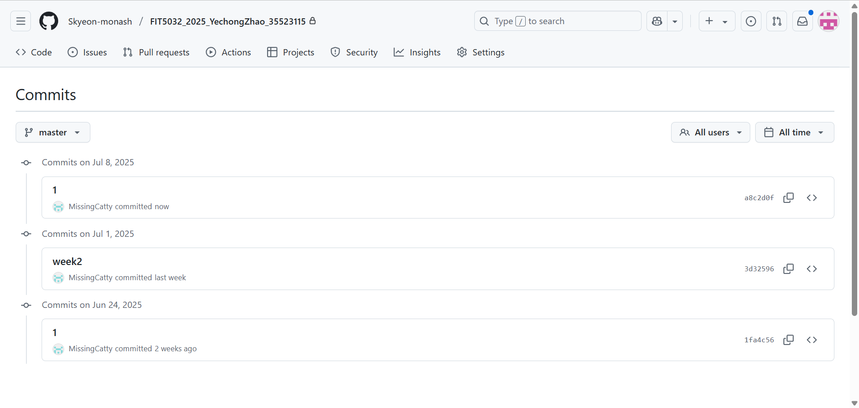

## Github URL

[Skyeon-monash/FIT5032_2025_YechongZhao_35523115](https://github.com/Skyeon-monash/FIT5032_2025_YechongZhao_35523115)