# EFOLIO TASK 3.1

## Activity 1

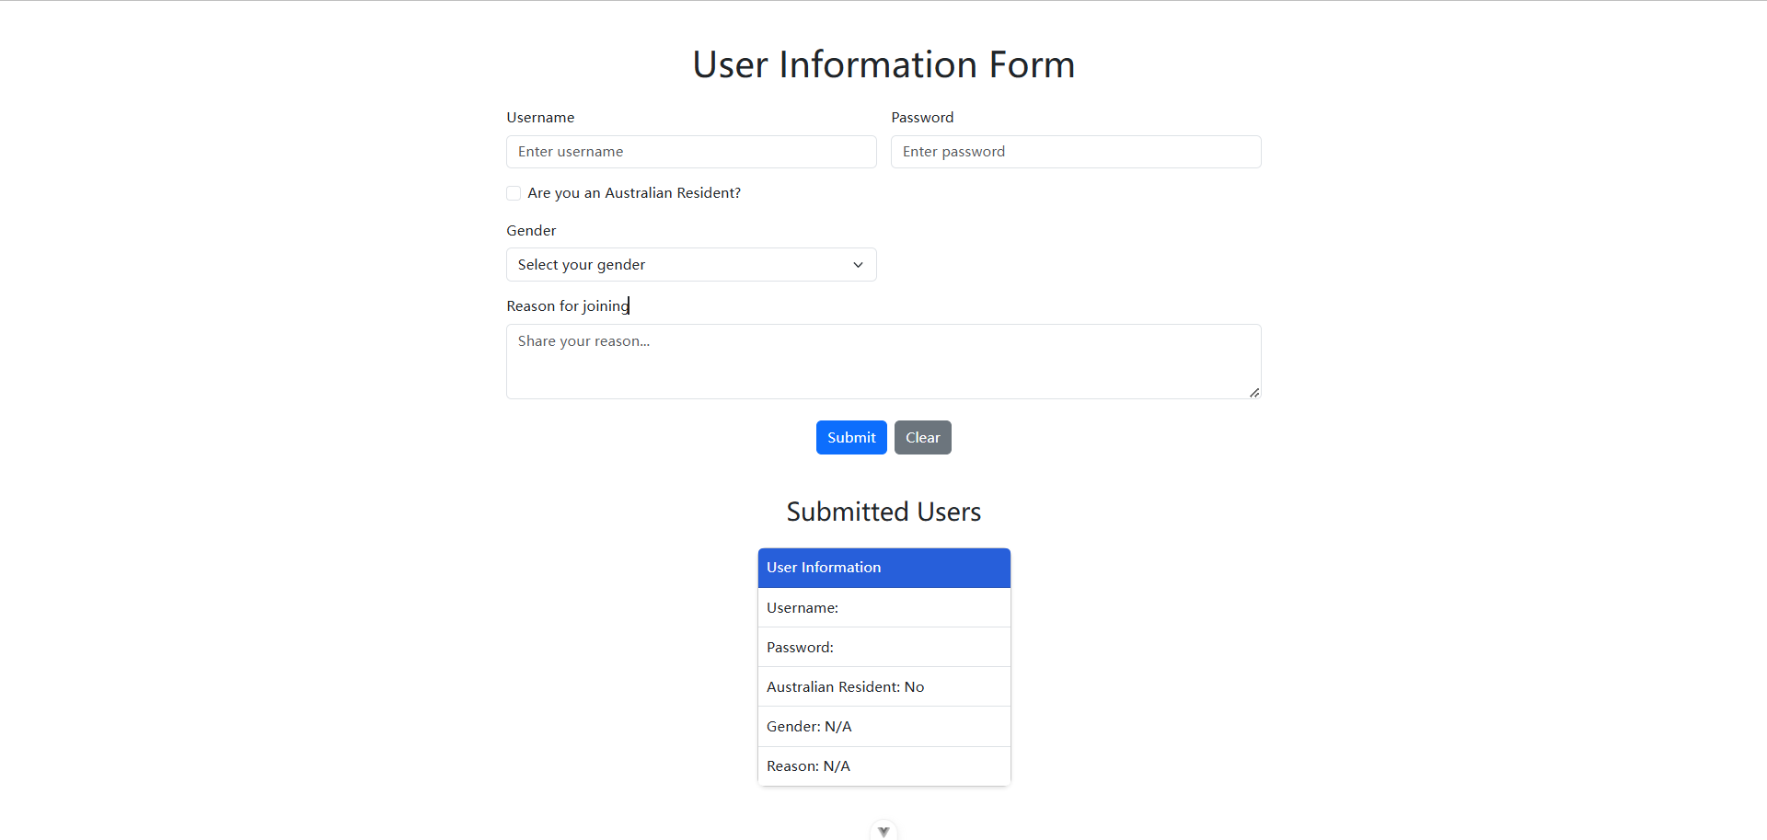

## Activity 2

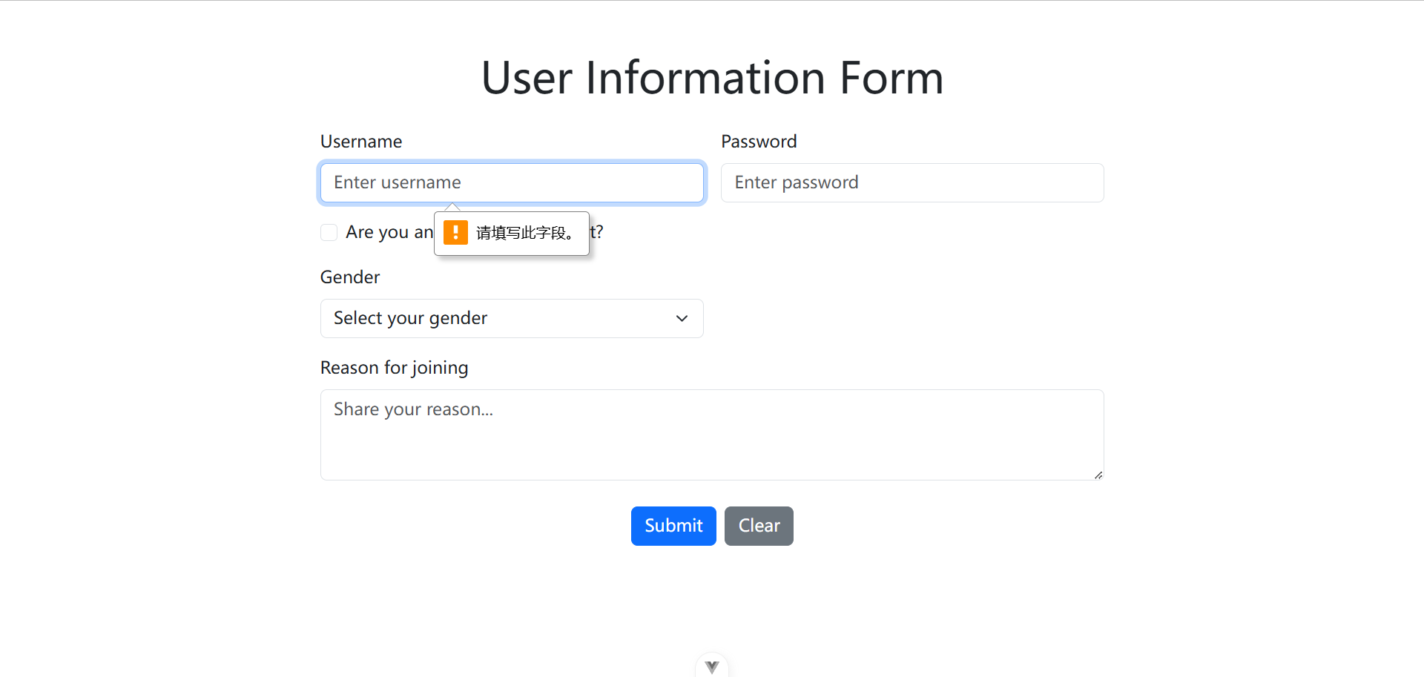

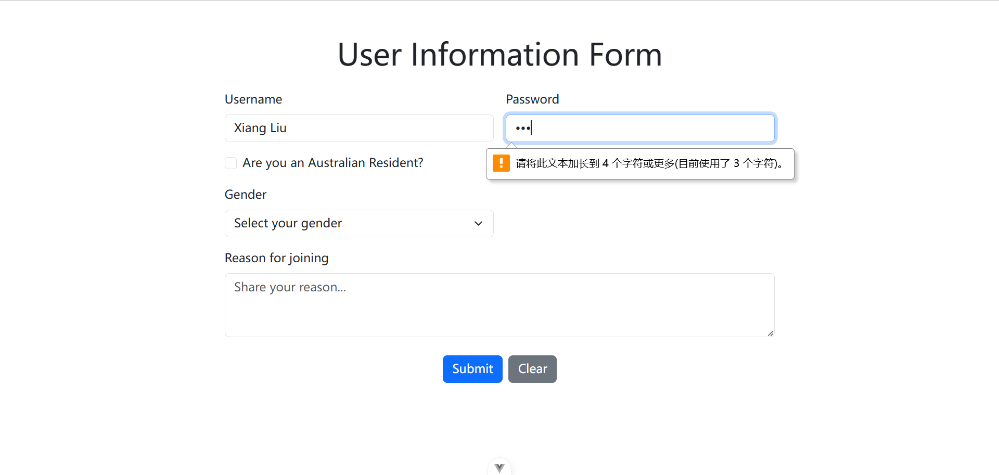

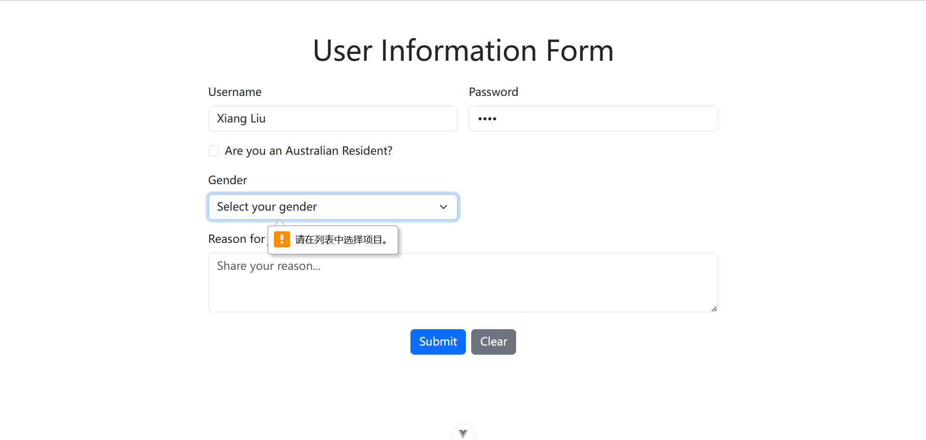

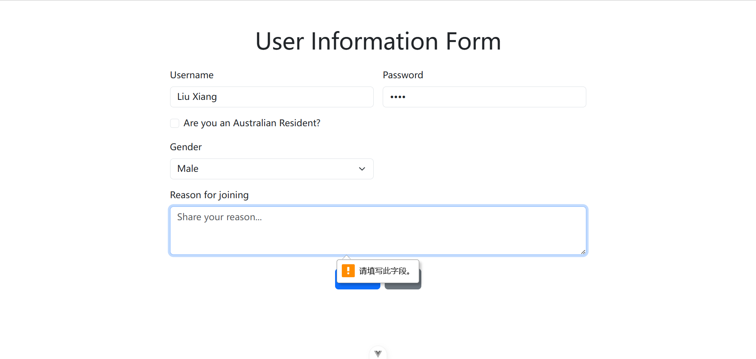

### Activity 3

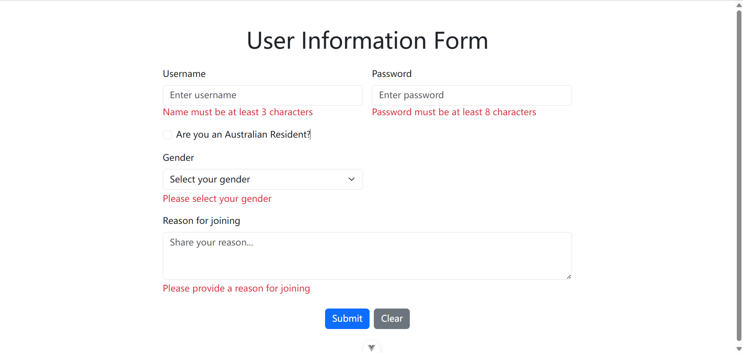

# EFOLIO TASK 3.2

**Screenshots of your front end demonstrating the form support on extra validations**



**A screenshot of your front end demonstrating a PrimeVue DataTable with submitted user information**

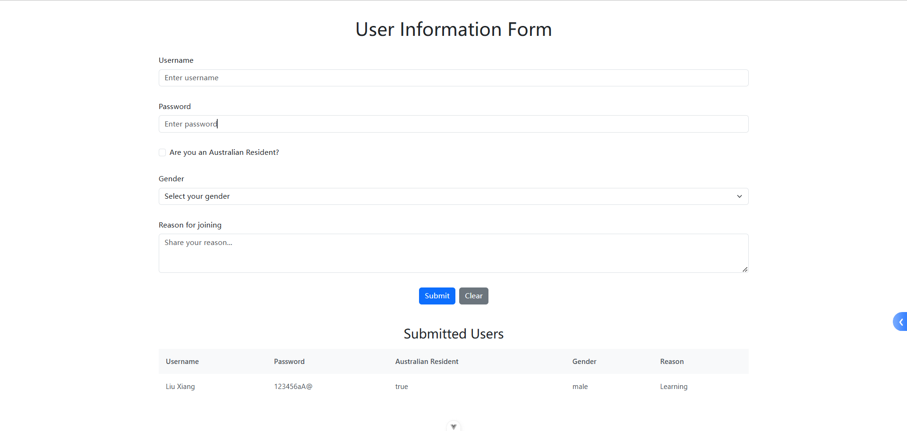

**A screenshot of the code for implementing extra validations and PrimeVue DataTable**

**Extra Validations**

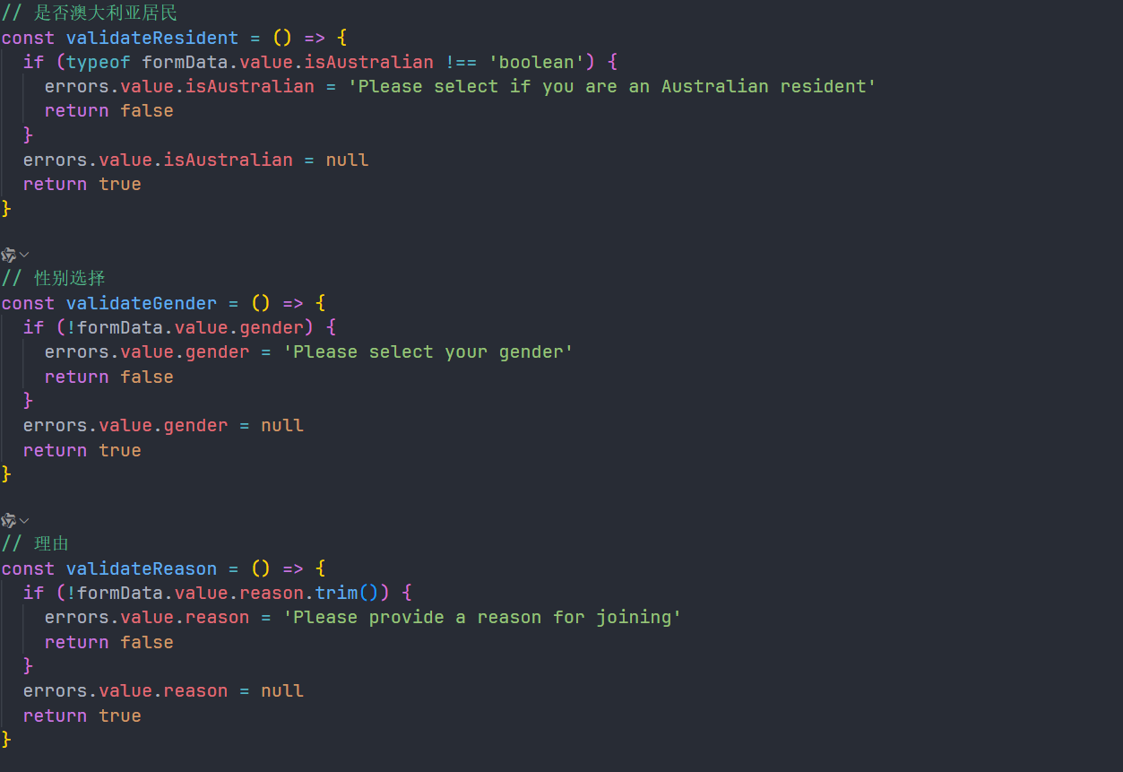

**DataTable**

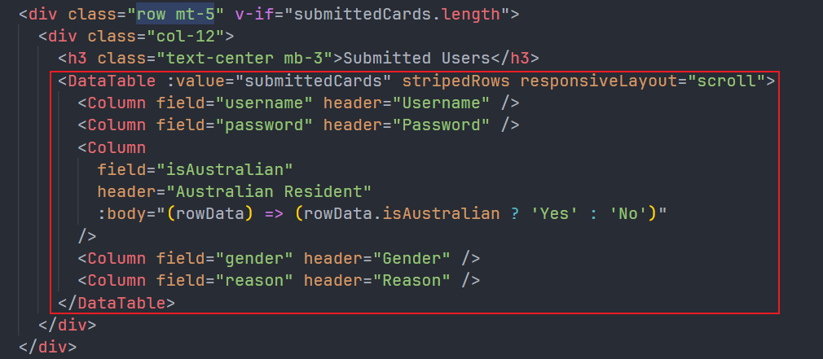

## A screenshot showing the GitHub commit history with your project update

## Github URL

[Skyeon-monash/FIT5032_2025_YechongZhao_35523115](https://github.com/Skyeon-monash/FIT5032_2025_YechongZhao_35523115)