# EFOLIO TASK 5.1

## Activity 1

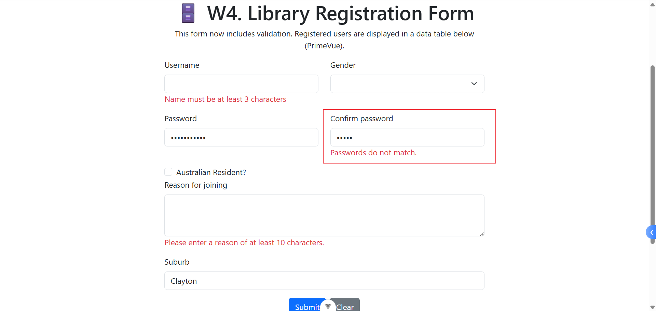

## Activity 2

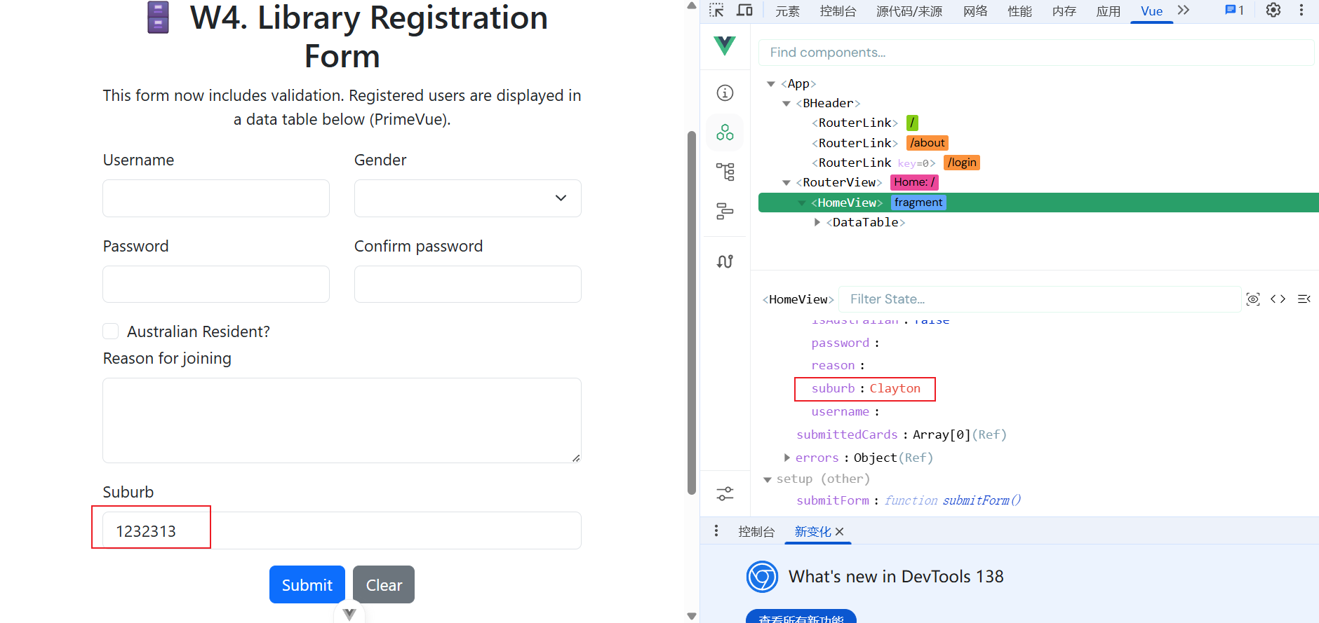

# EFOLIO TASK 5.2

**router/index.js**

import { createRouter, createWebHistory } from 'vue-router'

import HomeView from '../views/HomeView.vue'

import AboutView from '../views/AboutView.vue'

import LoginView from '../views/LoginView.vue'

import AccessDenied from '../views/AccessDenied.vue'

const routes = [

{ path: '/', name: 'Home', component: HomeView },

{ path: '/login', name: 'Login', component: LoginView },

{ path: '/access-denied', name: 'AccessDenied', component: AccessDenied },

{

path: '/about',

name: 'About',

component: AboutView,

meta: { requiresAuth: true }

}

]

const router = createRouter({

history: createWebHistory(),

routes

})

router.beforeEach((to, from, next) => {

const isAuthenticated = localStorage.getItem('isAuthenticated') === 'true'

if (to.meta.requiresAuth && !isAuthenticated) {

next('/access-denied') // 或 next('/login') 更严格

} else {

next()

}

})

export default router

**src/App.vue**

<script setup>

import JSONLab from './components/JSONLab.vue'

import BHeader from './components/BHeader.vue'

import LibraryRegistrationForm from './components/LibraryRegistrationForm.vue'

</script>

<template>

<div class="container">

<header>

<BHeader />

</header>

<main class="main-box">

<!-- <LibraryRegistrationForm /> -->

<!-- <JSONLab /> -->

<router-view></router-view>

</main>

</div>

</template>

<style scoped>

.container {

font-family: 'Segoe UI', Tahoma, Geneva, Verdana, sans-serif;

max-width: 80vw;

margin: 0 auto;

padding: 20px;

border-radius: 10px;

}

</style>

## src/views/HomeView.vue

<script setup>

import { ref } from 'vue'

import DataTable from 'primevue/datatable'

import Column from 'primevue/column'

const formData = ref({

username: '',

password: '',

comfirmPassword: '',

isAustralian: false,

reason: '',

gender: '',

suburb: 'Clayton'

})

const submittedCards = ref([])

const submitForm = () => {

validateName(true)

validatePassword(true)

if (!errors.value.username && !errors.value.password) {

submittedCards.value.push({ ...formData.value })

clearForm()

}

}

const clearForm = () => {

formData.value = {

username: '',

password: '',

isAustralian: false,

reason: '',

gender: ''

}

}

const errors = ref({

username: null,

password: null,

confirmPassword: null,

resident: null,

gender: null,

reason: null

})

const validateName = (blur) => {

if (formData.value.username.length < 3) {

if (blur) errors.value.username = 'Name must be at least 3 characters'

} else {

errors.value.username = null

}

}

const validatePassword = (blur) => {

const password = formData.value.password

const minLength = 8

const hasUppercase = /[A-Z]/.test(password)

const hasLowercase = /[a-z]/.test(password)

const hasNumber = /\d/.test(password)

const hasSpecialChar = /[!@#$%^&*(),.?":{}|<>]/.test(password)

if (password.length < minLength) {

if (blur) errors.value.password = `Password must be at least ${minLength} characters long.`

} else if (!hasUppercase) {

if (blur) errors.value.password = 'Password must contain at least one uppercase letter.'

} else if (!hasLowercase) {

if (blur) errors.value.password = 'Password must contain at least one lowercase letter.'

} else if (!hasNumber) {

if (blur) errors.value.password = 'Password must contain at least one number.'

} else if (!hasSpecialChar) {

if (blur) errors.value.password = 'Password must contain at least one special character.'

} else {

errors.value.password = null

}

}

/**

* Confirm password validation function that checks if the password and confirm password fields match.

* @param blur: boolean - If true, the function will display an error message if the passwords do not match.

*/

const validateConfirmPassword = (blur) => {

if (formData.value.password !== formData.value.confirmPassword) {

if (blur) errors.value.confirmPassword = 'Passwords do not match.'

} else {

errors.value.confirmPassword = null

}

}

const validateReason = (blur) => {

const reason = formData.value.reason.trim()

if (reason.length < 10) {

if (blur) errors.value.reason = 'Please enter a reason of at least 10 characters.'

return

}

if (reason.toLowerCase().includes('friend')) {

errors.value.reason = null

} else {

if (blur) errors.value.reason = null

}

}

</script>

<template>

<!-- 🗄️ W3. Library Registration Form -->

<div class="container mt-5">

<div class="row">

<div class="col-md-8 offset-md-2">

<h1 class="text-center">🗄️ W4. Library Registration Form</h1>

<p class="text-center">

This form now includes validation. Registered users are displayed in a data table below

(PrimeVue).

</p>

<form @submit.prevent="submitForm">

<div class="row mb-3">

<div class="col-md-6 col-sm-6">

<label for="username" class="form-label">Username</label>

<input type="text" class="form-control" id="username" @blur="() => validateName(true)"

@input="() => validateName(false)" v-model="formData.username" />

<div v-if="errors.username" class="text-danger">{{ errors.username }}</div>

</div>

<div class="col-md-6 col-sm-6">

<label for="gender" class="form-label">Gender</label>

<select class="form-select" id="gender" v-model="formData.gender" required>

<option value="male">Male</option>

<option value="female">Female</option>

<option value="other">Other</option>

</select>

</div>

</div>

<div class="row mb-3">

<div class="col-md-6 col-sm-6">

<label for="password" class="form-label">Password</label>

<input type="password" class="form-control" id="password" @blur="() => validatePassword(true)"

@input="() => validatePassword(false)" v-model="formData.password" />

<div v-if="errors.password" class="text-danger">{{ errors.password }}</div>

</div>

<div class="col-md-6 col-sm-6">

<label for="confirm-password" class="form-label">Confirm password</label>

<input type="password" class="form-control" id="confirm-password" v-model="formData.confirmPassword"

@blur="() => validateConfirmPassword(true)" />

<div v-if="errors.confirmPassword" class="text-danger">{{ errors.confirmPassword }}</div>

</div>

</div>

<div class="col-md-6 col-sm-6">

<div class="form-check">

<input type="checkbox" class="form-check-input" id="isAustralian" v-model="formData.isAustralian" />

<label class="form-check-label" for="isAustralian">Australian Resident?</label>

</div>

</div>

<div class="mb-3">

<label for="reason" class="form-label">Reason for joining</label>

<textarea class="form-control" id="reason" rows="3" v-model="formData.reason"

@blur="() => validateReason(true)" @input="() => validateReason(false)"></textarea>

<div v-if="errors.reason" class="text-danger">{{ errors.reason }}</div>

<div v-else-if="formData.reason.toLowerCase().includes('friend')" class="text-success">

Great to have a friend.

</div>

</div>

<div class="mb-3">

<label for="suburb" class="form-label">Suburb</label>

<input type="text" class="form-control" id="suburb" v-bind:value="formData.suburb" />

</div>

<div class="text-center">

<button type="submit" class="btn btn-primary me-2">Submit</button>

<button type="button" class="btn btn-secondary" @click="clearForm">Clear</button>

</div>

</form>

</div>

</div>

</div>

<div class="row mt-5">

<h4>This is a Primevue Datatable.</h4>

<DataTable :value="submittedCards" tableStyle="min-width: 50rem">

<Column field="username" header="Username"></Column>

<Column field="password" header="Password"></Column>

<Column field="isAustralian" header="Australian Resident"></Column>

<Column field="gender" header="Gender"></Column>

<Column field="reason" header="Reason"></Column>

</DataTable>

</div>

<div class="row mt-5" v-if="submittedCards.length">

<div class="d-flex flex-wrap justify-content-start">

<div v-for="(card, index) in submittedCards" :key="index" class="card m-2" style="width: 18rem">

<div class="card-header">User Information</div>

<ul class="list-group list-group-flush">

<li class="list-group-item">Username: {{ card.username }}</li>

<li class="list-group-item">Password: {{ card.password }}</li>

<li class="list-group-item">

Australian Resident: {{ card.isAustralian ? 'Yes' : 'No' }}

</li>

<li class="list-group-item">Gender: {{ card.gender }}</li>

<li class="list-group-item">Reason: {{ card.reason }}</li>

</ul>

</div>

</div>

</div>

</template>

<style scoped>

.container {

font-family: 'Segoe UI', Tahoma, Geneva, Verdana, sans-serif;

max-width: 80vw;

margin: 0 auto;

padding: 20px;

/* background-color: #e0bfbf; */

border-radius: 10px;

}

/* Class selectors */

.form {

text-align: center;

margin-top: 50px;

}

/* ID selectors */

#username:focus,

#password:focus,

#isAustralian:focus,

.card {

border: 1px solid #ccc;

border-radius: 10px;

box-shadow: 0 2px 4px rgba(0, 0, 0, 0.1);

}

.card-header {

background-color: #275fda;

color: white;

padding: 10px;

border-radius: 10px 10px 0 0;

}

.list-group-item {

padding: 10px;

}

</style>

## Screenshot of App in Localhost (browser) open on Home page

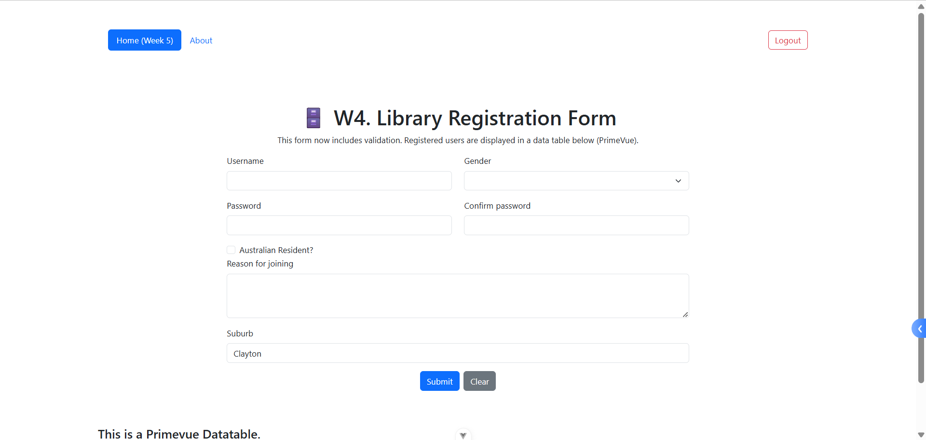

## Screenshot of App in Localhost (browser) open on About page

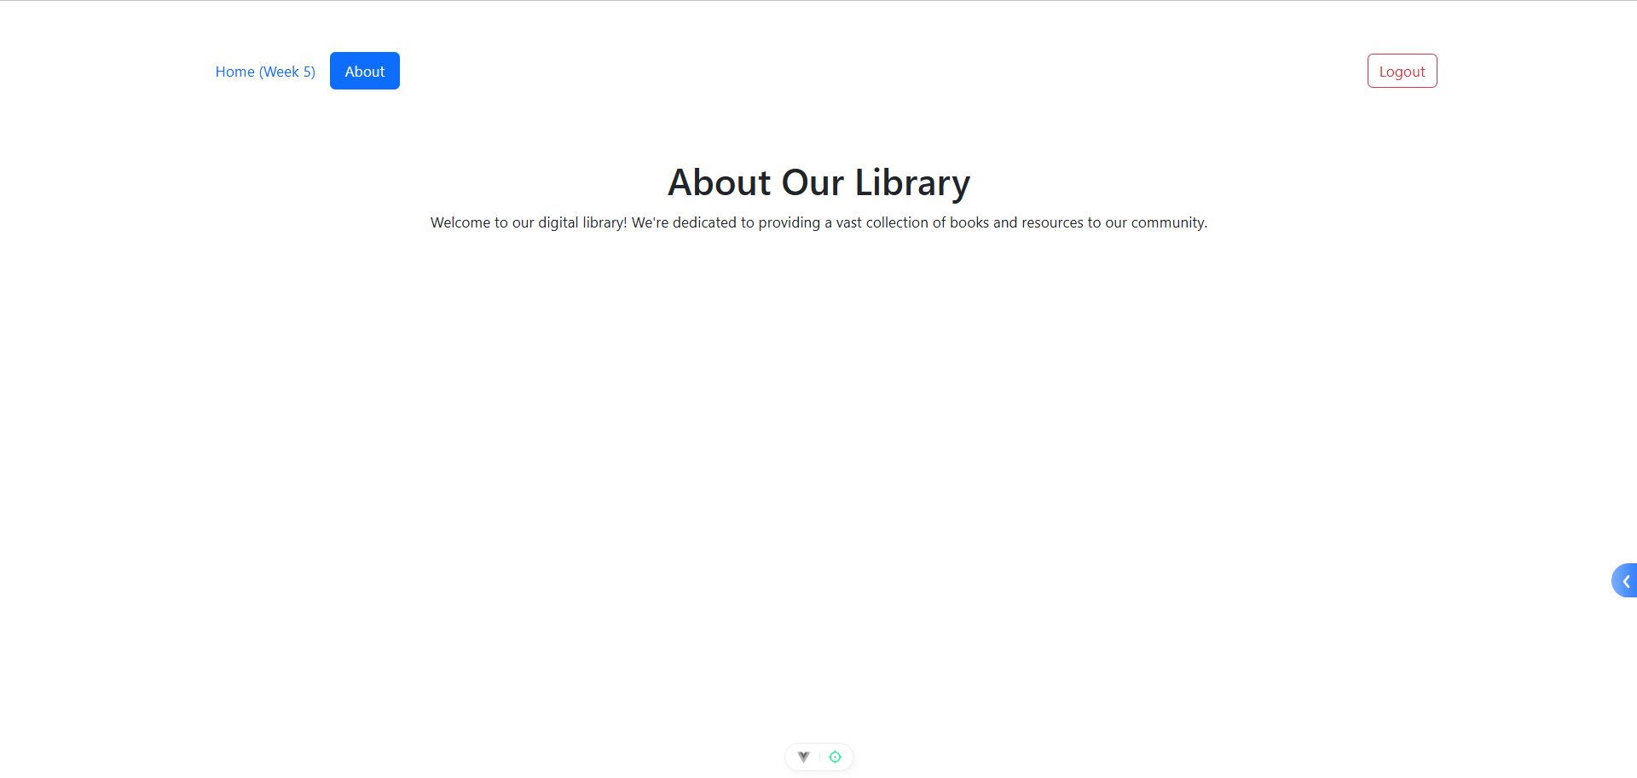

## Screenshots of Custom Routing



## Github URL

[Skyeon-monash/FIT5032_2025_YechongZhao_35523115](https://github.com/Skyeon-monash/FIT5032_2025_YechongZhao_35523115)