EFOLIO TASK 11.1

Screenshot Set1
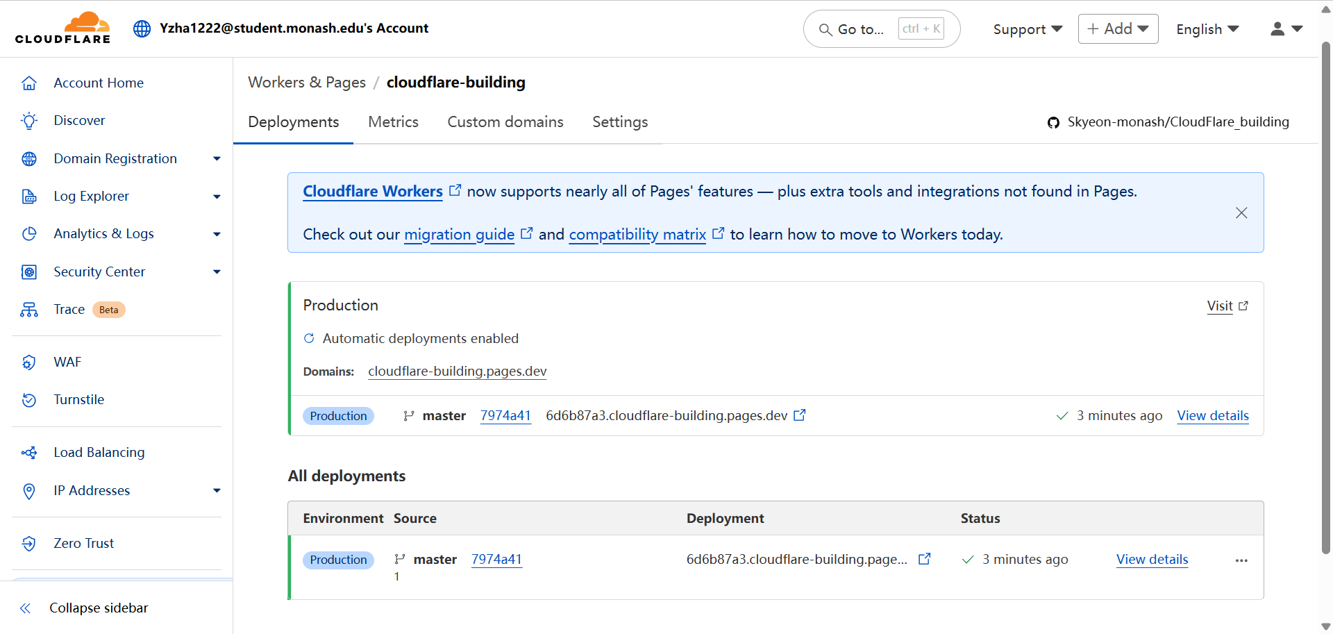

EFOLIO TASK 11.2

Screenshot Set1
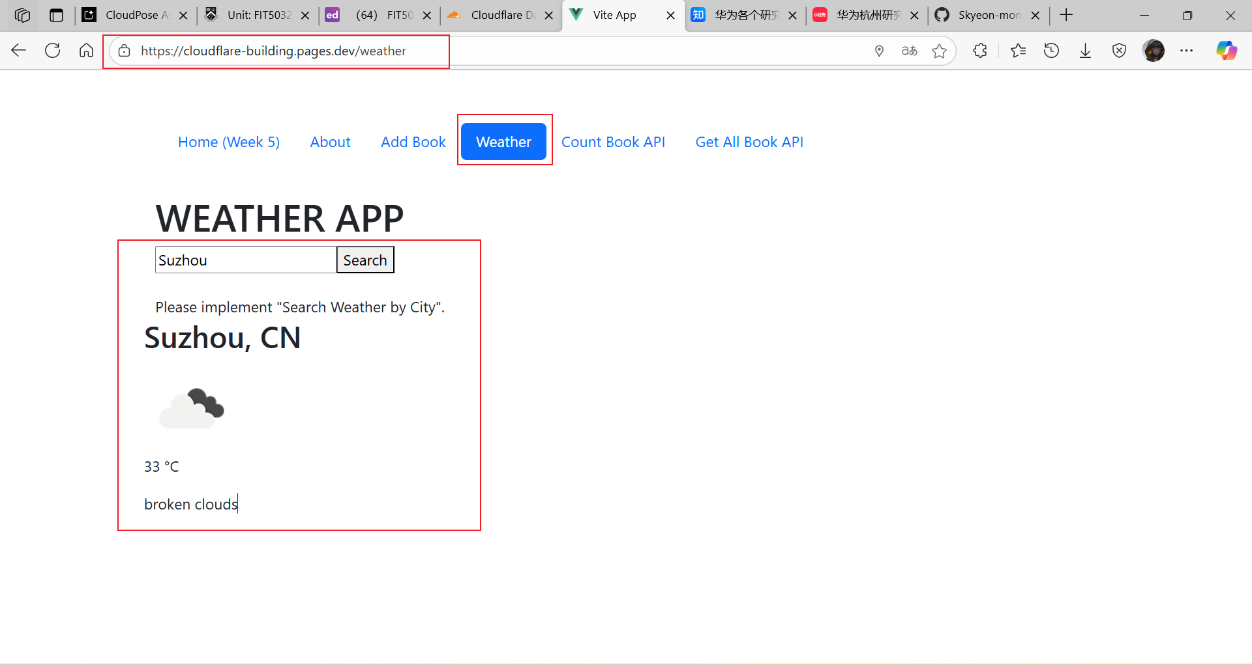

Github URL
Skyeon-monash/CloudFlare_building

