EFOLIO TASK 11.1

Screenshot Set1
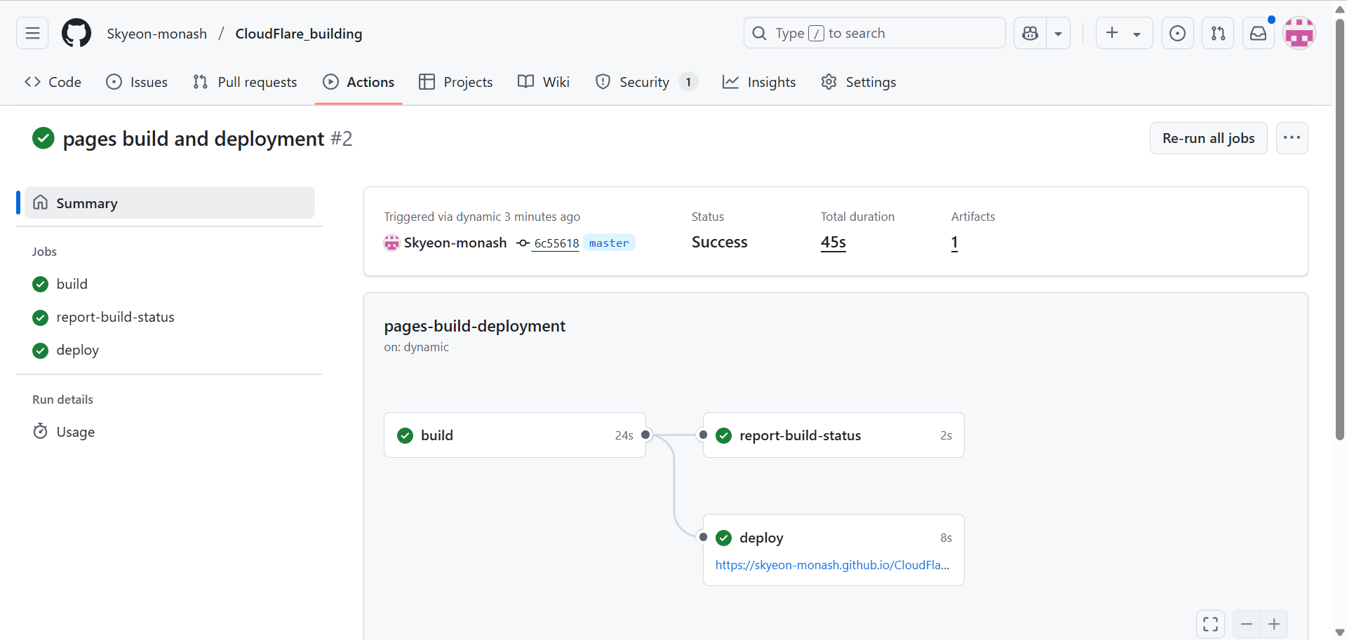
Deployed successfully, but appears blank
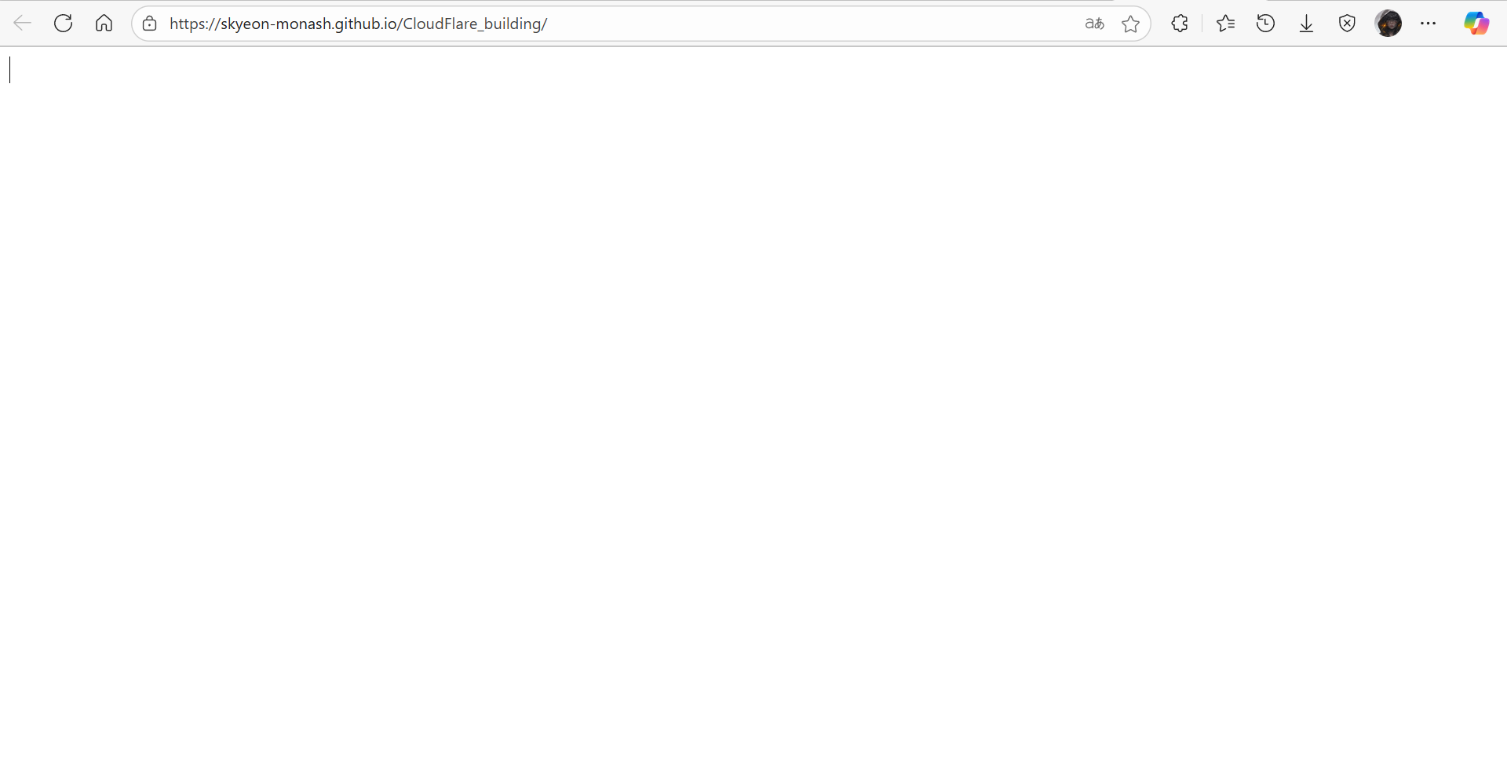

EFOLIO TASK 11.2
- Perform research on Time To First Byte (TTFB) and share how to reduce TTFB

Time To First Byte (TTFB) measures the time from a user's request to the first byte of the response, and it can be reduced by using faster hosting or a CDN, optimizing server-side processing (like reducing database queries and enabling caching), choosing high-performance server software (such as Nginx), improving TLS configuration, enabling HTTP/2, and regularly monitoring performance to identify and fix bottlenecks.

- Perform research on Hotlink and share how to avoid your site being hotlinked

Hotlinking is when another website directly links to files (usually images, videos, or other media) hosted on your server, using your bandwidth without permission. This can slow down your site, increase hosting costs, and violate your content rights.
To prevent hotlinking, the most effective method is to configure your web server to block external domains from directly accessing your media files. On Apache servers, you can use .htaccess rules to deny requests that don't originate from your own domain. Nginx users can achieve similar protection through the valid_referers directive. Another approach is to rename or move files and use signed URLs or tokens that expire after a short time, especially for high-value content. Hosting media on a CDN often comes with built-in hotlink protection options. Additionally, you can watermark your images or use JavaScript-based lazy loading to obscure the actual file paths, making unauthorized reuse more difficult.

Github URL
Skyeon-monash/CloudFlare_building

