**Yan Feng 281679**

**Q1.**

Consider a vocal tract of length 15cm, and a sound wave traveling through it at 340 m/s.

How many discrete sampling periods it does take for the whole travel, assuming that the sampling rate is 48 kHz?

$$n=15×{10}^{-2}÷\left(340÷48×{10}^{-3}\right)=21.176≈22$$

**Q2.**

What is the reflection coefficient k when a sound passes from section with area 1cm^2 to 2cm^2?

$$S_{1}=1 {cm}^{2}$$

$$S_{2}=2 {cm}^{2}$$

$$k=\frac{S_{1}-S_{2}}{S_{1}+S_{2}}=\frac{1-2}{1+2}=-\frac{1}{3}$$

**Q3**

Add the figures with MFCCs for both audio files in your report.

1. The picture of MFCCs for “gtr55.wav”

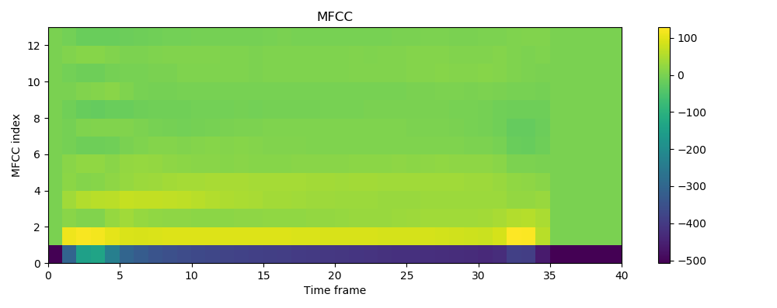

1. The picture of MFCCs for “oboe59.wav”

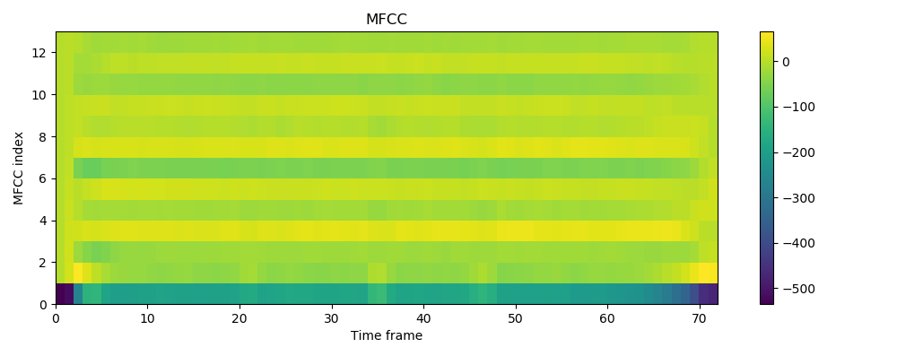

**Q4.**

Add the figures with spectrogram and pitches for both audio files in your report.

What is the average pitch for both signals?

1. The picture of spectrogram and pitches for “gtr55.wav”

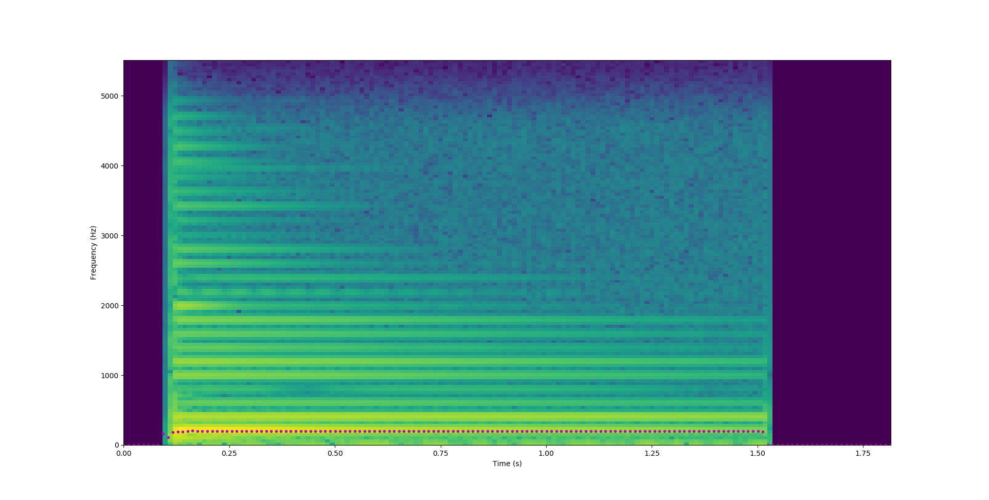 The average pitch for “gtr55.wav”: 197.67476

1. The picture of spectrogram and pitches for “oboe59.wav”

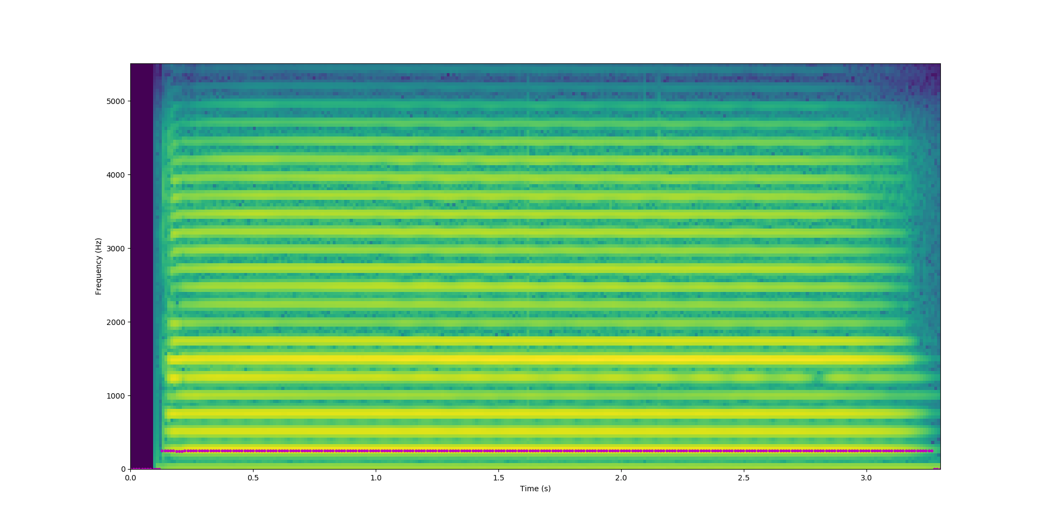

The average pitch for “oboe59.wav”: 248.30609