
1a. Result is as given for activation linear function where l(z) = a.z + b. Assuming b = 0, l(z) = a.z where given input (0.5, 1)
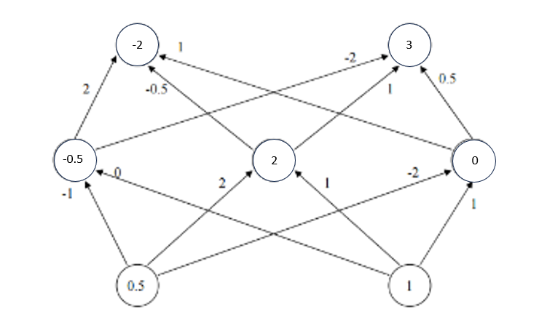
1b. Result is as given for activation linear function where l(z) = a.z + b. Assuming b = 0, l(z) = a.z where given input (1,2)
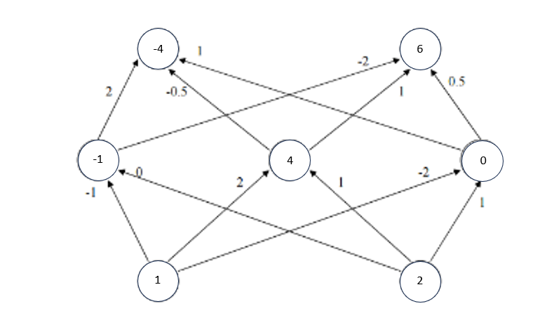
We need to repeat the computation because values in the “hidden” layer is calculated based on initial values and initial values has changed since the activation function is linear. Therefore, the “hidden” layer values will be different as well so we must recalculate.
1c. Result is as given for activation Sigmoid function where s(z) = 1 / (1 + e^{-z}) where given input (0.5, 1)
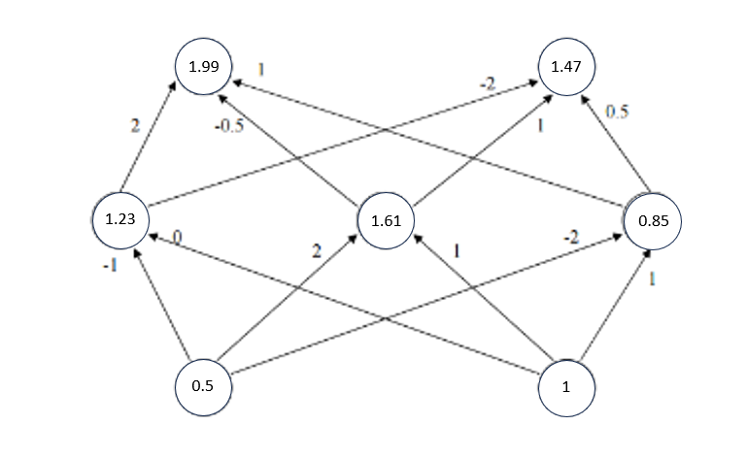

1d. 1c. Result is as given for activation Sigmoid function where s(z) = 1 / (1 + e^{-z}) where given input (1, 2)
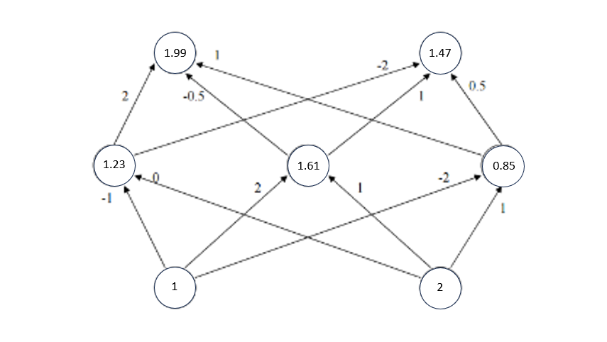
We do not need to repeat the calculation because the activation function of Sigmoid function calculates values based on the weights between 2 nodes. However, the weights don’t change despite the initial values changing so we don’t need to recalculate.

2. https://github.com/Skyhorizon2021/CS_4210/blob/main/Assignment4/perceptron.py

3. https://github.com/Skyhorizon2021/CS_4210/blob/main/Assignment4/deep_learning.py

4. Dataset:
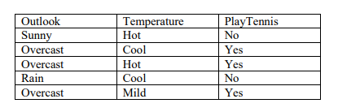
Representation:
- Outlook <Sunny, Overcast, Rain>
- Temperature <Hot, Mild, Cool>
First generation:
 |  | Prediction | Fitness | Place Ranking
C1 | 1001001 | XXXOX | 0.2 | 4th
C2 | 0100101 | OXXOO | 0.6 | 2nd
C3 | 1011000 | OOOXO | 0.8 | 1st
C4 | 1101100 | OOXXX | 0.4 | 3rd

Crossover C1 and C3 with mask 1110000 to produce two offspring of 1001000 and 1011001. These two offspring will replace C1 and C4 during the second generation since C1 and C4 has the lowest fitness.
C1 = 1001000; C2 = 0100101; C3 = 1011000; C4 = 1011001

Second generation:
 |  | Prediction | Fitness | Place Ranking
C1 | 1001000 | OOOXO | 0.8 | 1st
C2 | 0100101 | OXXOO | 0.6 | 2nd
C3 | 1011000 | OOOXO | 0.8 | 1st
C4 | 1011001 | XXXOX | 0.2 | 3rd

Crossover C1 and C2 with mask 0001100 to produce two offspring of 1000100 and 0101001. These two offspring will replace C2 and C4 for worst performance.
C1 = 1001000; C2 = 1000100; C3 = 1011000; C4 = 0101001
Applying mutation on C3
 |  | Mutation | Prediction | Fitness | Place Ranking
C1 | 1001000 | X | OOOXO | 0.8 | 2nd
C2 | 1000100 | X | XOOXO | 0.6 | 3rd
C3 | 1011000 | 1011010 | OOOOO | 1.0 | 1st
C4 | 0101001 | X | OXOOX | 0.6 | 3rd

Final Answer: C3 = 1011010 with accuracy = 1.0

5. Parameters given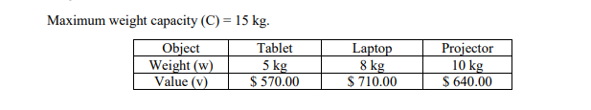
Representation:
- Inclusion <1st, 2nd, 3rd>

First generation:
 |  | Total weight (kg) | Fitness (values)
C1 | 000 | 0 | 0 (4th)
C2 | 001 | 10 | 640 (2nd)
C3 | 010 | 8 | 710 (1st)
C4 | 100 | 5 | 570 (3rd)

Crossover C2 and C4 with mask 110 to produce 101 and 000.
Crossover C2 and C3 with mask 110 to produce 011 and 000. However, 011 exceeds limit so we must use 010
C1 = 101; C2 = 000; C3 = 010; C4 = 000

Second generation:
 |  | Total weight (kg) | Fitness (values)
C1 | 101 | 15 | 1210 (1st)
C2 | 000 | 0 | 0 (3rd)
C3 | 010 | 8 | 710 (2nd)
C4 | 000 | 0 | 0 (4th)

Crossover C1 and C1 with mask 100 to produce 101 and 101
Crossover C1 and C3 with mask 100 to produce 110 and 001.
C1 = 101; C2 = 101; C3 = 110; C4 = 001

Applying mutation on 101
 |  | Total weight (kg) | Fitness (values)
C1 | 100 | 5 | 570 (3rd)
C2 | 100 | 5 | 570 (3rd)
C3 | 110 | 13 | 1280 (1st)
C4 | 001 | 10 | 640 (2nd)

Final Answer: C3 = 110 with max value of 1280 dollars and weight = 13 kg

