
- Accuracy
  - TP = 2, 7
TN = 3, 4, 6, 8
FP = 5
FN = 1
  - Precision = TP / (TP + FP) = 2 / (2+1) = 0.667 or 66.7%
Recall = TP / (TP + FN) = 2 / (2 + 1) = 0.667 or 66.7%
F1 = 2*0.667*0.667/ (0.667 + 0.667) = 0.667

- Source Code – https://github.com/Skyhorizon2021/CS_4210/blob/main/Assignment2/decision_tree_2.py

Output Screenshot
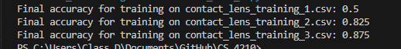

3a. 1NN Algorithm
Instance Coordinate | Predicted Class | True Class
2,1 | + | -
4,1 | + | -
3,2 | + | +
0,3 | - | -
3,3 | + | +
4,3 | + | +
1,4 | + | -
2,4 | - | +
4,4 | + | +
0,5 | - | -
Error rate = 4/10 = 40 %
3b. 3NN Algorithm
Instance Coordinate | Predicted Class | True Class
2,1 | + | -
4,1 | + | -
3,2 | + | +
0,3 | - | -
3,3 | + | +
4,3 | + | +
1,4 | - | -
2,4 | + | +
4,4 | + | +
0,5 | - | -
Error rate = 2/10 = 20%
3c. 9NN Algorithm
Instance Coordinate | Predicted Class | True Class
2,1 | + | -
4,1 | + | -
3,2 | - | +
0,3 | + | -
3,3 | - | +
4,3 | - | +
1,4 | + | -
2,4 | - | +
4,4 | - | +
0,5 | + | -
Error rate = 10 / 10 = 100%

3d. Decision boundary learned by 1NN algorithm
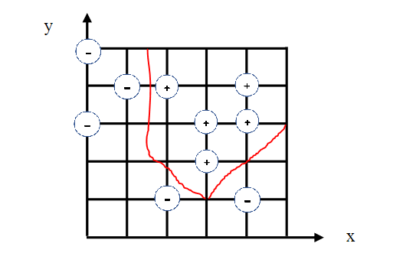

3e. Source Code - https://github.com/Skyhorizon2021/CS_4210/blob/main/Assignment2/knn.py
Output Screenshot
- 3NN Strategy
ID | Red | Green | Blue | Class | Distance to #10
1 | 220 | 20 | 60 | 1 | 196.67
2 | 255 | 99 | 21 | 1 | 274.35
3 | 250 | 128 | 14 | 1 | 281.21
4 | 144 | 238 | 144 | 2 | 313.23
5 | 107 | 142 | 35 | 2 | 181.21
6 | 46 | 139 | 87 | 2 | 170.31
7 | 64 | 224 | 208 | 3 | 312.31
8 | 176 | 224 | 23 | 3 | 285.80
9 | 100 | 149 | 237 | 3 | 297.27
10 | 154 | 205 | 50 | 2 | 0

Distance Calculations
D(1,10) = √(220 – 154)² + (20 – 205)² + (60 – 50)² = 196.67
D(2,10) = √(225 – 154)² + (99 – 205)² + (21 – 50)² = 274.35
D(3,10) = √(250 – 154)² + (128 – 205)² + (14 – 50)² = 281.21
D(4,10) = √(144 – 154)² + (238 – 205)² + (144 – 50)² = 313.23
D(5,10) = √(107 – 154)² + (142 – 205)² + (35 – 50)² = 181.21
D(6,10) = √(46 – 154)² + (139 – 205)² + (87 – 50)² = 170.31
D(7,10) = √(64 – 154)² + (224– 205)² + (208 – 50)² = 312.31
D(8,10) = √(176 – 154)² + (224 – 205)² + (23 – 50)² = 285.80
D(9,10) = √(100 – 154)² + (149 – 205)² + (237 – 50)² = 297.27

The 3 nearest neighbors’ classes are one 1, and two 2. Therefore, using the 3NN strategy, class of instance #10 will be 2.
5a.
P (PlayTennis= No | (Outlook = Sunny, Temperature = Mild, Humidity = Normal, Wind = Weak):
P(Sunny|PlayTennis = No) * P(Mild|PlayTennis = No) * P(Normal|PlayTennis = No) * P(Weak|PlayTennis = No) * P(PlayTennis = No) => 3/5 * 2/5 * 1/5 * 2/5 * 5/14 = 0.007

P (PlayTennis= Yes | (Outlook = Sunny, Temperature = Mild, Humidity = Normal, Wind = Weak):
P(Sunny|PlayTennis = Yes) * P(Mild|PlayTennis = Yes) * P(Normal|PlayTennis = Yes) * P(Weak|PlayTennis = Yes) * P(PlayTennis = Yes) => 2/9 * 4/9 * 6/9 * 6/9 * 9/14 = 0.028

Normalization:
P (PlayTennis= No | (Outlook = Sunny, Temperature = Mild, Humidity = Normal, Wind = Weak)
- 0.007 / (0.007 + 0.028) = 0.2
P (PlayTennis= Yes| (Outlook = Sunny, Temperature = Mild, Humidity = Normal, Wind =Weak):
- 0.028 / (0.007 + 0.028) = 0.8

The most probable classification is Yes for PlayTennis

5b. Source Code - https://github.com/Skyhorizon2021/CS_4210/blob/main/Assignment2/naive_bayes.py
Screenshot Output
