**CS 4310 Operating Systems Exam 2**

**Max: 200 points (12/12/2024)**

Name: Loc Nguyen

***Read these instructions before proceeding***.

* Closed book. Closed notes. You can use calculator.
* You have 110 minutes to complete this exam.
* *Important Notes:*

o

*Box your answers.*

* + *No questions will be answered during the exam period about the exam questions. Write down your assumptions and answer the best that you can.*
  + *Just in case you have trouble of submitting your exam here @Canvas, alternative way is to submit your completed exam to Prof. Young by emailing*

[*gsyoung@cpp.edu*](mailto:gsyoung@cpp.edu)

* You need to submit your completed exam paper in ***one PDF file***. Two popular ways that students work on the exam are:
  + (1) Print out the exam paper. Write your answers on the exam paper. Scan your completed exam papers or take photos of them. Then turn **in *one PDF file*** here @ *Canvas*.
  + (2) Read the exam from the computer screen and answer questions on your own white papers (number your answers). Scan your exam answers or take photos of them. Then turn in ***one PDF file*** here @ *Canvas*.
* Answer the problems on the blank spaces provided for each problem.

|  |  |  |  |  |  |
| --- | --- | --- | --- | --- | --- |
| Q.#1  (40) | Q.#2  (40) | Q.#3  (40) | Q.#4  (40) | Q.#5  (40) | Total  (200) |
|  |  |  |  |  |  |

# (40 points) Fill in the blanks & short answer

* 1. (4 pts) Files whose bytes or records can be read in any order are called

**Random** access files.

* 1. (4 pts) When the computer is booted, the BIOS reads in and executes Section 0 of the disk, called **Master Boot Record (MBR)**.
  2. (4 pts) A compute with a 32-bit address uses a three-level page table. Virtual addresses are split into a 6-bit top-level page table field, a 5-bit second-level page table field, a 5-bit third-level page table field, and an offset.

How many pages are there in the address space? **216 number of pages**

* 1. (4 pts) In theory, we can build secure systems as long as we keep the computer systems simple. However, as we introduce more **features**, more complexity arises, thus compromising the ability to develop a secure system.
  2. (4 pts) MD5 is a cryptographic hash function that produces a 16-byte result. Given a result (output), the practical infeasibility of brute force guessing in the worst-case scenario requires that we must guess an input **2128** number of times in order to find a match.
  3. (4 pts) Stack algorithm, such as LRU, does not suffer from **Belady’s Anomaly**.
  4. (h) (i) (j) (16 pts)

A deadlock situation can arise if and only if the following four conditions hold simultaneously in a system. (Coffman et al.)

1. **Mutual Exclusion**
2. **Hold and Wait**
3. **No preemption**
4. **Circular wait**
5. **(40 points)** Consider a swapping system in which memory consists of the following holes sizes in memory order: 11 KB, 13 KB, 10 KB, 12 KB, 14 KB, 15 KB, and 26 KB. Which hole is taken for successive segment requests of
6. KB,
7. KB,
8. KB,
9. KB,
   1. for first-fit?

13KB hole – 12KB

14KB hole – 13KB

11KB hole – 10KB

12KB hole – 11KB

* 1. for worst-fit?

26KB hole (14KB remain) – 12KB

15KB hole (2KB remain) – 13 KB

14KB hole (4KB remain) – 10 KB

13KB hole (2KB remain) – 11KB

* 1. for best-fit?

12KB hole – 12KB

13KB hole – 13KB

10KB hole – 10KB

11KB hole – 11KB

* 1. for next-fit?

13KB hole (1KB remain) – 12 KB

14KB hole (1KB remain) – 13KB

15KB hole (5KB remain) – 10KB

26KB hole (15KB remain) – 11KB

# (40 points)

* 1. If ***FIFO*** page replacement is used with four page frames and eight pages, how many page faults will occur with the reference string 01234016457365 if four frames are initially empty? *Show all your steps.*

There is 11 page faults using FIFO

|  |  |  |  |  |  |  |  |  |  |  |  |  |  |
| --- | --- | --- | --- | --- | --- | --- | --- | --- | --- | --- | --- | --- | --- |
| 0 | 1 | 2 | 3 | 4 | 0 | 1 | 6 | 4 | 5 | 7 | 3 | 6 | 5 |
| 0 | 0 | 0 | 0 | 4 | 4 | 4 | 4 | 4 | 5 | 5 | 5 | 5 | 5 |
|  | 1 | 1 | 1 | 1 | 0 | 0 | 0 | 0 | 0 | 7 | 7 | 7 | 7 |
|  |  | 2 | 2 | 2 | 2 | 1 | 1 | 1 | 1 | 1 | 3 | 3 | 3 |
|  |  |  | 3 | 3 | 3 | 3 | 6 | 6 | 6 | 6 | 6 | 6 | 6 |

* 1. Repeat the problem in part (a) for ***LRU***. *Show all your steps*

There is 12 page faults using LRU

|  |  |  |  |  |  |  |  |  |  |  |  |  |  |
| --- | --- | --- | --- | --- | --- | --- | --- | --- | --- | --- | --- | --- | --- |
| 0 | 1 | 2 | 3 | 4 | 0 | 1 | 6 | 4 | 5 | 7 | 3 | 6 | 5 |
| 0 | 0 | 0 | 0 | 4 | 4 | 4 | 4 | 4 | 4 | 4 | 4 | 6 | 6 |
|  | 1 | 1 | 1 | 1 | 0 | 0 | 0 | 0 | 5 | 5 | 5 | 5 | 5 |
|  |  | 2 | 2 | 2 | 2 | 1 | 1 | 1 | 1 | 7 | 7 | 7 | 7 |
|  |  |  | 3 | 3 | 3 | 3 | 6 | 6 | 6 | 6 | 3 | 3 | 3 |

# (40 points)

|  |  |  |
| --- | --- | --- |
|  | **Has** | **Max** |
| **A** | **1** | **3** |
| **B** | **0** | **1** |
| **C** | **2** | **6** |
| **D** | **2** | **7** |
| **E** | **1** | **3** |
| **Free: 2** | | |

Take a careful look at the above. Use the Banker’s Algorithm for a Single Resource to determine if each of the following requests leads to a safe state or an unsafe state.

* 1. If ***C*** asks for one more unit, does this lead to a safe state or an unsafe state? Justify your answer by showing all your steps.

**If C asks for one more unit, it will still be in a safe state because process B can still be completed. Refer to the table below for justification**

**Current table state which has two free units and process A or E can complete**

|  |  |  |  |
| --- | --- | --- | --- |
|  | Has | Max | Need |
| A | 1 | 3 | 2 |
| B | 0 | 1 | 1 |
| C | 2 | 6 | 4 |
| D | 2 | 7 | 5 |
| E | 1 | 3 | 2 |

**Table state after C asks for one more unit and only one free unit remaining. Process B can still complete so machine is still in a safe state**

|  |  |  |  |
| --- | --- | --- | --- |
|  | Has | Max | Need |
| A | 1 | 3 | 2 |
| B | 0 | 1 | 1 |
| C | 3 | 6 | 3 |
| D | 2 | 7 | 5 |
| E | 1 | 3 | 2 |

* 1. If ***E*** asks for one more unit (instead of C), does this lead to a safe state or an unsafe state? Justify your answer by showing all your steps

**If E asks for one more unit instead of C, it will still be in a safe state. Refer to the table below after E asks for one more unit**

|  |  |  |  |
| --- | --- | --- | --- |
|  | Has | Max | Need |
| A | 1 | 3 | 2 |
| B | 0 | 1 | 1 |
| C | 2 | 6 | 4 |
| D | 2 | 7 | 5 |
| E | 2 | 3 | 1 |

**Process B and E can still use the remaining unit to finish so machine is in safe state**

1. **(40 points)** A computer has 16-bit virtual addresses and 4-KB pages. It has 32 KB physical memory. A snap shot of the mapping from pages to page frames is as follows.

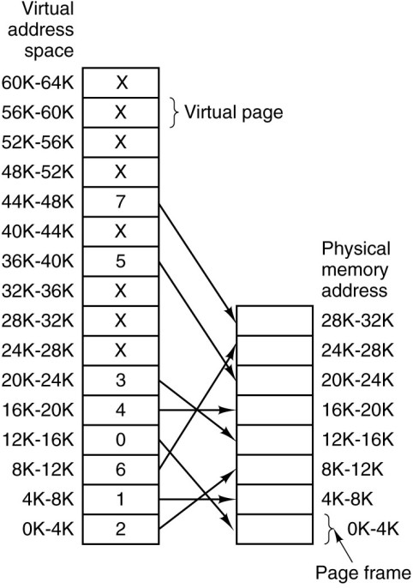

Calculate the physical address for each of following virtual addresses:

1. virtual address 21

Virtual address 21 belongs to virtual page 0 and virtual page 0 is mapped to physical frame 2. Therefore, the physical address would be = 8192 + (21-0) = 9013

1. virtual address 4097

Virtual address 4097 belongs to virtual page 1 and virtual page 1 is mapped to physical frame 1. Therefore, the physical address would be = 4096 + (4097 – 4096) = 4097

1. virtual address 13002

Virtual address 13002 belongs to virtual page 3 and virtual page 3 is mapped to physical frame 0. Therefore, the physical address would be = 0 + (13002 – 12288) = 714

1. virtual address 20003

Virtual address 20003 belongs to virtual page 4 and virtual page 4 is mapped to physical frame 4. Therefore, the physical address would be = 16384 + (20003 – 16384) = 20003