CS4350 Database Systems Lab#1

Given the following relation schemes:

**Name: Loc Nguyen**

Teacher = [CourseN, Quarter,TeacherName]

Course = [CourseN,CourseName, Nunit)

LocationNTime = [CourseN, Quarter , DayTime, RoomN]/ Examples of DayTime: M2:00AM,

W4:50PM, and T8:00PM. Note that DayTime is represented as a string.

Student = [studentName, CourseN, Quarter]

Express the following queries by SQL statements and test them using any appropriate database product. Submit screenshot s of your SQL statements and their outputs. Create your own table to test your SQL statements. Submit screenshots of the SQL statements and its output.

1. List the name of every teacher (distinct names) who teaches in RoomN ‘34’ in Winter2011

SELECT DISTINCT T."TeacherName"

FROM "Teacher" T

JOIN "LocationNTime" LNT ON T."CourseN" = LNT."CourseN" AND T."Quarter" = LNT."Quarter"

WHERE LNT."RoomN" = '34' AND LNT."Quarter" = 'Winter2011';

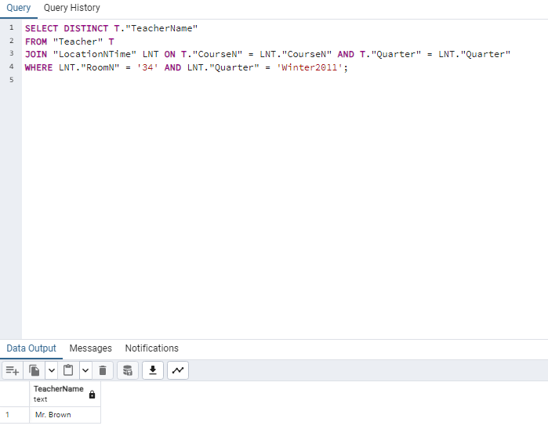

2. List CourseN, CourseName, and TeacherName of every course meets on Monday

PM.

SELECT C."CourseN", C."CourseName", T."TeacherName"

FROM "Course" C

JOIN "Teacher" T ON C."CourseN" = T."CourseN"

JOIN "LocationNTime" LNT ON C."CourseN" = LNT."CourseN" AND T."Quarter" = LNT."Quarter"

WHERE

LNT."DayTime" LIKE 'M%'

AND

TO_TIMESTAMP(LNT."DayTime", 'DYHH12:MIAM')::TIME >= '12:00:00';

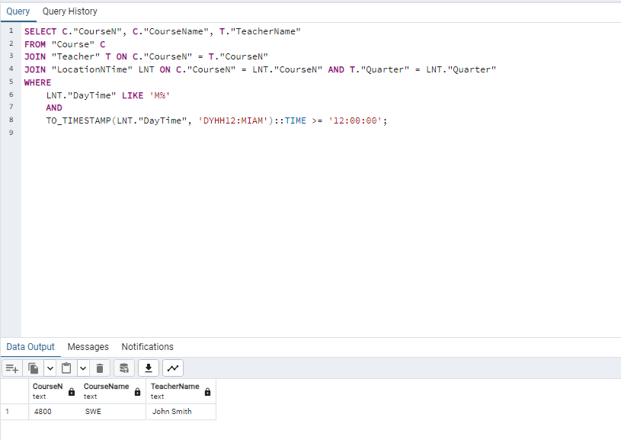

1. List the name of every teacher who taught at least one course in RroomN ‘723.’

SELECT DISTINCT T."TeacherName"

FROM "Teacher" T

JOIN "LocationNTime" LNT ON T."CourseN" = LNT."CourseN" AND T."Quarter" = LNT."Quarter"

WHERE LNT."RoomN" = '723';

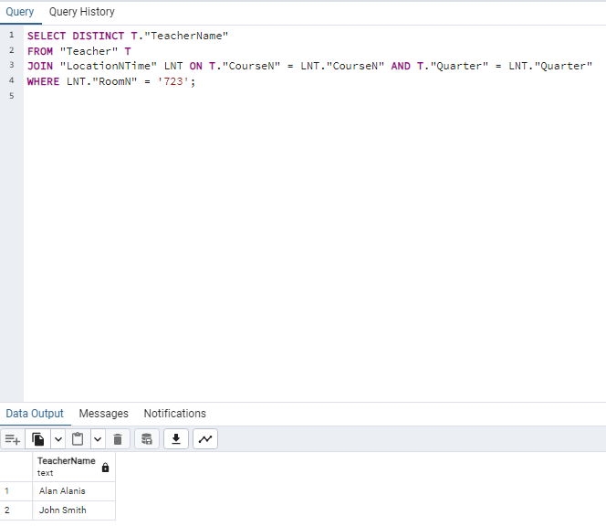

1. List the CourseN, Quarter, RoomN and DayTime of every course taught by ‘Karen Reed’ in the Spring 2005.

SELECT LNT."CourseN", LNT."Quarter", LNT."RoomN", LNT."DayTime"

FROM "LocationNTime" LNT

JOIN "Teacher" T ON LNT."CourseN" = T."CourseN" AND LNT."Quarter" = T."Quarter"

WHERE T."TeacherName" = 'Karen Reed' AND LNT."Quarter" = 'Spring 2005';

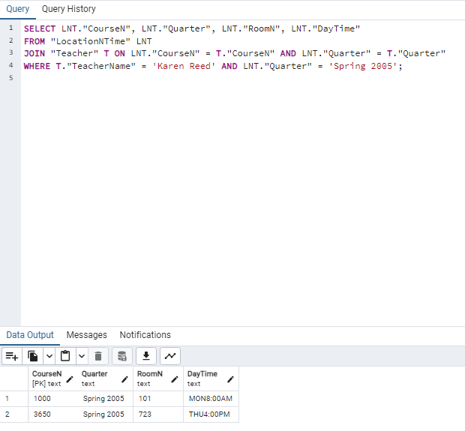

1. List the CourseN and TeacherName of every course taken by the student ‘Ron Smith’ or by the student ‘David Weidman.’

SELECT DISTINCT S."CourseN", T."TeacherName"

FROM "Student" S

JOIN "Teacher" T ON S."CourseN" = T."CourseN" AND S."Quarter" = T."Quarter"

WHERE S."StudentName" IN ('Ron Smith', 'David Weidman');

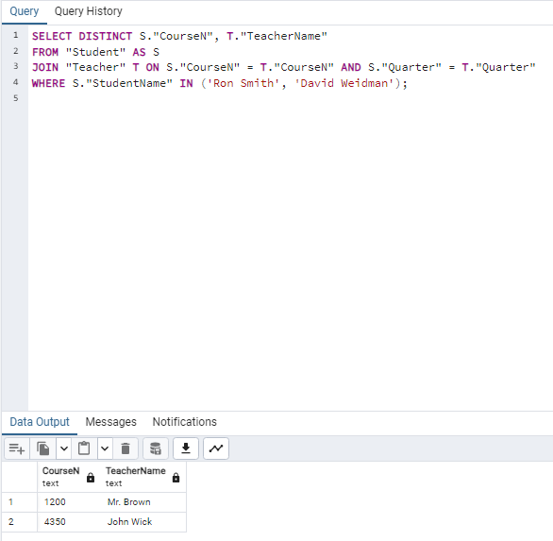

1. List the CourseN and Quarter of every course taught by ‘Karen Reed’ and met or meets in RoomN ‘713’.

SELECT DISTINCT LNT."CourseN", LNT."Quarter"

FROM "LocationNTime" LNT

JOIN "Teacher" T ON LNT."CourseN" = T."CourseN" AND LNT."Quarter" = T."Quarter"

WHERE T."TeacherName" = 'Karen Reed' AND LNT."RoomN" = '713';

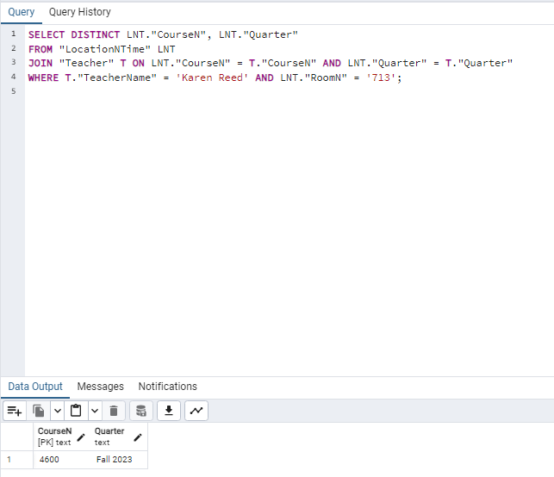

1. List the name of every teacher who has taught the same course at least two times.

SELECT T."TeacherName"

FROM "Teacher" T

GROUP BY T."TeacherName", T."CourseN"

HAVING COUNT(T."CourseN") >= 2;

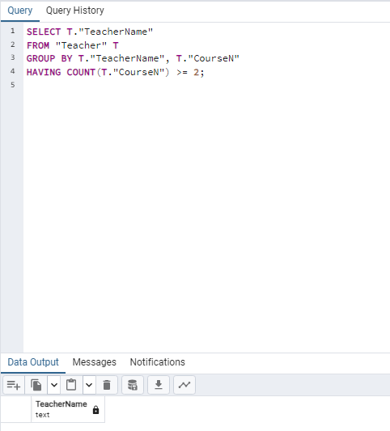

I’ve set the CourseN as primary key so it’s not possible to yield a result. However, if that wasn’t the case, “Karen Reed” would be yielded as a result using this table.

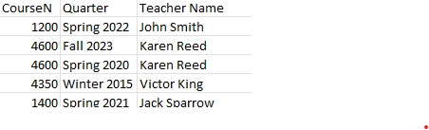

1. List the name of every teacher( distinct names) who has taught at least two different courses in the same or different quarters.

SELECT T."TeacherName"

FROM "Teacher" T

GROUP BY T."TeacherName"

HAVING COUNT(DISTINCT T."CourseN") >= 2;

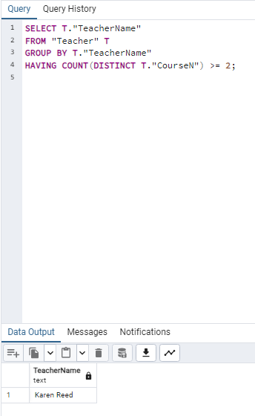

1. List the CourseN, CourseName, and Quarter which meets or met at least two times a week.

SELECT C."CourseN", C."CourseName", LNT."Quarter"

FROM "Course" C

JOIN "LocationNTime" LNT ON C."CourseN" = LNT."CourseN"

WHERE C."CourseN" IN (

SELECT LNT."CourseN"

FROM "LocationNTime" LNT

GROUP BY LNT."CourseN", LNT."Quarter"

HAVING COUNT(DISTINCT SUBSTRING(LNT."DayTime" FROM 1 FOR 1)) >= 2

);

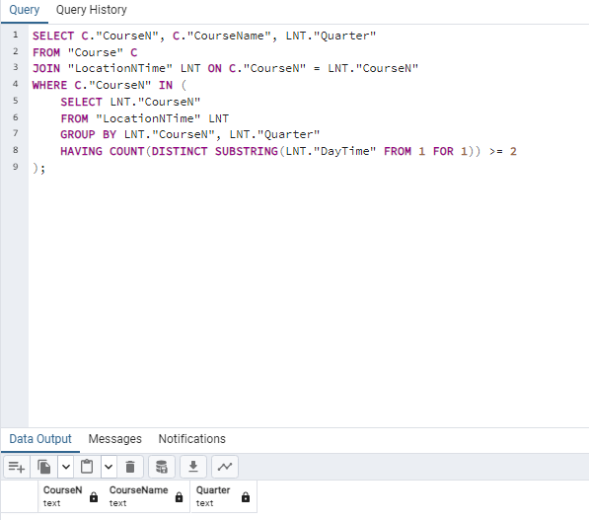

1. List the CourseN and CourseName of every course with number of units > 4.

SELECT "CourseN", "CourseName"

FROM "Course"

WHERE CAST("Nunit" AS INTEGER) > 4;

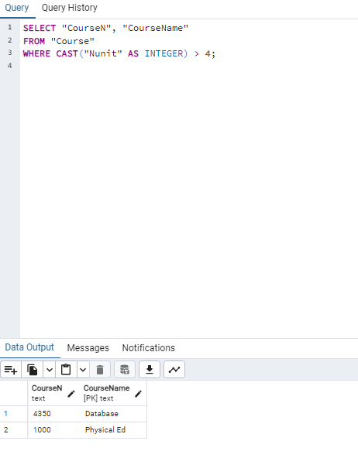

1. List every course number and student’s name who has taken the course at least twice.

SELECT S."CourseN", S."StudentName"

FROM "Student" S

GROUP BY S."CourseN", S."StudentName"

HAVING COUNT(S."StudentName") >= 2;

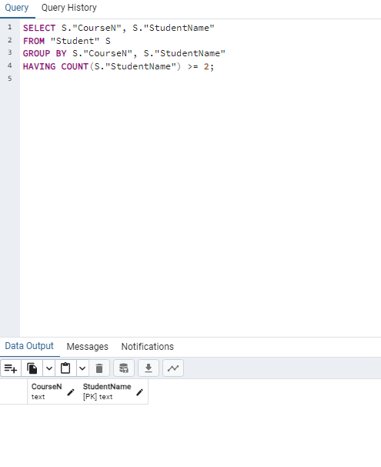

1. Use ‘*’ to list the CourseN, CourseName, Nunit, Quarter, TeacherName of every

course sorted by CourseN ascending, CourseName descending.

SELECT C."CourseN", C."CourseName", C."Nunit", T."Quarter", T."TeacherName"

FROM "Course" C

JOIN "Teacher" T ON C."CourseN" = T."CourseN"

ORDER BY C."CourseN" ASC, C."CourseName" DESC;

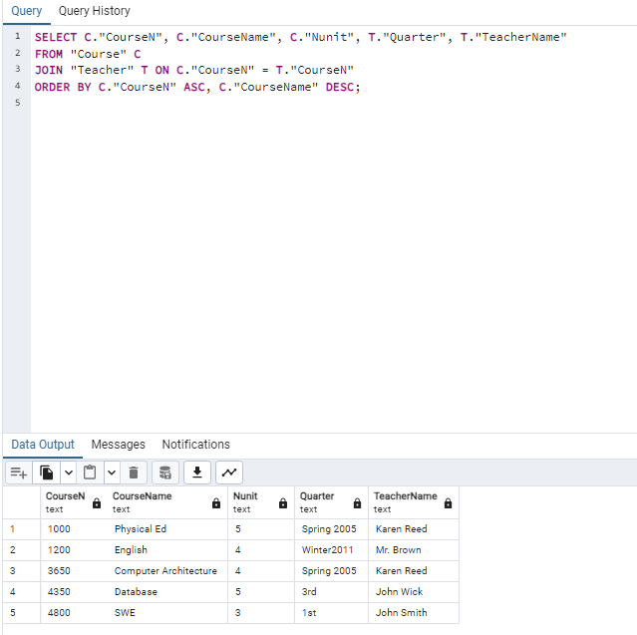

1. List the CourseN and Quarter of every course taught by two different instructors in the same quarter ordered by the CourseN in descending order.

SELECT T1."CourseN", T1."Quarter"

FROM "Teacher" T1

JOIN "Teacher" T2 ON T1."CourseN" = T2."CourseN" AND T1."Quarter" = T2."Quarter" AND T1."TeacherName" <> T2."TeacherName"

ORDER BY T1."CourseN" DESC;

