Lab 3 CS4350

Name: Loc Nguyen

**Solution**

1. The following assumptions were made to draw the attached ERD for a software that maintains and manages information related to employees, rooms, committees, and committee meetings of a company.
   1. An employee can have 1 or more shift (Employee’s Schedule) but a shift can only belong to 1 employee
   2. An employee can belong to 0 or more committee and a committee must belong to 1 or more employees
   3. A committee can have 0 or more meetings but a meeting must belong to 1 or more committee
   4. A committee can have 0 or more rooms but a room must belong to at least 1 committee
   5. A room can have 1 or more slot (Room’s Schedule) but a slot can only exist once a day in a room

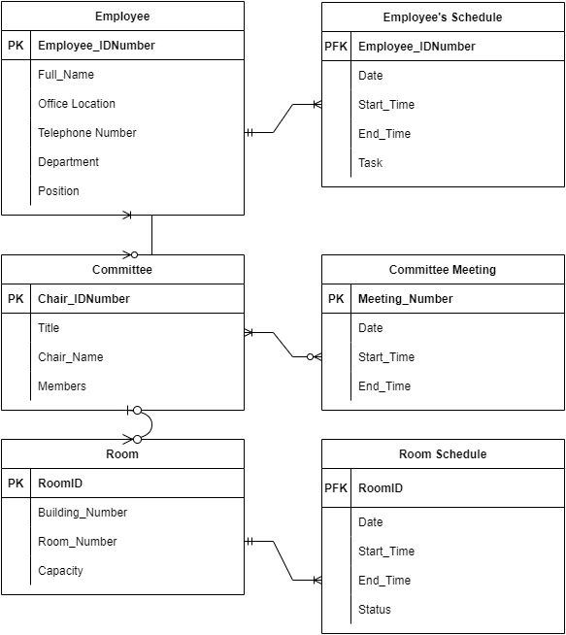

1. The following assumptions were made to draw the attached ERD for a software product that records and tracks all your bank accounts
   1. A statement can have 1 or more deposits but a deposit can only belong to 1 statement
   2. A statement can have 1 or more withdrawals but a withdrawal can only belong to 1 statement
   3. An account can have 1 or more deposits but a deposit can only belong to 1 account
   4. An account can have 1 or more withdrawal but a withdrawal can only belong to 1 account
   5. A statement can have 1 or more checks but a check can only belong to 1 statement
   6. New account can only have 1 account deletion and deletion can only delete 1 account

