**CS4350 Database Systems Lab#4**

**Name: Loc Nguyen**

Use the following tables to design and implement the Pomona Transit System using any database product and JDBC.

**Trip** ( TripNumber, StartLocationName, DestinationName)

**TripOffering** ( TripNumber, Date, ScheduledStartTime, SecheduledArrivalTime, DriverName, BusID)

**Bus** ( BusID, Model,Year)

**Driver**( DriverName, DriverTelephoneNumber)

**Stop** (StopNumber, StopAddress)

**ActualTripStopInfo** (TripNumber, Date, ScheduledStartTime, StopNumber, SecheduledArrivalTime, ActualStartTime, ActualArrivalTime, NumberOfPassengerIn,

NumberOf PassengerOut)

**TripStopInfo** ( TripNumber, StopNumber, SequenceNumber, DrivingTime)

The system should deal with at least the following transactions:

1. Display the schedule of all trips for a given StartLocationName and Destination Name, and Date. In addition to these attributes, the schedule includes: Scheduled StartTime, ScheduledArrivalTime , DriverID, and BusID



SELECT

"TO"."TripNumber",

"TO"."Date",

"TO"."ScheduledStartTime",

"TO"."ScheduledArrivalTime",

"TO"."DriverName" AS "DriverID",

"TO"."BusID"

FROM

"TripOffering" "TO"

JOIN

"Trip" "T" ON "TO"."TripNumber" = "T"."TripNumber"

WHERE

"T"."StartLocationName" = 'New York'

AND "T"."DestinationName" = 'Los Angeles'

AND "TO"."Date" = '2024-05-06';

2. Edit the schedule i.e. edit the table of Trip Offering as follows:

-Delete a trip offering specified by Trip#, Date, and ScheduledStartTime;

-Add a set of trip offerings assuming the values of all attributes are given (the software asks if you have more trips to enter) ;

- Change the driver for a given Trip offering (i.e given TripNumber, Date, ScheduledStartTime);

- Change the bus for a given Trip offering.

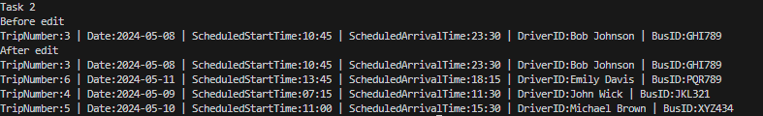

DELETE FROM "TripOffering"

WHERE

"TripNumber" = 2

AND "Date" = ‘2024-05-07'

AND "ScheduledStartTime" = ’09:30’;

INSERT INTO "TripOffering" ("TripNumber", "Date", "ScheduledStartTime", "ScheduledArrivalTime", "DriverName", "BusID")

VALUES

(4, '2024-05-09', '07:15', '11:30', 'Alice Johnson', 'JKL321'),

(5, '2024-05-10', '11:00', '15:30', 'Michael Brown', 'MNO456'),

(6, '2024-05-11', '13:45', '18:15', 'Emily Davis', 'PQR789');

UPDATE "TripOffering"

SET "DriverName" = John Wick'

WHERE

"TripNumber" = 4

AND "Date" = ‘2024-05-09'

AND "ScheduledStartTime" = ’07:15';

UPDATE "TripOffering"

SET "BusID" = ‘XYZ434'

WHERE

"TripNumber" = 5

AND "Date" = '2024-05-10’

AND "ScheduledStartTime" = '11:00’;

3. Display the stops of a given trip ( i.e. the attributes of the table **TripStopInfo**)

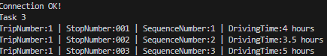

SELECT

"TripNumber",

"StopNumber",

"SequenceNumber",

"DrivingTime"

FROM

"TripStopInfo"

WHERE

"TripNumber" = 1;

4. Display the weekly schedule of a given driver and date.



SELECT

"TO"."TripNumber",

"TO"."Date",

"TO"."ScheduledStartTime",

"TO"."ScheduledArrivalTime",

"TO"."BusID"

FROM

"TripOffering" "TO"

JOIN

"Driver" "D" ON "TO"."DriverName" = "D"."DriverName"

WHERE

"D"."DriverName" = 'Bob Johnson'

AND "TO"."Date"::date >= '2024-05-08'::date

AND "TO"."Date"::date <= ('2024-05-08'::date + interval '6 days');

5. Add a driver

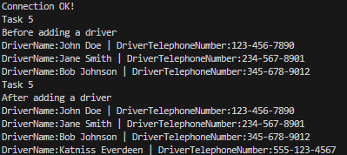

INSERT INTO "Driver" ("DriverName", "DriverTelephoneNumber")

VALUES ('Katniss Everdeen', '555-123-4567');

6. Add a bus

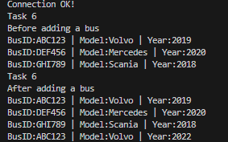

INSERT INTO "Bus" ("BusID", "Model", "Year")

VALUES ('ABC123', 'Volvo', '2022');

7. Delete a bus.

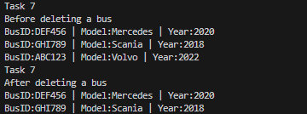

DELETE FROM "Bus"

WHERE "BusID" = 'ABC123';

8. Record (insert) the actual data of a given trip offering specified by its key. The actual data include the attributes of the table **ActualTripStopInfo.**

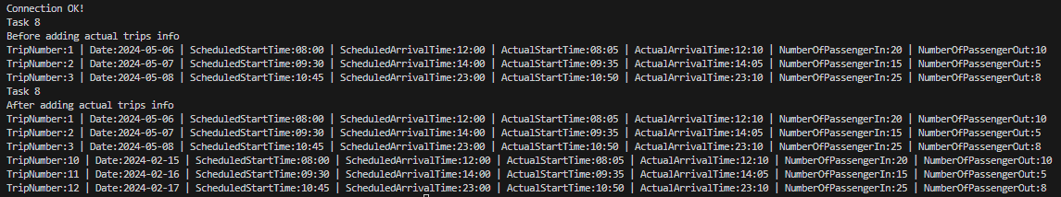

INSERT INTO "ActualTripStopInfo" ("TripNumber", "Date", "ScheduledStartTime", "StopNumber", "ScheduledArrivalTime", "ActualStartTime", "ActualArrivalTime", "NumberOfPassengerIn", "NumberOfPassengerOut")

VALUES (10, '2024-02-15', '08:00', '001', '12:00', '08:05', '12:10', 20, 10),

(11, '2024-02-16', '09:30', '002', '14:00', '09:35', '14:05', 15, 5),

(12, '2024-02-17', '10:45', '003', '23:00', '10:50', '23:10', 25, 8);