**Monte Carlo Simulation**

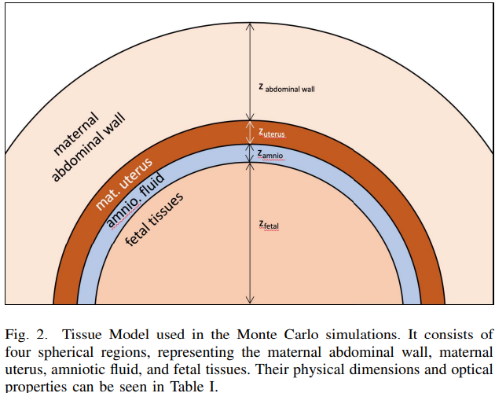

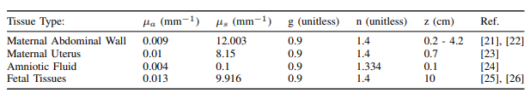

The absorption coefficient $α_{3}$ of the amniotic fluid layer (L3) can be set as a fixed value $μ_{3}$:

Step 1: For each photon, calculate its absorption in each tissue layer:

$$I_{n}\left(t\right)=\exp\left(-α_{1}\left(t\right)⋅L_{1n}\left(t\right)\right)⋅\exp\left(-α_{2}\left(t\right)⋅L_{2n}\left(t\right)\right)⋅\exp\left(-μ_{3}⋅L_{3n}\left(t\right)\right)⋅\exp\left(-α_{4}\left(t\right)⋅L_{4n}\left(t\right)\right)$$

where: $I_{n}\left(t\right)$ is the intensity of the $n^{th}$ photon at time $t$; $α_{i}\left(t\right)$ is the absorption coefficient of the $i^{th}$ tissue layer at time $t$, where $μ_{3}$ is the fixed absorption coefficient of the amniotic fluid layer (3rd layer); $L_{in}\left(t\right)$ is the propagation path length of the $n^{th}$ photon in the $\$i\$-th$ tissue layer, which is a function of time $t$.

Step 2: Group photons according to time to obtain the time-domain PPG signal $\$I(t)\$$:

$$I\left(t\right)=\sum_{n}{I_{n}\left(t\right)}$$

where: $I\left(t\right)$ is the total intensity of all photons received at time $t$, i.e., the value of the PPG signal at time $t$. Through these two steps, the time-domain PPG signal considering the fixed absorption coefficient of the amniotic fluid layer can be calculated.

Step3: After fitting the PPG signal, use two calculation methods in the time domain and frequency domain to obtain separate calculation results:  
PPG time domain signal calculation:

$$\frac{I_{max}-I_{min}}{I_{min}}$$

PPG frequency domain power spectrum calculation:

$$Energy of f_MHR / Total signal energy$$

, where: $I_{max}$ d $I_{min}$ present the maximum and minimum values of the PPG signal respectively; $f_{MHR}$ denotes the main frequency of the fetal heart rate; $Energy of f_MHR$ represents the energy of the main frequency $f_{MHR}$; $Total signal energy$ represents the total energy of the entire PPG signal.  
  
Then we can analyze whether the values of two methods of calculation of MHR and FHR are consistent.