## Doc 0119

The **calculation formula** of our model is :

Method 1:

Method 2:

**Implementation**

Use Monte-Carlo simulation to simulate the pathlength and , and then use experimentally obtained and , to calculate SpO2 through the formulations in Method 1 or Method 2. This can be compared with the ground truth SaO2 through Arterial Blood Gas.

**Sheep Data**

The data we obtained can be divided into three groups, each group representing a different individual pregnant ewe. Each group has two sets of data. The first set **DF1**, is a signal containing only the AC part, the DC part value is 0, and the measurement time of the data is 60s. The second set **DF2**, is the complete signal including the AC and DC parts, and the measurement time of the data is 300s. Each set has two wavelengths and two channels.

AC part: find the central frequency of the waveform in DF1 to find the heart beat frequency of the pregnant sheep. Construct a bandpass filter with this central frequency to filter the waveform in DF1 so as to obtain the maternal heart beat signal (AC part). This signal could be amplified by a factor of beta.

DC part: Calculate the average signal in DF2 to obtain the DC signal.

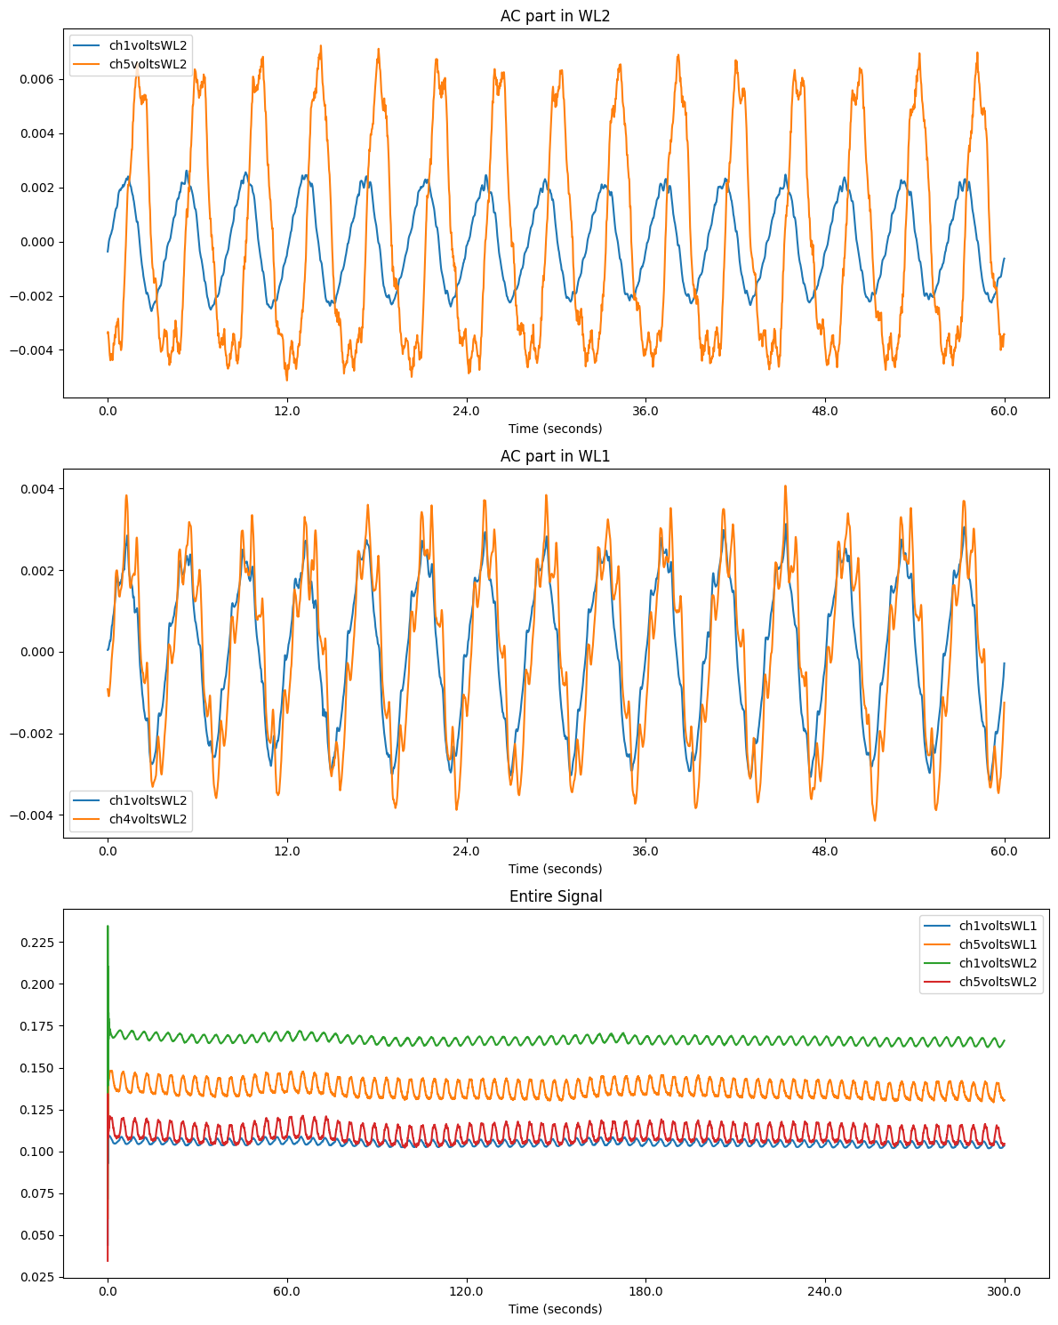

According to the center frequency of the fetal recorded in the data, we can design a filter to retain only the mother's signal in the one-subject model.

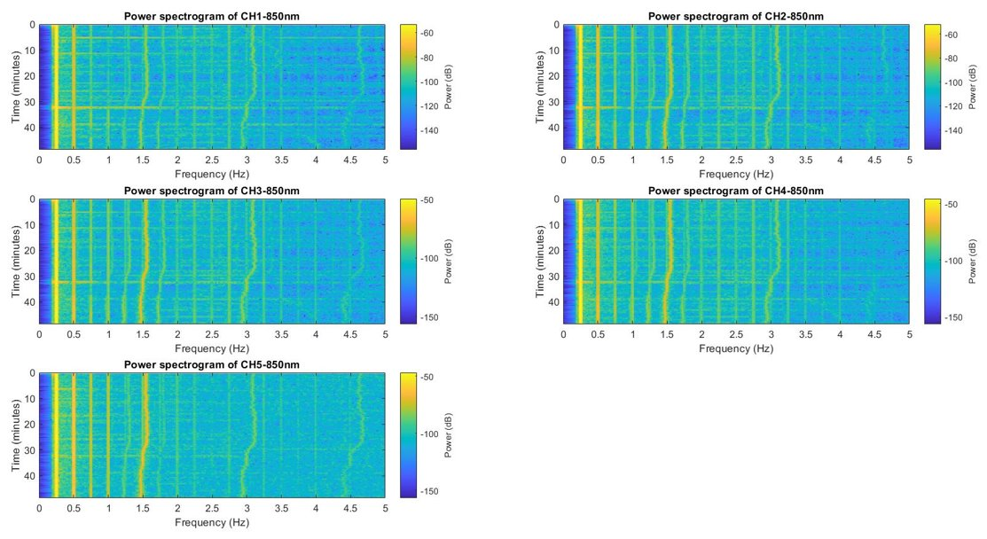

Signal comparison after filtering (using the first ewe's data DF1):

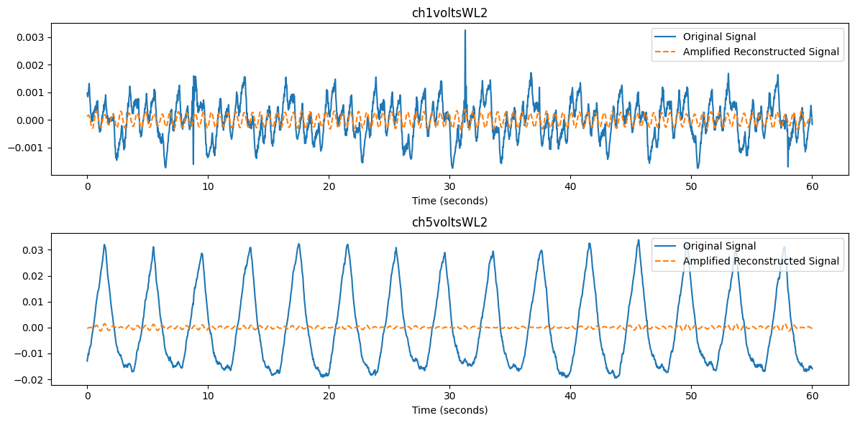

Why not use the entire signal DF2: Because FFT analysis is performed on both DF1 and DF2, the results show that the peak frequency of DF1 can be found, that is, filtering can be used on DF1. Analysis of DF2 showed no results.

DF1:

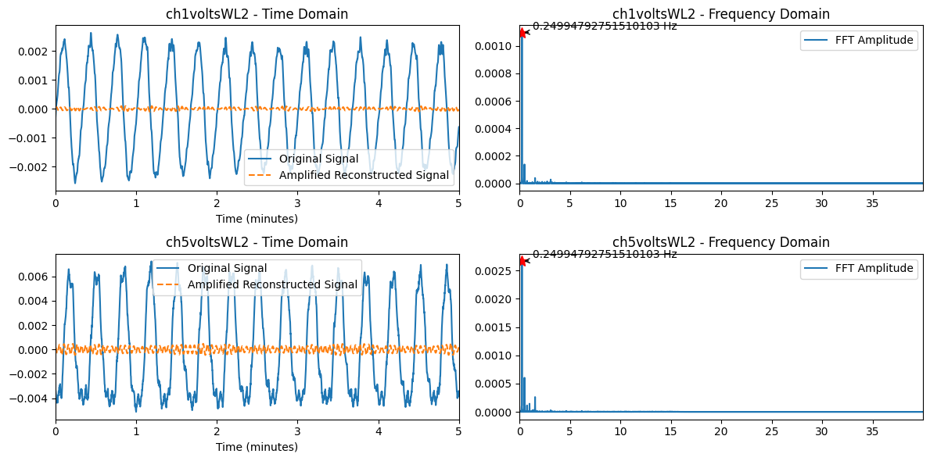

DF2:

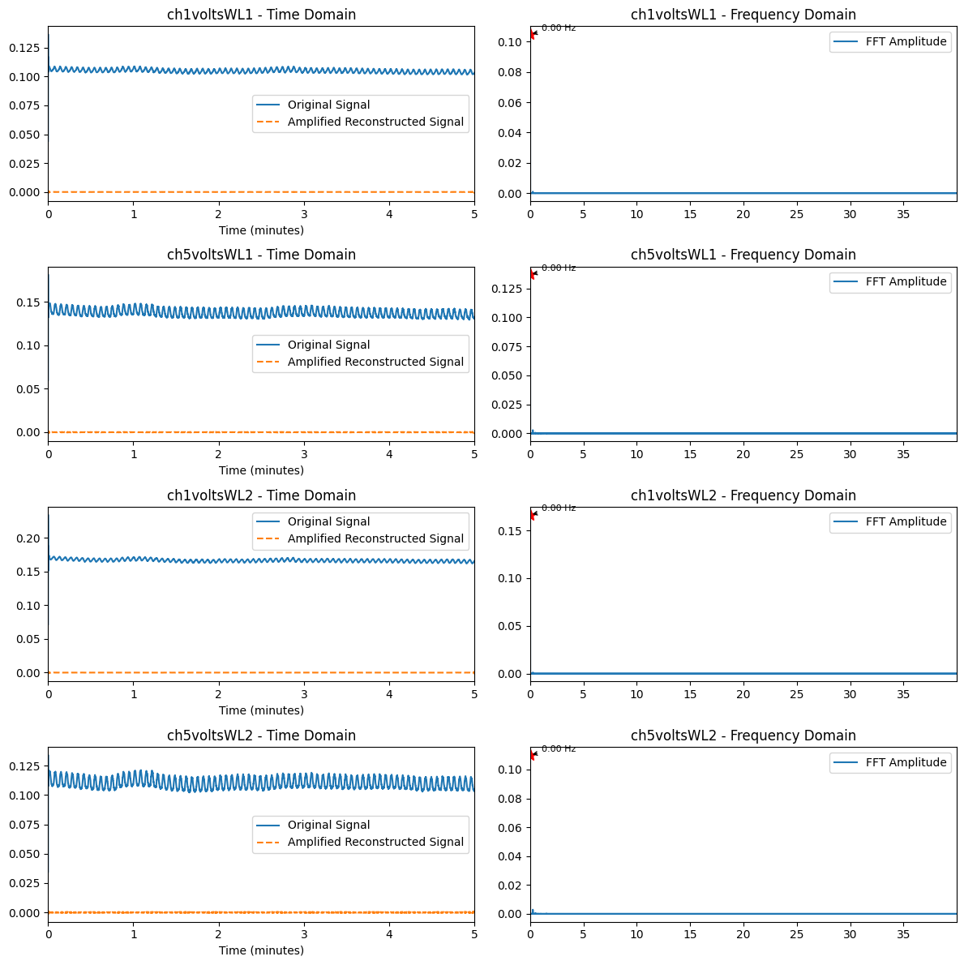

After filtering the signal, there will be some loss of the fetal signal during the filtering process. In other words, the filtered signal may be numerically smaller than the real signal. Therefore we amplify the filtered signal. Afterwards, in order to facilitate signal comparison, the value of the DC part is calculated from DF2 and directly added to the filtered signal as an offset.

Plot all these signals and compare them.

