Student Resource Portal - Deliverable #2 Mobile Website
Date: 10.18.2026

Project Purpose
The UMSI Engaged Learning Office (ELO) facilitates transformational engaged learning experiences for the School of Information and enables innovative, sustainable, and mutually-beneficial information solutions for local and global communities.

In order to meet this mission, the ELO seeks to improve its web presence by designing a new website to help students understand and locate resources available to them for their engaged learning courses and programs.
- The website should function as a guided learning resource rather than simply a repository of links and documents for students.
- The new site will feature an accessible and responsive design that works on multiple devices, a modern look and feel, and a refreshed site architecture and site content.
- The target user of this website is a UMSI undergraduate or graduate student—you might build yours specifically for a BSI/MSI student, but this is not required.
- The new website will be built using HTML5, CSS3, and JavaScript and will be hosted on Github.
Client Project Scope Document

Contacts:
- Student contact details are included in the submission copy.

URL’s
- Published Website URL: https://skylarsong0107.github.io/client_project_f26/
- Github Repo URL: https://github.com/SkylarSong0107/client_project_f26

Our Commitment:

Deliverable #2 - Mobile website
- This will include all of the content in one or more styled html files
- This will be a mobile first design - which means that our default web design is for mobile devices and smartphones - not large screens (desktops/laptops)
- This website will be responsive and all content will be viewable at larger sizes
- This website will be fully accessible and will pass accessibility validators such as WAVE and Axe

Meets Client’s Objectives
Optional Breakpoint to Grade at (should be below 480px):
390px wide
Explain how your website meets the Engaged Learning Office’s objectives for a new website to help students understand and locate resources available to them for their engaged learning courses and programs:
- Supports a range of engaged learning student experiences, including client-based projects, community engagement, global experiences, research, entrepreneurship and start-up development, and other forms of applied learning by providing access to relevant information and materials.
- Showcases the depth and breadth of resources, expertise, and support available through the ELO.
- Organized so that it follows the lifecycle of an engaged learning experience
My website helps UMSI students prepare for engaged learning projects. The Home page introduces the ELO and links to project opportunities. These include the AI Clinic, A2 Data Dive, Alternative Fall Break, and study abroad.
The pages follow the early stages of a project. Students can prepare, start working with a partner, and find campus support. The site explains what each resource is for. It also explains when students may need it. The Campus Partners page introduces the Ginsberg Center, C-SEED, and U-M Library services.

Explain how your design fits their requirements of a visually appealing modern website that fits within UM’s Branding Guidelines
I used Michigan blue (#00274C) and maize (#FFCB05). I also used the UMSI logo and photos from the course asset portal. Dark blue headings and maize accents connect the design to U-M. A light background makes the text easy to read. I kept the navigation and heading styles consistent on all four pages.

Explain how your design optimizes site content and images to work on mobile devices/smaller screens.
I used CSS Grid to let the layout fit the available space. Content moves into one column on a small screen. Navigation links wrap into rows. The paired photos stay side by side. Each image fits its container. I resized new photos for the web. I did not use width media queries. The only media query supports reduced motion. All four pages fit a 390px screen without horizontal scrolling.

Explain how you ensured that your site is fully accessible and usable for all students - including those with different disabilities.
Each page uses header, nav, main, and footer elements. Each page has one main heading. Photos have descriptive alt text. The skip link appears when it receives keyboard focus. It moves focus to the main content. Links have visible focus outlines. The current navigation link has an underline, a background, and aria-current. The footer focus outline is maize on navy. Reduced-motion preferences turn off smooth scrolling. All four pages passed the W3C HTML check with no messages. The supplied axe screenshots show 0 automatic issues on all four live pages under WCAG 2.1 AA, with Best Practices off. The WAVE screenshots show 0 errors and 0 contrast errors on all four pages. Home, Preparing, and Starting each show 1 redundant-link alert. Campus Partners shows 3. These alerts flag repeated destinations, such as the logo and Home link. They are not reported errors. The updated WAVE screenshots show the same results. The Preparing screenshot includes a GitHub Pages link. The browser address bar is not shown. I also checked all four pages with the keyboard. The skip link, Tab order, visible focus, Enter activation, Shift + Tab, and footer links worked. I did not get stuck on any page.

Explain how your design makes it easy for students to find resources and understand how to utilize them. Were there any changes you made from your first deliverable? What and why?
The same navigation appears on all four pages. The Home page has three cards for the main stages. Resource sections explain when and how to use each resource. The partner comparison lists each type of support beside a direct link to the right organization. Since the first deliverable, I added shared styles, responsive Grid layouts, photos, and clear content sections. Longer guidance points use individual cards. Short lists stay together in text blocks. Each content photo is used once. The first photo group is on the right on desktop. Later photo rows alternate sides. These choices make the information easier to scan.

Project Cost for Deliverable #2 Mobile Website

Item | Hours | Price | Total
Accessibility Testing | 1 | $110/hour | $110
Accessibility Fixes | 1 | $110/hour | $110
Designing navigation | 2 | $110/hour | $220
Responsive Design Work | 2 | $110/hour | $220
Styling website - aligns with UM Brand Standards | 3 | $110/hour | $330
Additional html & content work | 1 | $110/hour | $110
Other see below* | 1 | $110/hour | $110
Total Costs: | 11 |  | $1,210
* If there are other items you worked on for the website outside of what was listed in the Project Costs

Project Costs for Other include:
- Photo selection, image resizing, and GitHub version control.

Appendix

Appendix A: Accessibility Validation
Screenshots supplied on October 19, 2026. The four WAVE screenshots were updated after the recheck. Axe results show the live GitHub Pages URLs. WAVE reports 0 errors and 0 contrast errors on each page. Manual keyboard checks passed on all four pages on October 19, 2026.

Home — Accessibility Screenshots
WAVE: 0 errors; 0 contrast errors; 1 redundant-link alert(s).
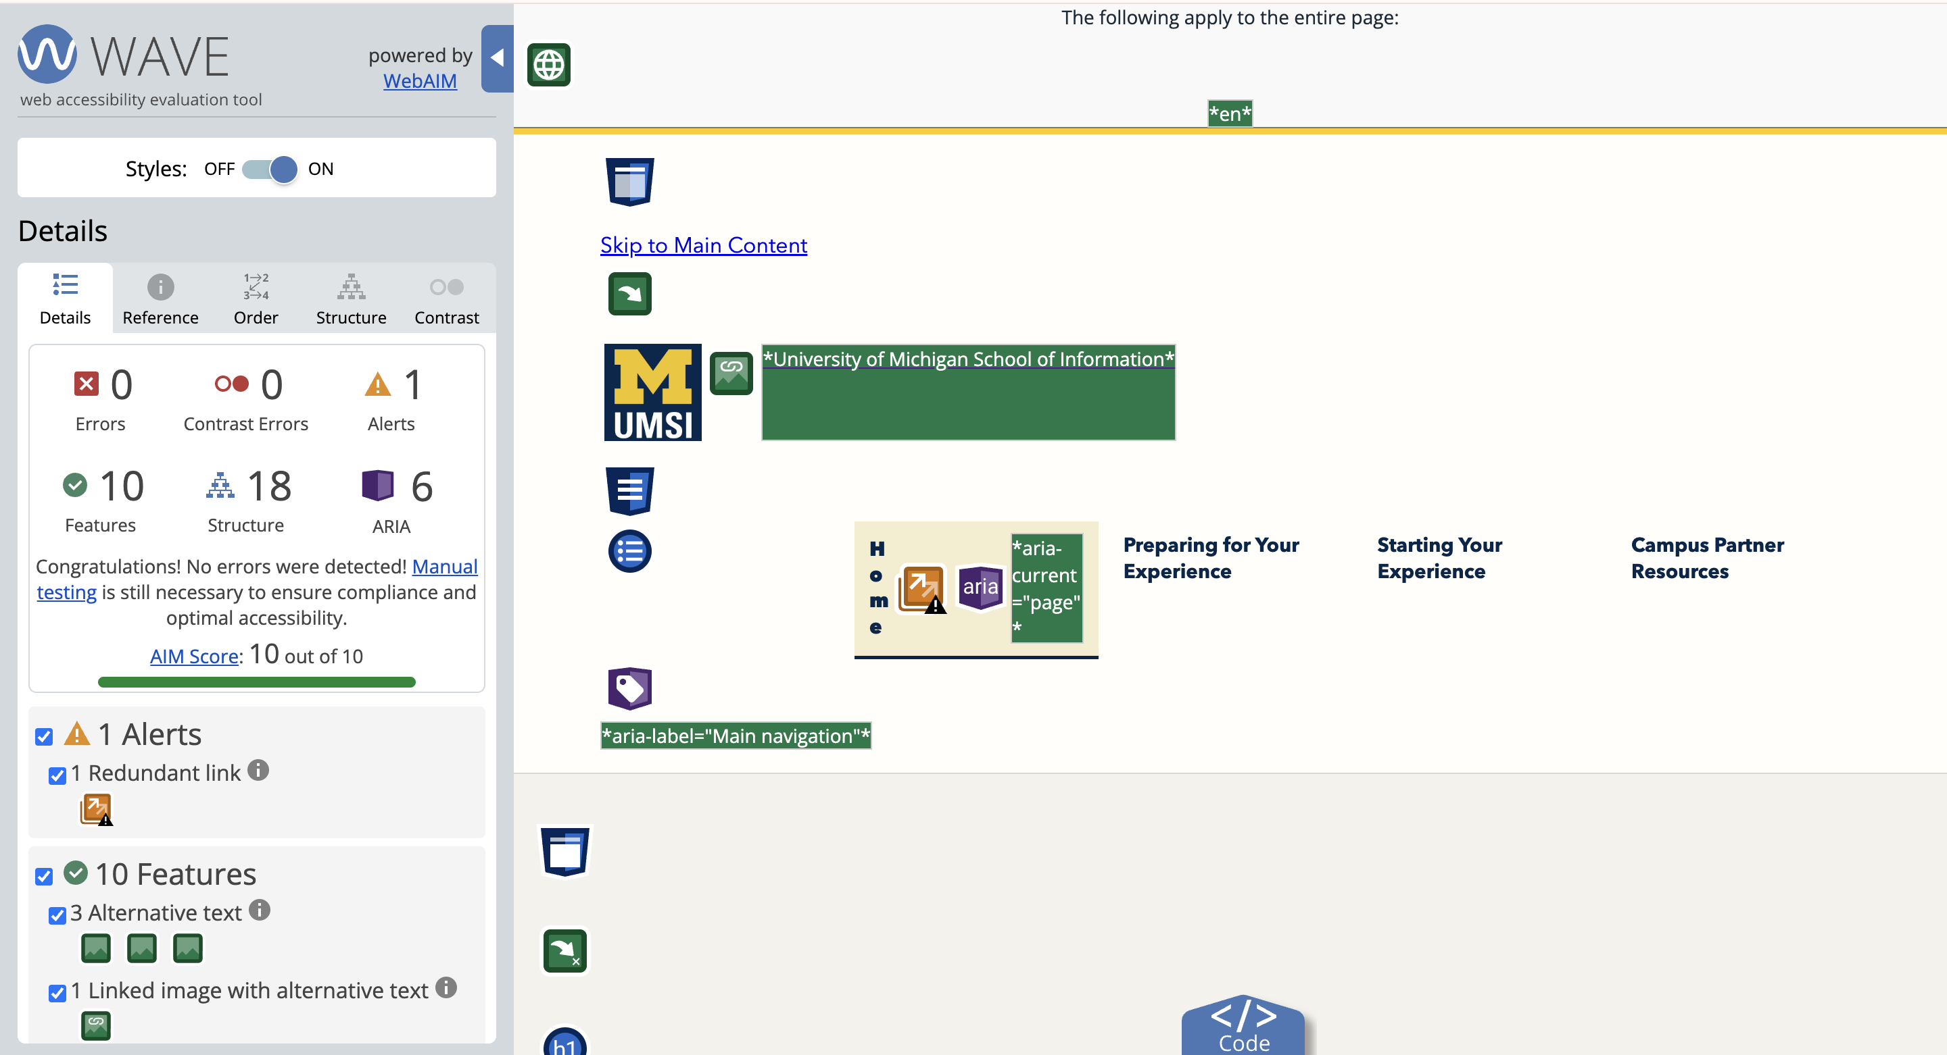
axe: 0 automatic issues; WCAG 2.1 AA; Best Practices off.
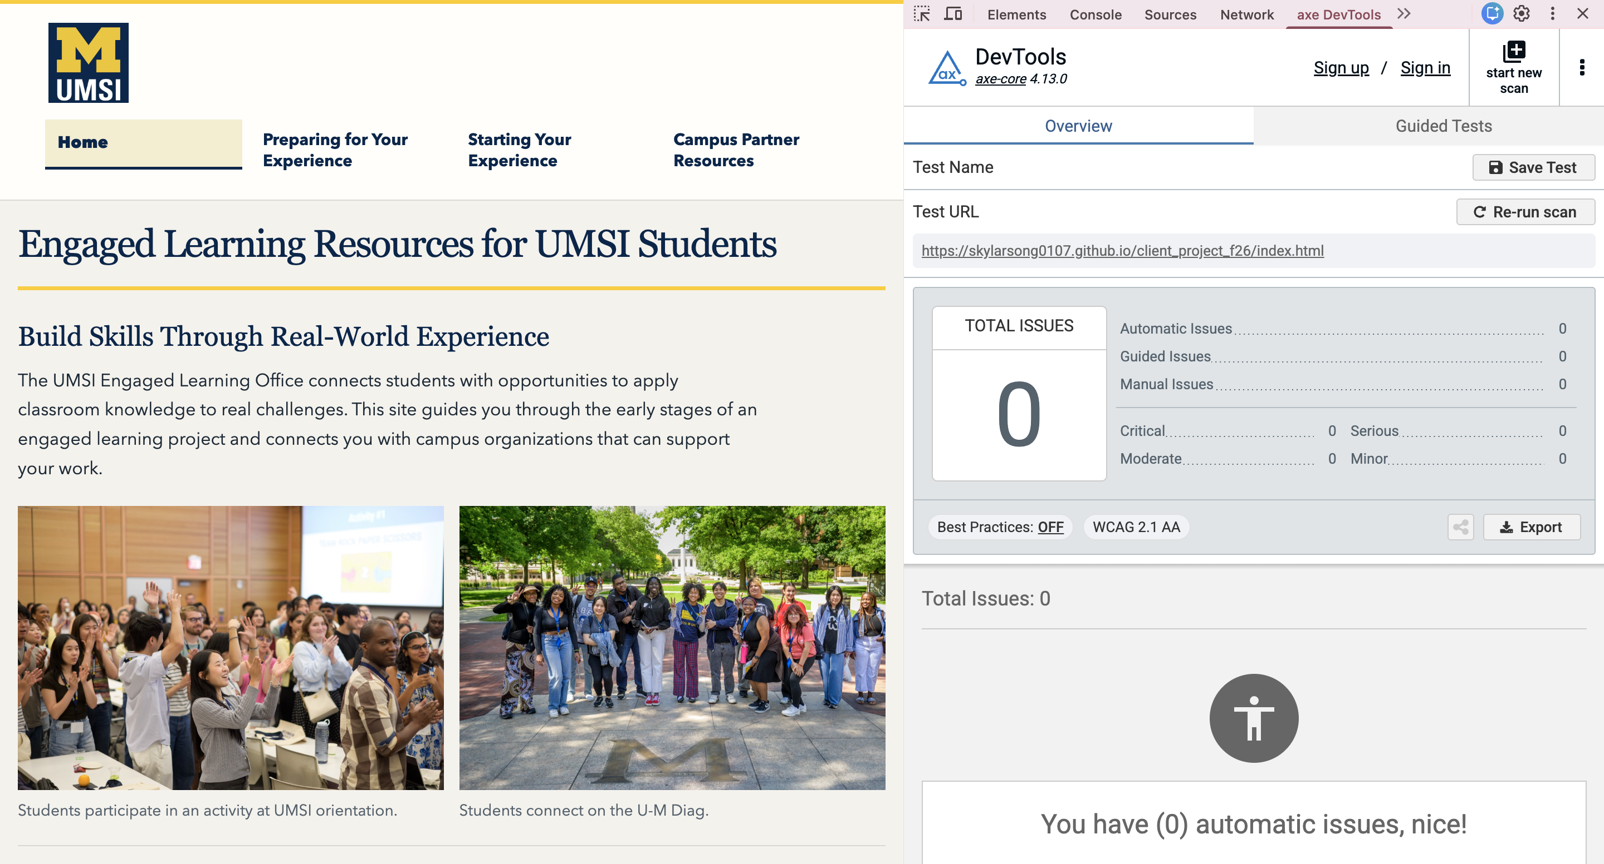

Preparing — Accessibility Screenshots
WAVE: 0 errors; 0 contrast errors; 1 redundant-link alert(s).
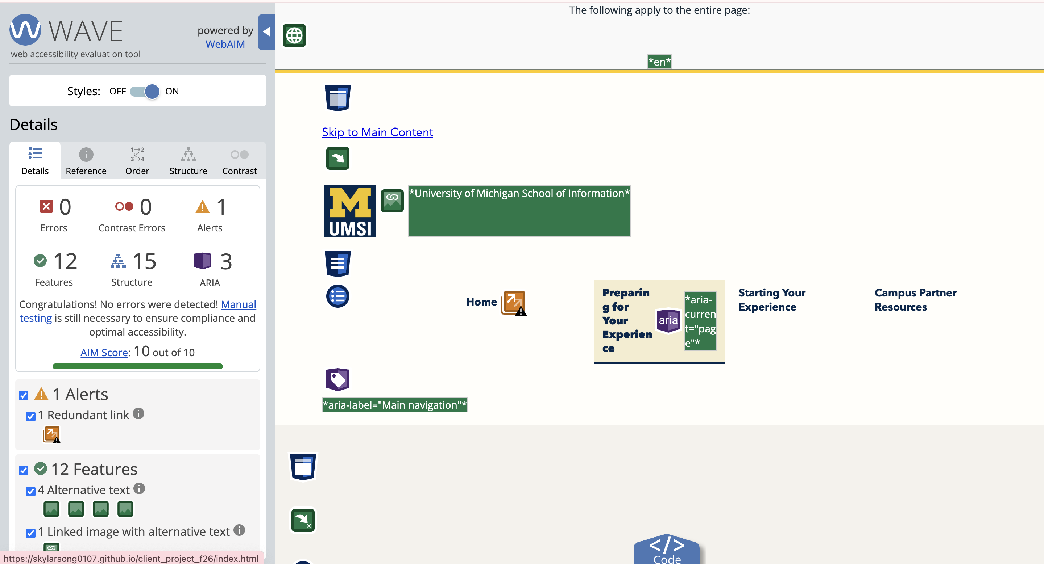
axe: 0 automatic issues; WCAG 2.1 AA; Best Practices off.
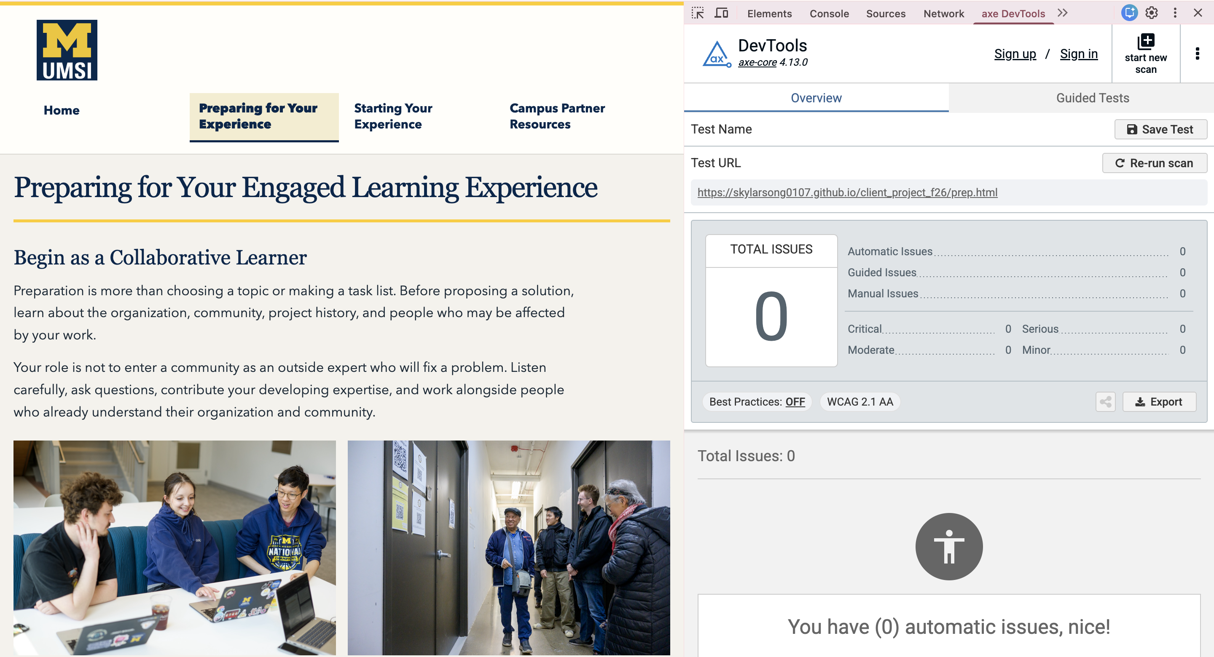

Starting — Accessibility Screenshots
WAVE: 0 errors; 0 contrast errors; 1 redundant-link alert(s).
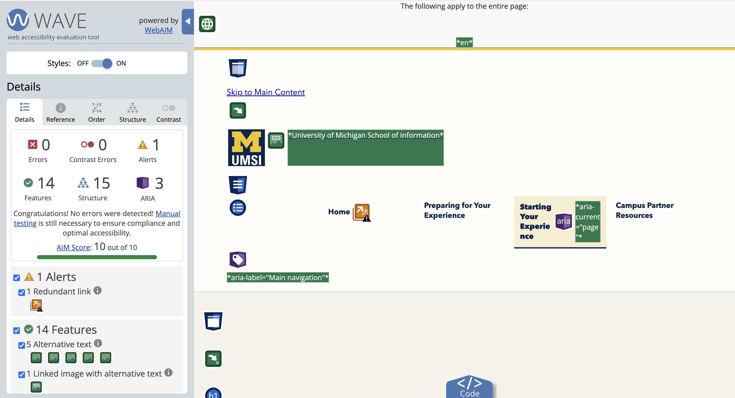
axe: 0 automatic issues; WCAG 2.1 AA; Best Practices off.
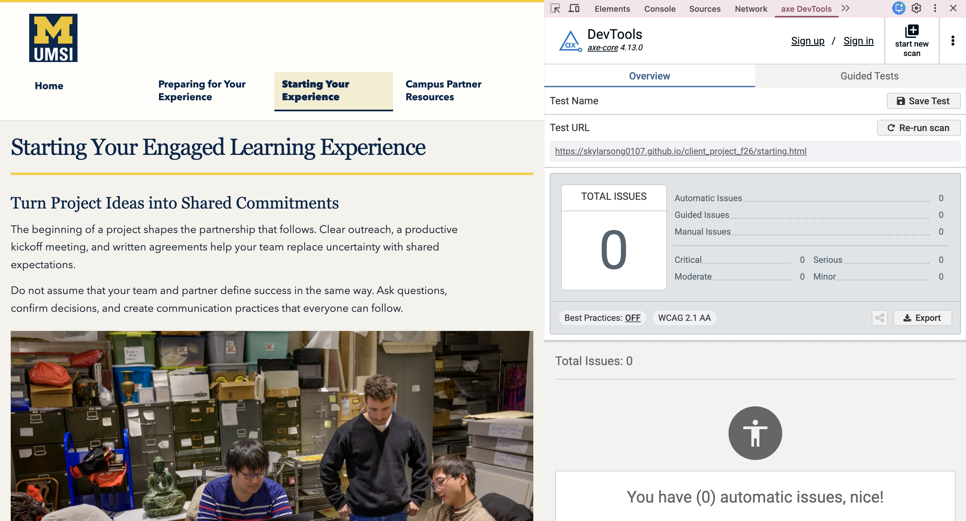

Campus Partners — Accessibility Screenshots
WAVE: 0 errors; 0 contrast errors; 3 redundant-link alert(s).
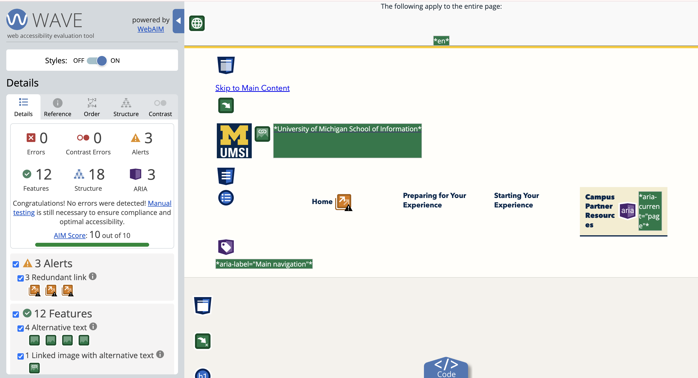
axe: 0 automatic issues; WCAG 2.1 AA; Best Practices off.
