Computational Details
Geometry optimizations and vibrational frequency calculations were performed using the calculation methods reported in the source files [1].

References
[1] Test reference supplied for output verification.

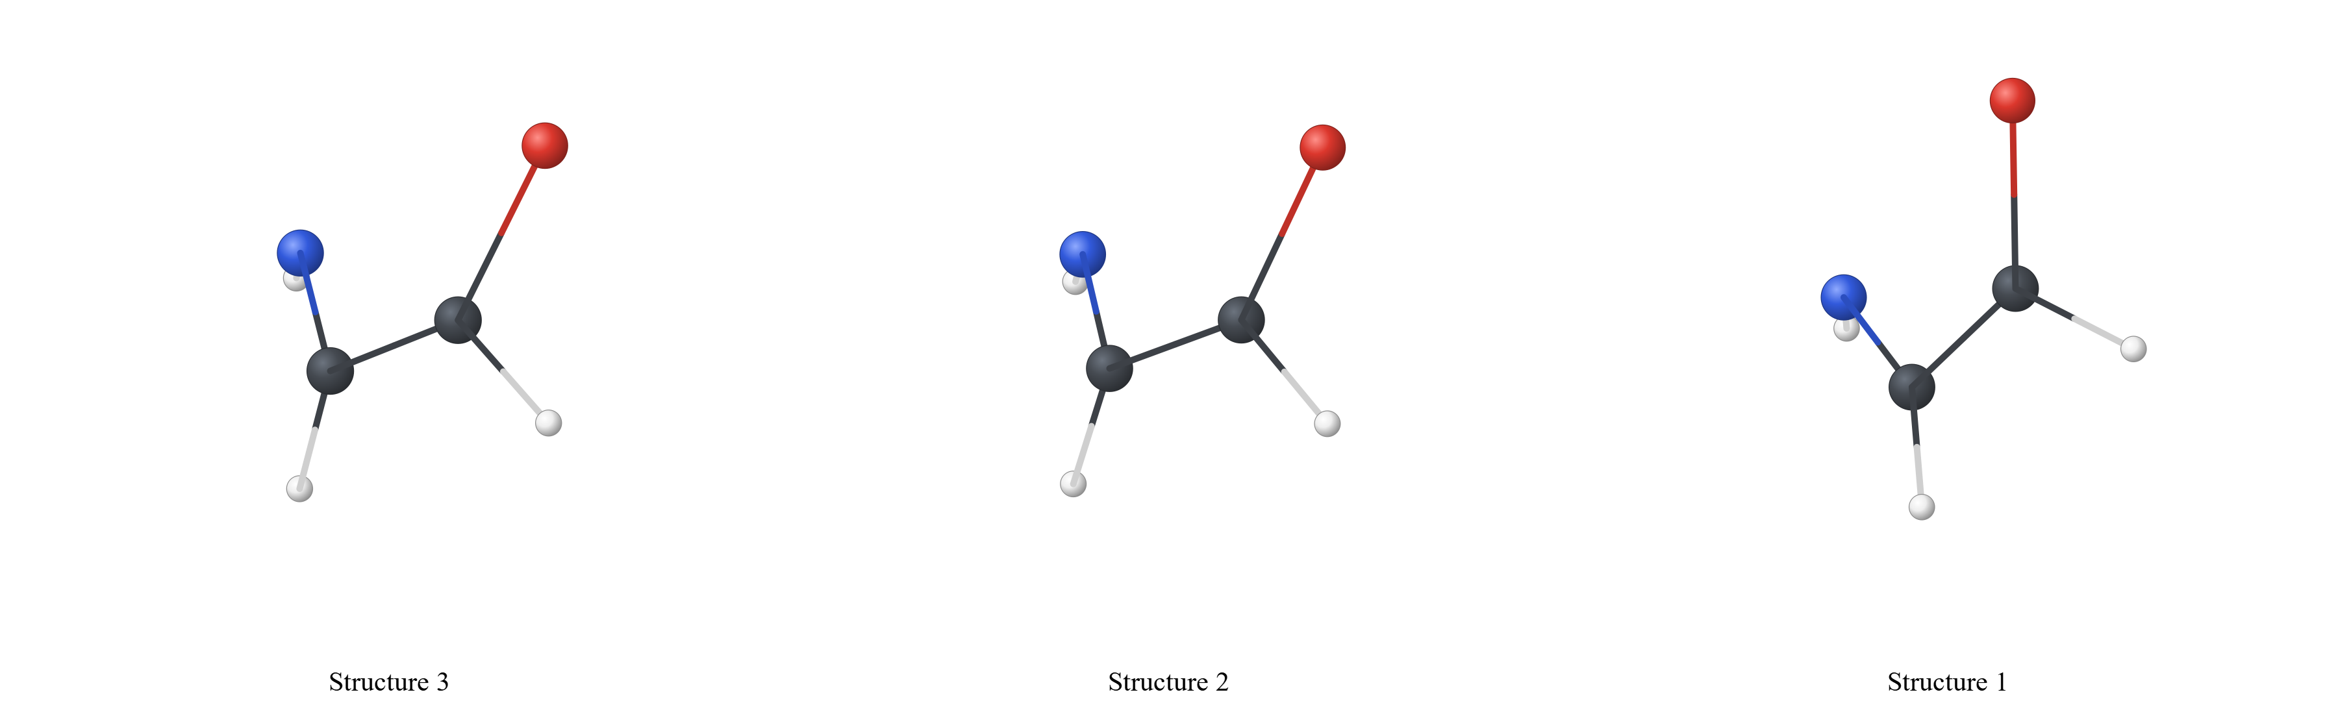

Figure S1. Structure 3 / Structure 2 / Structure 1
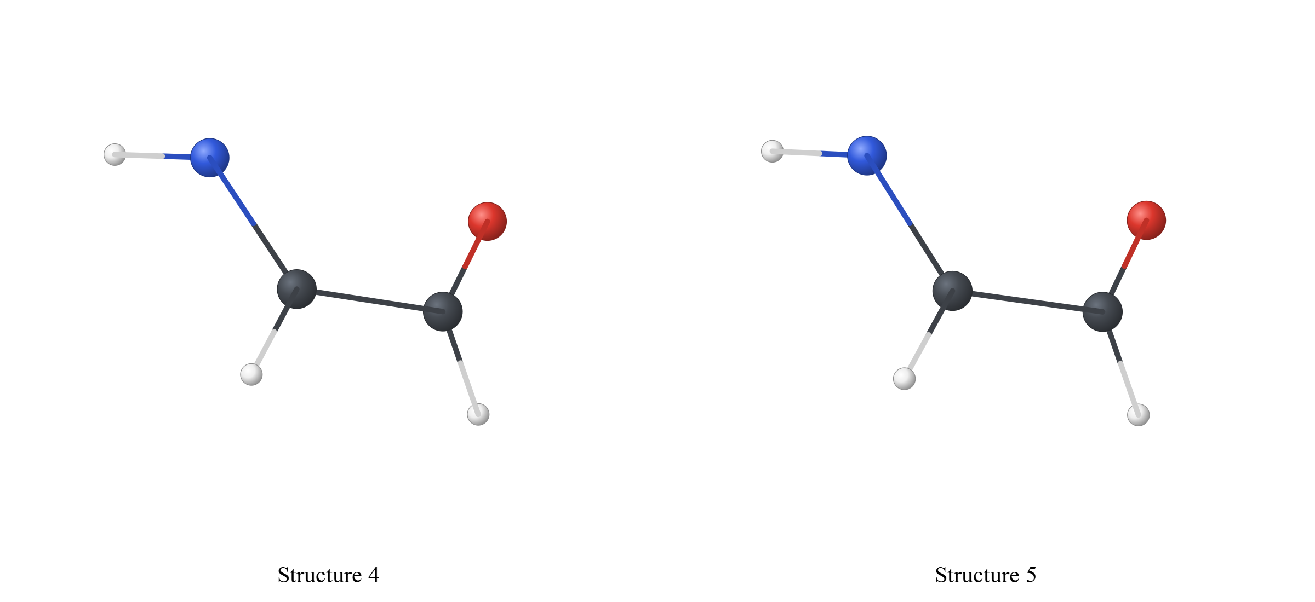

Figure S2. Structure 4 / Structure 5
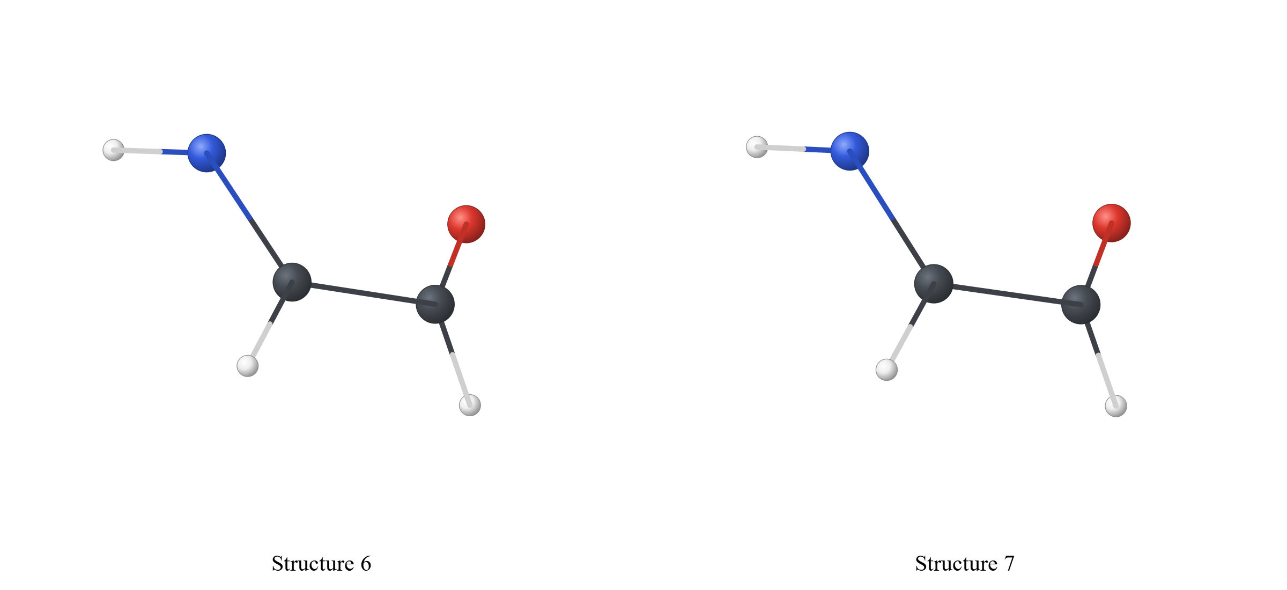

Figure S3. Structure 6 / Structure 7
Structure | Value
Structure 1 | 0.000

Table S1. Section 0
Structure | Value
Structure 1 | 0.000

Table S2. Section 1
Relative energies were calculated with respect to the selected reference. Energy basis: current/default behavior. Conversion factor: 1 Hartree = 627.509474 kcal mol⁻¹.
Structure | Value
Structure 1 | 0.000

Table S3. Section 2
Structure | Value
Structure 1 | 0.000

Table S4. Section 3

Cartesian Coordinates

Structure 1
C 0.000000 0.000000 0.000000
C 1.400000 0.000000 0.000000
O 2.100000 1.100000 0.000000
N -0.700000 1.200000 0.300000
H -0.400000 -0.800000 0.000000
H 1.900000 -0.800000 0.300000
H -1.400000 1.300000 0.800000
Structure 2
C 0.000000 0.000000 0.000000
C 1.400000 0.000000 0.000000
O 2.100000 1.100000 0.120000
N -0.700000 1.200000 0.300000
H -0.400000 -0.800000 0.000000
H 1.900000 -0.800000 0.300000
H -1.400000 1.300000 0.800000
Structure 3
C 0.000000 0.000000 0.000000
C 1.400000 0.000000 0.000000
O 2.100000 1.100000 0.240000
N -0.700000 1.200000 0.300000
H -0.400000 -0.800000 0.000000
H 1.900000 -0.800000 0.300000
H -1.400000 1.300000 0.800000
Structure 4
C 0.000000 0.000000 0.000000
C 1.400000 0.000000 0.000000
O 2.100000 1.100000 0.360000
N -0.700000 1.200000 0.300000
H -0.400000 -0.800000 0.000000
H 1.900000 -0.800000 0.300000
H -1.400000 1.300000 0.800000
Structure 5
C 0.000000 0.000000 0.000000
C 1.400000 0.000000 0.000000
O 2.100000 1.100000 0.480000
N -0.700000 1.200000 0.300000
H -0.400000 -0.800000 0.000000
H 1.900000 -0.800000 0.300000
H -1.400000 1.300000 0.800000
Structure 6
C 0.000000 0.000000 0.000000
C 1.400000 0.000000 0.000000
O 2.100000 1.100000 0.600000
N -0.700000 1.200000 0.300000
H -0.400000 -0.800000 0.000000
H 1.900000 -0.800000 0.300000
H -1.400000 1.300000 0.800000
Structure 7
C 0.000000 0.000000 0.000000
C 1.400000 0.000000 0.000000
O 2.100000 1.100000 0.720000
N -0.700000 1.200000 0.300000
H -0.400000 -0.800000 0.000000
H 1.900000 -0.800000 0.300000
H -1.400000 1.300000 0.800000

