M11102122 陳煜翔 影像處理 Homework 2

I package all function which I will use in the cv_image class.

The object have image and new_image for original image and the histogram equalization image.

Function of convert2gray is used to conver BGR image to Grayscale.

Function of gamma_correction_image is use gamma correction function to make image lighter of darker. In our task we use for darker.

Function of plt_histogram is used to get the histogram information and save the figure of it.

Function of Histogram_equalization is used to calculate the new image for algorithm.

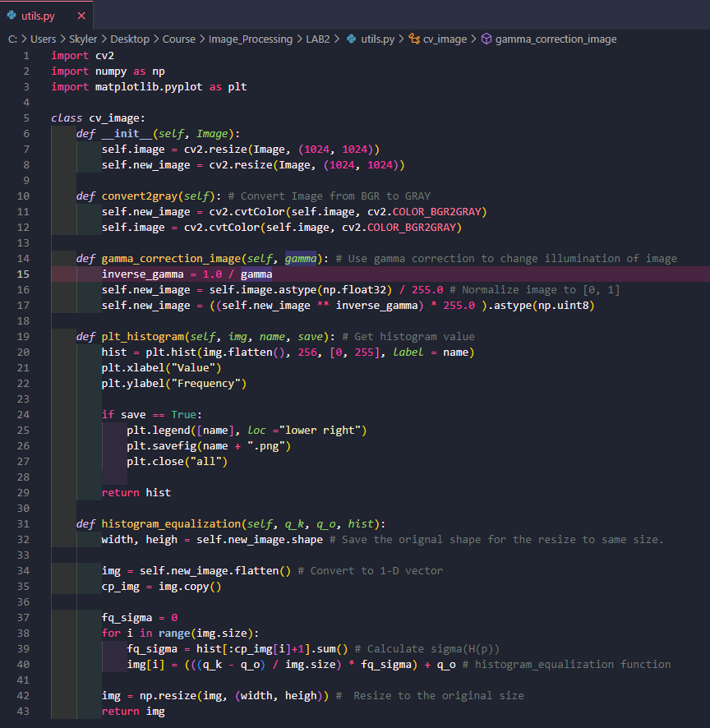

|  |  |
| --- | --- |
|  |  |
|  |  |
| Gamma Image (Dark image) | Result (Histogram Equalization) |