i)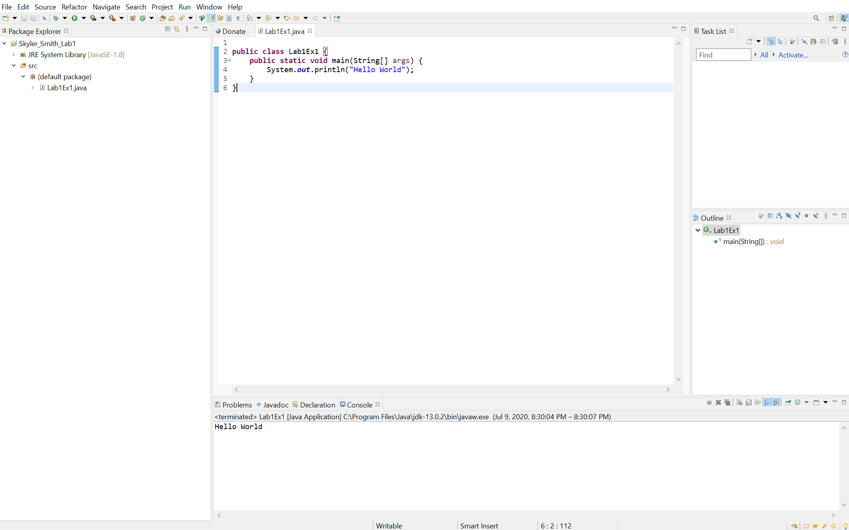

a)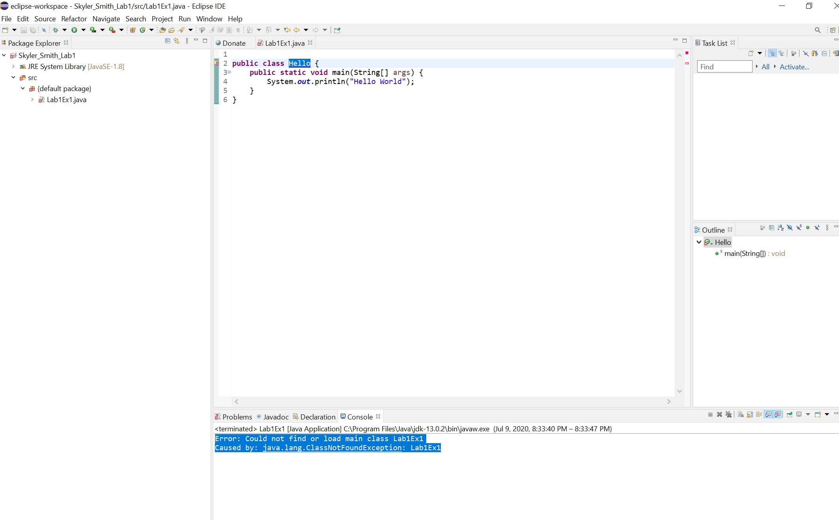Error: Could not find or load main class Lab1Ex1

Caused by: java.lang.ClassNotFoundException: Lab1Ex1

I suspect this is happening because the class name in the package explorer is called Lab1Ex1 but there is no Lab1Ex1 class in the source code anymore

b)

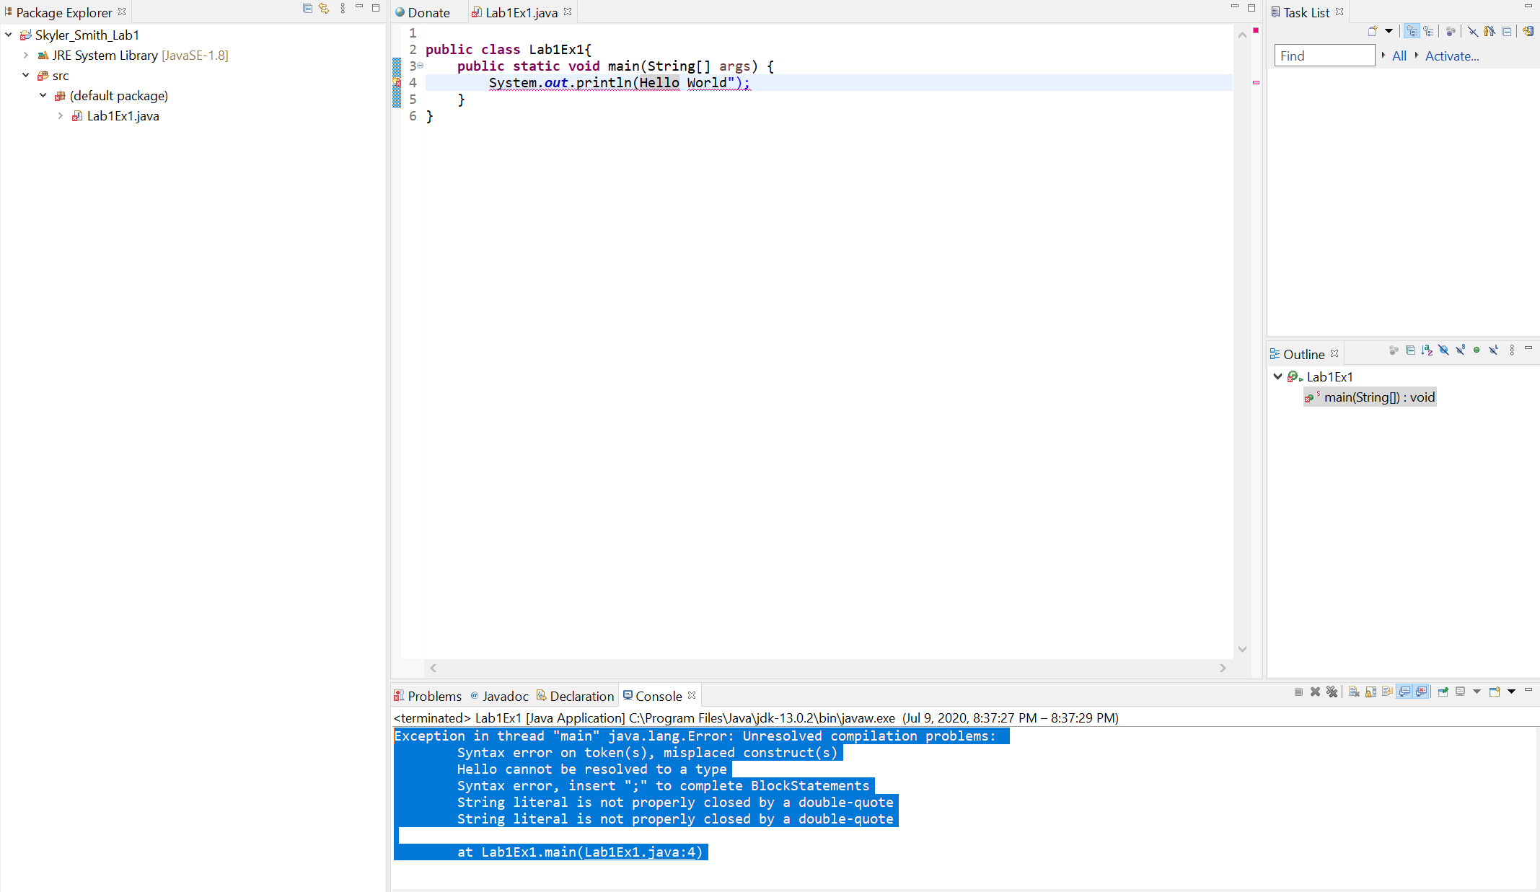

Exception in thread "main" java.lang.Error: Unresolved compilation problems:

Syntax error on token(s), misplaced construct(s)

Hello cannot be resolved to a type

Syntax error, insert ";" to complete BlockStatements

String literal is not properly closed by a double-quote

String literal is not properly closed by a double-quote

at Lab1Ex1.main(Lab1Ex1.java:4)

In this case, it appears there is a syntax error because “Hello World” Is not being properly identified as a string literal object due to the lack of enclosing double quotes.

c) 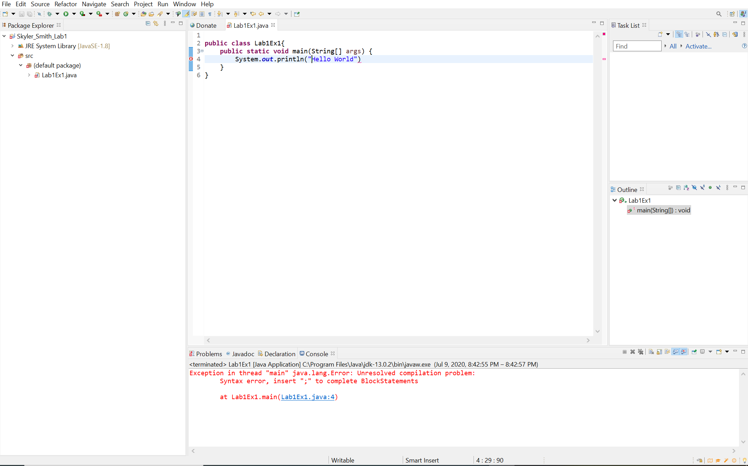

Exception in thread "main" java.lang.Error: Unresolved compilation problem:

Syntax error, insert ";" to complete BlockStatements

at Lab1Ex1.main(Lab1Ex1.java:4)

Removing the semicolon gives a syntax error because the compiler does not know where the method ends.

d) 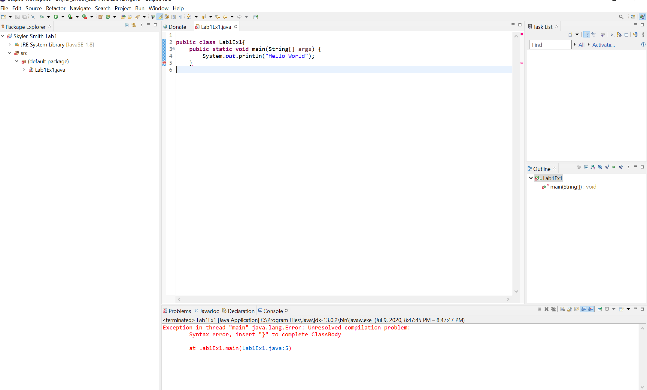

Exception in thread "main" java.lang.Error: Unresolved compilation problem:

Syntax error, insert "}" to complete ClassBody

at Lab1Ex1.main(Lab1Ex1.java:5)

In this case, there is a syntax error because the compiler cannot tell if the last brace encloses the method or the class. The one that was removed encloses the class.