**Module 1 Peer Review for Jory Griffith**

**By Skyler Elmstrom**

Hello! I like to write documents instead of canvas comments for peer reviews so I can provide links, code, and explain my thoughts in more detail.

**R Markdown**

Your markdown style is clean, but I have some suggestions for readability:

* Move your class notes to the bottom or use a markdown template that allows you to create tabs or pages. I generally keep two documents: one for my submission and one for my own notes.
* I’m not sure why exactly because I can’t see your markdown code, but the ToC on the side of your document duplicates when I open the “My Work” section from the ToC shortcut (in Chrome and Edge browser, this may not be your fault):

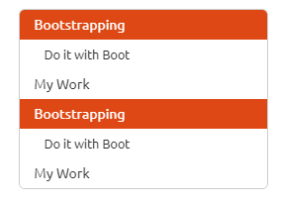

* Make your markdown code visible to others! I like doing this as I can share the code and my output markdown in the same HTML document. Add this to your R markdown YAML header if interested:

Output:

html_document:

code_download: true

**R code**

Here are a couple code bits I think you might find valuable:

* Alternative to multiple rbinds – I noticed you used rbind several times to join all your boot outputs in your My Work section. Code that is a little faster and more optimized might look something like:

library(data.table)

Boot.table <- data.table(Oak1, Oak2, Oak3)

a <- do.call(rbind, Boot.list)

* Lapply – Check out my markdown on GitHub [here](https://github.com/SkylerElmstrom/ESCI599-MachineLearning/blob/main/Week1-Bootstrap/SElmstrom_Module1_Bootstrap.md#bootstrapping-simpsons-diversity-index-sdi-for-each-habitat) for how I managed to use lapply with the data.