Q1

a)

|  |  |  |  |  |
| --- | --- | --- | --- | --- |
|  | UCS | IDS | A* | IDA* |
| start10 | 2565 | 2407 | 33 | 29 |
| start20 | Mem | 5297410 | 915 | 952 |
| start27 | Mem | Time | 1873 | 2237 |
| start35 | Mem | Time | Mem | 215612 |
| start43 | Mem | Time | Mem | 2884650 |

b)

UCS : This algorithm has the highest space efficiency as it need take lots of memory. So it has the lowest efficiency.

IDS : This algorithm always expand the deepest unexpanded node, which could be failed in infinite-depth spaces ,or spaces with loops, so IDS has the low time efficiency especially between start27 to start43.

A* : This algorithm is similar to UCS, but it will avoid some unnecessary search, but sometime it will also take up big memory from start35 on.

IDA* : This algorithm is a low-memory variant of A*, so it has both the time and space efficiency.

Q2

1. H = 25, H = 43.
2. N = 551168

c)

This algorithm will change the max depth when it doesn't reach the goal state, so I think the reason is that the max depth of start49 is much larger than start51, that will expand more nodes.

Q3

a) c)

|  |  |  |  |  |  |  |
| --- | --- | --- | --- | --- | --- | --- |
|  | start49 | | start60 | | start64 | |
| IDA∗ | 49 | 178880187 | 60 | 321252368 | 64 | 1209086782 |
| 1.2 | 51 | 988332 | 62 | 230861 | 66 | 431033 |
| 1.4 | 57 | 311704 | 82 | 3673 | 94 | 188917 |
| Greedy | 133 | 5237 | 166 | 1617 | 184 | 2174 |

b)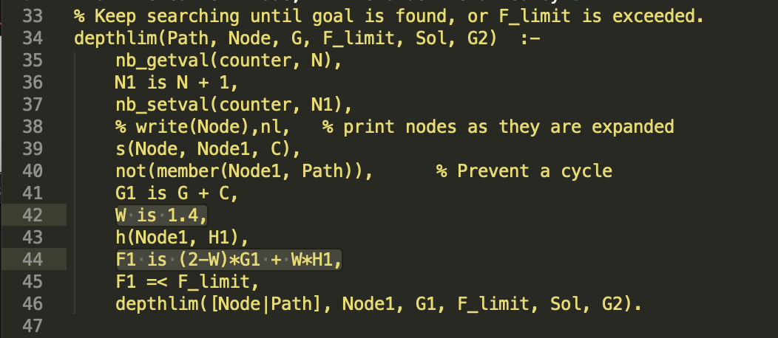

d) When w = 2 ,it’s Greedy algorithm which is the fastest algorithm, When w = 0, it's UCS, when w = 1 it's A*. And wen w ranging from 1.2 to 1.4, w and N have a proportional relation, it means that when w increases and N decrease. Hence faster speed with worse quality.

Q4

1. Manhattan Distance heuristic. hMD(x,y,xG,yG) =􏰀 | x - xG | + | y - yG |

b)

1. No, it will not be admissible, because according to this question, when it moves diagonally, a diagonal step is still considered to have the same ‘cost’ as one move, but actually the cost is sqrt(2), a little bit larger than 1. So it is not admissible.
2. No, heuristic from part(a) is the sum of all vertical and horizontal move, but as I mentioned above, this heuristic have same cost in vertical, horizontal and diagonal. So heuristic from part(a) is not admissible.
3. | x - xG | 𝑖𝑓 𝑥𝐺 − 𝑥 ≥ 𝑦 − 𝑦𝐺

h(x,y,xG,yG) = {

| y - yG | 𝑖𝑓 𝑥𝐺 − 𝑥 <𝑦 − 𝑦𝐺

Q5

a) My game tree shows below:

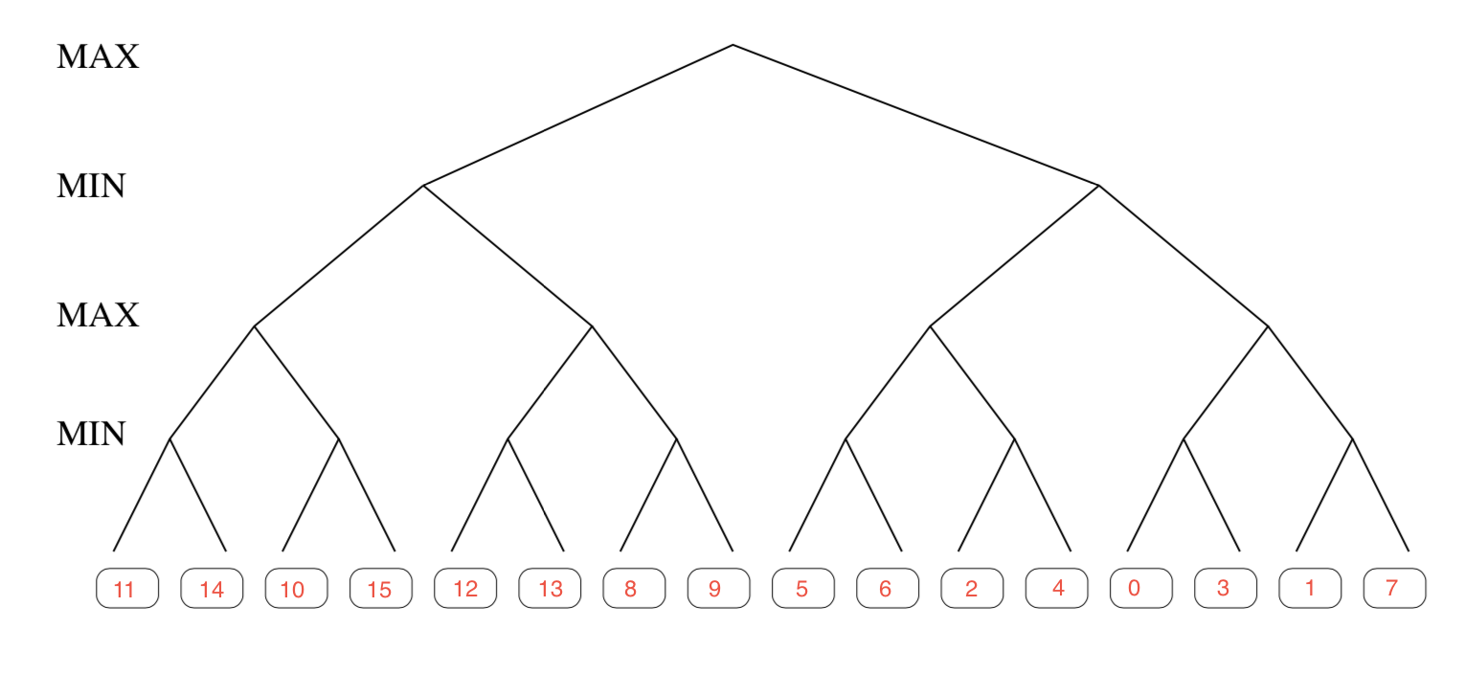

b) 7 original leaves are evaluated and the others are pruned, which shows in graph below:

c) As we can see, there will have 17 of original leaves are evaluated, after trace through the alpha-beta search algorithm on this tree. The graph below shows the shape of the pruned tree.



d) The time complexity of alpha-beta search is O(b^(d/2)).

Where b = branching factor, d = depth of the tree.

 If the best move is always examined first(at every branch of the tree), the number of leaf node positions evaluated is about *O*(*b*\*1\**b*\*1*...\**b*) for odd depth and *O*(*b*\*1\**b*\*1*...*1) for even depth, or O(b^(d/2)).

