All Method convergence plots

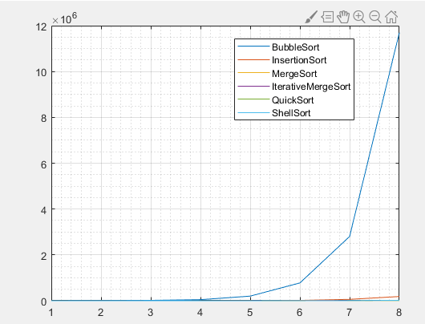

500 1000 2000 4000 8000 16000 32000 64000

All non-O(n^2) plots

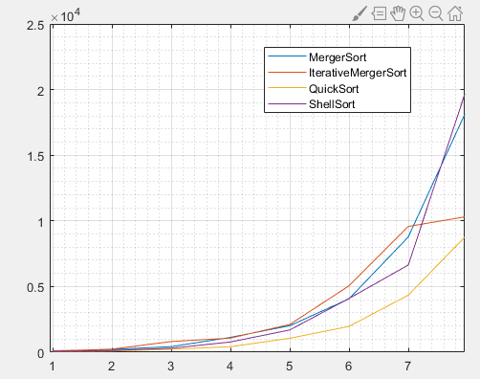

500 1000 2000 4000 8000 16000 32000 64000