Version plan

Version 1:
Focus is put on core features during this release. The goal is to have a minimum viable product ready before this release date. This means that focus is put on only the most necessary features such as logging in and signing up.
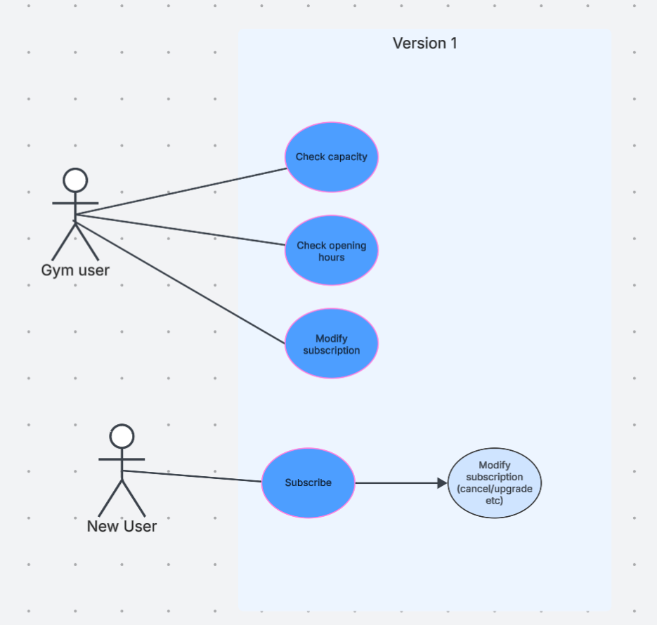
Version 2:
The second release aims to give users extra features such as the ability to browse and sign up for classes.
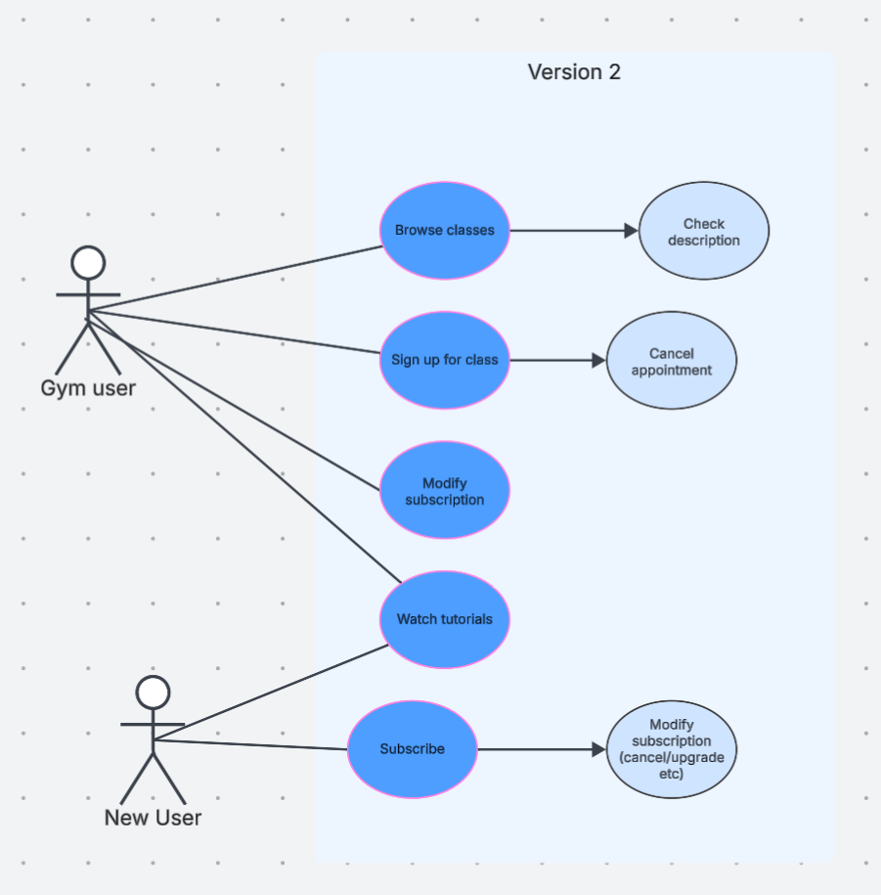
Version 3:
This release aims to add features such as finding the nearest gym. These features are nice extensions, but do not dramatically change the application.
