EXPERIENTIAL LEARNING GROUP ASSIGNMENT
Language Processing Using Machine Learning and LLMs for Audio, Image, Text and Other Applications
Semantic Similarity and
Plagiarism Detection
Finding passages that mean the same thing, and showing why that is not the same as copying.
Group 4
Name | Roll number
Oishani Majumder | 2330316
Shubhradeep Paul | 2330337

Submission date: 12 November 2026
Project report | Part of the GitHub submission

1. Title and Group Details
Project title: Semantic Similarity and Plagiarism Detection
Task chosen: Task 4 from the assignment list. Generate sentence embeddings with Sentence Transformers, compare documents using cosine similarity, identify potentially similar passages, and distinguish semantic similarity from plagiarism.

1.1 Group members and contributions
Member | Roll number | What they worked on
Oishani Majumder | 2330316 | Chose and tested the model and datasets; ran the STS-B and MRPC evaluations; wrote the results and limitations sections of this report.
Shubhradeep Paul | 2330337 | Built the document-comparison pipeline (sentence splitting, similarity matrix, copied / paraphrase labelling); prepared the sample documents; set up the GitHub repository; made the presentation.

Both members wrote the report together and rehearsed the recorded presentation and demonstration together.

2. Problem Statement and Objectives

2.1 The problem
A teacher marking two assignments, or an editor comparing two articles, often wants to know one thing: has one of these been taken from the other? The simplest tool is a word-matching checker. It works well when text is copied exactly, but it fails as soon as someone rewrites the sentence in different words. Compare these two sentences:
- “Rising sea levels threaten millions of people living in coastal cities.”
- “Coastal cities with millions of residents are at risk as the oceans keep rising.”
They share almost no words in the same order, yet a human reader sees at once that they say the same thing. A word-matching checker would miss this. A system that understands meaning would not.
There is also a second, quieter problem. Even when a system finds two passages that mean the same thing, that alone does not prove anybody copied anything. Two students can independently write “Water boils at 100 degrees Celsius at sea level”. This project deals with both halves of the problem: finding the similar passages, and being honest about what the finding does and does not prove.

2.2 Motivation
- Paraphrasing is the most common way to hide copied work, and keyword tools are weak against it.
- Pretrained sentence-embedding models are now small and free enough to run on an ordinary laptop, so a student project can use real, modern NLP without training anything.
- A plagiarism tool that overclaims can hurt innocent people. We wanted the output to say “look at this passage”, not “this person cheated”.

2.3 Objectives
1. Convert sentences into vectors (embeddings) using a pretrained Sentence Transformer.
2. Compare two documents sentence by sentence using cosine similarity.
3. Flag passages that are potentially similar and separate near-verbatim copying from paraphrasing.
4. Check how good the embeddings are on two public benchmarks, against a simple TF-IDF baseline.
5. Show, with examples, why high semantic similarity is not proof of plagiarism.

2.4 Expected outcomes
A working notebook that takes two pieces of text and returns a colour-coded, sentence-level report, together with measured benchmark results and a clear statement of the limits of the method.

3. Proposed Methodology and Processing Pipeline
The whole system is a short pipeline. Nothing is trained: we use a pretrained model as it is and add our own comparison logic around it.
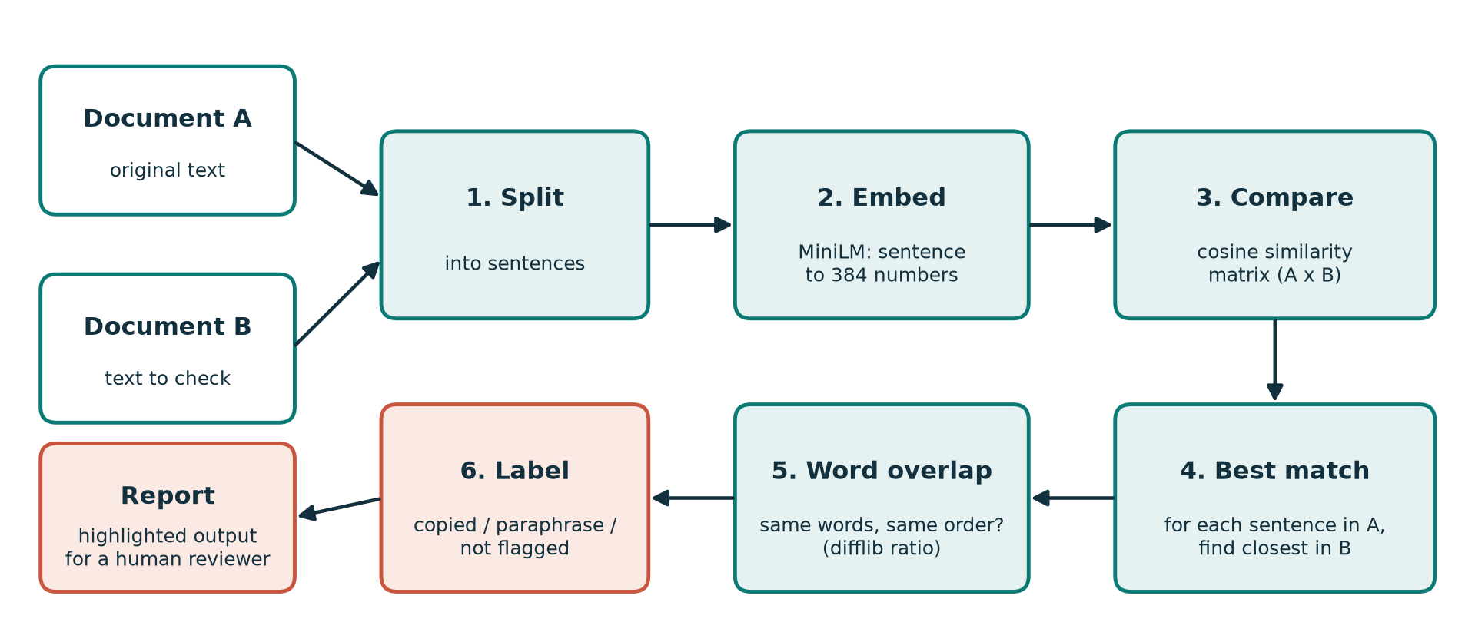
Figure 1. Processing pipeline from two input documents to a reviewer-ready report.

3.1 Input and output
- Input: two plain-text documents, A (the original) and B (the text being checked).
- Intermediate data: lists of sentences, one 384-number vector per sentence, and a similarity matrix with one row per sentence of A and one column per sentence of B.
- Output: for every sentence in A, its closest match in B, a meaning score, a wording score and a label, shown as a table, a heatmap and a colour-highlighted report.

3.2 Step-by-step
1. Split. Each document is cut into sentences at full stops, question marks and exclamation marks. Fragments shorter than four words are dropped because they carry too little meaning to compare.
2. Embed. The model turns each sentence into a vector of 384 numbers. Sentences with similar meaning get vectors that point in similar directions. Vectors are normalised to length 1.
3. Compare. Cosine similarity measures the angle between two vectors: cos(a, b) = (a · b) / (|a| |b|). A score of 1 means the same direction (same meaning), a score near 0 means unrelated. Because our vectors are already length 1, this is just a dot product, so the whole matrix is one fast matrix multiplication.
4. Best match. For each sentence in A we take the sentence in B with the highest cosine score.
5. Word overlap. Meaning alone cannot tell copying from rewording, so we add a second signal: how much of the wording is the same and in the same order. We use the match ratio from Python’s difflib.SequenceMatcher on the lower-cased words.
6. Label. The two scores are combined with the rule in the table below.

3.3 Labelling rule
Meaning score (cosine) | Word overlap | Label | How to read it
≥ 0.65 | ≥ 0.75 | Likely copied | Same idea in nearly the same words. Needs checking: could be a quotation.
≥ 0.65 | < 0.75 | Paraphrase / same idea | Same idea, different words. Could be copying or could be independent.
< 0.65 | any | Not flagged | No close match in the other document.

The two thresholds (0.65 for meaning, 0.75 for wording) are settings, not laws. We chose 0.65 after looking at the benchmark results and our sample documents, and they can be changed in one line of the notebook.

4. Models and Tools Used

4.1 Model
Item | Details
Model | all-MiniLM-L6-v2 (Sentence Transformers)
Source | https://huggingface.co/sentence-transformers/all-MiniLM-L6-v2
Size and output | About 22 million parameters, around 90 MB. Produces a 384-number vector per sentence. Reads up to 256 word-pieces per sentence.
How it was made | A small distilled version of Microsoft’s MiniLM, further trained on over a billion sentence pairs so that sentences with the same meaning get nearby vectors.
Why we chose it | It is fast on a CPU, free, widely used and gives good quality for its size, so it suits a student project that must run on free Colab.

4.2 Datasets
Dataset | Source | What it contains | How we used it
STS-B (test split) | huggingface.co/datasets/sentence-transformers/stsb | 1,379 sentence pairs with human similarity scores (stored as 0 to 1) | Checks whether the model’s scores agree with human judgement
MRPC (validation split) | huggingface.co/datasets/nyu-mll/glue (config mrpc) | 408 sentence pairs labelled paraphrase or not paraphrase | Checks whether a cosine threshold can detect paraphrases
Our own sample documents | Written by us (in the notebook) | Two short climate-change texts (copied, paraphrased, unrelated sentences) and 18 hand-labelled sentence pairs | Demonstration of the pipeline and accuracy test of the three-way label

4.3 Baseline for comparison
To see whether embeddings really add something, we compared them with TF-IDF plus cosine similarity. TF-IDF scores sentences by the words they share and has no idea of meaning, so it is the natural “dumb but fair” baseline.

4.4 Libraries and environment
- Python 3 in Google Colab (the free CPU runtime is enough; no GPU needed).
- sentence-transformers for the model, datasets (Hugging Face) for loading STS-B and MRPC.
- scikit-learn for TF-IDF, accuracy and F1; SciPy for Spearman and Pearson correlation.
- NumPy, pandas, matplotlib for the matrices, tables and plots; difflib and re from the standard library.

5. Implementation and Usability

5.1 How the notebook is organised
Section | What it does
1. Setup | Installs libraries, loads the model.
2. Core idea | Shows four sentence pairs (exact copy, paraphrase, same topic, unrelated) with their cosine scores.
3. STS-B evaluation | Correlation between model scores and human scores, against TF-IDF.
4. MRPC evaluation | Finds the best cosine threshold for paraphrase detection; accuracy and F1 against TF-IDF.
5. Document comparison | The full pipeline: sample documents, report table, heatmap, highlighted output, and a cell where you paste your own text.
5.5 Labeller accuracy | Tests the three-way label on 18 hand-labelled sentence pairs and prints accuracy and a confusion table.
6. Similarity is not plagiarism | A worked example and a list of what a human must still check.

5.2 How to run it
On Google Colab (recommended)
1. Open the notebook from the GitHub repository using the Colab link in the README, or upload the .ipynb file to colab.research.google.com.
2. Choose Runtime → Run all. A CPU runtime is fine. The first run downloads the model and the two datasets and takes a few minutes.
3. To test your own text, edit the two strings in section 5.4 of the notebook (my_a and my_b) and run that cell again.
On your own computer
1. Install Python 3, then run: pip install sentence-transformers datasets scikit-learn scipy matplotlib pandas
2. Open the notebook in Jupyter or VS Code and run the cells from top to bottom.

5.3 Practical uses
- Teachers and markers: a first-pass check that points to passages worth reading closely.
- Students: check that your own paraphrase is not still too close to the source you read.
- Editors and publishers: find duplicated or near-duplicated content across articles.
- Support teams: spot duplicate questions in an FAQ or help-desk list (the same technique, different purpose).

5.4 Design choices worth knowing
- Sentence level. Comparing whole documents as a single vector would blur everything together. Sentence level lets us point at the exact passage.
- Best match only. Each sentence of A is compared against all of B but keeps only the closest match, which keeps the report short and readable.
- Two signals, not one. Using meaning together with wording lets the report say “copied” and “paraphrased” separately.
- No training. Everything is reproducible by re-running the notebook.

6. Results and Sample Outputs
All numbers below come from running the notebook code end to end. Running the same code in Colab should give the same results, give or take tiny numerical differences.

Accuracy at a glance
Test | What it measures | Sentence Transformer | Reference
STS-B (1,379 pairs) | Agreement with human similarity scores (Spearman) | 0.820 | TF-IDF 0.693
MRPC (408 pairs) | Accuracy at the best threshold | 74.0% | TF-IDF 70.8%; always "paraphrase" 68.4%
Labeller (18 hand-labelled pairs) | Accuracy of the three-way label | 94.4% (17 of 18) | Chance level 33.3%

6.1 Sanity check: four sentence pairs
Pair (first sentence: “The cat sat on the mat.”) | Second sentence | Cosine
Exact copy | The cat sat on the mat. | 1.000
Paraphrase | A feline was resting on the rug. | 0.563
Same topic | Dogs are loyal animals. | 0.161
Unrelated | The stock market fell sharply today. | 0.075

The ordering is exactly what we hoped for: identical > paraphrase > same topic > unrelated. Note that the paraphrase scores 0.56, well above the unrelated pair (0.08) but below our 0.65 flagging threshold. A short, loosely worded paraphrase can slip under a strict threshold. This is a real trade-off, discussed in 6.3.

6.2 STS-B: does the model agree with humans?
Method | Spearman correlation | Pearson correlation
Sentence Transformer (all-MiniLM-L6-v2) | 0.820 | 0.827
TF-IDF baseline | 0.693 | 0.707

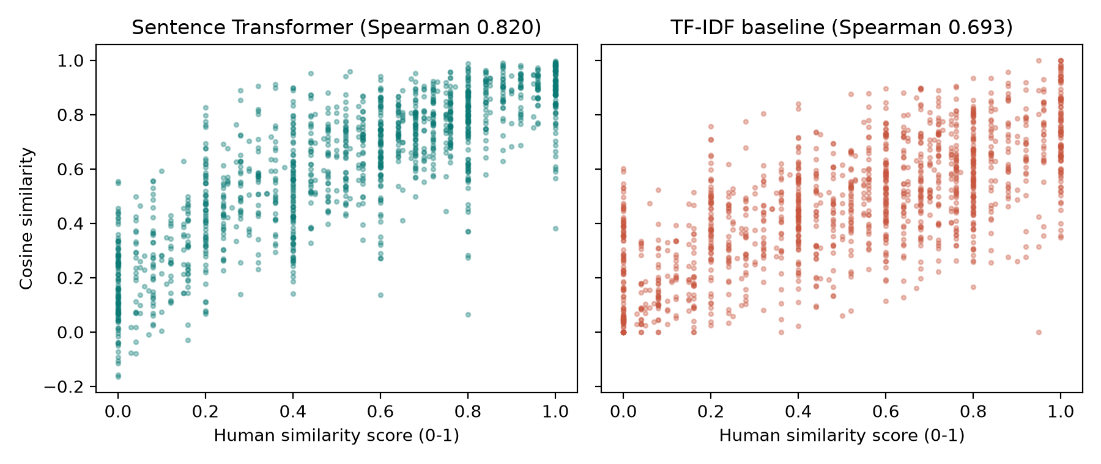
Figure 2. Model score against human score on 1,379 STS-B pairs. The embedding scores follow the human scores much more closely.
The embedding model reaches a Spearman correlation of 0.82 with human ratings, compared with 0.69 for TF-IDF. In plain words: when humans say one pair is more similar than another, the embedding model usually agrees, and it agrees clearly more often than a word-matching method does.

6.3 MRPC: can a threshold detect paraphrases?
Method | Best threshold | Accuracy | F1 score
Sentence Transformer (all-MiniLM-L6-v2) | 0.57 | 0.740 | 0.835
TF-IDF baseline | 0.35 | 0.708 | 0.824
Reference: always answer “paraphrase” | - | 0.684 | 0.812

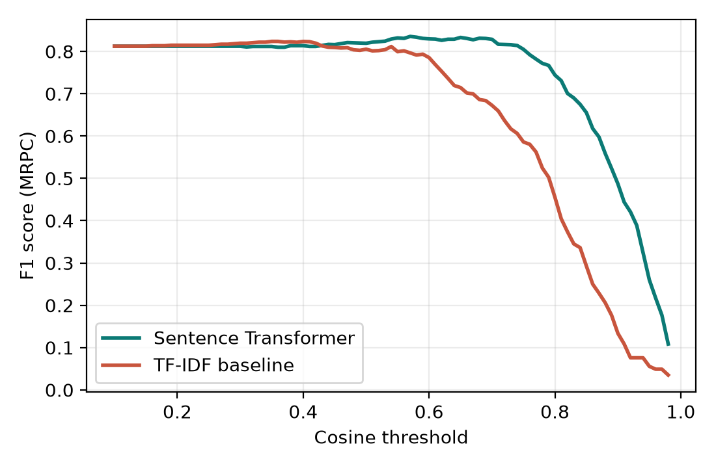
Figure 3. F1 score on MRPC as the cosine threshold changes.
This result is more modest, and we want to be upfront about it:
- The embedding model is better than TF-IDF on both measures (accuracy 0.740 vs 0.708, F1 0.835 vs 0.824), but the gap is small.
- MRPC is unbalanced: 68% of pairs are paraphrases, so even a system that always says “paraphrase” gets F1 0.812. Our F1 gain over that trivial reference is small.
- MRPC pairs were collected from news stories and are mostly lexically very similar, even when they are not true paraphrases. A single similarity threshold is a blunt tool for that.
- The best threshold (0.57) was picked on the same 408 pairs we report on, so these figures are slightly optimistic. We did not hold out a separate set.
The practical lesson is about the threshold. A lower value catches more real paraphrases but raises more false alarms; a higher value does the opposite. This is why the final tool shows the scores and does not hide them behind a yes/no verdict.

6.4 Document comparison: sample output
We wrote two short texts on climate change. Text B was built to cover every case: one sentence copied word for word, three paraphrased, and one unrelated. The system labelled each sentence of A as follows:
# | Sentence in A | Best match in B | Meaning | Words | Label
A1 | Climate change refers to long-term shifts in temperatures and weather patterns. | Climate change refers to long-term shifts in temperatures and weather patterns. | 1.00 | 1.00 | Likely copied
A2 | Burning fossil fuels such as coal, oil and gas is the main driver of global warming. | The main cause of the rise in global temperatures is the combustion of coal, oil and natural gas. | 0.70 | 0.18 | Paraphrase / same idea
A3 | Renewable energy sources like solar and wind power can reduce greenhouse gas emissions. | Wind and solar generation are able to cut emissions of heat-trapping gases. | 0.73 | 0.08 | Paraphrase / same idea
A4 | Many countries have pledged to reach net-zero emissions by the middle of this century. | Wind and solar generation are able to cut emissions of heat-trapping gases. | 0.28 | 0.23 | Not flagged
A5 | Rising sea levels threaten millions of people living in coastal cities. | Coastal cities with millions of residents are at risk as the oceans keep rising. | 0.83 | 0.16 | Paraphrase / same idea

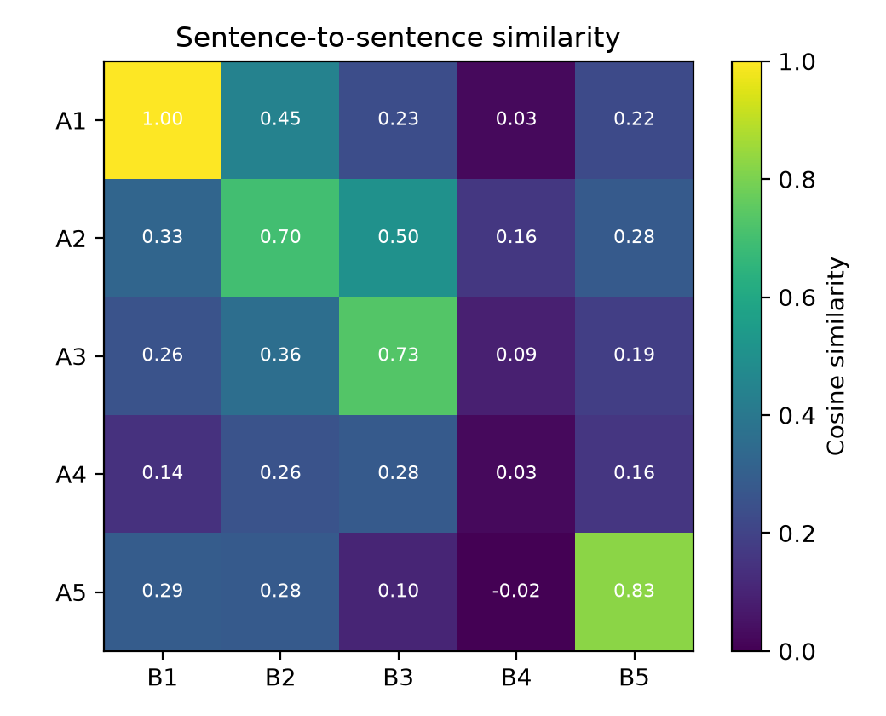
Figure 4. Similarity between every sentence in A and every sentence in B. The bright cells are the matches.
Result: A1 was correctly marked “Likely copied”. A2, A3 and A5 (rewritten) were correctly marked “Paraphrase / same idea” even though their word overlap is only 0.08 to 0.18. A4 had no counterpart in B, and the unrelated cricket sentence in B was matched to nothing, so nothing was wrongly flagged. All five sentences came out as intended. To be fair, this is a small hand-written demonstration, not a benchmark: we designed the cases, so it shows the pipeline works, not how it performs on real student submissions.

6.5 Accuracy of the full labeller
The benchmarks above test the embeddings. To test the three-way label itself, we wrote 18 sentence pairs and labelled them by hand: 6 that are copied, 6 that are paraphrased and 6 that are unrelated. With the thresholds fixed at 0.65 and 0.75 (not tuned on this set), the labeller got 17 of 18 correct, an accuracy of 94.4%.
Actual (rows) / Predicted | Likely copied | Paraphrase / same idea | Not flagged
Likely copied | 6 | 0 | 0
Paraphrase / same idea | 0 | 5 | 1
Not flagged | 0 | 0 | 6

The one mistake was a genuine paraphrase, “She was too tired to continue working on the project.” and “Exhaustion kept her from carrying on with the assignment.”. Its meaning score fell under 0.65, so it was not flagged. This is the same trade-off seen in 6.1: a loosely worded paraphrase can slip under a strict threshold. Copied and unrelated pairs were all labelled correctly. As with 6.4, this is a small set we wrote ourselves, so it shows that the rule behaves as designed, not how it would perform on real student submissions.

6.6 Semantic similarity is not plagiarism
Take two sentences written independently by two people: “Water boils at 100 degrees Celsius at sea level.” and “At sea level, water reaches its boiling point at 100 degrees Celsius.” The model scores them 0.92. That is a very high score and nobody has copied anything: it is a plain fact that any student would state in similar words.
What a high score does not tell you: whether the source was cited, whether the passage is a quotation, whether it is common knowledge or a standard definition, or whether it was written independently. Those judgements need a human reader. Our report therefore says “Likely copied” or “Paraphrase” as a pointer for review, never as a verdict.

6.7 Limitations
- Thresholds depend on the text. 0.65 / 0.75 suit our sample; other subjects and styles will need re-tuning.
- Short paraphrases can be missed. The cat-and-mat paraphrase scored 0.56, under the 0.65 threshold.
- Closest-match only. A sentence in A is compared against one best sentence in B. Plagiarism spread across several sentences (merged or split) can be under-reported.
- English only. The chosen model is built for English. Other languages would need a multilingual model.
- Two documents at a time. The tool does not search the web or a database of sources, so it cannot say where text came from.
- Sentence length. Anything beyond about 256 word-pieces is truncated.
- Small evaluation. Our own document test and our 18-pair labelled set are tiny and written by us; the MRPC threshold was tuned and reported on the same data.

7. Conclusion and Future Scope

7.1 What we achieved
- Built a complete, runnable pipeline that compares two documents sentence by sentence using Sentence Transformer embeddings and cosine similarity.
- Showed on STS-B that the embeddings agree with human similarity ratings clearly better than TF-IDF (Spearman 0.82 vs 0.69).
- Showed on MRPC that a threshold approach reaches 74.0% accuracy, only modestly better than a word-matching baseline (70.8%), which taught us why thresholds need care.
- Added a word-overlap check so the report can separate “likely copied” from “paraphrased”, and measured the three-way label at 94.4% accuracy (17 of 18) on a small hand-labelled set.
- Demonstrated, with an example, that semantic similarity is evidence for human review and not proof of plagiarism.

7.2 Possible improvements
- Use a multilingual model (for example paraphrase-multilingual-MiniLM-L12-v2) so Hindi and Odia texts can be compared.
- Compare windows of two or three sentences to catch plagiarism that is merged or split across sentences.
- Add a re-ranking step with a cross-encoder model to improve borderline cases.
- Evaluate on a proper plagiarism corpus (such as the PAN datasets) and choose the thresholds on held-out data.
- Wrap the notebook in a small Gradio or Streamlit page with file upload for PDF and Word documents.
- Search a collection of reference documents, so the tool can point to likely sources and not only compare two files.

8. References and GitHub Repository Link

8.1 GitHub repository
https://github.com/<your-username>/<your-repo-name>

8.2 Models and datasets
1. all-MiniLM-L6-v2 model card. Hugging Face. https://huggingface.co/sentence-transformers/all-MiniLM-L6-v2
2. STS Benchmark (sentence-transformers/stsb). Hugging Face. https://huggingface.co/datasets/sentence-transformers/stsb
3. GLUE benchmark, MRPC subset (nyu-mll/glue). Hugging Face. https://huggingface.co/datasets/nyu-mll/glue

8.3 Papers
1. Reimers, N. and Gurevych, I. (2019). Sentence-BERT: Sentence Embeddings using Siamese BERT-Networks. Proceedings of EMNLP-IJCNLP 2019.
2. Wang, W., Wei, F., Dong, L., Bao, H., Yang, N. and Zhou, M. (2020). MiniLM: Deep Self-Attention Distillation for Task-Agnostic Compression of Pre-Trained Transformers. NeurIPS 2020.
3. Cer, D., Diab, M., Agirre, E., Lopez-Gazpio, I. and Specia, L. (2017). SemEval-2017 Task 1: Semantic Textual Similarity, Multilingual and Cross-lingual Focused Evaluation. SemEval-2017.
4. Dolan, W. B. and Brockett, C. (2005). Automatically Constructing a Corpus of Sentential Paraphrases. Proceedings of the Third International Workshop on Paraphrasing (IWP 2005).
5. Wang, A., Singh, A., Michael, J., Hill, F., Levy, O. and Bowman, S. (2019). GLUE: A Multi-Task Benchmark and Analysis Platform for Natural Language Understanding. ICLR 2019.

8.4 Software
sentence-transformers (https://www.sbert.net), Hugging Face datasets, scikit-learn, SciPy, NumPy, pandas, matplotlib.

