WEEK 1 INTERNSHIP REPORT
Data Cleaning and Preliminary Analysis with R
Virtual R Data Analyst Internship • 04-Sep-2026 to 02-Oct-2026

1. Objective
The objective of Week 1 is to perform data cleaning, preprocessing, and preliminary exploratory analysis using R. The work covers dataset inspection, missing-value treatment, duplicate checking, outlier detection, variable transformation, feature engineering, descriptive statistics, and initial interpretation of important patterns.

2. Dataset Selection and Overview
The analysis uses the publicly available Titanic passenger dataset. The dataset contains 891 passenger records and 12 original variables. It includes numerical variables such as Age, Fare, SibSp, Parch, PassengerId, and Pclass; categorical variables such as Sex, Embarked, and Cabin; and the binary target variable Survived. This dataset was selected because it contains missing values, mixed data types, skewed numerical values, and a meaningful outcome suitable for preliminary data analysis.
Dataset source: Data Science Dojo public datasets repository. Raw CSV used in the R script: https://raw.githubusercontent.com/datasciencedojo/datasets/master/titanic.csv

3. Initial Data Quality Assessment
Quality Check | Result
Rows | 891
Original columns | 12
Missing Age | 177 (19.9%)
Missing Cabin | 687 (77.1%)
Missing Embarked | 2 (0.2%)
Duplicate PassengerId values | 0
Target variable | Survived (0 = No, 1 = Yes)
The initial inspection shows that Cabin is extremely sparse, Age has moderate missingness, and Embarked has only two missing observations. There are no duplicate PassengerId values. Because Age is analytically important, its missing values are imputed rather than removing affected rows.

4. Data Cleaning and Preprocessing
- Cabin was removed from the analytical dataset because 687 of 891 observations (77.1%) are missing. Direct imputation would introduce substantial uncertainty.
- Age was imputed using the median Age within each Pclass × Sex group. This preserves differences between passenger groups instead of applying one global median.
- The two missing Embarked values were replaced with the modal category, S.
- Fare outliers were detected using the IQR rule. Q1 = 7.9104, Q3 = 31.0000, IQR = 23.0896, and the upper fence = 65.6344. There are 116 observations above this fence.
- Instead of deleting high-fare observations, Fare was capped at the upper IQR fence to reduce the effect of extreme values while retaining all 891 passengers.
- FamilySize = SibSp + Parch + 1 and IsAlone were created as derived variables.
- SexBinary was created as a 0/1 representation of Sex.
- Age and Fare_Capped were standardized using z-scores for later scale-sensitive analysis.

5. R Code Used
library(dplyr)
# Import public Titanic dataset
url <- "https://raw.githubusercontent.com/datasciencedojo/datasets/master/titanic.csv"
df <- read.csv(url, stringsAsFactors = FALSE)
# Initial inspection
dim(df)
str(df)
colSums(is.na(df))
sum(duplicated(df$PassengerId))
# Remove very sparse Cabin field
df_clean <- df %>% select(-Cabin)
# Impute Age using Pclass x Sex group medians
df_clean <- df_clean %>%
group_by(Pclass, Sex) %>%
mutate(Age = ifelse(is.na(Age),
median(Age, na.rm = TRUE), Age)) %>%
ungroup()
# Impute missing Embarked with mode
mode_embarked <- names(sort(table(df_clean$Embarked),
decreasing = TRUE))[1]
df_clean$Embarked[is.na(df_clean$Embarked)] <- mode_embarked
# Feature engineering
df_clean <- df_clean %>%
mutate(
FamilySize = SibSp + Parch + 1,
IsAlone = ifelse(FamilySize == 1, 1, 0),
SexBinary = ifelse(Sex == "male", 1, 0)
)
# IQR-based outlier treatment for Fare
Q1 <- quantile(df_clean$Fare, 0.25, na.rm = TRUE)
Q3 <- quantile(df_clean$Fare, 0.75, na.rm = TRUE)
IQR_value <- Q3 - Q1
upper <- Q3 + 1.5 * IQR_value
df_clean$Fare_Capped <- pmin(df_clean$Fare, upper)
# Standardization
df_clean$Age_Z <- as.numeric(scale(df_clean$Age))
df_clean$Fare_Z <- as.numeric(scale(df_clean$Fare_Capped))
# Final checks
summary(df_clean)
colSums(is.na(df_clean))

6. Cleaning Results
Variable / Metric | Before Cleaning | After Cleaning
Age missing values | 177 | 0
Embarked missing values | 2 | 0
Cabin missing values | 687 | Field removed
Fare maximum | 512.3292 | 65.6344 (capped)
Total records | 891 | 891
Remaining missing values | 866 across Age/Cabin/Embarked | 0 in analytical fields
No passenger records were deleted during cleaning. This is important because the target variable is preserved for every observation. The resulting analytical table contains 891 complete records for the variables used in the Week 1 analysis.

7. Descriptive Statistics
Variable | N | Mean | Std. Dev. | Min | Max
Age | 891 | 29.112 | 13.304 | 0.42 | 80.00
Fare | 891 | 32.204 | 49.693 | 0.00 | 512.33
Fare_Capped | 891 | 24.047 | 20.482 | 0.00 | 65.63
FamilySize | 891 | 1.905 | 1.613 | 1.00 | 11.00

8. Initial Analysis and Insights
- Female passengers had a survival rate of 74.2%, compared with 18.9% for male passengers.
- Survival varied strongly by passenger class: approximately 63.0% in first class, 47.3% in second class, and 24.2% in third class.
- Fare_Capped has a positive correlation with Survived of approximately 0.317, while Pclass has a negative correlation of approximately -0.338.
- Age has a small negative correlation with Survived of approximately -0.060, indicating that Age alone is a weaker linear indicator than Sex or Pclass in this dataset.
- The cleaned dataset contains no missing values in the analytical fields and retains all 891 passenger records.
- The preliminary results suggest that Sex, Pclass, and Fare should receive particular attention in subsequent visualization and predictive analysis.

9. Visual Evidence
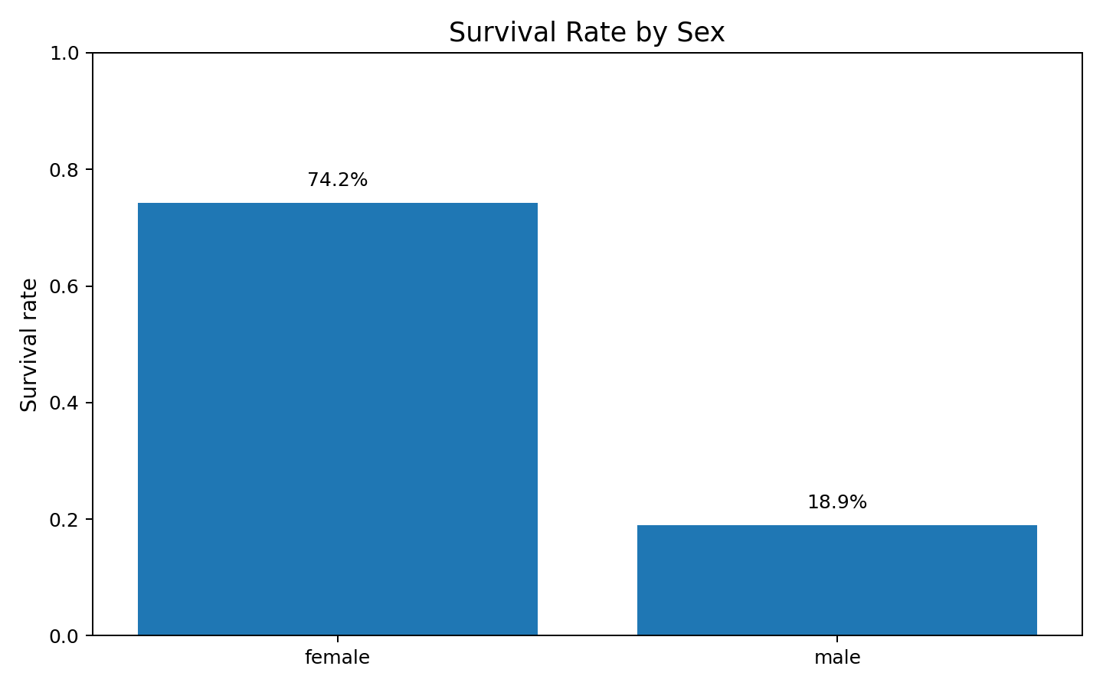
Figure 1. Survival rate by sex.
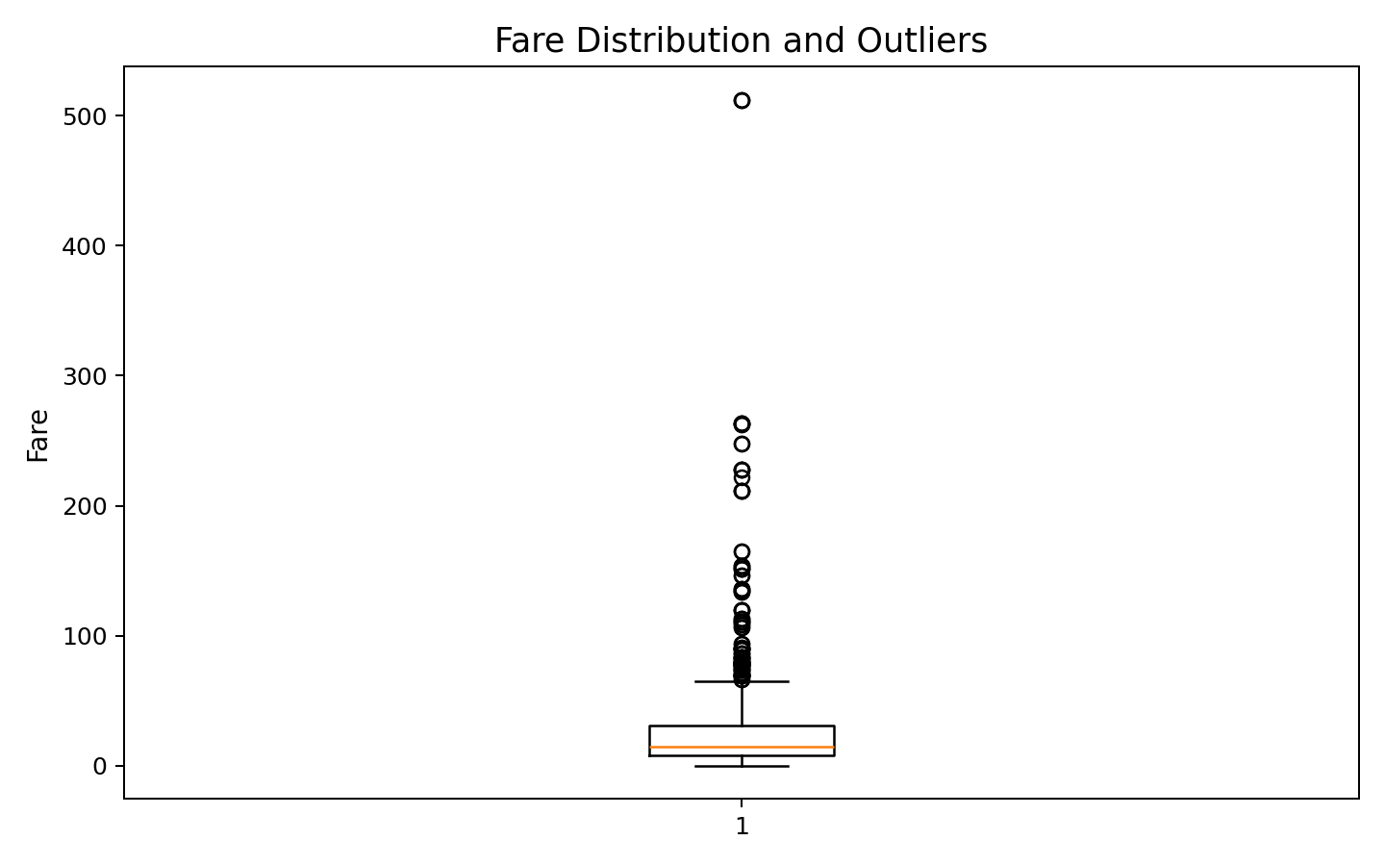
Figure 2. Fare distribution showing extreme values.
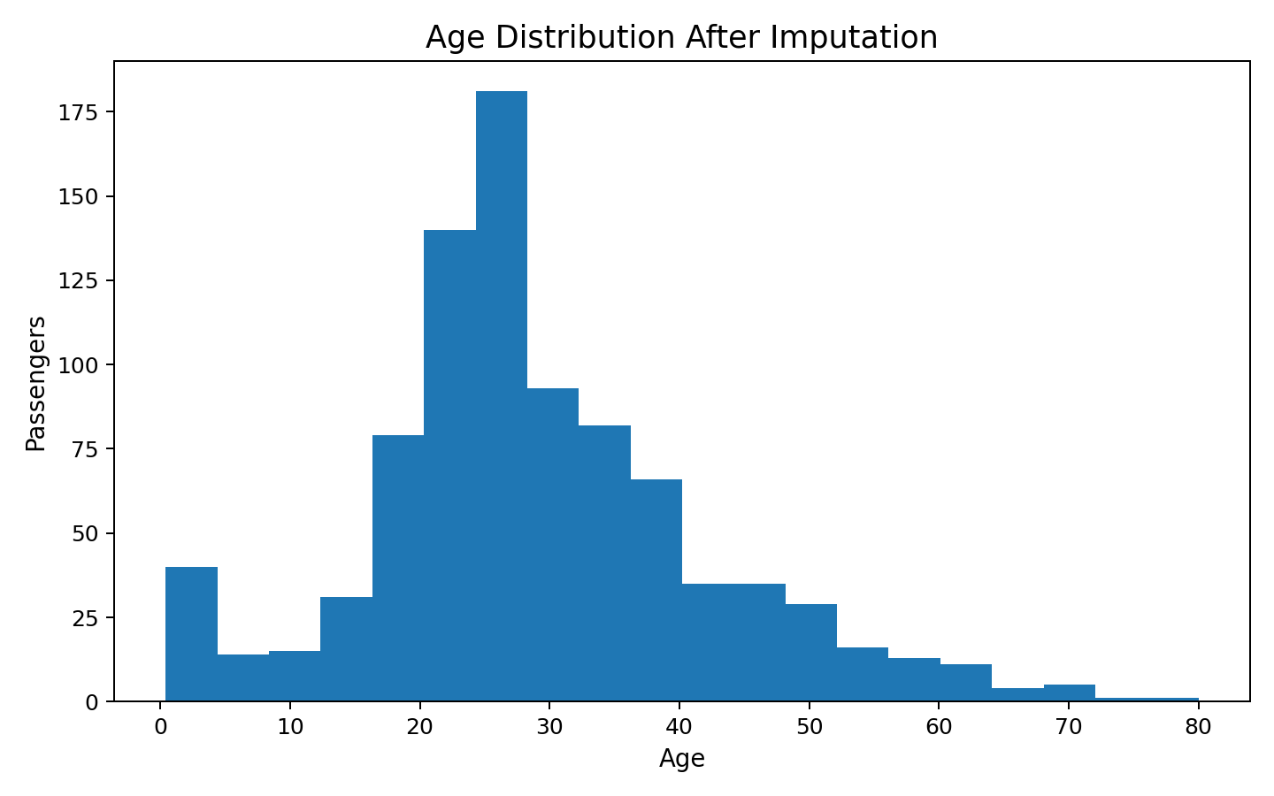
Figure 3. Age distribution after missing-value treatment.

10. Conclusion
The Week 1 analysis established a reproducible data-cleaning workflow in R. The dataset was inspected for structure, missingness, duplicates, and outliers before transformation. Cabin was removed because of excessive missingness, Age was imputed using group-specific medians, and Embarked was completed using the modal category. Fare was treated using an IQR-based cap rather than deleting valid records. Additional variables were engineered to support later analysis, and standardized versions of Age and Fare were created. The final analytical dataset contains 891 records with no remaining missing values in the variables used for analysis. Preliminary results show substantial differences in survival across Sex and Passenger Class and indicate that these variables, along with Fare, are promising candidates for deeper exploratory and predictive analysis in subsequent weeks.

11. Reproducibility
The complete R script used for this report is named week1_cleaning.R. Running the script from top to bottom reproduces the import, cleaning, feature engineering, outlier treatment, standardization, and summary checks documented above.

