Milestone 3 Truck Truck Go Instructions.

Configurations are hard! No need to add any configuration to run graphics or console! Simply run QueryRunner the same as we did in class without configuration.

**Make sure you are logged in to the SU VPN for our server to work!**

You will see this prompt:



Typing ‘c’ and hitting enter will have you continue in the console. Typing ‘g’ and hitting enter will bring up the gui.

Let’s go over the console first.

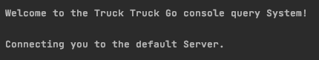

The gui will automatically connect you to our group server! How convenient!

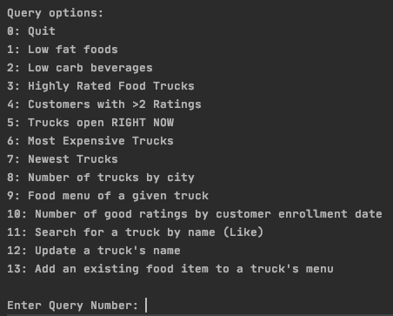

Simply enter the query number and hit enter.

For Queries 1-8 and 10 You shouldn’t need to enter any paramenters.

For Query 9 You need to enter the name of a truck. Try “"Floral and Hardy".

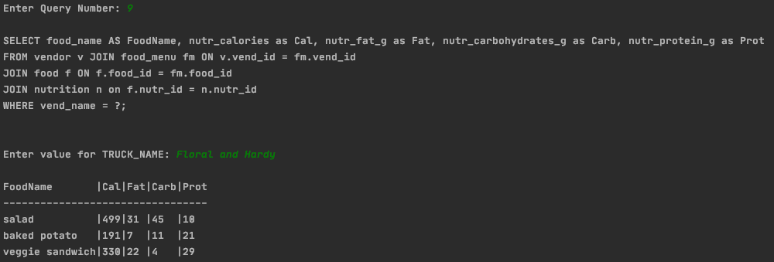

For Query 11 You are using a “like” parameter to find truck names. Try “%the%”

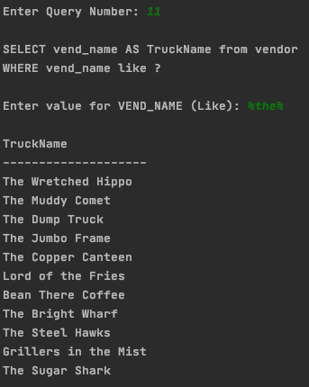

For Query 12 You need to enter the new name, then the old name. Try entering “The Gold Falcon” and then “The Steel Hawk” to change the name of “The Steel Hawk”.

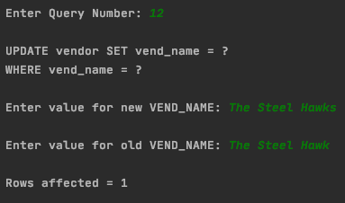

For Query 13 You need to enter a price, then a truck name, then a food item. Try entering “4.99” then “The Dump Truck” then “baked potato”. You can check your results by doing Query 9 again with “The Dump Truck”!

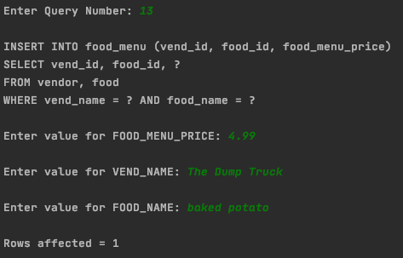

Type “exit” when you are done or “0” when prompted for a query # to quit.

Let’s go over the graphical interface next.

The login information for our server is now pre filled, so all you have to do is hit connect

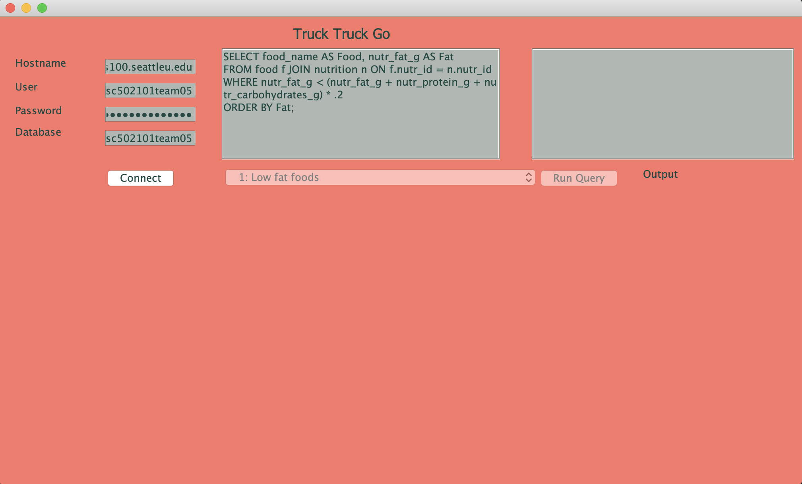

All of the queries have descriptions in the query dropdown of what they do!

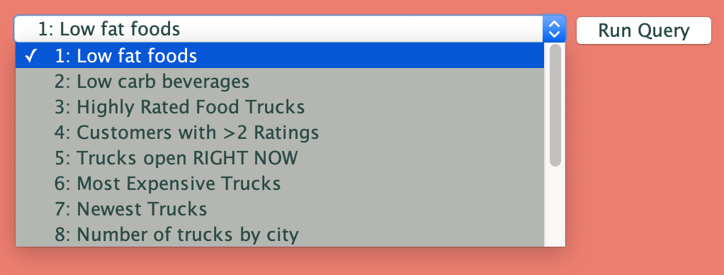

Queries 1-8 require no parameters. For Query 9 you could use Embers!

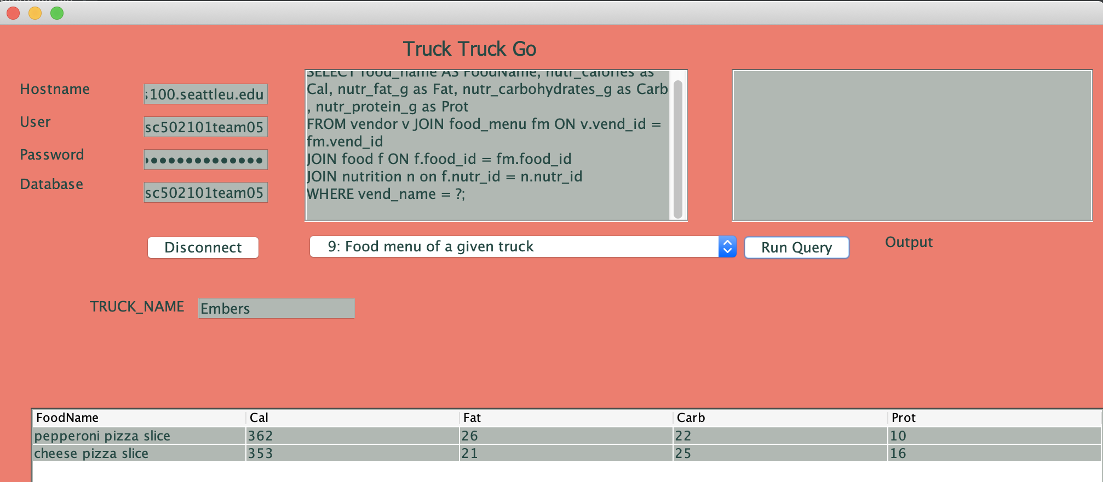

For query 10 we could see how many food trucks have the word “truck” in the name. Only 1!

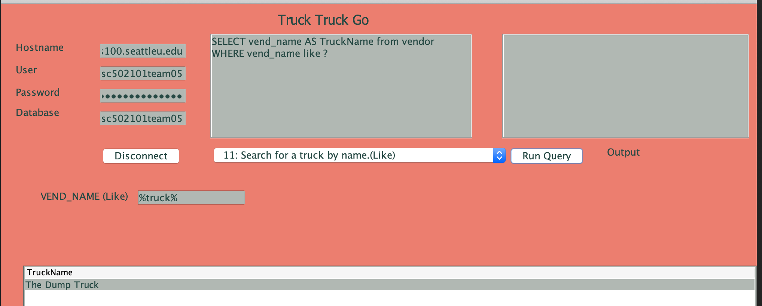

And maybe For Query 11 We can change the food truck named Lord of the Fries to Mr. Potato.

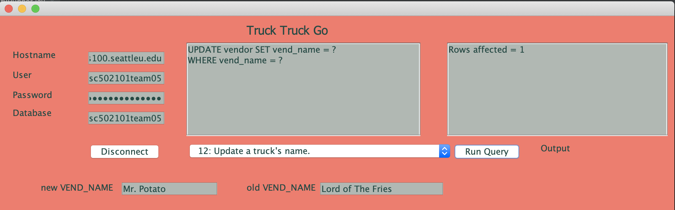

It worked!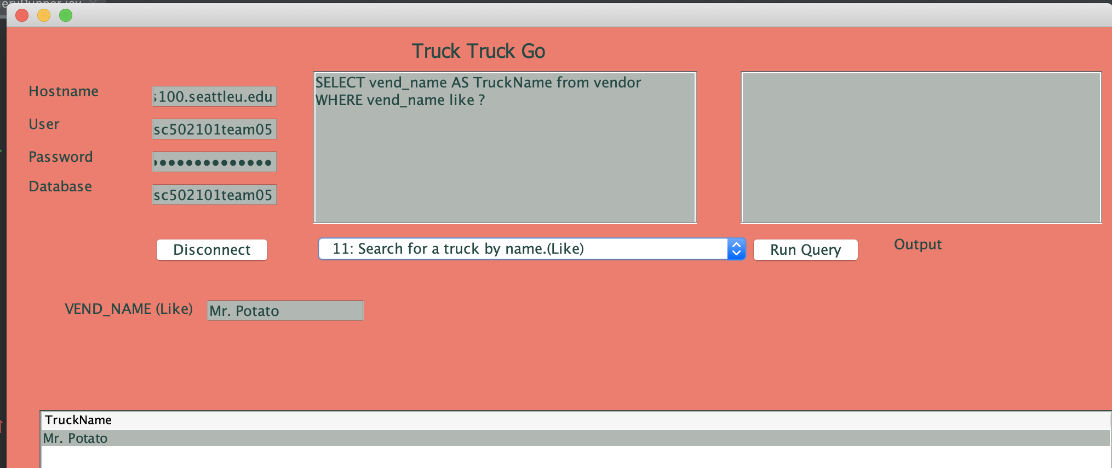

Finally, for Query 12, we could add tacos to the embers menu

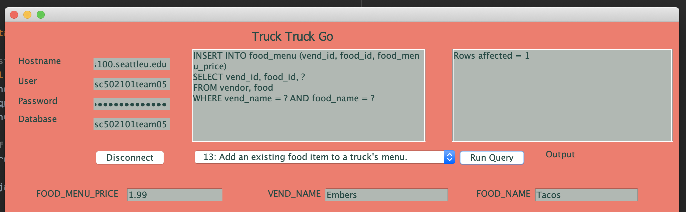

Not just a pizza place anymore!

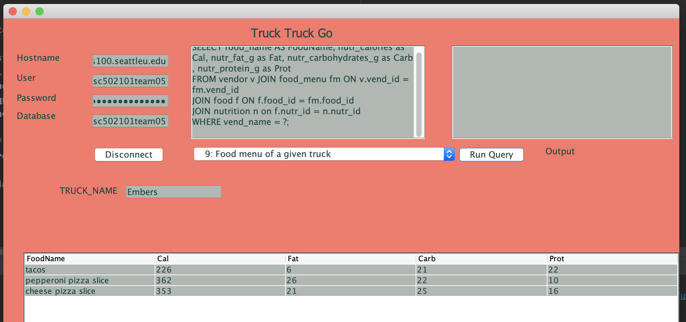

All of these transactions should work the same for you – changes have been undone on the database.